Module 5: Critical Thinking
Greg Fritz
Professor Herbert Pensado
CSC450-1
January 18, 2026

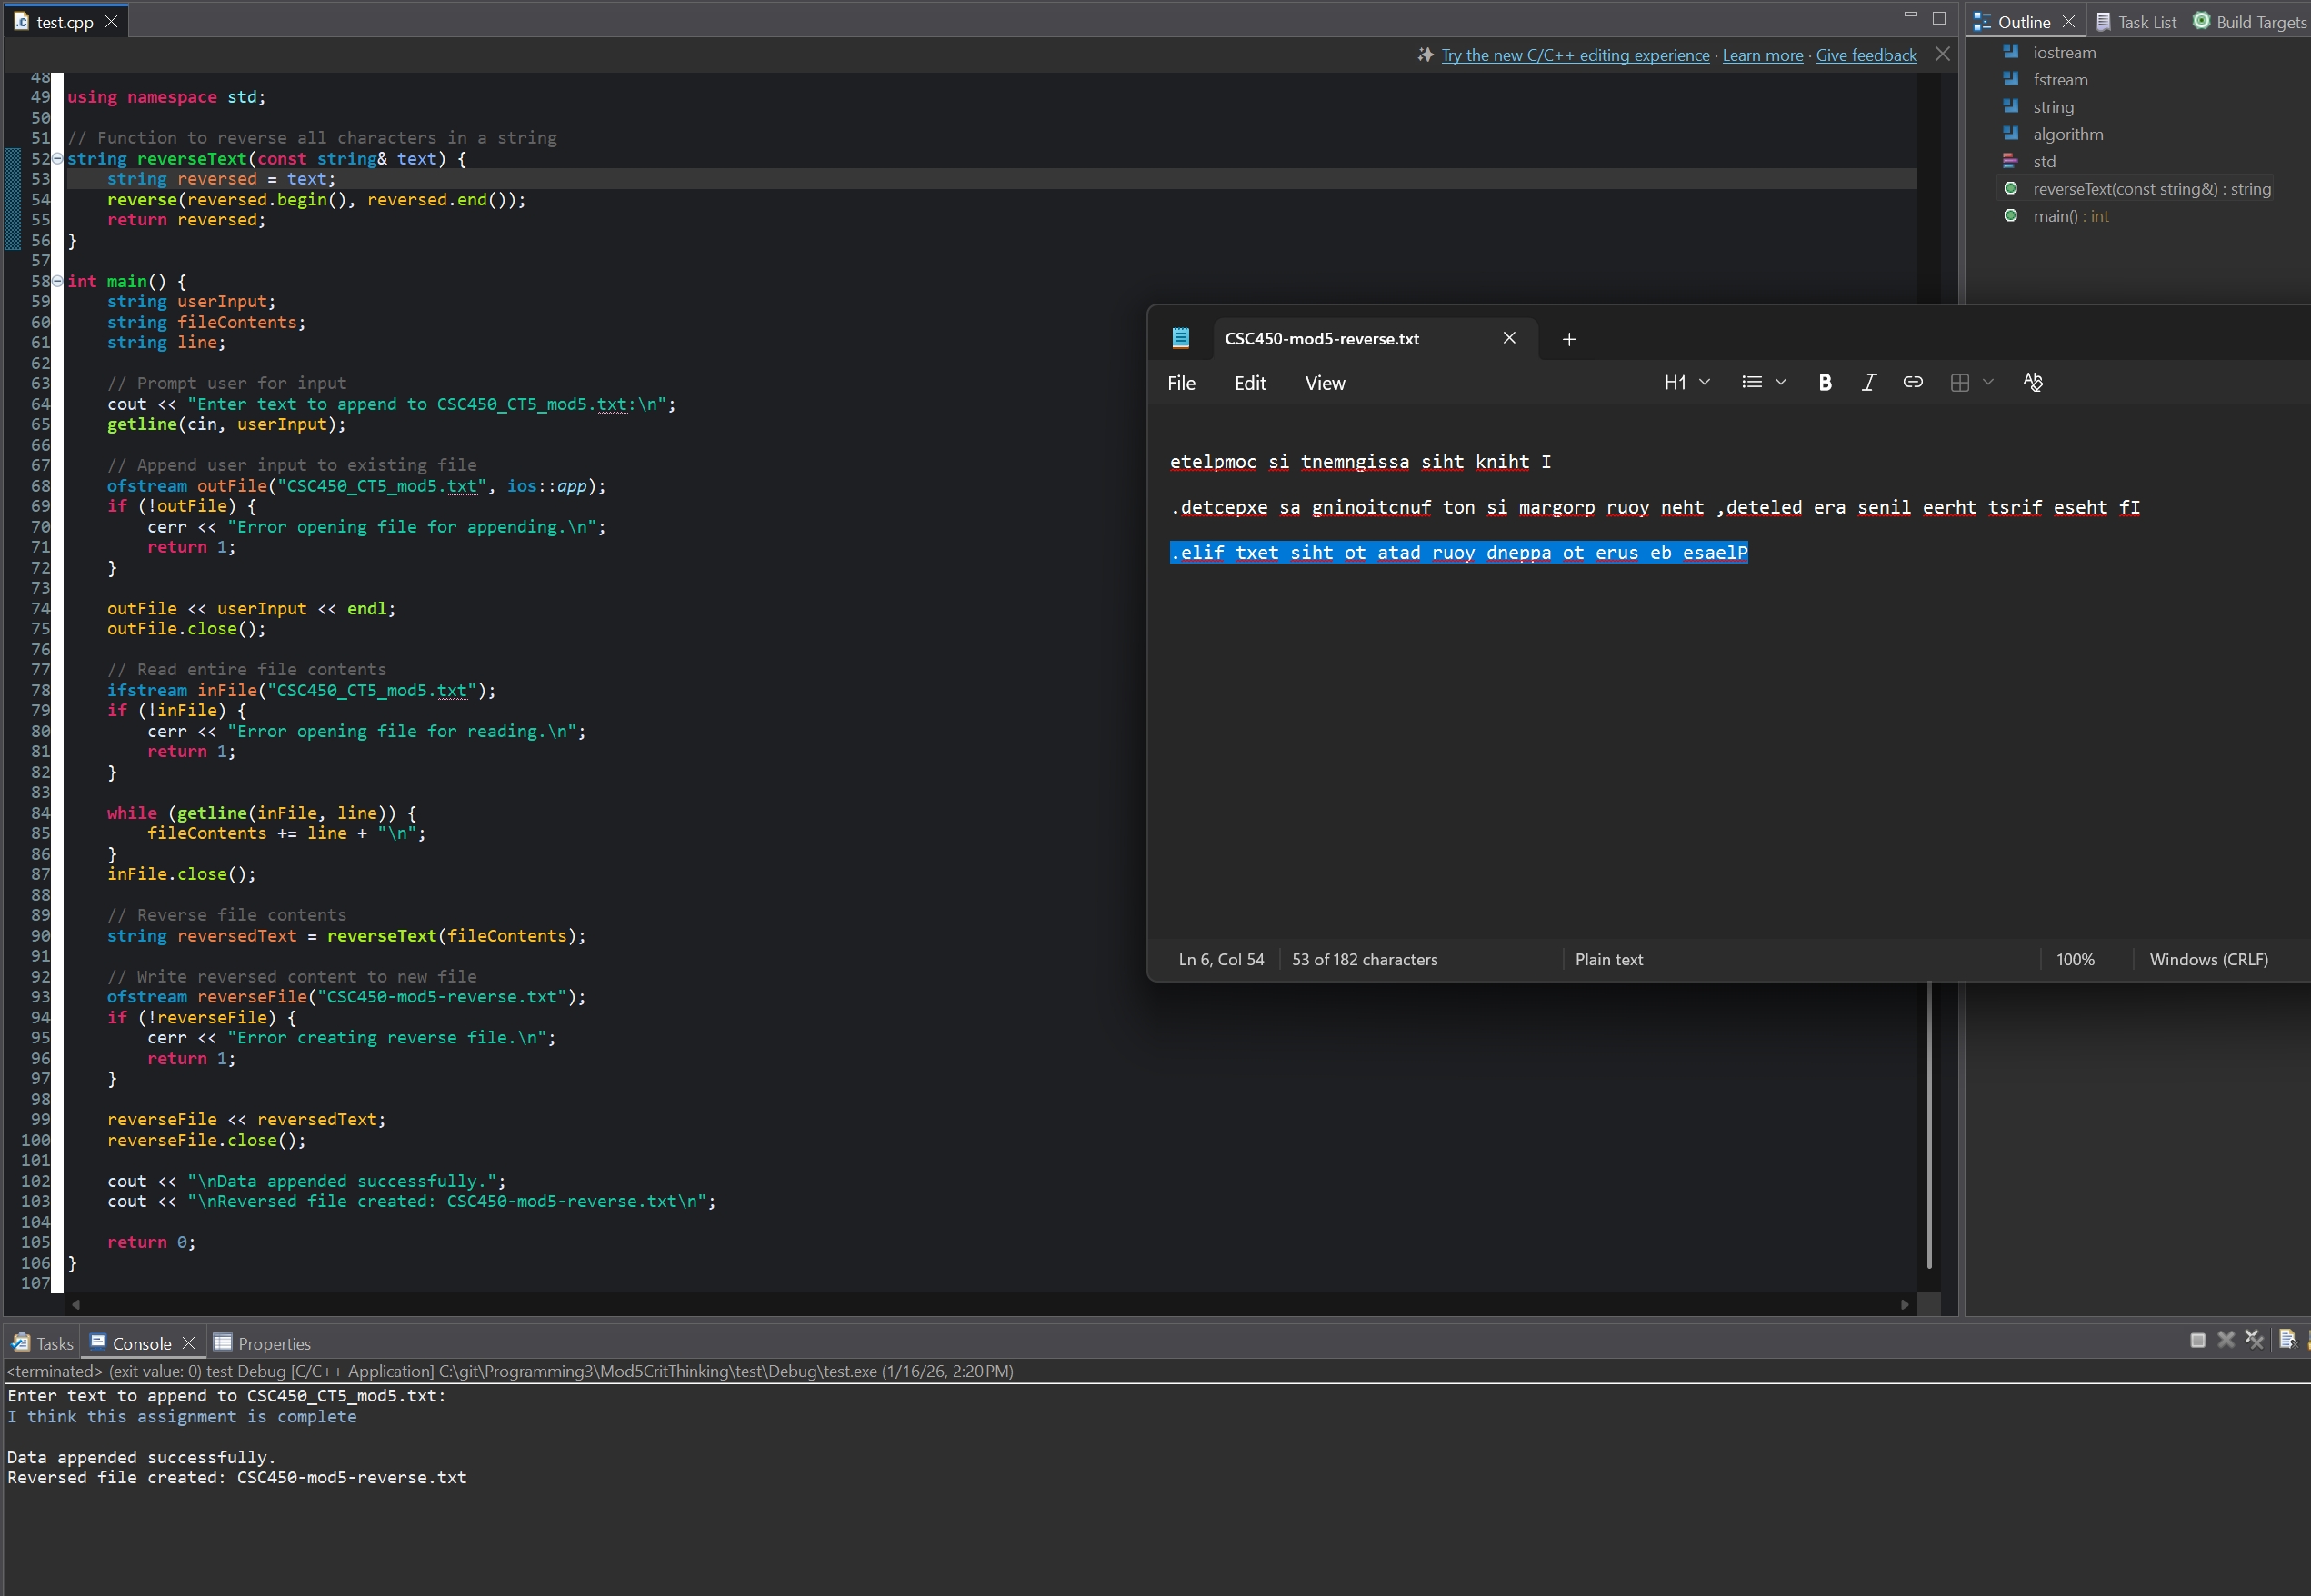

Git Hub links:
https://github.com/gfritzcsu/Programming3/tree/main/Mod5CritThinking
https://github.com/gfritzcsu/Programming3/commits/main/Mod5CritThinking

