

***LAZER***

***STORE***

**E-Project Documentation**

**Teacher Name : AIJAZ ALI**

**APTECH COMPUTER EDUCATION**

**HYDERABAD-1 PAKISTAN**

**Issue Date : 22-Dec-2022**

TABLE OF CONTENT

|  |  |  |
| --- | --- | --- |
| **S No** | **Contents** | **Page No** |
| 01 | Certificate | 3 |
| 02 | Acknowledgement | 4 |
| 03 | Project Report | 5 |
| 04 | Problem Definition | 6 |
| 05 | Customer Requirements Specification  (CRS) | 7 |
| 06 | Architecture Design of the Project | 9 |
| 07 | System Requirement | 10 |
| 08 | Task Sheet | 11 |
| 09 | Project Plan | 13 |
| 10 | Checklist of work Progress | 14 |
|  |  |  |
| 11 | Screen Shots | 15 |
| 12 | Source Code | 19 |

CERTIFICATE

This is to certify that

**Murtaza Shakir**

Has successfully Designed

LAZER STORE

Submitted by:

**Murtaza**

Date of Issue: 22-Dec-2022

**Authorized Signature:** AIJAZ ALI

ACKNOWLEDGEMENT

First and foremost, we would like to express our deep gratitude and most heartfelt thanks to almighty ALLAH for his blessings, for lightening up our heart with the torch of knowledge and for giving us the ability to complete this project.

We would like to thanks Aptech Worldwide and the team of E-Project for their generous support and clarifying the doubts regarding e-project. We would like to acknowledge the way of explanation which the team of e-project gave in e-project to make website and we are equally grateful to our teacher (Sir Amjad Ali) for giving us a moral support and guiding us different matters regarding project in all the time about the research and writing of this project.

We are greatly indebted to Aptech Worldwide, Sir Amjad Ali, Faculty Members and ACE Hyderabad, Pakistan for encouragement and incessant help.

PROJECT REPORT

**BY:**

**MUHAMMAD SAQUIB**

**Project Title : LAZER STORE,**

**Members Name : Murtaza Shakir,sami,**

**Batch Code : 2207D**

**Start Date : 22-Dec-2022**

**End Date : 11-Jan-2023**

**Course : ACCP (CPISM)**

**Teacher : AIJAZ ALI**

**Center Manager : Sir Shoaib Ahmed**

**Center Academic Head : Sir Zubair Ahmed**

**Center Name : ACE Hyderabad-1, Pakistan**

Submitted as

E Project Documentation

**PROBLEM DEFINITION**

**Persol is selling various types of air conditioners. Company has a large collection**

**of splte (ac). The company advertises by distributing the pamphlets,**

**advertising on television and so on. Due to rapid development in internet field, the**

**company decides to launch a website where people will get all the information about**

**the various products available with them easily.**

**You are supposed to create a website for them with the below mentioned**

**requirement specifications.**

**You are supposed to create a Single-Page-Application and responsive Website for**

**them with the below mentioned requirement specifications.**

**The website is to be developed for the Windows Platform using HTML5, JSON,**

**Angular JS, JavaScript and Geolocation. The site should work well in all leading**

**browsers including Chrome, IE, Firefox etc.**

**Customer Requirement Specification**

The portal will be designed as a Single-Page-Application and responsive Website with

a set of pages and menus that represent choice of activities to be performed. The

pages, menus, and other visual elements must be designed in a visually appealing

manner with attractive fonts, colors, and animations. All of these should also be laid

out in a responsive manner.

The Web site is to be created based on the following requirements.

1) The Top of the Page should contain logo of the site with suitable images.

2) The site should display a menu which will contain the options for brief

introduction about the various frames and lenses available, location of the

shop and any other information if required.

3) The information should be categorized according to the brand names of the

products like if a User wants to see only “top selling product” products or any other

companies products then he/she can click on a Link/button/menu etc and can

see only that Brand products.

4) Another category option for “Services”, “Contact” etc. should be

created and accordingly the products should be listed.

5) A brief summary of features of individual products should be displayed on the

Web Page along with the product but detailed Features should be stored in

Individual Word documents which can be downloaded or viewed by the User

who wishes to see the same.

6) The user should also be able to compare the various products of different as

well as similar brands.

7) There should be a “Contact Us” page which will have the Address of the

Company which is as follows and the mail address which when clicked will

invoke the local mail client from where they can send an email. Address of the

Company should be displayed using GeoLocation API (eg. GoogleMaps).

PROJECT OBJECTIVE:

The Objective of this program is to give a sample project to work on real life

projects. These applications help you build a larger more robust application.

The objective is not to teach you JSON/JavaScript/Dreamweaver/HTML5 but to

provide you with a real life scenario and help you create basic applications using the

tools.

You can revise the chapters before you start with the project.

This project is meant for students who have completed the module of HTML5. These

programs should be done in the Lab sessions with assistance of the faculty if

required.

It is very essential that a student has a clear understanding of the subject. Students

should go through the project and solve the assignments as per requirements given.

Kindly get back to eProjects Team in case of any doubts regarding the application or

its objectives.

Architecture & Design of the Project:

Since the website will have client server architecture it will have one-tier architecture.

System Requirement:

|  |  |  |
| --- | --- | --- |
| **SR.No** | **Items** | **Description** |
| 01 | Operating System | Window XP, Win7 or win8 |
| 02 | Main Processor | Minimum 2ghz or better |
| 03 | Ram (Memory) | Minimum 512mb or better |
| 04 | Web Browser | Google Chrome or Firefox (Latest) |
| 05 | Software | VS code,Photoshop,  Illustrator |

TASK SHEET

|  |  |  |  |  |  |
| --- | --- | --- | --- | --- | --- |
| **Project Ref. No:** | | **Date of Preparation of Activity Plan:** | | | |
| SR.  No | Task | Actual  Start  Date: | Actual  Day: | Team  Mates  Names: | Status: |
| 01 | Planing | 30-Oct-2019 | 1 | NOOR-UL-SAJDEEN | YES |
| 02 | Data  Collection | 30-Oct-2019 | 1 | MUHAMMAD UMAR | YES |
| 03 | Designing  Home  Page | 01-Nov-2019 | 4 | NOOR-UL-SAJDEEN | YES |
| 04 | Linking | 10-Nov2019 | 9 | MUHAMMAD UMAR | YES |
| 05 | Check  Links | 12-Nov-2019 | 2 | NOOR-UL-SAJDEEN | YES |
| 06 | Finalizing | 15-Nov-2019 | 3 | MUHAMMAD UMAR | YES |
| 07 | Testing | 17-Nov-2019 | 2 | NOOR-UL-SAJDEEN | YES |
| 08 | Documentation | 18-Nov-2019 | 1 | NOOR-UL-SAJDEEN | YES |
| 09 | Uploading | 20-Nov-2019 | 2 | NOOR-UL-SAJDEEN | YES |

PROJECT PLAN

* Website is able to execute quickly.
* The color scheme of the site looks attractive.
* The collection of data is authentic and taken by the most popular product websites.
* There is authentic information of facilities products with their specifications.
* Background is different to main page.
* The HOME is well prepared exactly for the same page as user clicks on the link..
* A visitor can also view the individual image of our everygallery.

CHECK LIST OF WORK PROGRESS

|  |  |  |
| --- | --- | --- |
| **SR.No** | **Aspect Tested** | **Remarks** |
| 01 | Data Collection | **Yes** |
| 02 | Designing Home Page | **Yes** |
| 05 | Linking The Pages | **Yes** |
| 06 | Finalization | **Yes** |
| 08 | Tasting The Site | **Yes** |
| 09 | Documentation | **Yes** |

SCREEN SHOTS

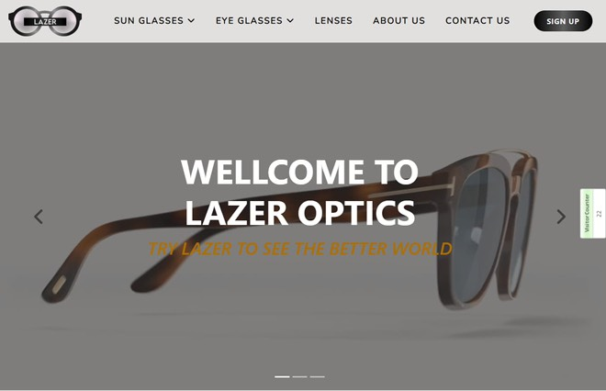

Home-page-1

Home-page-2

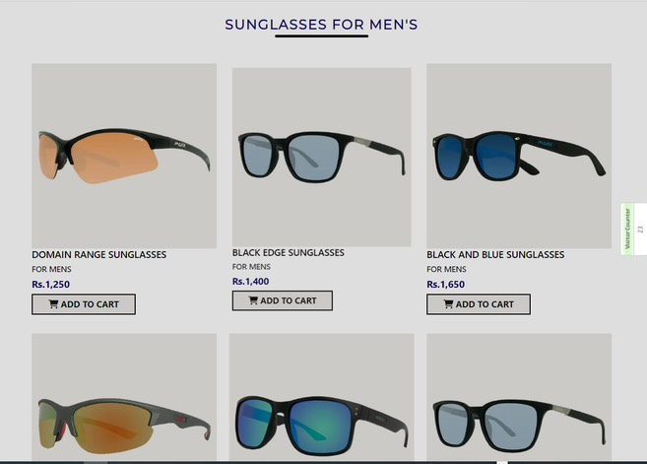

Home-page-3

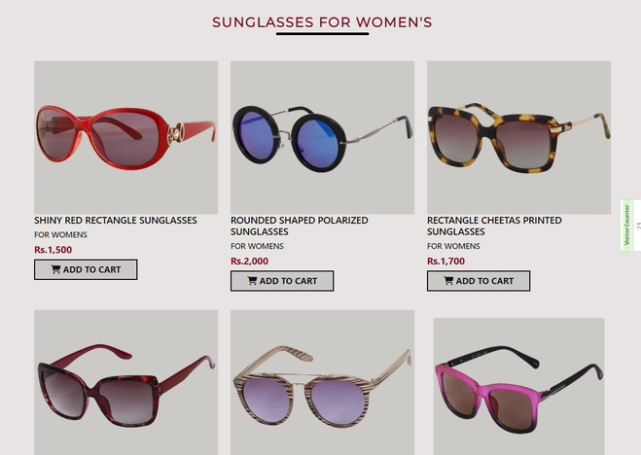

Home-page-4

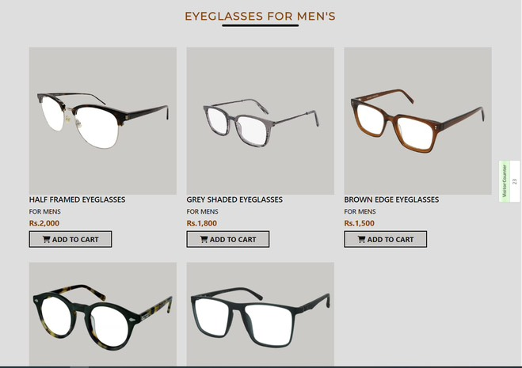

Home-page-5

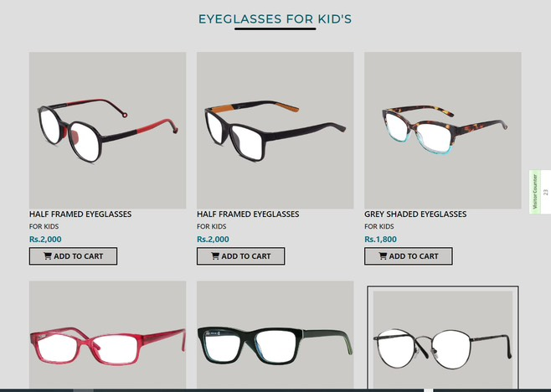

Home-page-6

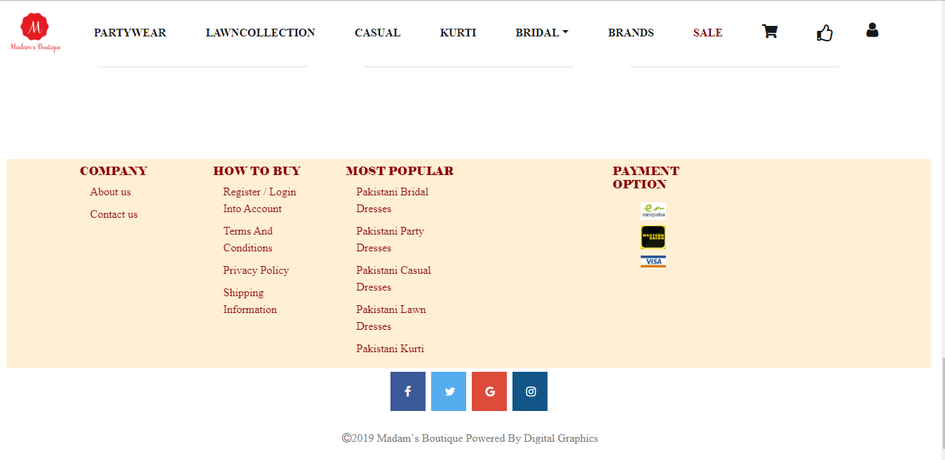

Category Page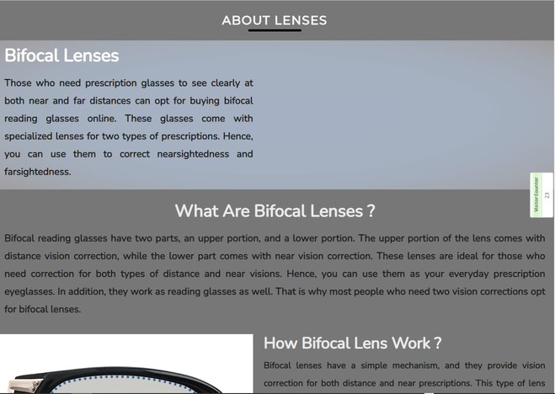

Contact-us

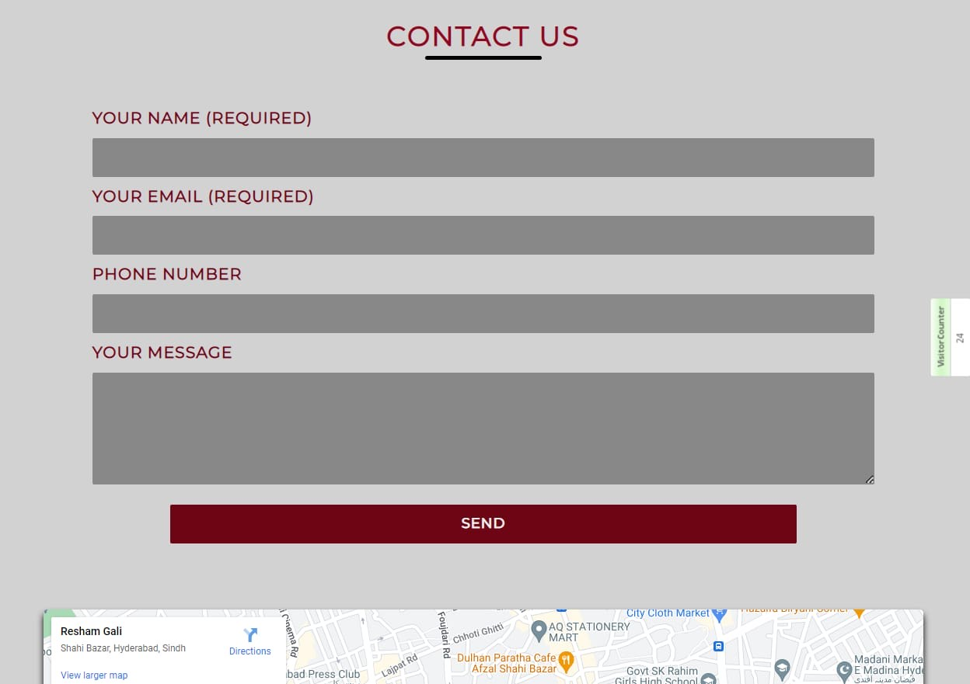

Product-page

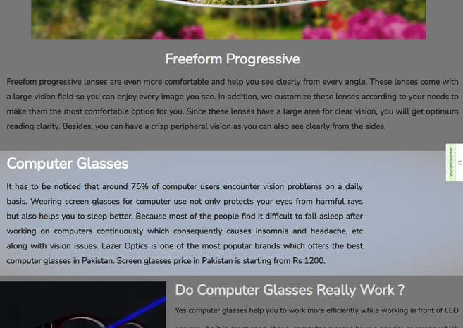

SOURCE CODE

<!DOCTYPE html>

<html lang="en">

<head>

<meta charset="UTF-8">

<meta name="viewport" content="width=device-width, initial-scale=1.0">

<meta http-equiv="X-UA-Compatible" content="ie=edge">

<link rel="stylesheet" href="https://cdnjs.cloudflare.com/ajax/libs/twitter-bootstrap/4.3.1/css/bootstrap.min.css">

<link rel="stylesheet" href="https://cdnjs.cloudflare.com/ajax/libs/font-awesome/5.11.2/css/all.min.css">

<link rel="stylesheet" href="b.css">

<script src="https://kit.fontawesome.com/a076d05399.js"></script>

<link rel="stylesheet" href="https://cdnjs.cloudflare.com/ajax/libs/font-awesome/4.7.0/css/font-awesome.min.css">

<title>Madam Boutique</title>

<

<script src="https://cdnjs.cloudflare.com/ajax/libs/jquery/3.4.1/jquery.slim.min.js"></script>

<script src="https://cdnjs.cloudflare.com/ajax/libs/popper.js/1.15.0/umd/popper.min.js"></script>

<script src="https://cdnjs.cloudflare.com/ajax/libs/twitter-bootstrap/4.3.1/js/bootstrap.min.js"></script>

    </div>

</body>

</html>

Thank you

­­­