- 训练代码：
import argparse
import torch
import torch.nn as nn
import torch.nn.functional as F
import torch.optim as optim
from torchvision import datasets, transforms
from torch.optim.lr_scheduler import StepLR

class Net(nn.Module):
def __init__(self):
super(Net, self).__init__()
self.conv1 = nn.Conv2d(1, 32, 3, 1)
self.conv2 = nn.Conv2d(32, 64, 3, 1)
self.dropout1 = nn.Dropout(0.25)
self.dropout2 = nn.Dropout(0.5)
self.fc1 = nn.Linear(9216, 128)
self.fc2 = nn.Linear(128, 10)

def forward(self, x):
x = self.conv1(x)
x = F.relu(x)
x = self.conv2(x)
x = F.relu(x)
x = F.max_pool2d(x, 2)
x = self.dropout1(x)
x = torch.flatten(x, 1)
x = self.fc1(x)
x = F.relu(x)
x = self.dropout2(x)
x = self.fc2(x)
output = F.log_softmax(x, dim=1)
return output

def train(args, model, device, train_loader, optimizer, epoch):
model.train()
for batch_idx, (data, target) in enumerate(train_loader):
data, target = data.to(device), target.to(device)
optimizer.zero_grad()
output = model(data)
loss = F.nll_loss(output, target)
loss.backward()
optimizer.step()
if batch_idx % args.log_interval == 0:
print('Train Epoch: {} [{}/{} ({:.0f}%)]\tLoss: {:.6f}'.format(
epoch, batch_idx * len(data), len(train_loader.dataset),
100. * batch_idx / len(train_loader), loss.item()))
if args.dry_run:
break

def test(model, device, test_loader):
model.eval()
test_loss = 0
correct = 0
with torch.no_grad():
for data, target in test_loader:
data, target = data.to(device), target.to(device)
output = model(data)
test_loss += F.nll_loss(output, target, reduction='sum').item() # sum up batch loss
pred = output.argmax(dim=1, keepdim=True) # get the index of the max log-probability
correct += pred.eq(target.view_as(pred)).sum().item()

test_loss /= len(test_loader.dataset)

print('\nTest set: Average loss: {:.4f}, Accuracy: {}/{} ({:.0f}%)\n'.format(
test_loss, correct, len(test_loader.dataset),
100. * correct / len(test_loader.dataset)))

def main():
# Training settings
parser = argparse.ArgumentParser(description='PyTorch MNIST Example')
parser.add_argument('--batch-size', type=int, default=64, metavar='N',
help='input batch size for training (default: 64)')
parser.add_argument('--test-batch-size', type=int, default=1000, metavar='N',
help='input batch size for testing (default: 1000)')
parser.add_argument('--epochs', type=int, default=14, metavar='N',
help='number of epochs to train (default: 14)')
parser.add_argument('--lr', type=float, default=1.0, metavar='LR',
help='learning rate (default: 1.0)')
parser.add_argument('--gamma', type=float, default=0.7, metavar='M',
help='Learning rate step gamma (default: 0.7)')
parser.add_argument('--no-accel', action='store_true',
help='disables accelerator')
parser.add_argument('--dry-run', action='store_true',
help='quickly check a single pass')
parser.add_argument('--seed', type=int, default=1, metavar='S',
help='random seed (default: 1)')
parser.add_argument('--log-interval', type=int, default=10, metavar='N',
help='how many batches to wait before logging training status')
parser.add_argument('--save-model', action='store_true',
help='For Saving the current Model')
args = parser.parse_args()

use_accel = not args.no_accel and torch.accelerator.is_available()

torch.manual_seed(args.seed)

if use_accel:
device = torch.accelerator.current_accelerator()
else:
device = torch.device("cpu")

train_kwargs = {'batch_size': args.batch_size}
test_kwargs = {'batch_size': args.test_batch_size}
if use_accel:
accel_kwargs = {'num_workers': 1,
'persistent_workers': True,
'pin_memory': True,
'shuffle': True}
train_kwargs.update(accel_kwargs)
test_kwargs.update(accel_kwargs)

transform=transforms.Compose([
transforms.ToTensor(),
transforms.Normalize((0.1307,), (0.3081,))
])
dataset1 = datasets.MNIST('../data', train=True, download=True,
transform=transform)
dataset2 = datasets.MNIST('../data', train=False,
transform=transform)
train_loader = torch.utils.data.DataLoader(dataset1,**train_kwargs)
test_loader = torch.utils.data.DataLoader(dataset2, **test_kwargs)

model = Net().to(device)
optimizer = optim.Adadelta(model.parameters(), lr=args.lr)

scheduler = StepLR(optimizer, step_size=1, gamma=args.gamma)
for epoch in range(1, args.epochs + 1):
train(args, model, device, train_loader, optimizer, epoch)
test(model, device, test_loader)
scheduler.step()

if args.save_model:
torch.save(model.state_dict(), "mnist_cnn.pt")

if __name__ == '__main__':
main()

- 训练结果：
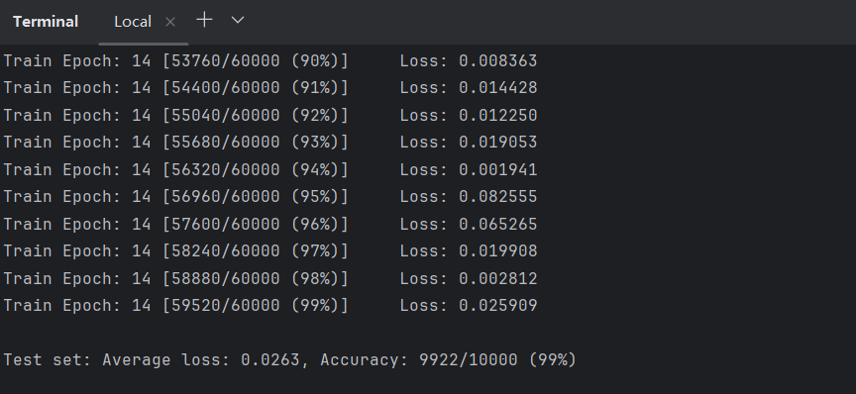
- 模型信息
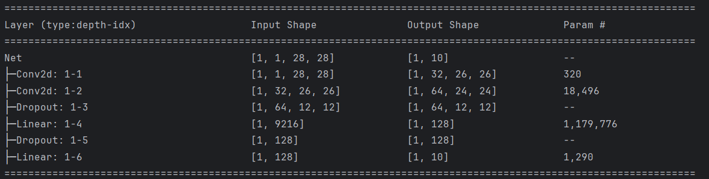
- 模型优化（优化后的结果）
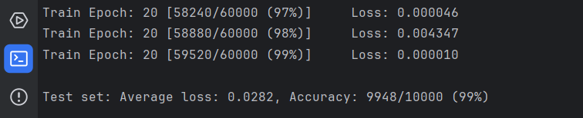
准确率提升：0.26%
- 模型优化（优化后的代码）
import argparse
import torch
import torch.nn as nn
import torch.nn.functional as F
import torch.optim as optim
from torchvision import datasets, transforms
from torch.optim.lr_scheduler import StepLR

class Net(nn.Module):
def __init__(self):
super(Net, self).__init__()

self.conv_block1 = nn.Sequential(
nn.Conv2d(1, 32, 3, padding=1),
nn.BatchNorm2d(32),
nn.ReLU()
)

self.conv_block2 = nn.Sequential(
nn.Conv2d(32, 64, 3, padding=1),
nn.BatchNorm2d(64),
nn.ReLU(),
nn.MaxPool2d(2) # 28×28 → 14×14
)

self.conv_block3 = nn.Sequential(
nn.Conv2d(64, 128, 3, padding=1),
nn.BatchNorm2d(128),
nn.ReLU(),
nn.MaxPool2d(2) # 14×14 → 7×7
)

self.fc = nn.Sequential(
nn.Dropout(0.25), # 轻量 Dropout
nn.Linear(128 * 7 * 7, 256),
nn.ReLU(),
nn.Linear(256, 10)
)

def forward(self, x):
x = self.conv_block1(x)
x = self.conv_block2(x)
x = self.conv_block3(x)
x = torch.flatten(x, 1)
x = self.fc(x)
return F.log_softmax(x, dim=1)

def train(args, model, device, train_loader, optimizer, epoch):
model.train()
for batch_idx, (data, target) in enumerate(train_loader):
data, target = data.to(device), target.to(device)
optimizer.zero_grad()
output = model(data)
loss = F.nll_loss(output, target)
loss.backward()
optimizer.step()
if batch_idx % args.log_interval == 0:
print('Train Epoch: {} [{}/{} ({:.0f}%)]\tLoss: {:.6f}'.format(
epoch, batch_idx * len(data), len(train_loader.dataset),
100. * batch_idx / len(train_loader), loss.item()))
if args.dry_run:
break

def test(model, device, test_loader):
model.eval()
test_loss = 0
correct = 0
with torch.no_grad():
for data, target in test_loader:
data, target = data.to(device), target.to(device)
output = model(data)
test_loss += F.nll_loss(output, target, reduction='sum').item() # sum up batch loss
pred = output.argmax(dim=1, keepdim=True) # get the index of the max log-probability
correct += pred.eq(target.view_as(pred)).sum().item()

test_loss /= len(test_loader.dataset)

print('\nTest set: Average loss: {:.4f}, Accuracy: {}/{} ({:.0f}%)\n'.format(
test_loss, correct, len(test_loader.dataset),
100. * correct / len(test_loader.dataset)))

def main():
# Training settings
parser = argparse.ArgumentParser(description='PyTorch MNIST Example')
parser.add_argument('--batch-size', type=int, default=64, metavar='N',
help='input batch size for training (default: 64)')
parser.add_argument('--test-batch-size', type=int, default=1000, metavar='N',
help='input batch size for testing (default: 1000)')
parser.add_argument('--epochs', type=int, default=14, metavar='N',
help='number of epochs to train (default: 14)')
parser.add_argument('--lr', type=float, default=1.0, metavar='LR',
help='learning rate (default: 1.0)')
parser.add_argument('--gamma', type=float, default=0.7, metavar='M',
help='Learning rate step gamma (default: 0.7)')
parser.add_argument('--no-accel', action='store_true',
help='disables accelerator')
parser.add_argument('--dry-run', action='store_true',
help='quickly check a single pass')
parser.add_argument('--seed', type=int, default=1, metavar='S',
help='random seed (default: 1)')
parser.add_argument('--log-interval', type=int, default=10, metavar='N',
help='how many batches to wait before logging training status')
parser.add_argument('--save-model', action='store_true',
help='For Saving the current Model')
args = parser.parse_args()

use_accel = not args.no_accel and torch.accelerator.is_available()

torch.manual_seed(args.seed)

if use_accel:
device = torch.accelerator.current_accelerator()
else:
device = torch.device("cpu")

train_kwargs = {'batch_size': args.batch_size}
test_kwargs = {'batch_size': args.test_batch_size}
if use_accel:
accel_kwargs = {'num_workers': 1,
'persistent_workers': True,
'pin_memory': True,
'shuffle': True}
train_kwargs.update(accel_kwargs)
test_kwargs.update(accel_kwargs)

transform=transforms.Compose([
transforms.ToTensor(),
transforms.Normalize((0.1307,), (0.3081,))
])
dataset1 = datasets.MNIST('../data', train=True, download=True,
transform=transform)
dataset2 = datasets.MNIST('../data', train=False,
transform=transform)
train_loader = torch.utils.data.DataLoader(dataset1,**train_kwargs)
test_loader = torch.utils.data.DataLoader(dataset2, **test_kwargs)

model = Net().to(device)
optimizer = optim.Adam(model.parameters(), lr=0.001)

scheduler = StepLR(optimizer, step_size=5, gamma=0.5)

for epoch in range(1, args.epochs + 1):
train(args, model, device, train_loader, optimizer, epoch)
test(model, device, test_loader)
scheduler.step()

if args.save_model:
torch.save(model.state_dict(), "mnist_cnn.pt")

if __name__ == '__main__':
main()

- 模型优化（优化细节）
1，加入 Batch Normalization 并将卷积层模块化（Conv + BN + ReLU），使训练过程更稳定、收敛更快。

2，采用 逐层增加通道数并延迟下采样 的卷积结构，增强特征表达能力并减少关键信息丢失。

3，将 Dropout 集中在全连接层并降低比例，在抑制过拟合的同时避免对有效特征学习的过度干扰。

