REPORT HW1 ML 2022
Gabriele G. Di Marzo, 2021633

intro:
the assignment involved the analysis of 2 problem, respectively a classification problem and a regression one.

In the classification setting the goal was to separate the trajectory of a swarm of drones by number of collision. In the regression one the target was the CPA, the minimal contact point of approach.
My solutions involved in the use of Logistic Regression model, SVM, Ensemble methods and HyperParameters search.
As anticipate during the seminar, this task is pretty unfeasible for simple ML tools, indeed my results are for both the task.

Classification:

The main problem of the classification task was the dataset, highly unbalanced.
Here the class distributions:
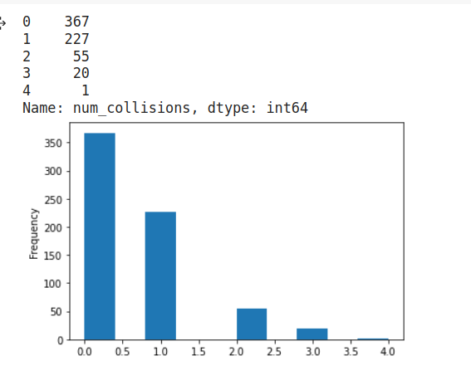
Evaluation of the models

For a classical classification task, in general we use the accuracy score.
In this case, I prefer compare the result on the f1 score, that can handle very well case like that, where also a model with constant predicted class can get a high accuracy score, thanks to the huge number of sample of class 0
The f1 score is calculated as:
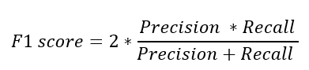
where precision and recall are 2 performance metrics based on the number of True/False Positive/Negative prediction.

Considering the multi-class setting, the f1 score are calc for each class and the total return of the functon f1_score are the average value across them.

The other metrics used was confusion matrix, where Each row of the
represents the instances in an actual class while each column represents the instances in a predicted class, or vice versa

Pre-processing:

The range of the feature was to high, so the first operation for work with this data was the standardization. I choose to use the StandardScaler by sklearn, that return a standardize version of the data according to the formula
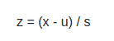

where u is the mean of the features and s is the standard deviation.
The mean and the std-dev are been calculate only on the training data. I considered the idea of re-assemble the dataset for unify the different drones and training the scaler on this data, but in my view the difference will be not so big, so I keep the classical dataset for this part of the experiment.

Weight dict:

Knowing that the original solutions for this task was related to the Reinforcement Learning setting, I decide to create a weight dict for avoid the problem of unbalanced classes. The reference should be to the Prioritize Reply Buffer, where the data of a reinforcement learning task are stored and sample according to the importance of the episode. For this reason my weight dict are created on a simple measure of the inverse of the frequency, according to the formula in the following snipped of code:
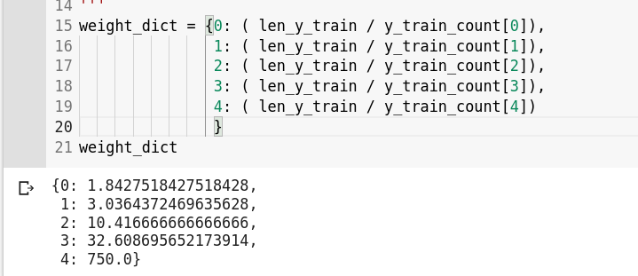
On the notebook are present also other hypothetical version of the weight dict, but I should notice that the difference was not substantial

Method for the classification task

Logistic Regression
Logistic Regression is a Machine Learning algorithm which is used for the classification problems, it is a predictive analysis algorithm and based on the concept of probability. This model is known also as logit regression, and is in general used for binary classification.
For use the logistic regression in the multiclass setting we should change topic to the multinoimal logistic regression, a model that parametrize a task with k class using k-1 vector.
The solver used for the first experiment was the SAGA, a solver that can use a multinomial loss.
I have also increased the number of iteration for reach the convergence of the algorithm, hopping that the model can converge to a optimal solution.
The result are full of noise, with a small F1 score and a confusion matrix that show a horrible capacity of generalization. In the next page the results.

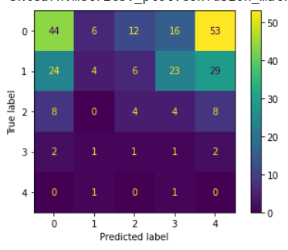Figure 1: Confusion Matrix of a logistic regressor

Supported Vector Machine

The SVM are a classifier that finds a hyper-plane that creates a boundary between the types of data.
SVM can only performe binary classification but can be extended to a multiclass case using an approach like the One-Vs-One, where the mutli-class classification are split into one binary classification problem for each pair of class.
I tried also here to implement the weight dictionary for handle the unbalance data. Neither the svm was unable to achieve satisfactory results, but the F1 score grow up to a 50%. Here the confusion matrix:
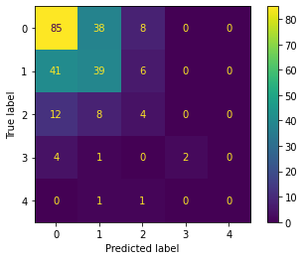

Hand-made Ensemble class

The last class of model that I try to use for the classification task was a hand-made ensemble class: Considering the disproportion between the data, I tried to separate the problem in 2 subtask, using a model for classify the set of drone with collision and set of drone without collision, ignoring the number of that.
The base structure of this class look like this:
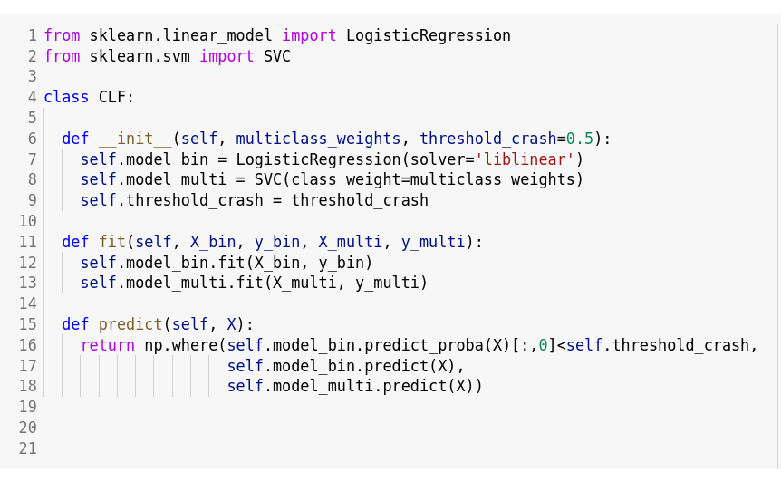
the first model calc the probability of a sample to have collision, than, if this probability is bigger that a particular threshold, the second model will check the number of collision.
The 2 model for the first implementation are again a LogisticRegressor and a supported vector machine. The solver for the logisticRegressor is the “libLinear”, that should work better with binary case.
There is also a new dictionary of weight for the multi-class model, created on the frequency of the subdata that I used for training.
This subdata are different between model, because I needed to use different label for each model.

The procedure was this:
First, separate the data in train data and test data, sampling the 33% of the original dataset for create the test set.
Then I re-training the StandarScaler for normalize the data. I have also re-split the train set in 2 dataframe: the df_collision, that keep the old label, and the df_clf, that has as label a 0 or a 1.
The 2 classes on the df_clf was totally balanced:
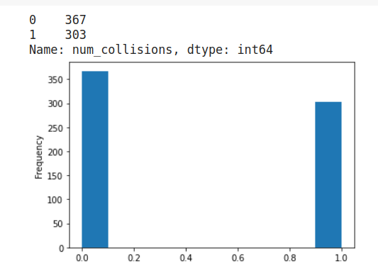

I failed to reduce the disproportion between classes in the multicase, and I suppose that for this reason my classifier work at same level of the linear one, or worst.
The threshold was found empirically
The same architecture was tried also with combination of 2 logistic model or 2 svm

Regression:

For the regression problem I preferred to try a different approach, using an assemble methods and a hyper-parameters search.
First, I try to optimize the parameters of a SVR, a variant of the supported vector machine for regression problem.
After that I create a dictionary of params and several option for each one, I used the scikit-optimize for make a bayesian hyper parameter search on the model.
The Bayesian approach, in contrast to random or grid search, keep track of past evaluation results which they use to form a probabilistic model mapping hyperparameters to a probability of a score on the objective function:
P(score | hyper-parameters)
finally, I tried to build up a set of model based on the GradientBoostingRegressor.
This method create a ensemble of decision tree and fit them on the negative gradient of the mean square error loss.

Both of this method cannot learn nothing by the data, still after the hyper-parameters search. The MSE, that should decrease to 0, remain on huge level. The only detail that should be notice is the error on the train set, for some combination of parameters was definitely lower

