IoT-Enabled Smart Belt for Continuous Fetal Movement Monitoring Using Sensor Fusion, Cloud Analytics, and Machine Learning
Kunal Bansal ^{*1}, Gokulnath G^{*2}, Naeem M^{*3} Rohit Ghogare^{*4} Dr.Soumitra Das^{*5}
^{*1} Student, Department of Computer Engineering, Indira College of Engineering and Management, Pune, Maharashtra, India.
^{*2} Student, Department of Computer Engineering, Indira College of Engineering and Management, Pune, Maharashtra, India.
^{*3} Student, Department of Computer Engineering, Indira College of Engineering and Management, Pune, Maharashtra, India.
^{*4} Student, Department of Computer Engineering, Indira College of Engineering and Management, Pune, Maharashtra, India.
^{*5} Dean of Academics, Department of Computer Engineering, Indira College of Engineering and Management, Pune, Maharashtra, India.
ABSTRACT (Font-Cambria, Bold, Font Size -12)
This paper presents an IoT-enabled Smart Belt prototype for continuous fetal movement and maternal health monitoring. The system is designed as a low-cost and portable solution that enables remote prenatal monitoring using embedded sensors, cloud computing, and machine learning. A DHT11 sensor measures maternal abdominal temperature, a finger-contact pulse sensor records pulse rate, and a vibration sensor detects fetal movement events. The acquired data is processed by an ESP32 microcontroller and transmitted to Firebase Realtime Database for real-time storage and visualization through a web dashboard. A Random Forest classifier trained on the publicly available UCI Cardiotocography (CTG) dataset is integrated to classify fetal conditions as Normal, Suspect, or Pathological. The prototype demonstrates successful real-time data acquisition, cloud synchronization, dashboard visualization, and prediction pipeline integration. Although the system is intended only as a prototype and has not undergone clinical validation, it highlights the feasibility of developing affordable IoT-based prenatal monitoring solutions for home healthcare, telemedicine, and rural medical applications.
Keywords: IoT, Fetal Health Monitoring, ESP32, Firebase Realtime Database, Machine Learning, Random Forest.
- INTRODUCTION (Font-Cambria, Bold, Font Size -12)
Fetal movement is one of the most important indicators of fetal well-being and neurological development during pregnancy. A noticeable reduction or irregularity in fetal movement may indicate complications such as fetal hypoxia, intrauterine growth restriction, or fetal distress. In current clinical practice, monitoring is often based on subjective maternal perception or periodic hospital visits, which may not provide continuous assessment and can delay the detection of abnormalities.
Advanced monitoring techniques such as Cardiotocography (CTG) and Doppler ultrasound provide accurate fetal assessment but require expensive equipment, specialized infrastructure, and trained medical professionals. Consequently, their accessibility is limited in rural and low-resource healthcare environments, creating a need for affordable and portable alternatives.
Recent developments in the Internet of Things (IoT), cloud computing, and machine learning have enabled the development of intelligent healthcare systems capable of continuous monitoring and remote supervision. Wearable devices integrated with low-cost sensors and wireless communication technologies can collect physiological data in real time and transmit it to cloud platforms for storage, visualization, and analysis.
Several researchers have explored wearable fetal movement detection, IoT-based maternal monitoring systems, and machine learning models for fetal health prediction. However, most existing solutions focus on only one aspect of monitoring and do not provide an integrated framework combining sensor data acquisition, cloud analytics, and predictive intelligence in a single portable system.

To address this research gap, this work proposes an IoT-enabled Smart Belt prototype for continuous fetal movement and maternal health monitoring. The system utilizes an ESP32 microcontroller with temperature, pulse, and vibration sensors to collect physiological data, which is transmitted to Firebase Realtime Database for remote monitoring. A Random Forest machine learning model trained on the UCI Cardiotocography (CTG) dataset is integrated to classify fetal health conditions into Normal, Suspect, and Pathological categories. The proposed prototype demonstrates the feasibility of developing a low-cost and scalable prenatal monitoring solution suitable for home healthcare, telemedicine, and rural medical applications.

METHODOLOGY
The proposed IoT-enabled Smart Belt is designed to provide continuous monitoring of fetal movement and maternal physiological parameters using low-cost hardware components, cloud computing, and machine learning techniques. The overall system consists of sensing, processing, cloud communication, and application layers that work together to acquire, transmit, analyze, and visualize health data in real time. A hybrid implementation approach combining actual sensor readings with controlled simulation was adopted to ensure reliable system validation.
A. Proposed System
The proposed IoT-enabled Smart Belt is designed to provide continuous monitoring of fetal movement and maternal physiological parameters using low-cost hardware components, cloud computing, and machine learning techniques. The overall system consists of sensing, processing, cloud communication, and application layers that work together to acquire, transmit, analyze, and visualize health data in real time. A hybrid implementation approach combining actual sensor readings with controlled simulation was adopted to ensure reliable system validation.

B. Hardware Components
The hardware prototype consists of an ESP32 development board, DHT11 temperature sensor, analog pulse sensor, vibration sensor, breadboard, jumper wires, and USB power supply. The ESP32 serves as the primary controller responsible for sensor interfacing, preprocessing, and wireless communication. During development, MAX30102 and MPU6050 modules were also evaluated; however, due to inconsistent readings and hardware instability, they were excluded from the final prototype implementation. The selected hardware components provide a cost-effective solution suitable for prototype-level validation.

C. Data Flow and Cloud Integration
Sensor readings are continuously collected by the ESP32 microcontroller and preprocessed before transmission. The processed data is sent through Wi-Fi to Firebase Realtime Database, where it is stored and synchronized in real time. The dashboard retrieves the latest values directly from Firebase and displays live graphs, sensor readings, and health status indicators. Firebase Cloud Functions are utilized to monitor threshold conditions and generate alerts whenever abnormal values are detected. This cloud-based architecture enables remote monitoring and centralized data management.

D. Machine Learning Model
A Random Forest classifier was implemented to predict fetal health conditions using physiological features derived from the prototype. The model was trained using the publicly available UCI Cardiotocography (CTG) dataset and categorizes fetal health into three classes: Normal, Suspect, and Pathological. Feature inputs include pulse rate, temperature, and movement-related parameters available from the prototype system. The trained model generates predictions that are displayed on the web dashboard to assist users in understanding the current health status. The machine learning component is intended as a prototype-level decision support mechanism and is not a substitute for clinical diagnosis.

- MODELING AND ANALYSIS
The proposed IoT-enabled Smart Belt integrates sensing, embedded processing, cloud computing, and machine learning to provide continuous fetal movement and maternal health monitoring. The overall architecture consists of four major layers: sensing layer, processing layer, cloud layer, and application layer. These layers work together to acquire physiological parameters, transmit them to the cloud, perform intelligent analysis, and provide real-time visualization to the end user.

A. System Architecture
The sensing layer consists of a DHT11 temperature sensor, a finger-contact pulse sensor, and a vibration sensor for movement detection. These sensors are interfaced with an ESP32 microcontroller that performs signal acquisition and preprocessing. The processed data is transmitted through Wi-Fi to Firebase Realtime Database for cloud storage and synchronization.

The application layer retrieves the latest sensor readings from Firebase and displays them through a web-based dashboard. The dashboard provides real-time visualization of temperature, pulse rate, movement events, and fetal health predictions. A Random Forest machine learning model processes the available features and classifies fetal health conditions into Normal, Suspect, and Pathological categories. The complete system architecture is illustrated in Figure 1.
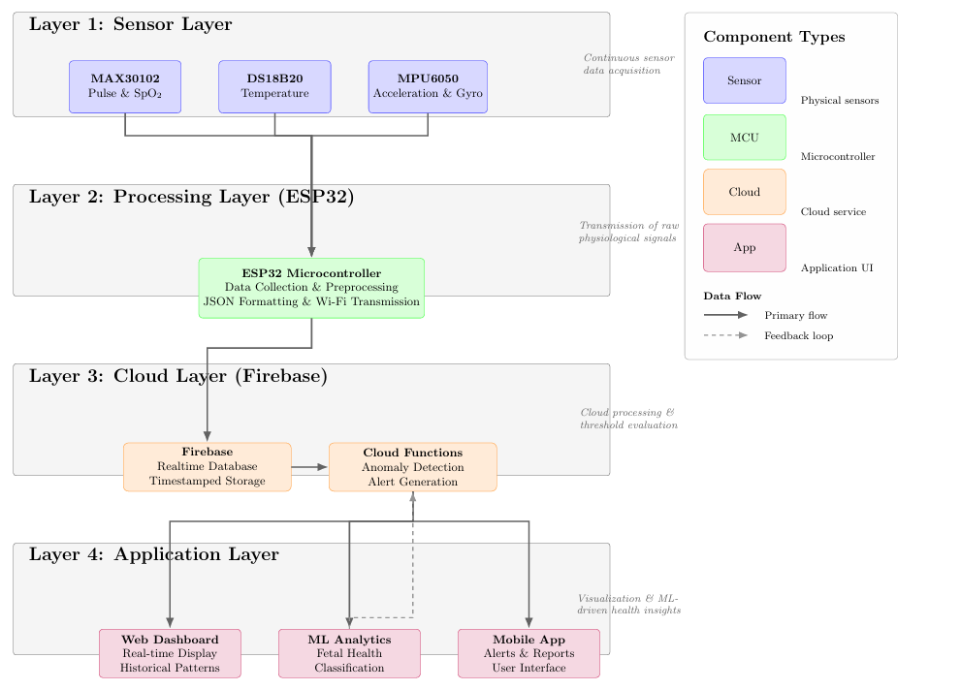
Figure 1: System Architecture.

B. Prototype implementation
A hardware prototype was developed using an ESP32 development board integrated with a DHT11 temperature sensor, pulse sensor, and vibration sensor. The prototype was assembled on a breadboard to validate sensor interfacing, cloud communication, and dashboard functionality. During development, MAX30102 and MPU6050 modules were evaluated but excluded from the final implementation due to inconsistent readings and hardware instability. The final prototype demonstrates successful end-to-end communication between hardware and cloud infrastructure.
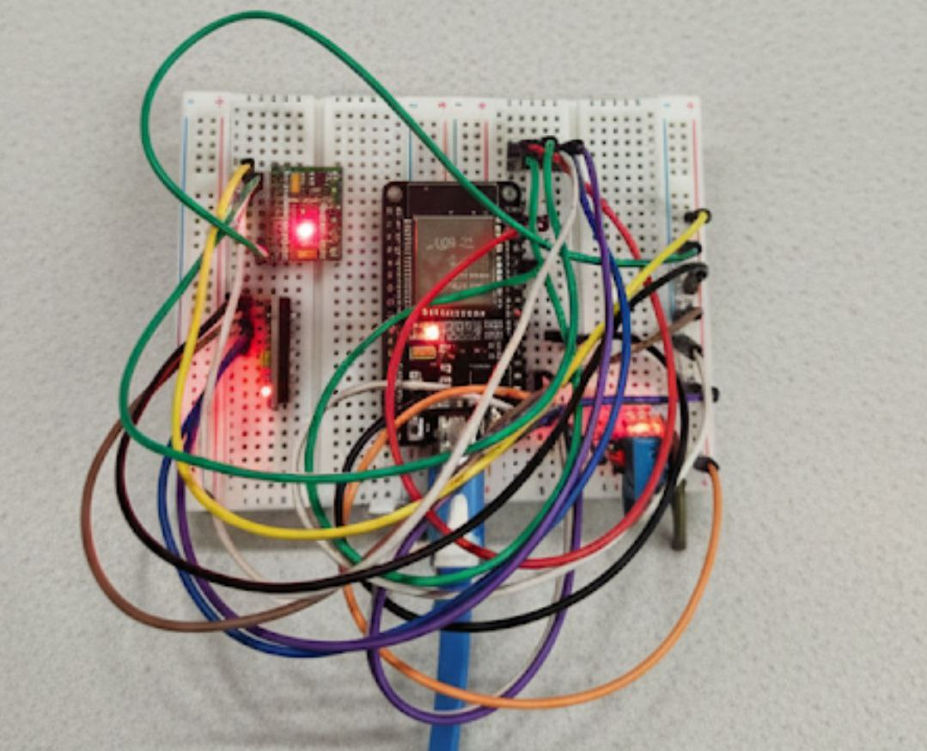
Figure 2: Hardware prototype.

C. Data Flow and Cloud Integration
Sensor readings collected by the ESP32 are preprocessed and transmitted to Firebase Realtime Database using Wi-Fi connectivity. Firebase provides centralized storage and real-time synchronization of incoming data. The dashboard continuously retrieves updated values and presents them as graphs and status indicators. Threshold-based alerts are generated whenever abnormal parameter values are detected, enabling timely notification of potential health risks.

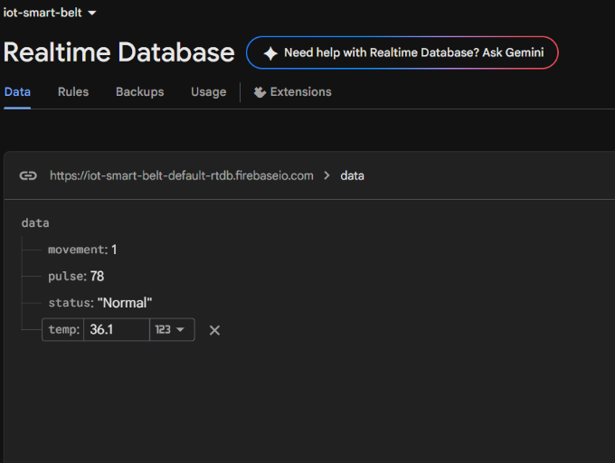
Figure 3: Firebase Realtime Database.

D. Dashboard and Machine Learning Integration
A web-based dashboard was developed to provide remote monitoring capabilities. The dashboard displays live sensor values, graphical trends, and machine learning predictions. The Random Forest classifier was trained using the UCI Cardiotocography (CTG) dataset and predicts fetal health conditions as Normal, Suspect, or Pathological based on available physiological features. The prediction results are synchronized with Firebase and displayed in real time, demonstrating the integration of IoT and machine learning within a unified monitoring platform.
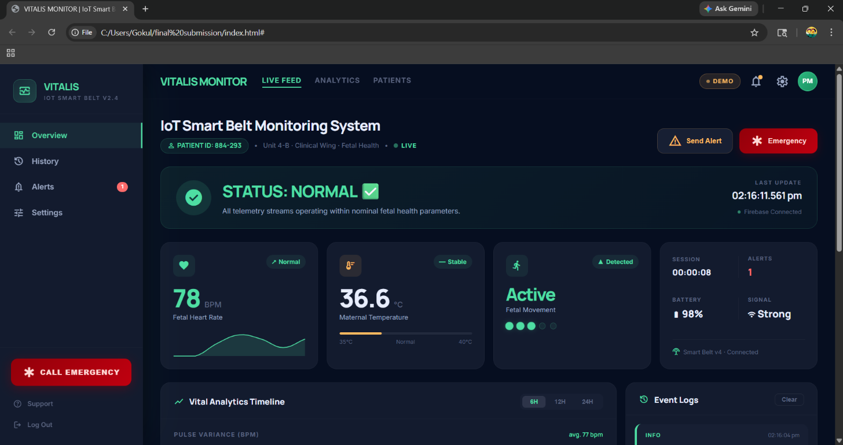
Figure 4: Web Dashboard.

- RESULTS AND DISCUSSION
The developed prototype was experimentally evaluated under controlled indoor conditions to verify the functionality of the sensing hardware, cloud communication pipeline, dashboard visualization, and machine learning integration. The primary objective of the evaluation was to validate the end-to-end operation of the proposed IoT-enabled monitoring system rather than perform clinical testing.

A. Sensor Performance
The DHT11 temperature sensor successfully measured ambient and simulated body temperature values with stable digital output throughout the testing process. The finger-contact pulse sensor generated pulse rate values that were transmitted successfully through the complete pipeline. The vibration sensor detected manually induced movement events, allowing the prototype to simulate fetal movement activity. Although the vibration sensor is not sufficiently sensitive for clinical fetal kick detection, it effectively validated the event acquisition and transmission mechanism implemented in the system.
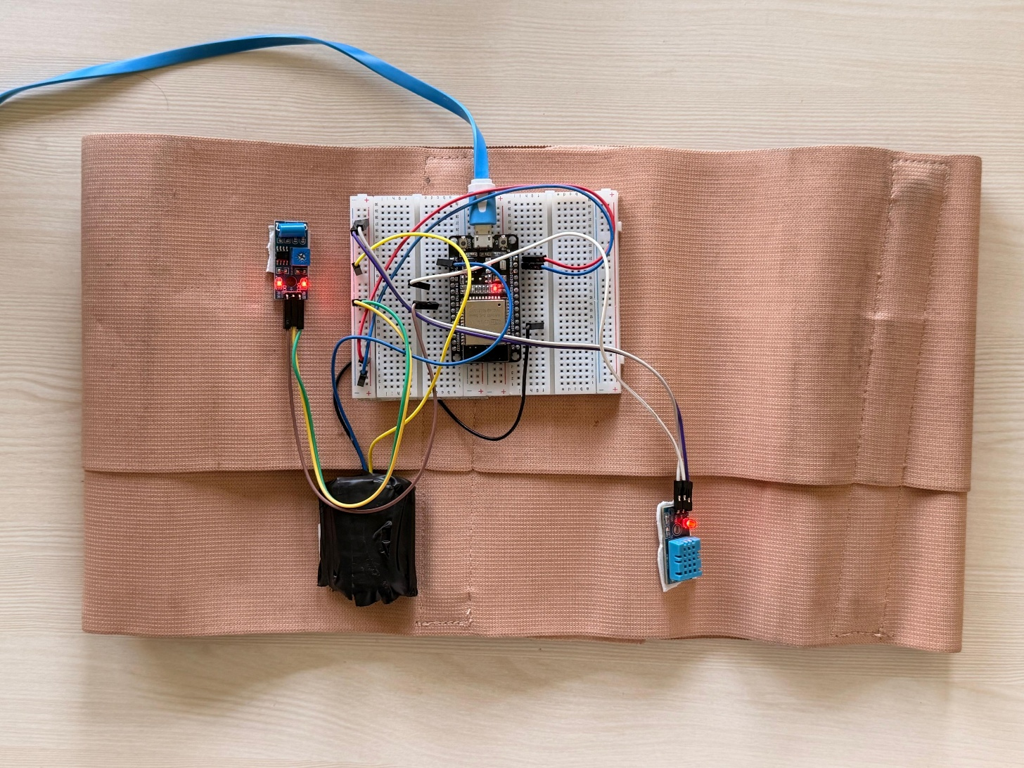
Figure 5 : Hardware Setup.

B. Cloud Communication and Dashboard Visualization
The ESP32 microcontroller successfully transmitted sensor readings to Firebase Realtime Database using Wi-Fi connectivity. The cloud database synchronized incoming values in real time, enabling continuous updates on the web dashboard. The dashboard displayed live temperature values, pulse rate, movement events, and graphical trends without noticeable latency during testing. Threshold-based alerts were also generated whenever abnormal conditions were simulated, demonstrating successful integration between the sensing layer, cloud infrastructure, and user interface.
C. Machine Learning Prediction
The proposed system integrates a Random Forest classifier trained using the publicly available UCI Cardiotocography (CTG) dataset to classify fetal health conditions into three categories: Normal, Suspect, and Pathological. The machine learning model receives prototype-level physiological parameters and generates prediction results that are displayed on the dashboard in real time. Although the model has been trained on benchmark clinical data, the current implementation serves as a proof-of-concept demonstrating successful integration of machine learning within an IoT-based monitoring framework.
D. Overall System Performance
Experimental evaluation confirms that the proposed prototype successfully performs data acquisition, cloud synchronization, machine learning-based classification, and dashboard visualization as an integrated system. The ESP32 operated reliably throughout testing while maintaining stable communication with Firebase. The architecture demonstrates the feasibility of combining low-cost embedded hardware, cloud computing, and machine learning to create a scalable fetal monitoring solution suitable for future development. However, the prototype has not undergone clinical validation and should be considered a proof-of-concept rather than a medical diagnostic device.
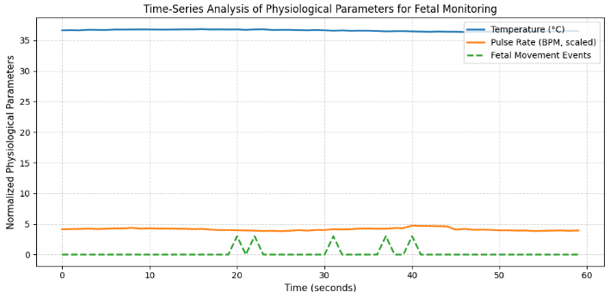
Figure 6: Time-series representation of physiological parameters including pulse
rate, temperature, and movement events recorded over a controlled test session.

- CONCLUSION
This paper presented an IoT-enabled Smart Belt prototype for continuous fetal movement and maternal health monitoring using embedded sensing, cloud computing, and machine learning techniques. The proposed system integrates an ESP32 microcontroller with temperature, pulse, and vibration sensors to acquire physiological data and transmit it to Firebase Realtime Database for real-time visualization and analysis. A Random Forest classifier trained on the UCI Cardiotocography dataset provides prototype-level fetal health classification into Normal, Suspect, and Pathological categories.

Experimental results demonstrate successful sensor interfacing, cloud synchronization, dashboard visualization, and machine learning integration within a unified architecture. Although the prototype is not clinically validated and currently serves as a proof-of-concept, it establishes the feasibility of developing an affordable and portable prenatal monitoring solution. Future enhancements may include improved sensor hardware, mobile application support, TinyML deployment, and extensive real-world validation to further enhance system reliability and practical applicability.

- REFERENCES
[1] C. Yang, L. Zhou, and M. Ren, “Fetal movement detection by wearable accelerometer duo based on machine learning,” Biomedical Signal Processing and Control, vol. 88, 2024.

[2] L. Spicher, F. O’Brien, and D. Howard, “Comparative analysis of machine learning approaches for fetal movement detection using IMUs,” Sensors, vol. 25, no. 3, 2025.

[3] K. H. Pietilä, R. Korpela, and M. Samuel, “Long-term IoT-based maternal monitoring: System design and implementation,” International Journal of Medical Informatics, vol. 156, 2021.

[4] A. Efendi, et al., “IoT-based elderly health monitoring using ESP32 and Firebase,” Journal of Ambient Intelligence, vol. 19, 2025.

[5] S. Handoko, F. Yulianto, and A. Gunawan, “Design of fetal movement monitoring device using MPU6050 and K-means,” Universitas Brawijaya Repository, 2025.

[6] S. Chavan and V. Borse, “Wearable-compatible health monitoring using ESP32,” Journal of Emerging Technologies and Innovative Research (JETIR), vol. 10, no. 6, 2023.

[7] Y. Golestan and J. Hu, “Wearable sensors for monitoring maternal health: A comprehensive review,” Sensors, vol. 23, no. 14, 2023.

[8] A. Kumar and R. Singh, “Stress monitoring with MAX30102 sensor in wearable biomedical systems,” IAES International Journal of Electronics, vol. 12, no. 3, 2023.

[9] S. Reddy and M. Venkatesh, “Early detection of fetal distress using machine learning algorithms,” Journal of Engineering Science and Computing, 2024.

[10] N. Roozbeh, et al., “Machine learning-based prediction of non-reassuring fetal health states,” Scientific Reports, vol. 15, 2025.

[11] UCI Machine Learning Repository, “Fetal Health Dataset,” Available: https://archive.ics.uci.edu/ml/datasets/Fetal+Health (Accessed: April 2026).

[12] Espressif Systems, “ESP32 Series Datasheet,” Available: https://www.espressif.com (Accessed: April 2026).

[13] Google, “Firebase Realtime Database Documentation,” Available: https://firebase.google.com/docs/database (Accessed: April 2026).

