CLONED_KM Kulim
PART A:

  - 2

  - 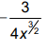

  - shown

PART B

  - 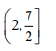

  - 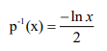

  - -1.145

    - 1
    - f(x) is continuous at x = 0

  - 2

  - 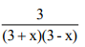
  - 1 or 1/4

  - 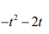

  - 16

  - (3, 6) relative minimum, (-3, -6) relative maximum

    - Shown
    - 64

