CLONED_KMPh
PART A:

  - 6
  - 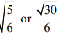

  - 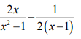
  - -0.5931
  - 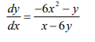

  - 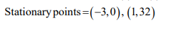

PART B

  - 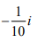
  - 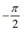

  - 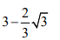

  - 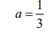b =-2 or

, b =0

  - i. ln 2 ii.
  - 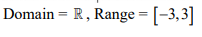
  - 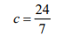

  - a = 8, b = 4
  - shown

  - Shown , 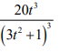
  - Shown, deduced
- Width = length = height =

