CLONED_KMKK
PART A:

  - 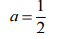,

  - 2x + 2

  - 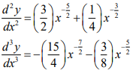

  - 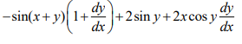

- 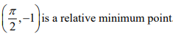

PART B
- x= 1, y = -2, -1.107

  - x = ln 4
  - 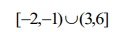

  - 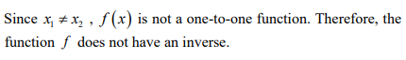

  - M = 2

    - Shown
    - 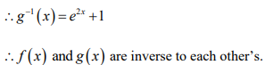

    - Graph
    - 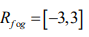

    - 0
    - -2
  - m = -2, n = 8

  - f is not differentiable at x = 1

  - 

 