CLONED_KMM
PART A:

  - 1

  - 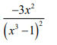
  - 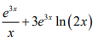

  - 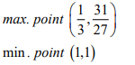
  - 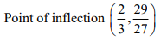

PART B
- , 5

  - 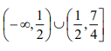

  - 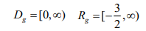
  - Shown

  - ,
  - 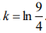

  - 1 CMS⁻¹
  - 6.75 S

  - 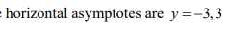
  - i) g(x) is discontinuous at x = 0
ii) g(x) is continuous from the right at x =0

  - i) shown ii)

