

THE IMAGINATION UNIVERSITY PROGRAMME

RVfpga Lab 8
Timers

Introduction

Hardware timers are common peripherals found in microcontrollers and SoCs. They are typically used to generate precise timing. Timers increment or decrement a counter at a fixed frequency, which is often configurable, and then interrupt the processor when the counter reaches zero or a predefined value. More sophisticated timers can also perform other functions, such as generating pulse-width modulated (PWM) waveforms to control the speed of a motor or the brightness of a light.

In this lab, using a similar structure to that of previous labs, we first describe the high-level specification of the timer included in the RVfpgaEL2 System and then explain its low-level implementation. Finally, some exercises are proposed that show how to use the timer.

High-Level Specification of the Timer Included in RVfpgaEL2

In this section, we first analyse the high-level specification of the timer used in the RVfpgaEL2 System and then we propose one exercise that uses this peripheral.

- Timer high-level specification

The timer module used in the RVfpgaEL2 System has been obtained from OpenCores (https://opencores.org/projects/ptc). If you download the package, a document is provided that describes the high-level specification of the module (and which we provide at: [RVfpgaBasysPath]/src/VeeRwolf/Peripherals/ptc/docs/ptc_spec.pdf). We summarize the main operation and features of the timer module here; however, the complete information can be found in the above document.

The timer module has the following main features:
- Uses a Wishbone Interconnection
- 32-bit counter/timer facility
- Single-run or continuous run of PWM/Timer/Counter (PTC)
- Programmable PWM (Pulse-width modulation) mode
- System clock and external clock sources for timer functionality
- HI/LO Reference and Capture registers
- Three-state control for PWM output driver
- PTC functionalities can cause an interrupt to the CPU

Section 4 of the timer module specification document describes the control and status registers available inside the timer module, each of which is assigned to a different address (see Table 1). The base address for the timer in the RVfpgaEL2 System is 0x80001200.
Table 1. Timer registers
Name | Address | Width | Access | Description
RPTC_CNTR | 0x80001200 | 1-32 | R/W | Main PTC counter
RPTC_HRC | 0x80001204 | 1-32 | R/W | PTC HI Reference/Capture register
RPTC_LRC | 0x80001208 | 1-32 | R/W | PTC LO Reference/Capture register
RPTC_CTRL | 0x8000120C | 9 | R/W | Control register

The RPTC_CNTR register is the actual counter register, and it is incremented at every counter/timer clock cycle. The RPTC_CTRL register is used for controlling the timer module; Table 2 shows the function of each of its bits. RPTC_HRC and RPTC_LRC are used as reference/capture registers.
Table 2. RPTC_CTRL bits
Bit | Access | Reset | Name & Description
0 | R/W | 0 | EN  When set, RPTC_CNTR increments.
1 | R/W | 0 | ECLK  Selects the clock signal: external clock, through ptc_ecgt (1), or system clock (0).
2 | R/W | 0 | NEC  Used for selecting the negative/positive edge and low/high period of the external clock (ptc_ecgt).
3 | R/W | 0 | OE  Enables PWM output driver.
4 | R/W | 0 | SINGLE  When set, RPTC_CNTR is not incremented after  it reaches value equal to the RPTC_LRC value. When cleared, RPTC_CNTR is restarted after it reaches value in the RPTC_LCR register.
5 | R/W | 0 | INTE  When set, PTC asserts an interrupt when RPTC_CNTR value is equal to the value of RPTC_LRC or RPTC_HRC. When the signal is cleared, interrupts are masked.
6 | R/W | 0 | INT  When read, this bit represents pending interrupt. When it is set, an interrupt is pending. When this bit is written with ‘1’, interrupt request is cleared.
7 | R/W | 0 | CNTRRST  When set, RPTC_CNTR is reset. When cleared, normal operation of the counter occurs.
8 | R/W | 0 | CAPTE  When set, RPTC_CNTR is captured into RPTC_LRC or RPTC_HRC registers. When cleared, capture function is masked.

TASK: Locate the declaration of registers RPTC_CNTR, RPTC_HRC, RPTC_LRC and RPTC_CTRL in the timer module, as well as the definition of their addresses (0x80001200, 0x80001204, 0x80001208 and 0x8000120C respectively). The timer module is available inside folder [RVfpgaBasysPath]/src/VeeRwolf/Peripherals/ptc.
R
The timer can operate in different modes (we next briefly describe the modes that you will use in this lab; see Section 3 of the timer module specification document for more details):
- Timer/Counter mode: In this mode, the system clock or external clock reference increments register RPTC_CNTR if the counter is enabled (RPTC_CTRL[EN] = 1). When RPTC_CNTR equals the RPTC_LRC, if RPTC_CTRL[INTE] is set, RPTC_CTRL[INT] goes high.
- PWM mode: A pulse width modulated (PWM) signal is a method for generating an analog signal using a digital source. A PWM signal consists of two values that define its behaviour: the duty cycle and frequency. The duty cycle describes the amount of time the signal is high as a percentage of the total time of it takes to complete one cycle. The frequency is how often that cycle repeats. By cycling a digital signal off and on at a fast enough rate, and with a certain duty cycle, the output will appear to behave like a constant voltage analog signal when providing power to devices. For example, a signal with a 50% duty cycle (half the cycle time it is high) and a high voltage of 3.3 V would appear to an analog load as 1.67 V (the average voltage across the cycle). The same signal with a 33% duty cycle would appear to be 1.1V. To operate in PWM mode, RPTC_CTRL[OE] should be set. Registers RPTC_HRC and RPTC_LRC should be set with the value of high and low periods of the PWM output signal: the PWM signal should go high RPTC_HRC clock cycles after reset (of RPTC_CNTR); and the PWM signal should go low RPTC_LRC clock cycles after reset (of the RPTC_CNTR).

Exercise

Exercise 1. Write a program that displays an ascending count on the 8-digit 7-segment displays. The value should change about once per second and, for creating this delay, you must use the timer module.
- First, write the program in RISC-V assembly language and run it on the Basys 3 Board.
- Then, perform a simulation in the different RVfpgaEL2 tools.
- Now write the program in C and run it on the Basys 3 Board.
- Simulate your C program as in part (b) for the RISC-V assembly program.

Timer Low-Level Implementation

In this section, we first describe the low-level implementation of the timer module in the RVfpga System and then propose some exercises where you will first modify the module and then use it in a program for controlling the tri-colour LEDs available on the Basys 3 Board.

- Low-level implementation of the timer

Similarly to the scheme that we followed in previous labs, we divide the analysis of the timer module into phases.

- Integration of the new module in the VeeRwolfX SoC (left shadowed region in Figure 1)
- Connection between the new module and the VeeR EL2 Core (right shadowed region in Figure 1).

Note that, as opposed to previous labs, this peripheral (the timer) is not connected physically to the Basys 3 Board. The timer is internal to VeeRwolfX.

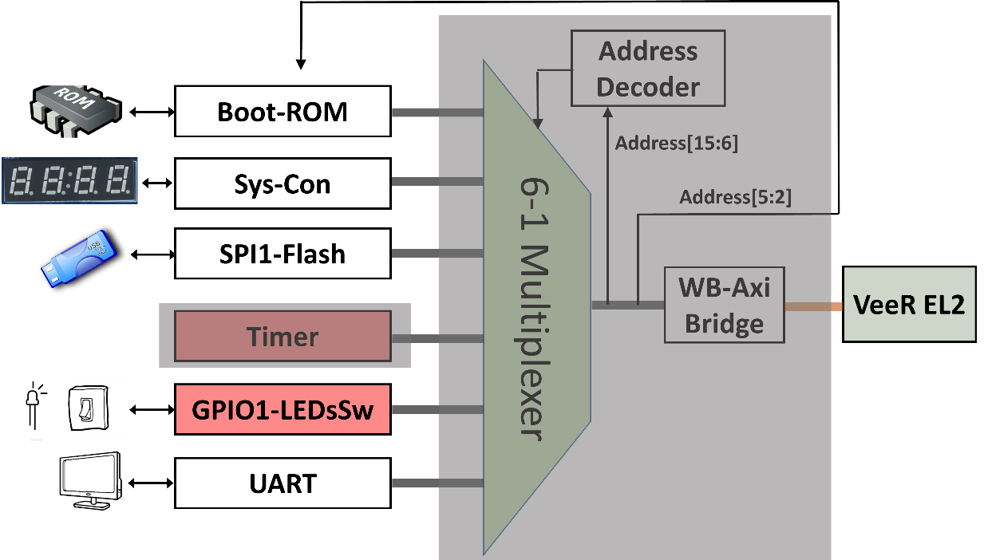
Figure 1. Timer module analysis in 2 phases

- Integration of the timer module in the SoC

In module veerwolf_core ([RVfpgaBasysPath]/src/VeeRwolf/veerwolf_core.v) the timer module is instantiated (see Figure 2).

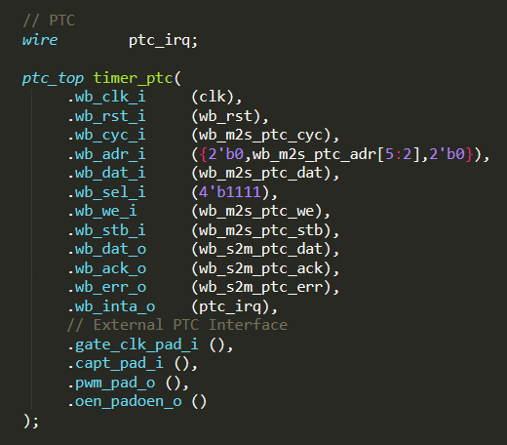
Figure 2. Integration of the timer module (file veerwolf_core.v).

As usual, the interface of the module can be divided in two blocks: Wishbone signals (Table 3) and External I/O signals (Table 4). The Wishbone signals allow the VeeR EL2 Core to communicate with the timer using a controller/peripheral model. The External I/O signals, connect the timer module with external devices; for example, pwm_pad_o provides the PWM output signal when operating in the PWM mode described above (you will have to use this signal in Exercise 2 to connect the timer modules with the tri-colour LEDs).
Table 3. Wishbone Signals
Port | Width | Direction | Description
wb_cyc_i | 1 | Inputs | Indicates valid bus cycle (core select)
wb_adr_i | 15 | Inputs | Address inputs
wb_dat_i | 32 | Inputs | Data inputs
wb_dat_o | 32 | Outputs | Data outputs
wb_sel_i | 4 | Inputs | Indicates valid bytes on data bus (during valid cycle, this signal must be 0xf)
wb_ack_o | 1 | Output | Acknowledgment output (indicates normal transaction termination)
wb_err_o | 1 | Output | Error acknowledgment output (indicates an abnormal transaction termination)
wb_rty_o | 1 | Output | Not used
wb_we_i | 1 | Input | Write transaction when asserted high
wb_stb_i | 1 | Input | Indicates valid data transfer cycle
wb_inta_o | 1 | Output | Interrupt output

Table 4. External I/O signals
Port | Width | Direction | Description
gate_clk_pad_i | 1 | Input | External clock / Gate input
capt_pad_i | 1 | Input | Capture input
pwm_pad_o | 1 | Output | PWM output
oen_padoen_o | 1 | Output | PWM output driver enable (for three-state or open-drain driver)

As shown in Figure 2, bits [5:2] of the address provided by the core in the Wishbone bus signal (wb_m2s_ptc_adr[5:2]) are used for selecting one among the 4 available registers (Memory Mapped I/O). Thus, we can access register RPTC_CNTR at address 0x80001200, register RPTC_HRC at address 0x80001204, register RPTC_LRC at address 0x80001208, and register RPTC_CTRL at address 0x8000120C.

- Connection between the timer and the VeeR EL2 Core

As described in Lab 6, the device controllers are connected to the VeeR EL2 Core using a multiplexer (see Figure 3). Remember that the 6:1 multiplexer is instantiated in file [RVfpgaBasysPath]/src/VeeRwolf/Interconnect/WishboneInterconnect/wb_intercon.v. Then, the wb_intercon module is instantiated in file [RVfpgaBasysPath]/src/VeeRwolf/Interconnect/WishboneInterconnect/wb_intercon.vh. This latter file is included in the veerwolf_core module located here: [RVfpgaBasysPath]/src/VeeRwolf/veerwolf_core.v.

The multiplexer selects which peripheral to read or write, connecting the CPU (wb_io_* signals) with the Wishbone Bus of one peripheral, depending on the address. For example, if the address generated by the CPU is in the range 0x80001200-0x8000123F, the timer module is selected, and thus signals wb_io_* are connected with signals wb_ptc_*.

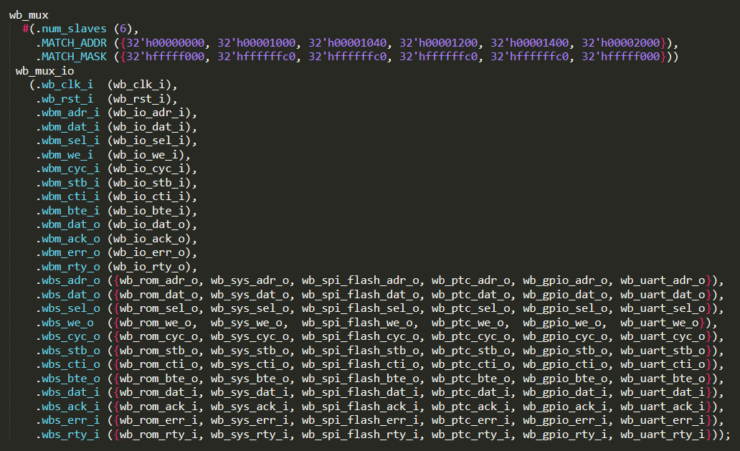
Figure 3. 6:1 multiplexer that selects the peripheral connected with the CPU (file wb_intercon.v)

