TASK: Remove all nop instructions in the example from Figure 2. Generate the trace with the RVfpga-Trace simulator, analyse the simulation on RVfpga-Pipeline, and then compute the IPC by using the Performance Counters while executing the program on the board (remember that you must uncomment all instructions in the main function, in file Test.c).

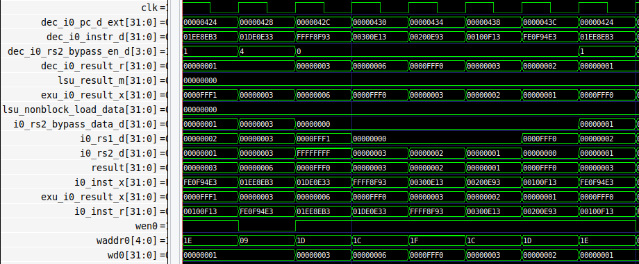

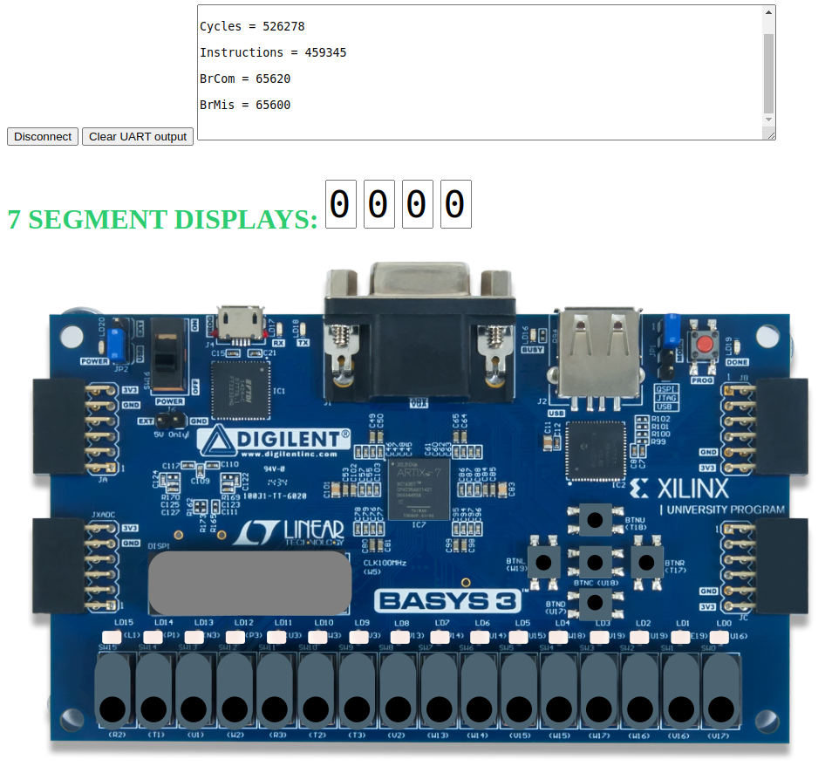

- The forwarding logic allows the dependent instruction to not stall. However, there is 1 bubble due to the branch. So, the number of cycles = 7 instructions + 1 bubble.
- The number of cycles is as expected 0xffff * 8 = 524280

Exercise 1: In the example from Figure 2, analyse and explain similar situations where you replace the dependent add instruction for other dependent instructions, such as:

- add t4,t4,t5
mul t3,t3,t4

- add t4,t4,t5
div t3,t3,t4

- add t4,t4,t5
lw t3, 0(t4)

Solution not provided for this exercise.

