Overview of Test Scenarios for Text/File Translation and Audio Generation
The document mentions several test scenarios for file translation, including translating typed text, text files, CSV files, Excel files, and PDF files.
Each scenario is presented as a heading or label within the document, indicating the focus and type of content to be translated. The structure suggests a comprehensive approach to testing translation and audio generation capabilities across diverse text input methods and file formats.

The document lists five primary test scenarios, each addressing a specific type of input for translation:

• Test Scenario #1: Typed Text Translation and Audio Generation

This scenario involves translating and generating audio for manually typed text, exemplified by a short story format. It serves to test the translation and audio generation system’s capability to handle direct text input.

• Test Scenario #2: Text File Translation and Audio Generation

This scenario focuses on translating and generating audio for plain text files, assessing the translation of content stored in simple text document formats and generating audio files for it.

• Test Scenario #3: CSV File Translation and Audio Generation

This scenario tests the translation of CSV (Comma-Separated Values) files, which typically contain structured tabular data. The scenario evaluates how well the translation and audio generation system manages text within data tables.

• Test Scenario #4: Excel File Translation and Audio Generation

This scenario involves translating Excel files, which are commonly used for spreadsheets. The scenario evaluates how well the translation and audio generation system manages text within excel files.

• Test Scenario #5: PDF File Translation and Audio Generation

This final scenario tests the translation of PDF files, a widely used format for documents that may include text, images, and formatted layouts. This evaluates the system’s ability to extract and translate text and create audio from PDF content.

Test Scenario #1 : Typed TEXT Translation and Audio Generation
(Short story)

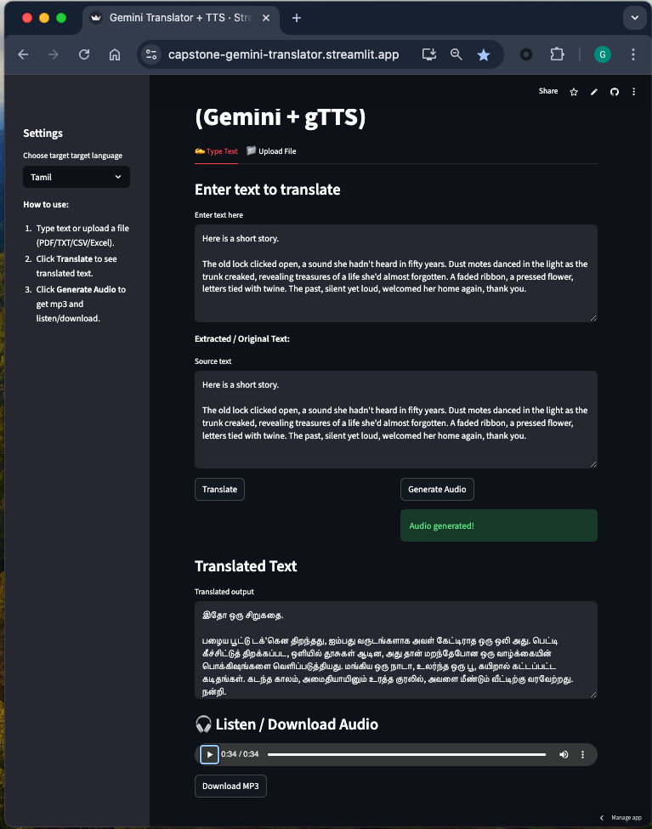

Test Scenario #2 : TEXT File Translation and Audio Generation

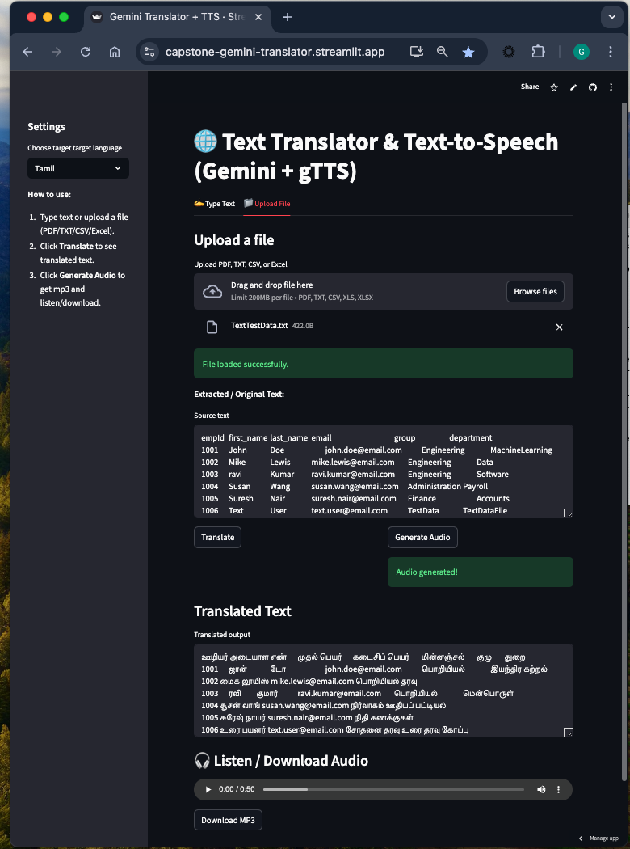

Test Scenario #3 : CSV File Translation and Audio Generation

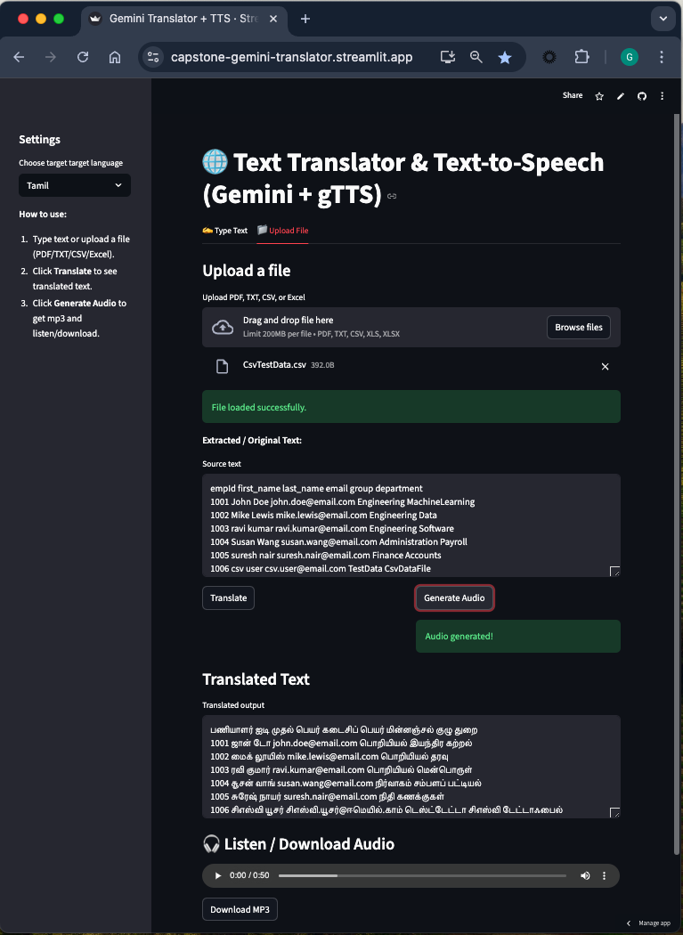

Test Scenario #4 : Excel File Translation and Audio Generation

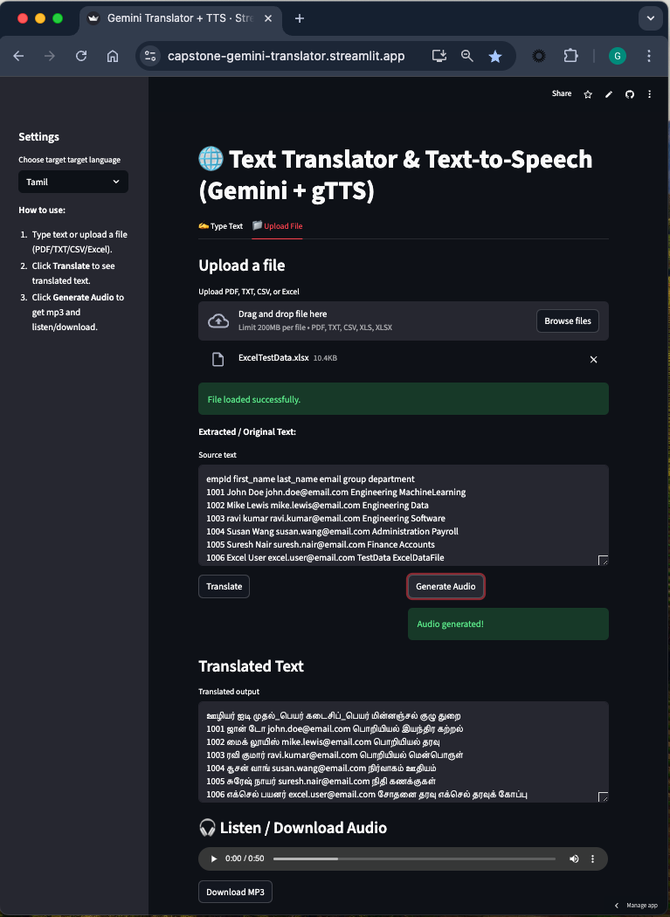

Test Scenario #5 : PDF File Translation and Audio Generation
