**NASA Needs Fresh Meat**

*An Outsider's Analysis of NASA's Current Astronaut Roster*

by Graham Ganssle, Ph.D.

April 3rd, 2016

As a scientist (and an adrenaline junkie), getting blasted off the planet by 150,000 kilos of liquid oxygen and kerosene sounds awesome to me, so I submitted an application to NASA to join the new cohort of astronaut candidates. However, judging by historical data, it’s likely applicants like myself have a chance of acceptance on the order of forty thousandths of a percent. Those odds are pretty thin, but the home run of acceptance isn’t the only derived benefit of the application process. It’s been a great pleasure to meet fellow astronaut candidate applicants and former/current employees of NASA. These people are the brightest, hardest working people in the US, so how does NASA choose between them and what skills is the current NASA astronaut roster missing?

During my whimsical Googlings about NASA’s current astronaut corps, I found a page with their biographical information. I hypothesized it’d be possible to answer the above questions using this information, so I banged on my keyboard for a while until I learned Python, how to webscrape PDFs, and the intricacies of the human-language-data / machine-language-data interface. I’m not sure I came up with any interesting answers, but the simple analysis I did, and the cleaned data itself, isn’t available anywhere else. So for the benefit of NASA (who probably already has this information somewhere!) and the eight or so applicants who have the Right Stuff, I hope this information helps you out in some small way. For the rest of us, I hope this project is the starting point for a conversation between likeminded data nerds, and can be a place to meet NASA interested scientists/engineers/soldiers/teachers/pilots/etc of the highest caliber.

The project can be accessed here: <https://github.com/gganssle/astroBio> Please comment, question, add to, or remove from this as you see fit. But above all, introduce yourself!

**Methods**

I used a Mathematica script to webscrape the raw data from the interwebs and then cleaned the PDF data to text with pdftotext.com. I wrote a Python program to do a rough clean on the textual data, and then a Python script in a Jupyter notebook to do the analysis and make things look pretty. Matplotlib was instrumental in presenting the data in a meaningful way. Initially I planned to use the excellent NLTK (Natural Language Toolkit), but the analysis within wasn’t sophisticated enough to warrant its use.

**Results / Pretty Pics**

All of these figures can be found full size for detail in the open source repository: <https://github.com/gganssle/astroBio>

Only 83% of the biographies had age data, but of the data which was populated, the average age of the current astronaut corps is 50 years old. The figure below shows all of the age data populated in the biographies.

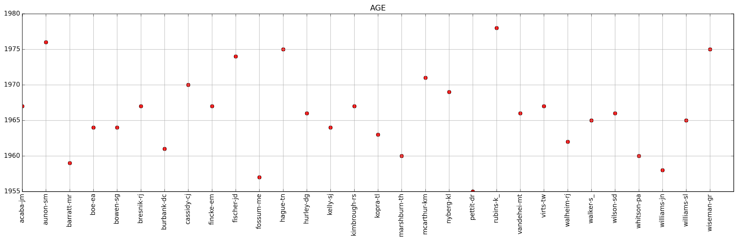

As expected, the average number of children the astronauts have is near the national average.

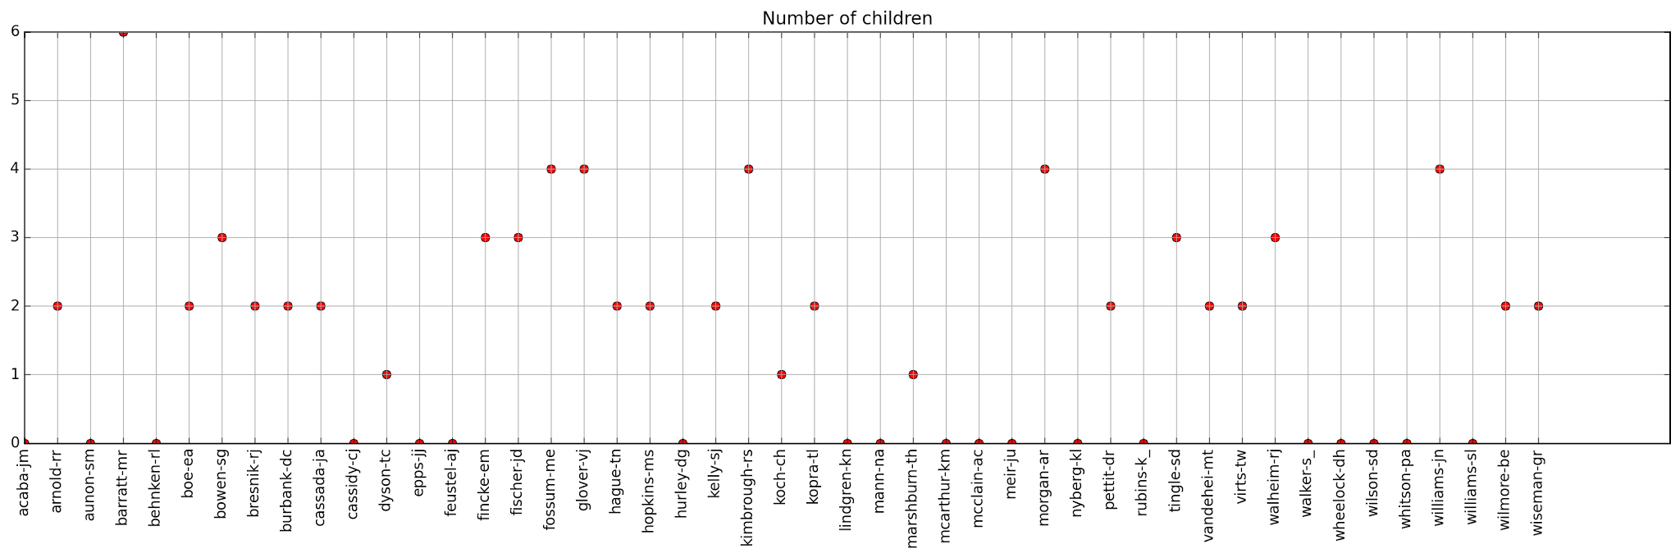

No information was disclosed in the biographies about explicitly unmarried astronauts, so in this analysis if not stated explicitly “married” the astronauts were counted unmarried.

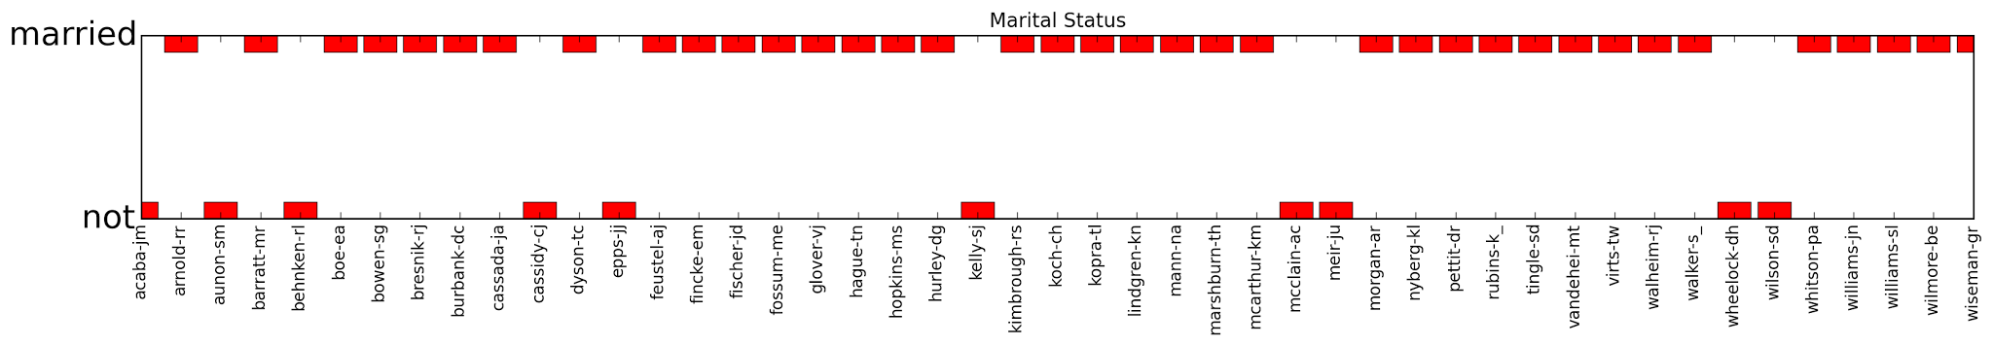

The next figure discloses flight experience, nondiscriminating of military or private experience.

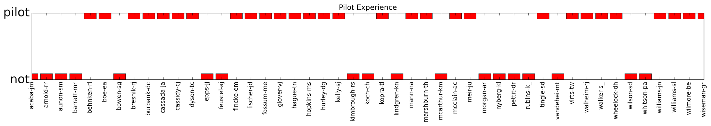

The following figure describes each astronaut’s military affiliation and rank, with service branch in color and rank as bar height.

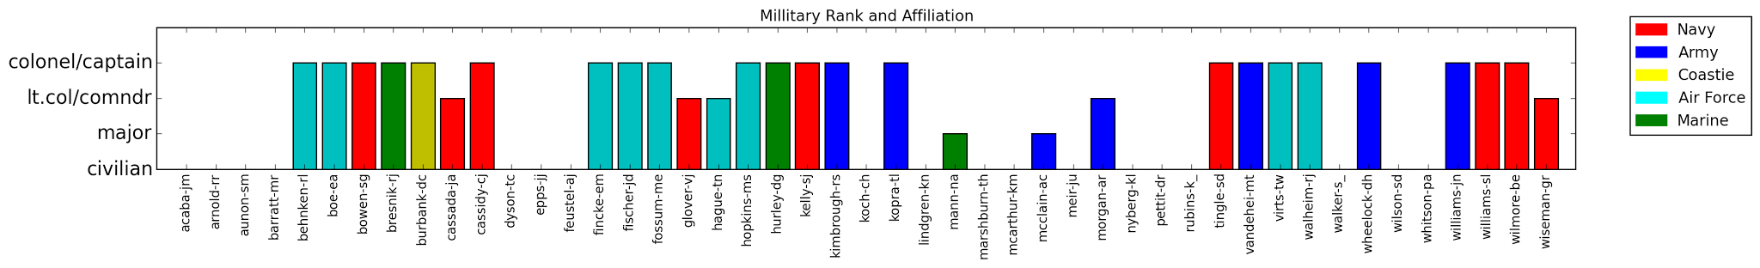

The figure below (again, see <https://github.com/gganssle/astroBio> for a full size version where you can read the details) shows the astronauts’ educational history. A white square means they have the degree, a black square means they do not. The red labels indicate the specialty of each degree. The process was limited by syntactical constraints, as you’ll notice by a few mis-populations.

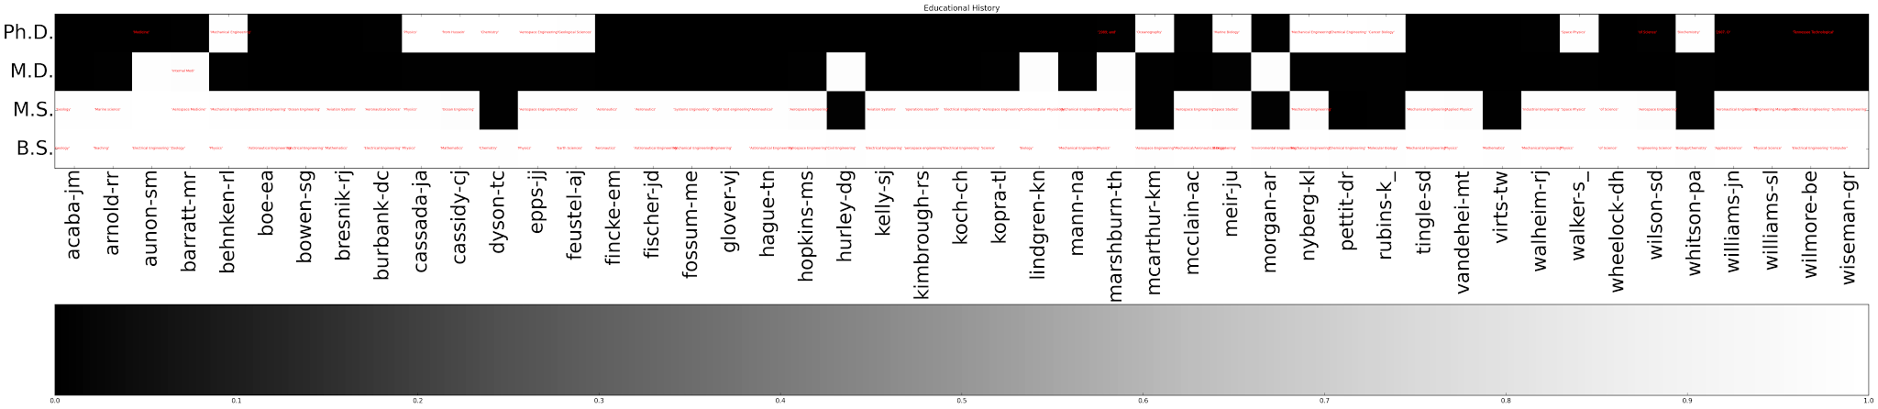

Hooray! Pie charts! The next figure is a representation of how many astronauts share the same personal interests and hobbies. The numbers next to the tags are how many astronauts share the hobby.

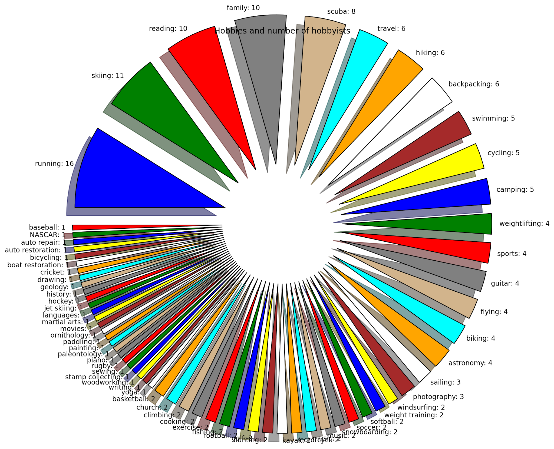

Work history is represented in the next figure. The number next to the tag is the number of astronauts who’ve had the same profession.

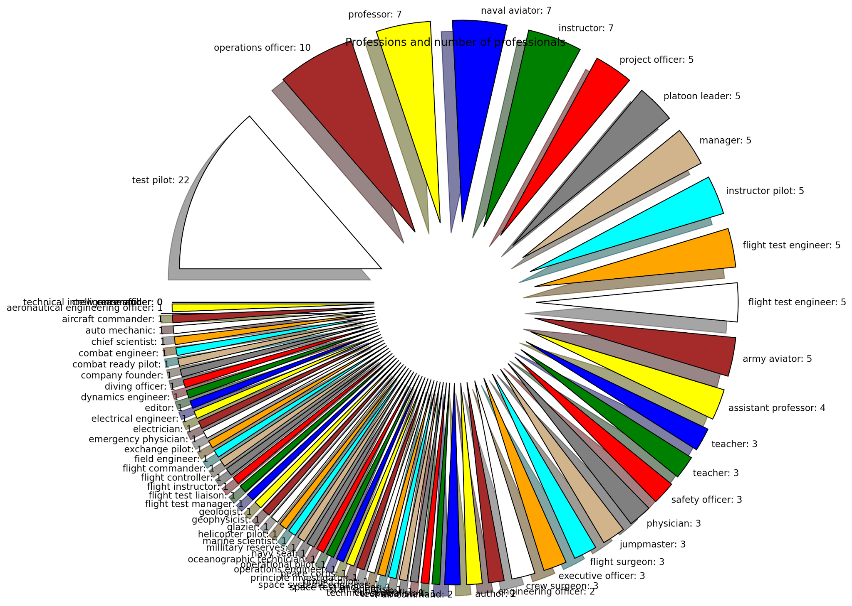

**NASA Did a Fine Job, Folks**

Wow. These people are impressive. Period. I mean a USAF colonel with a doctorate! How does a person even physically have the energy to do that? NASA has done an awesome job selecting candidates with exceptional backgrounds. But again, these people *were* chosen because they’re the smartest, most driven people in the world. So with all accolades and respect in mind, let’s tear them to shreds with quantitative analysis!

The most striking thing that popped out in this analysis is the age range of the current roster. This analysis suggests that the average age of an astronaut is 50 years old. As mentioned above, the public data does not include the ages of all the astronauts. And in fact out of the astronaut bios without age data, 64% have been recruited in the two most recent classes. If we assume a relatively stationary age range of recruits over the years, the 50 year old age is skewed older than is true. However, it’s evident NASA needs some young blood.

Also surprising is the lack of civilian pilots. Civilian astronauts as mission specialists could more efficiently serve NASA if they were also pilots. As mentioned, there are a few astronauts with both military experience and an exceptional educational history; these people can serve combined specialty mission specialist / pilot roles. Since NASA is now developing the SLS, they will certainly be in need of more pilots in the near future.

It seems to me that astronauts need a great deal of ability in the mechanical repair domain. Living aboard, and working on, the International Space Station for six months at a time necessitates an intuitive cognizance of mechanical systems. I was shocked to see very few hobbies and past professions in mechanically oriented trades. There are a few astronauts who are interested in auto or boat repair and woodworking, which probably helps them tremendously in space. In astronaut candidate training you can teach a person the difference between a half inch and a three eighths socket wrench, but you can’t expect them to hand torque a critical bolt close to, but not over, twenty foot pounds by feel alone.

**What’s Next?**

My recommendations to astronaut hopefuls (including myself) are the following: 1. Work harder and on more passion projects; no one cares that you’re tired. 2. Apply early; NASA needs some young pups to blast to Mars. 3. Learn to fly a plane; especially if you’re non military. 4. Turn wrenches on some stuff, learn to weld, and wire something up.

Fork this repository (<https://github.com/gganssle/astroBio>) and keep analyzing. The work I’ve done here is simply a starting point. Also, please contact me. If you’re interested in this project I’d love to chat.