Advanced Computer Networks – PCS223
Assignment 1

- Screenshot showing Wireshark Home screen showing all interfaces and the active interface (Wi-Fi)

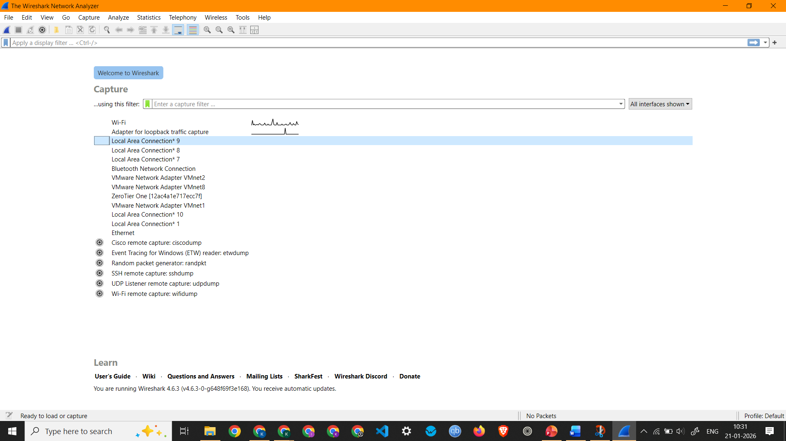

- Showing Live Packet Capture on Wi-Fi

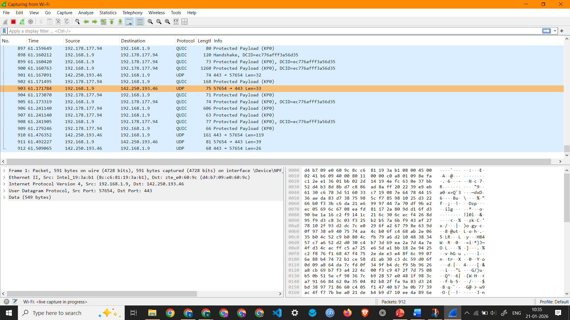

3.Screenshot showing ICMP Packets Captured by pinging google.com

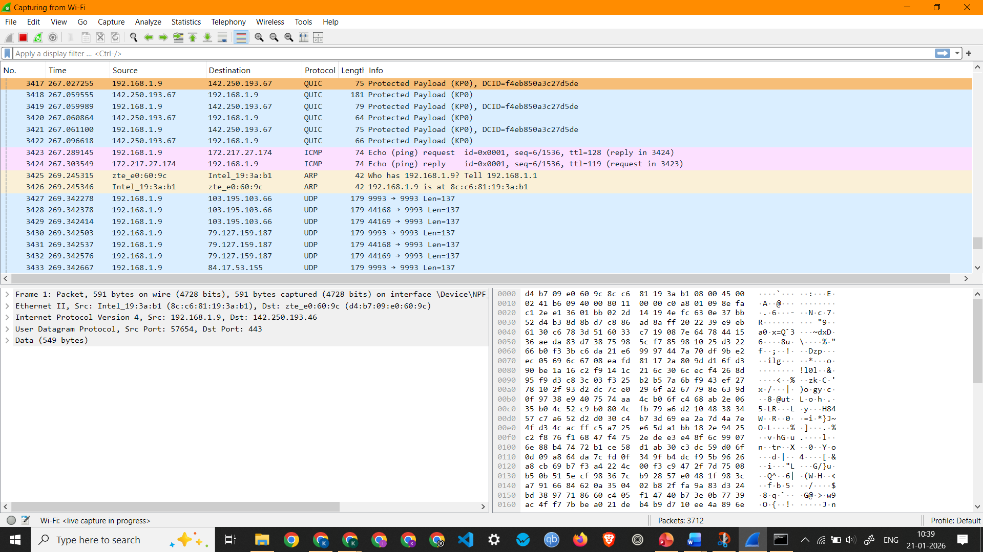

- Screenshot showing IP Packets

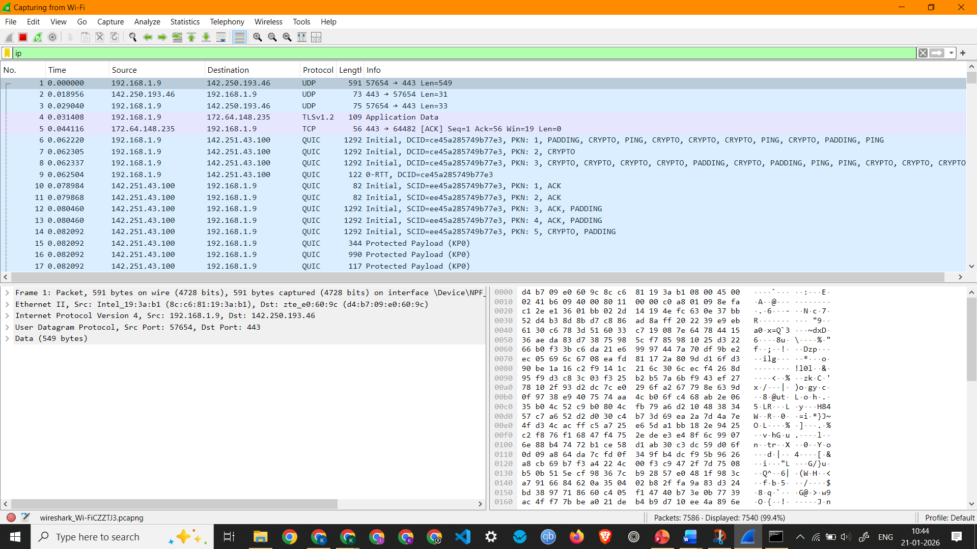

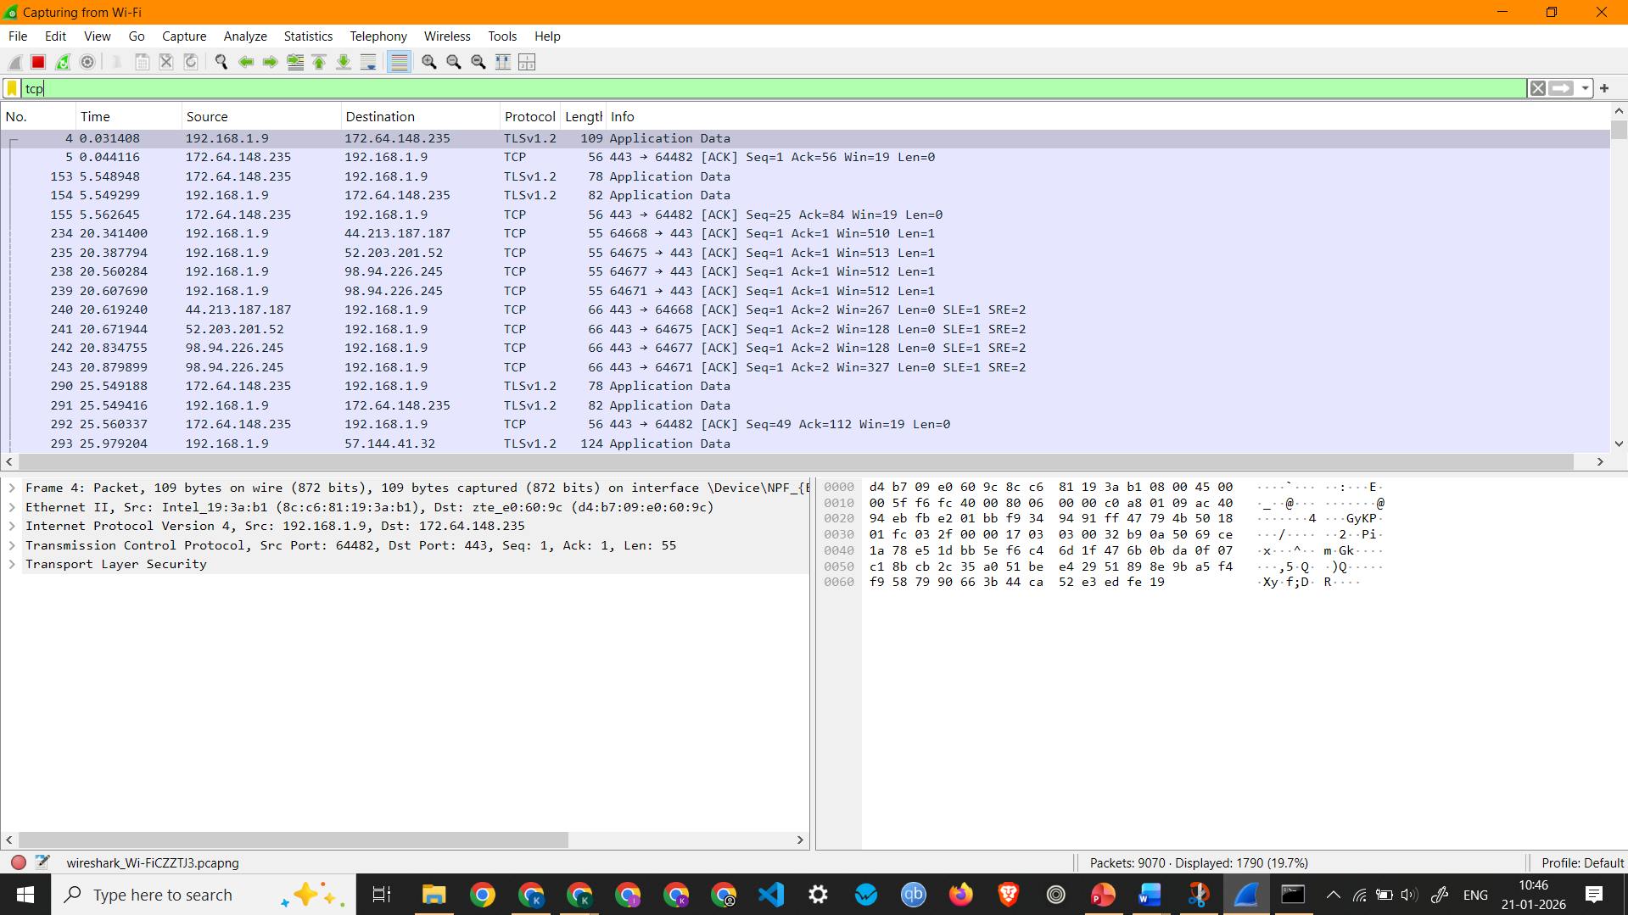
Screenshot showing TCP Packets Capture

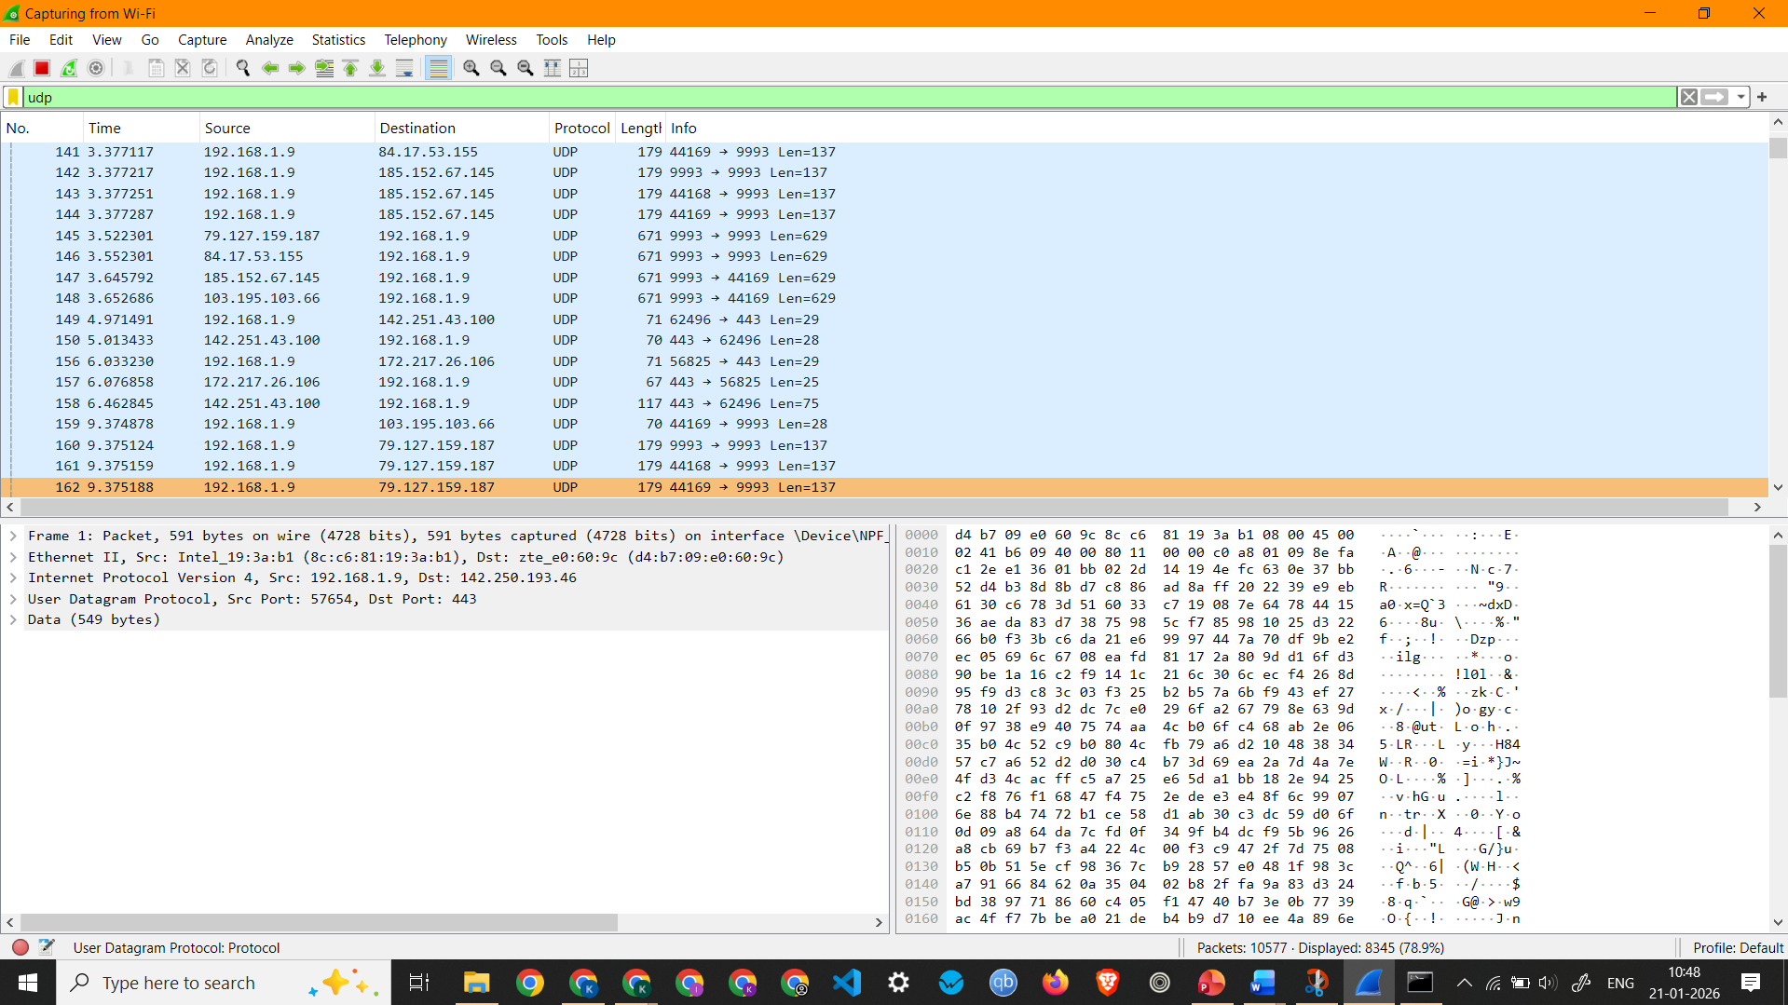
Screenshot showing UDP Packets Capture
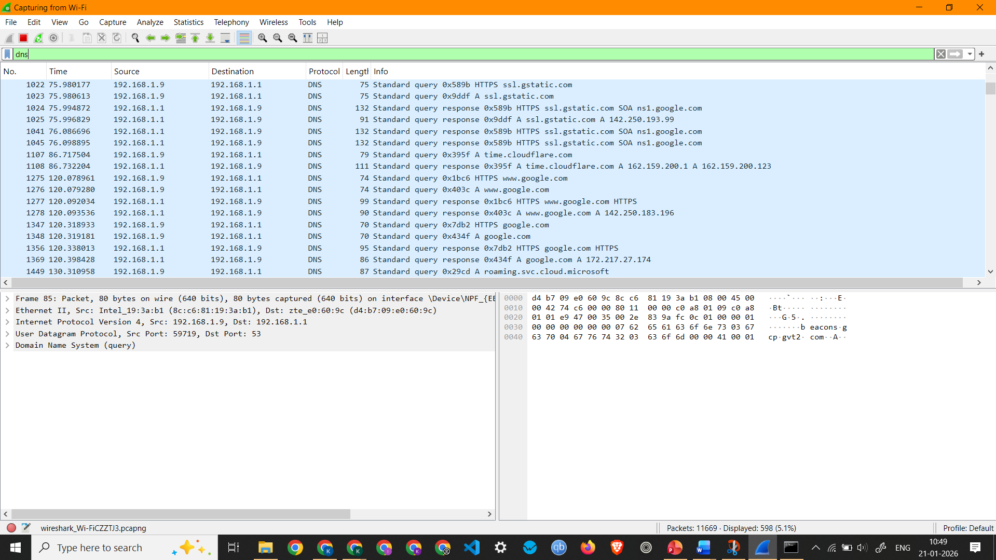
Screenshot showing DNS Packets Capture

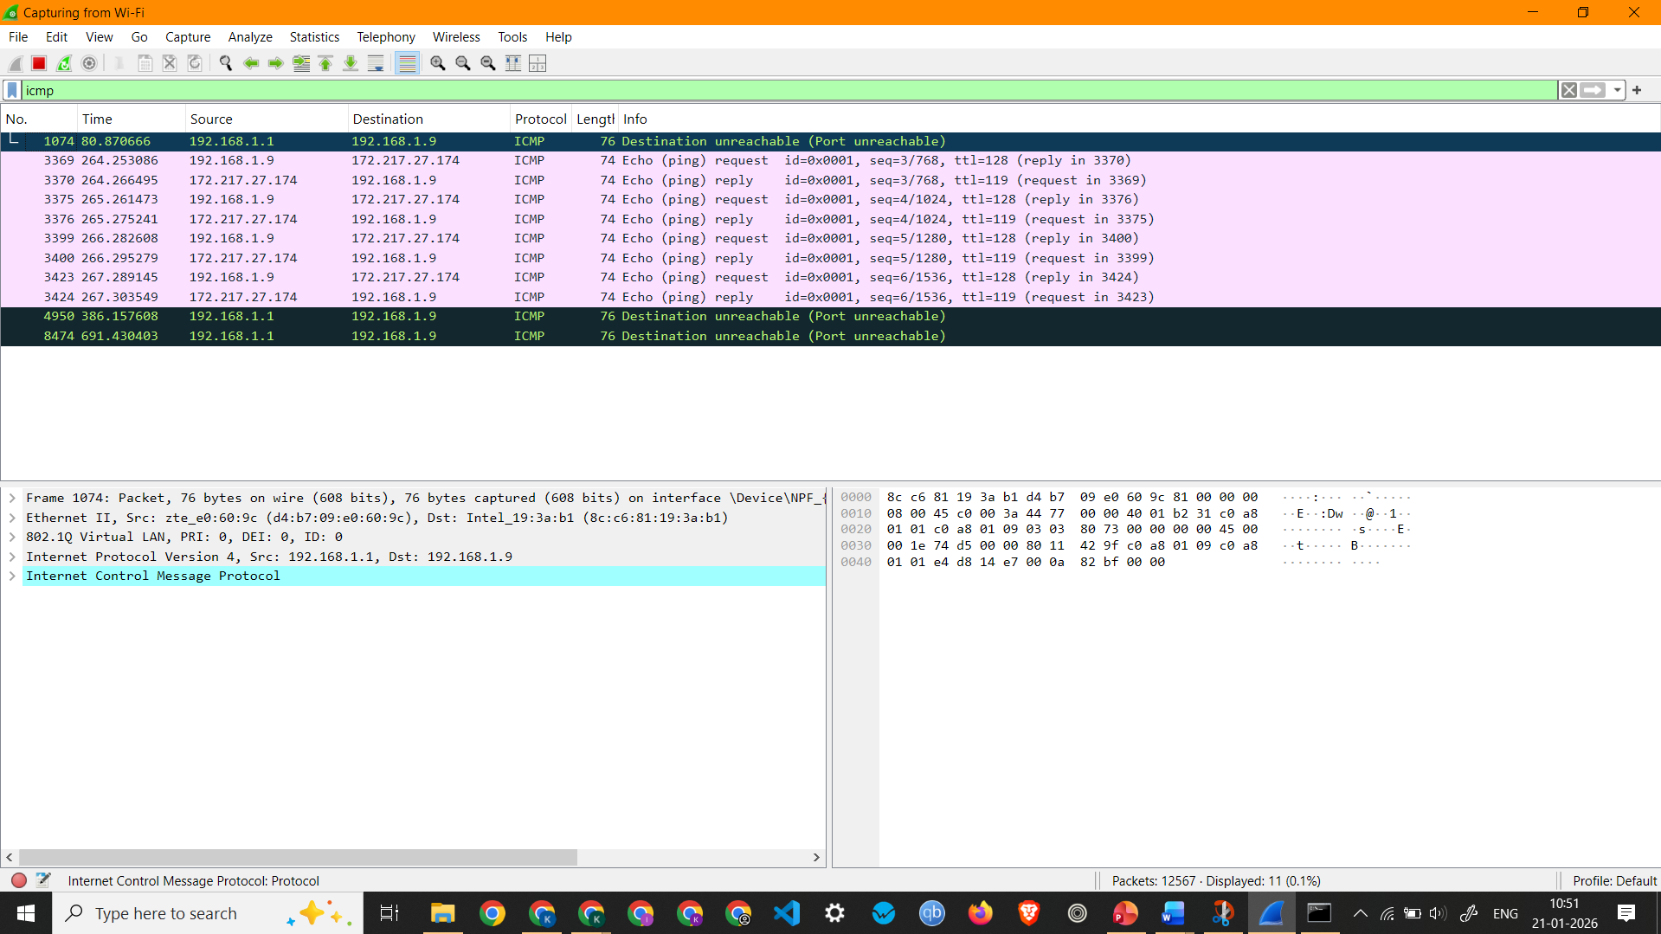
Screenshot showing ICMP Packets Capture
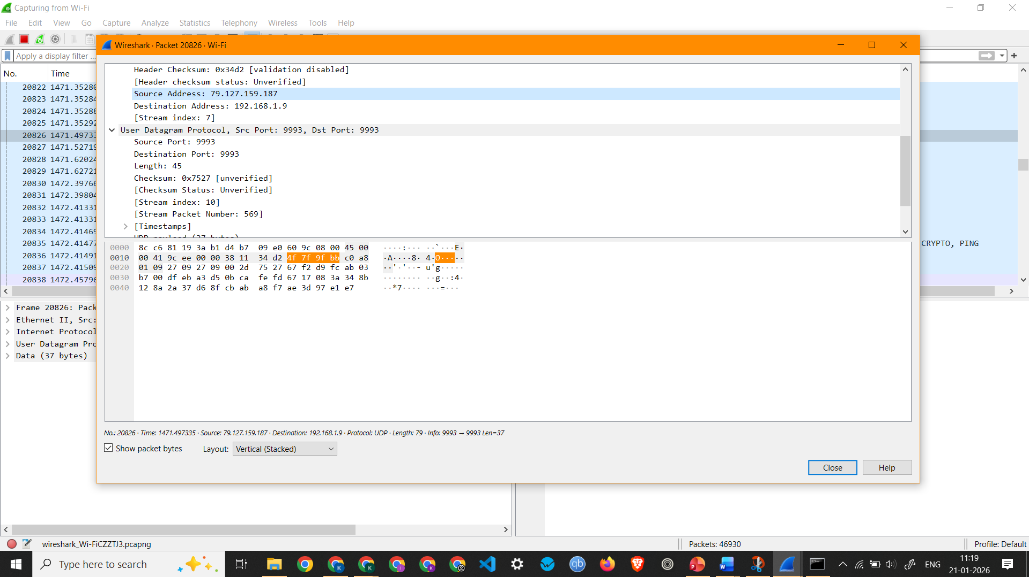
Screenshot showing details of a UDP Packet

Observation: UDP Packet 20826 –
  - Interface Used: Wi-Fi
  - Protocols Observed: Ethernet II, Internet Protocol Version 4, and User Datagram Protocol
  - Source IP Address: 79.127.159.187
  - Destination IP Address: 192.168.1.9
  - Packet Length: 79 Bytes

