VBA Homework

Gilberto Garza Gonzalez | Data Science Bootcamp | January 7, 2021

2016

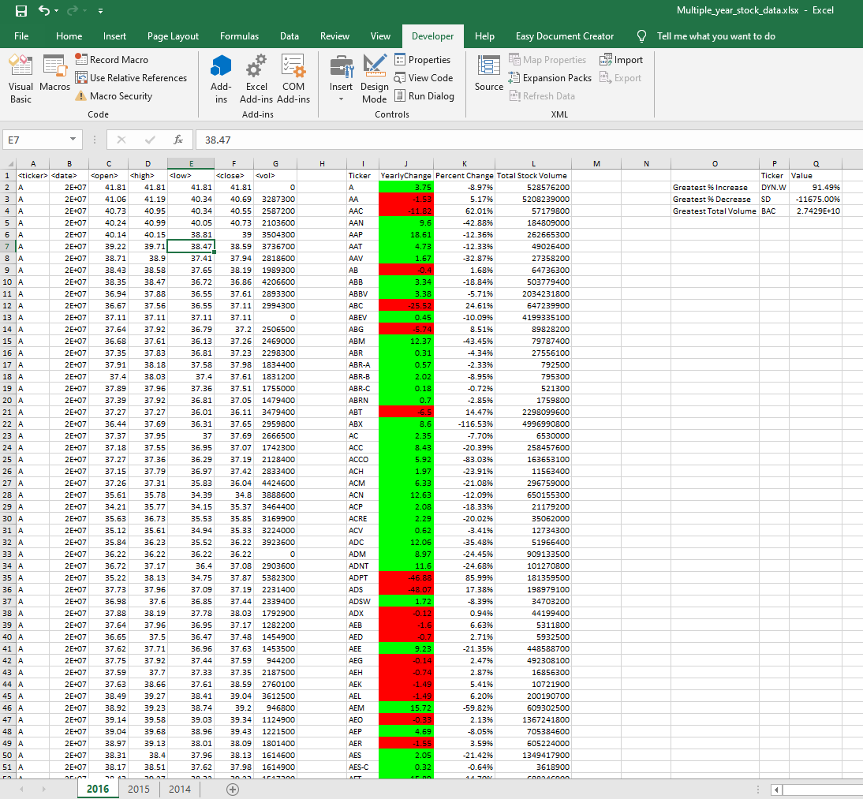

2015

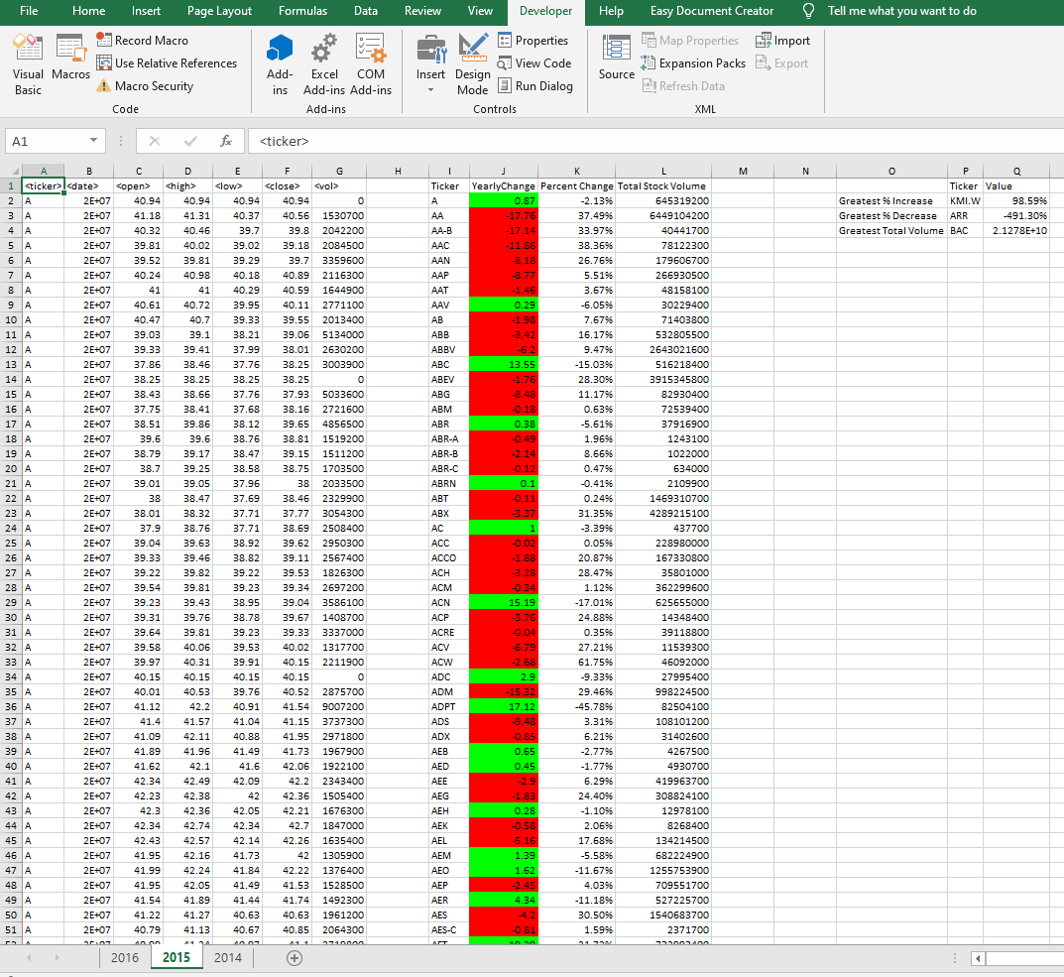

2014

