SYSTEM DESIGN DOCUMENT
Architecture · Database · API · Development Roadmap
SAHAYOG
Unified Multi-Agency Resource Deduplication & Allocation Platform
Companion document to the Software Requirements Specification (SRS) v1.0
Document Version | 1.0
Date | 15 August 2026
Related Document | SAHAYOG_SRS.docx v1.0
Status | Draft — for internal team / faculty mentor review

—. Revision History
Version | Date | Author | Description
1.0 | 15-Aug-2026 | Project Team | Initial draft: architecture, ER model, API spec, sprint roadmap

Table of Contents

1. Introduction

1.1 Purpose
This System Design Document (SDD) translates the requirements defined in SAHAYOG_SRS.docx v1.0 into a concrete technical design: system architecture, database schema, module-level design, API contract, and a sprint-wise development roadmap. It is the primary reference for implementation and code review.

1.2 Scope
This document covers the design of the SIH MVP (flood-relief scenario: 4 districts, 3 agency types, 5 resource types) and notes, where relevant, extension points for the full system vision described in SRS Section 6. It does not restate functional requirements in full — refer to the SRS for the authoritative requirement list (FR-xxx / NFR-xxx IDs used below match the SRS).

1.3 Design Goals
- Correctness of the deduplication and matching logic over visual polish.
- Clear separation between the optimization/forecasting logic and the API layer, so algorithms can be swapped without changing contracts (supports SRS Section 5.4, Maintainability).
- A data model that treats resource_type and disaster_type as configurable values rather than hard-coded enums, so new disaster scenarios can be added without schema migration (supports SRS Section 6).
- A human-in-the-loop authorization step before any resource is marked IN TRANSIT (supports SRS Section 5.2, Safety).

2. System Architecture

2.1 High-Level Architecture
SAHAYOG follows a layered pipeline architecture. Agency users submit data through a common API Gateway; that data flows through the Deduplication Engine, then the Matching & Optimization Engine, then the Priority & Forecasting module, before recommendations and live status reach the Command Centre Dashboard. Authorization actions from the dashboard flow back through the same gateway.
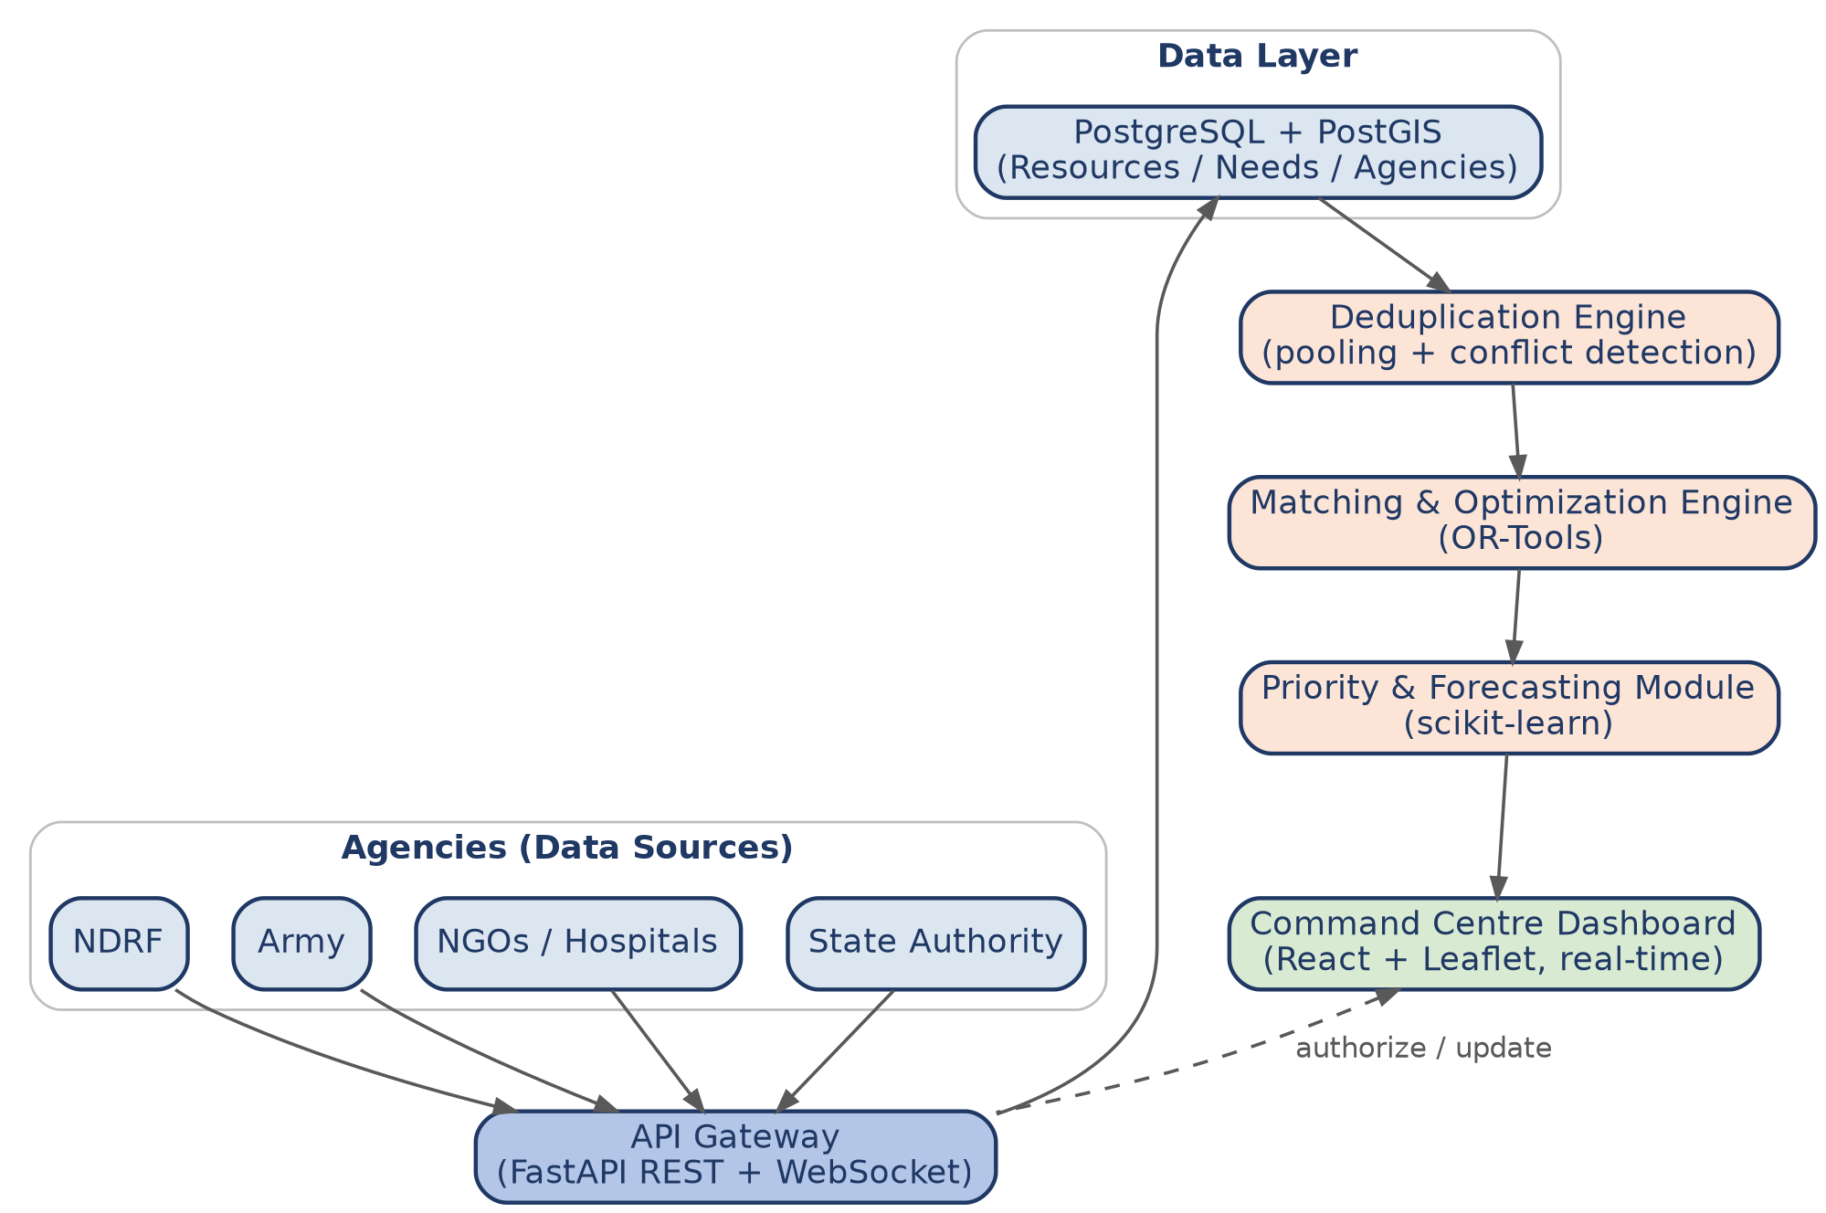
Figure 2.1 — High-level layered architecture.

2.2 Deployment / Component View
The application is containerized (Docker) and deployed across three tiers: a static client tier, an application tier hosting the REST API, WebSocket service, and two background workers (optimization and forecasting), and a data tier.
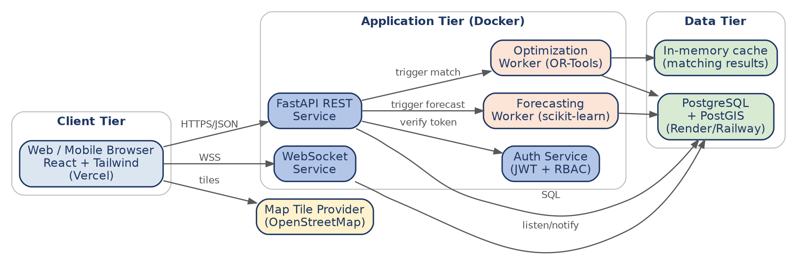
Figure 2.2 — Deployment and component diagram.
Component | Responsibility
FastAPI REST Service | CRUD for agencies, resources, needs; auth; orchestrates calls to optimization/forecasting workers.
WebSocket Service | Publishes real-time resource/need/allocation state changes to subscribed dashboard clients (FR-RT-01).
Optimization Worker | Runs the OR-Tools-based matching algorithm on demand or on a schedule (FR-MAT-01–07).
Forecasting Worker | Computes time-to-shortage estimates using scikit-learn models (FR-FOR-01–03).
Auth Service | Issues/validates JWTs, enforces RBAC (FR-SEC-01–03, NFR-SEC-01–03).
PostgreSQL + PostGIS | System of record; PostGIS supports nearest-resource geospatial queries.
Table 2.1 — Component responsibilities.

2.3 Technology Stack
Layer | Technology
Frontend | React.js + Tailwind CSS + shadcn/ui + Recharts
Maps / GIS | Leaflet + OpenStreetMap
Backend | FastAPI (Python 3.11+)
Database | PostgreSQL 15 + PostGIS extension
Optimization | Google OR-Tools (CP-SAT / linear solver)
ML / Forecasting | scikit-learn (linear/regression models for MVP)
Real-time | WebSockets (FastAPI native) + PostgreSQL LISTEN/NOTIFY
Auth | JWT (access + refresh) + RBAC middleware
Containerization / Hosting | Docker; Vercel (frontend); Render/Railway (backend + DB)
CI / Testing | GitHub Actions; Pytest (backend); Vitest/RTL (frontend)
Table 2.3 — Technology stack by layer.

3. Database Design

3.1 Entity-Relationship Diagram
The core entities are Agency, User, District, Resource, Need, Allocation, AllocationItem, Notification, and AuditLog. Resource and Need are the two central tables the Deduplication and Matching engines operate over; Allocation/AllocationItem record the outcome of a match once a Command Centre operator authorizes it.
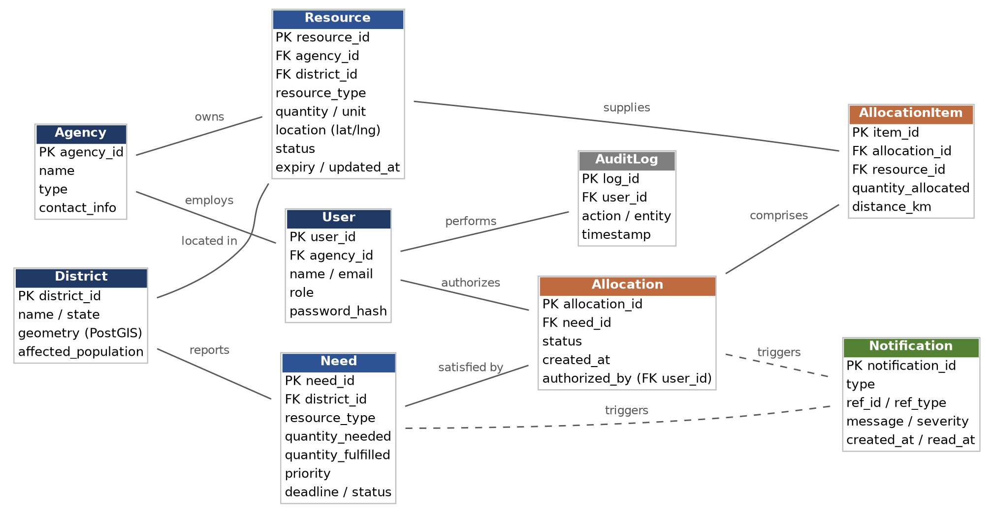
Figure 3.1 — Entity-relationship diagram.

3.2 Table Definitions

3.2.1 agency
Column | Type | Notes
agency_id | UUID (PK) | —
name | VARCHAR(120) | e.g., "NDRF Battalion 5"
type | VARCHAR(40) | NDRF | ARMY | SDRF | NGO | HOSPITAL | STATE_AUTHORITY
contact_info | JSONB | phone, email, address
created_at | TIMESTAMPTZ | default now()

3.2.2 user
Column | Type | Notes
user_id | UUID (PK) | —
agency_id | UUID (FK -> agency) | nullable for SUPER_ADMIN
name / email | VARCHAR | email unique, indexed
role | VARCHAR(30) | SUPER_ADMIN | STATE_OPERATOR | AGENCY_ADMIN | AGENCY_STAFF
password_hash | VARCHAR | bcrypt/argon2, never plaintext (NFR-SEC-01)

3.2.3 district
Column | Type | Notes
district_id | UUID (PK) | —
name / state | VARCHAR | e.g., Kota, Rajasthan
geometry | GEOMETRY(Polygon,4326) | PostGIS boundary; centroid used for distance calc
affected_population | INTEGER | used by forecasting module

3.2.4 resource
Column | Type | Notes
resource_id | UUID (PK) | —
agency_id | UUID (FK) | owning agency (FR-DED-02)
district_id | UUID (FK) | —
resource_type | VARCHAR(40) | BOAT | AMBULANCE | GENERATOR | FOOD_PACKET | DRINKING_WATER | … (configurable, FR extensible)
quantity / unit | NUMERIC / VARCHAR | e.g., 15 / "units", 5000 / "packets"
location | GEOGRAPHY(Point,4326) | PostGIS point; drives distance ranking (FR-MAT-02)
status | VARCHAR(20) | AVAILABLE | DEPLOYED | IN_TRANSIT | RESERVED | DAMAGED | EXPIRED
expiry / updated_at | TIMESTAMPTZ | expiry nullable

3.2.5 need
Column | Type | Notes
need_id | UUID (PK) | —
district_id | UUID (FK) | —
resource_type | VARCHAR(40) | matches resource.resource_type domain
quantity_needed / quantity_fulfilled | NUMERIC | fulfilled updated as allocations are accepted
priority | VARCHAR(10) | CRITICAL | HIGH | MEDIUM | LOW — derived (FR-PRI-01)
deadline | TIMESTAMPTZ | drives priority derivation
status | VARCHAR(20) | OPEN | PARTIALLY_MET | RESOLVED | EXPIRED

3.2.6 allocation & allocation_item
Column | Type | Notes
allocation_id | UUID (PK) | —
need_id | UUID (FK) | —
status | VARCHAR(20) | PROPOSED | ACCEPTED | MODIFIED | REJECTED
authorized_by | UUID (FK -> user) | nullable until authorized (FR-MAT-05)
item_id / allocation_id / resource_id | UUID | allocation_item child rows
quantity_allocated / distance_km | NUMERIC | per-resource split (FR-MAT-03)

3.2.7 notification & audit_log
- notification: notification_id, type (DUPLICATE_DEPLOYMENT | SHORTAGE_ALERT | FORECAST_ALERT), ref_id, ref_type, message, severity, created_at, read_at.
- audit_log: log_id, user_id, action, entity, entity_id, before/after snapshot (JSONB), timestamp — satisfies FR-REG-05.

4. Module-Level Design

4.1 Deduplication Engine
Implemented as a database view / materialized aggregation rather than an application-level loop, for correctness and performance: GROUP BY (district_id, resource_type) over resource rows where status = 'AVAILABLE', summing quantity. Recomputed on every write via a trigger-backed refresh or a short-interval scheduled job (satisfies FR-DED-01/03).
- Conflict detection (FR-DED-04/05/06) runs as a separate scheduled job comparing recent resource/need writes within a configurable time and geography window and inserting Notification rows when thresholds are crossed.

4.2 Matching & Optimization Engine
A stateless service function: given a need_id, it (1) queries candidate resources of matching type and AVAILABLE status within a search radius, (2) computes distance via PostGIS ST_Distance, (3) builds a constrained allocation problem — minimize total distance-weighted cost subject to not exceeding each resource's available quantity and meeting the need's quantity — solved with OR-Tools' CP-SAT solver for the MVP scale, falling back to a greedy nearest-first heuristic if the solver times out. Output is a proposed Allocation + AllocationItem set with status PROPOSED, never auto-committed (FR-MAT-01–05).

4.3 Priority & Forecasting Module
Priority (FR-PRI-01) is a pure function of a need's deadline, recalculated on read/write — no ML needed. Forecasting (FR-FOR-01/02) uses a lightweight linear regression / moving-average model over simulated historical consumption per (district, resource_type), producing an estimated_depletion_time; when this falls under a configurable threshold, the module creates a synthetic "pre-emptive" need feeding into the same matching pipeline.

4.4 Access Control Middleware
A FastAPI dependency validates the JWT, loads the user's role and agency_id, and injects a scope object used by every route handler to filter queries (e.g., Agency Staff can only UPDATE resource rows where resource.agency_id == user.agency_id). This mirrors the requirement that authorization is enforced server-side, not just in the UI (NFR-SEC-02).

4.5 Real-Time Update Service
Uses PostgreSQL LISTEN/NOTIFY triggered by row-level changes on resource, need, and allocation tables; the WebSocket service subscribes to these channels and rebroadcasts scoped events to connected dashboard clients over authenticated WSS connections (FR-RT-01/02). Clients reconcile state via a REST fetch on reconnect if a gap is detected (FR-RT-03).

5. Key Process Flow — Matching & Allocation
This flow illustrates the end-to-end path from a new need being reported to the dashboard reflecting a resolved state, and is the sequence demonstrated live in the SIH prototype (see SRS Appendix C).
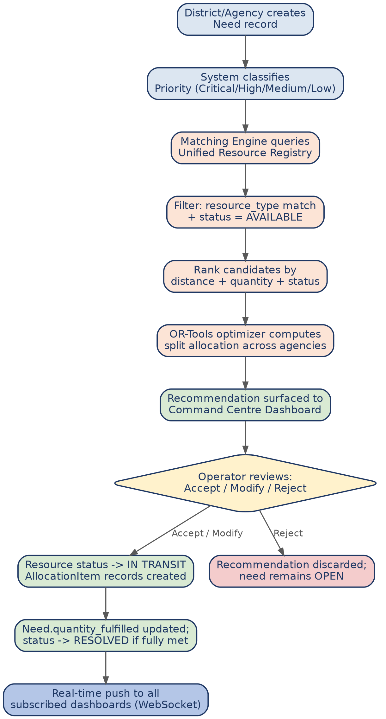
Figure 5.1 — Matching engine process flow.

6. API Design
All endpoints are prefixed /api/v1 and require a bearer JWT unless noted. Responses are JSON; errors follow { "error": { "code": ..., "message": ... } }.

6.1 Authentication
Method | Endpoint | Description
POST | /auth/login | Authenticate; returns access + refresh JWT.
POST | /auth/refresh | Exchange refresh token for new access token.
POST | /auth/logout | Revoke refresh token.

6.2 Resources
Method | Endpoint | Description
GET | /resources?district_id=&resource_type=&status= | List resources, filterable; RBAC-scoped (FR-REG, FR-DED-02).
POST | /resources | Create a resource record (FR-REG-01).
PATCH | /resources/{id} | Update quantity/status; owning agency only (FR-REG-03).
GET | /resources/pooled?district_id=&resource_type= | Deduplicated pooled totals by district/type (FR-DED-01).
GET | /resources/nearby?lat=&lng=&resource_type=&radius_km= | PostGIS proximity search.

6.3 Needs
Method | Endpoint | Description
GET | /needs?district_id=&status=&priority= | List needs, filterable (FR-REG-02).
POST | /needs | Create a need; priority auto-derived (FR-PRI-01).
PATCH | /needs/{id} | Update quantity/deadline/status.

6.4 Matching & Allocations
Method | Endpoint | Description
POST | /needs/{id}/match | Trigger the matching engine; returns a PROPOSED allocation (FR-MAT-01–04).
GET | /allocations?status= | List allocations, filterable by status.
POST | /allocations/{id}/authorize | Accept/modify a proposed allocation; sets resources IN_TRANSIT (FR-MAT-05/06).
POST | /allocations/{id}/reject | Reject a proposed allocation; need remains OPEN.

6.5 Dashboard, Forecasting & Notifications
Method | Endpoint | Description
GET | /dashboard/summary | Aggregated surplus/deficit per district/resource type for the map view (FR-MAP-01–03).
GET | /districts/{id}/forecast?resource_type= | Time-to-shortage estimate (FR-FOR-01).
GET | /notifications?unread=true | List alerts for the current user's scope (FR-SEC-04/05).
WS | /ws/dashboard | Authenticated WebSocket channel streaming resource/need/allocation change events (FR-RT-01).

6.6 Sample Payload — POST /needs/{id}/match response
{
"allocation_id": "a1e2...",
"need_id": "n001",
"status": "PROPOSED",
"items": [
{ "resource_id": "r-ndrf-01", "agency": "NDRF", "quantity_allocated": 10, "distance_km": 35 },
{ "resource_id": "r-army-04", "agency": "Army", "quantity_allocated": 12, "distance_km": 48 },
{ "resource_id": "r-ngo-02", "agency": "NGO X", "quantity_allocated": 8, "distance_km": 12 }
],
"quantity_requested": 30,
"quantity_covered": 30,
"unmet": 0
}

7. Development Roadmap — Sprint Plan
An eight-sprint plan (assuming ~1 week sprints, adjustable to the hackathon timeline) takes the project from schema to demo-ready MVP, mirroring the phased build order recommended in the ideation notes (basic system → deduplication → matching → map → AI).
Sprint | Theme | Key Deliverables
0 | Setup & Schema | Repo scaffolding, Docker Compose (API + Postgres/PostGIS), DB schema + migrations, CI pipeline skeleton.
1 | Auth & Core CRUD | JWT auth, RBAC middleware, Agency/User models, /resources and /needs CRUD endpoints (FR-REG).
2 | Frontend Shell | React app shell, login flow, role-based routing, resource/need entry forms.
3 | Deduplication Engine | Pooled-totals view/endpoint, per-agency breakdown, unused-surplus flagging (FR-DED-01–03,06).
4 | Matching Engine v1 | Greedy nearest-first matching, PostGIS distance queries, allocation authorize/reject flow (FR-MAT-01–06).
5 | Map & Dashboard | Leaflet map with status colour-coding, district drill-down panel, summary cards (FR-MAP-01–03).
6 | Real-Time + Optimization Upgrade | WebSocket live updates (FR-RT-01–03); upgrade matching to OR-Tools CP-SAT (FR-MAT-07); duplicate-deployment detection (FR-DED-04/05).
7 | Forecasting, Polish & Demo | Forecasting module (FR-FOR-01–03), notifications (FR-SEC-04/05), end-to-end flood-scenario demo data, UI polish, deployment, rehearsal.
Table 7.1 — Sprint-wise development roadmap.

7.1 Definition of Done — MVP Demo
- All Critical-priority requirements from the SRS (FR-*/NFR-* marked Critical) are implemented and demonstrable.
- The 4-district / 3-agency / 5-resource-type flood scenario (SRS Appendix C) runs end-to-end: data entry → pooled totals → critical need → recommended allocation → authorization → map updates to RESOLVED.
- The system is deployed and reachable via a public URL for judges, with seeded demo data reset between runs.

A. Appendix A — Traceability Note
Functional and non-functional requirement IDs used throughout this document (FR-REG-xx, FR-DED-xx, FR-MAT-xx, FR-PRI-xx, FR-FOR-xx, FR-MAP-xx, FR-SEC-xx, FR-RT-xx, NFR-xx) correspond one-to-one with the requirement tables in SAHAYOG_SRS.docx, Sections 3 and 5. Any change to a requirement ID in the SRS should be reflected here to keep design and requirements traceable.

