Database Design Document
ResearchOS
Autonomous Research Laboratory Platform
Companion document to the ResearchOS SRS and Software Design Document (SDD)
Document Version: 1.0
Date: July 27, 2026
Status: Draft for Review

Revision History
Version | Date | Description | Author
1.0 | July 27, 2026 | Initial database design: PostgreSQL schema, MongoDB, Qdrant, Neo4j, and Redis design. | Project Team

Table of Contents

1. Introduction

1.1 Purpose
This Database Design Document (DDD) specifies the physical data design for ResearchOS across its five data stores: PostgreSQL, MongoDB, Qdrant, Neo4j, and Redis. It translates the data-related responsibilities assigned to each functional module in the Software Design Document (SDD) into concrete schemas, collections, indexes, and key structures.

1.2 Scope
This document covers table-level design for PostgreSQL (columns, types, constraints, indexes), document schema design for MongoDB, vector collection design for Qdrant, graph schema design for Neo4j, and key-space design for Redis. It also defines which store owns which data, how stores stay consistent with one another, and baseline backup and retention guidance.

1.3 Relationship to Other Documents
- SRS — defines the functional requirements this data design supports (FR-xx-nn identifiers referenced throughout).
- SDD — defines the module responsibilities and technology rationale this document assumes as given.

1.4 Design Principles
- Each data store is used for the access pattern it is best suited to: relational integrity in PostgreSQL, flexible/evolving content in MongoDB, similarity search in Qdrant, relationship traversal in Neo4j, and ephemeral/high-speed access in Redis.
- PostgreSQL is the system of record for identity, access control, and cross-module relationships; other stores hold content that is always reachable from a PostgreSQL row (e.g., a papers.id or workspaces.id).
- Every table uses a UUID primary key so that identifiers can be generated by any service without a round trip to a central sequence.
- Soft-deletion (status flags) is preferred over hard deletion for workspaces and papers to preserve auditability; hard deletion (ON DELETE CASCADE) is used for dependent rows that have no standalone meaning (e.g., workspace_members, comments).

2. Database Architecture Overview
ResearchOS uses a polyglot persistence model: each data store owns a distinct subset of the system's data, chosen for the access pattern that subset requires. PostgreSQL remains the source of truth for identifiers referenced from every other store.
Store | Data Owned | Primary Access Pattern
PostgreSQL | Users, workspaces, membership, mentorship, teams, tasks, comments, feed, drafts metadata, activity log. | Transactional reads/writes with strong consistency and joins.
MongoDB | Notes, AI paper analysis, research-gap suggestions, draft content, agent conversation logs. | Flexible-schema document reads/writes, nested structures.
Qdrant | Paper embeddings for semantic search. | Approximate nearest-neighbor vector similarity search.
Neo4j | Knowledge graph: papers, authors, datasets, methods, citations. | Multi-hop relationship traversal.
Redis | Sessions, caches, Celery queues, Socket.IO backplane. | Sub-millisecond key-value reads/writes; pub/sub.

3. PostgreSQL — Relational Schema Design
PostgreSQL is the system of record for identity, access control, workspace structure, and the relational parts of every module. All primary keys are UUIDs; all tables include timestamps sufficient to support the activity log and auditability requirements from the SRS (Section 6.3) and SDD (Section 11.3).

3.1 Entity-Relationship Diagram — Identity, Workspace, Literature, and Mentorship
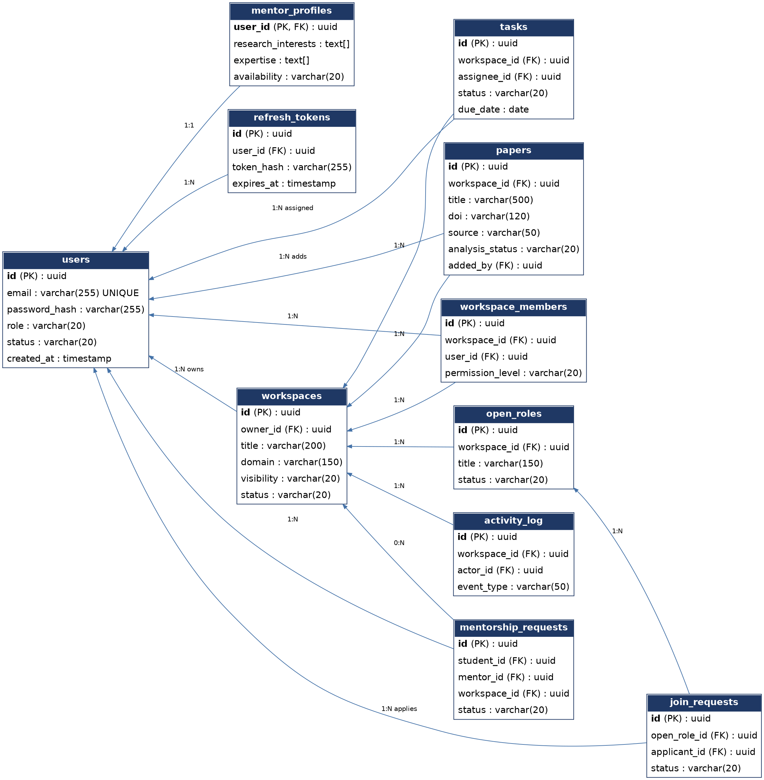
Figure 1 — ER diagram: identity, workspace, literature, and mentorship/team entities.

3.2 Entity-Relationship Diagram — Collaboration and Community
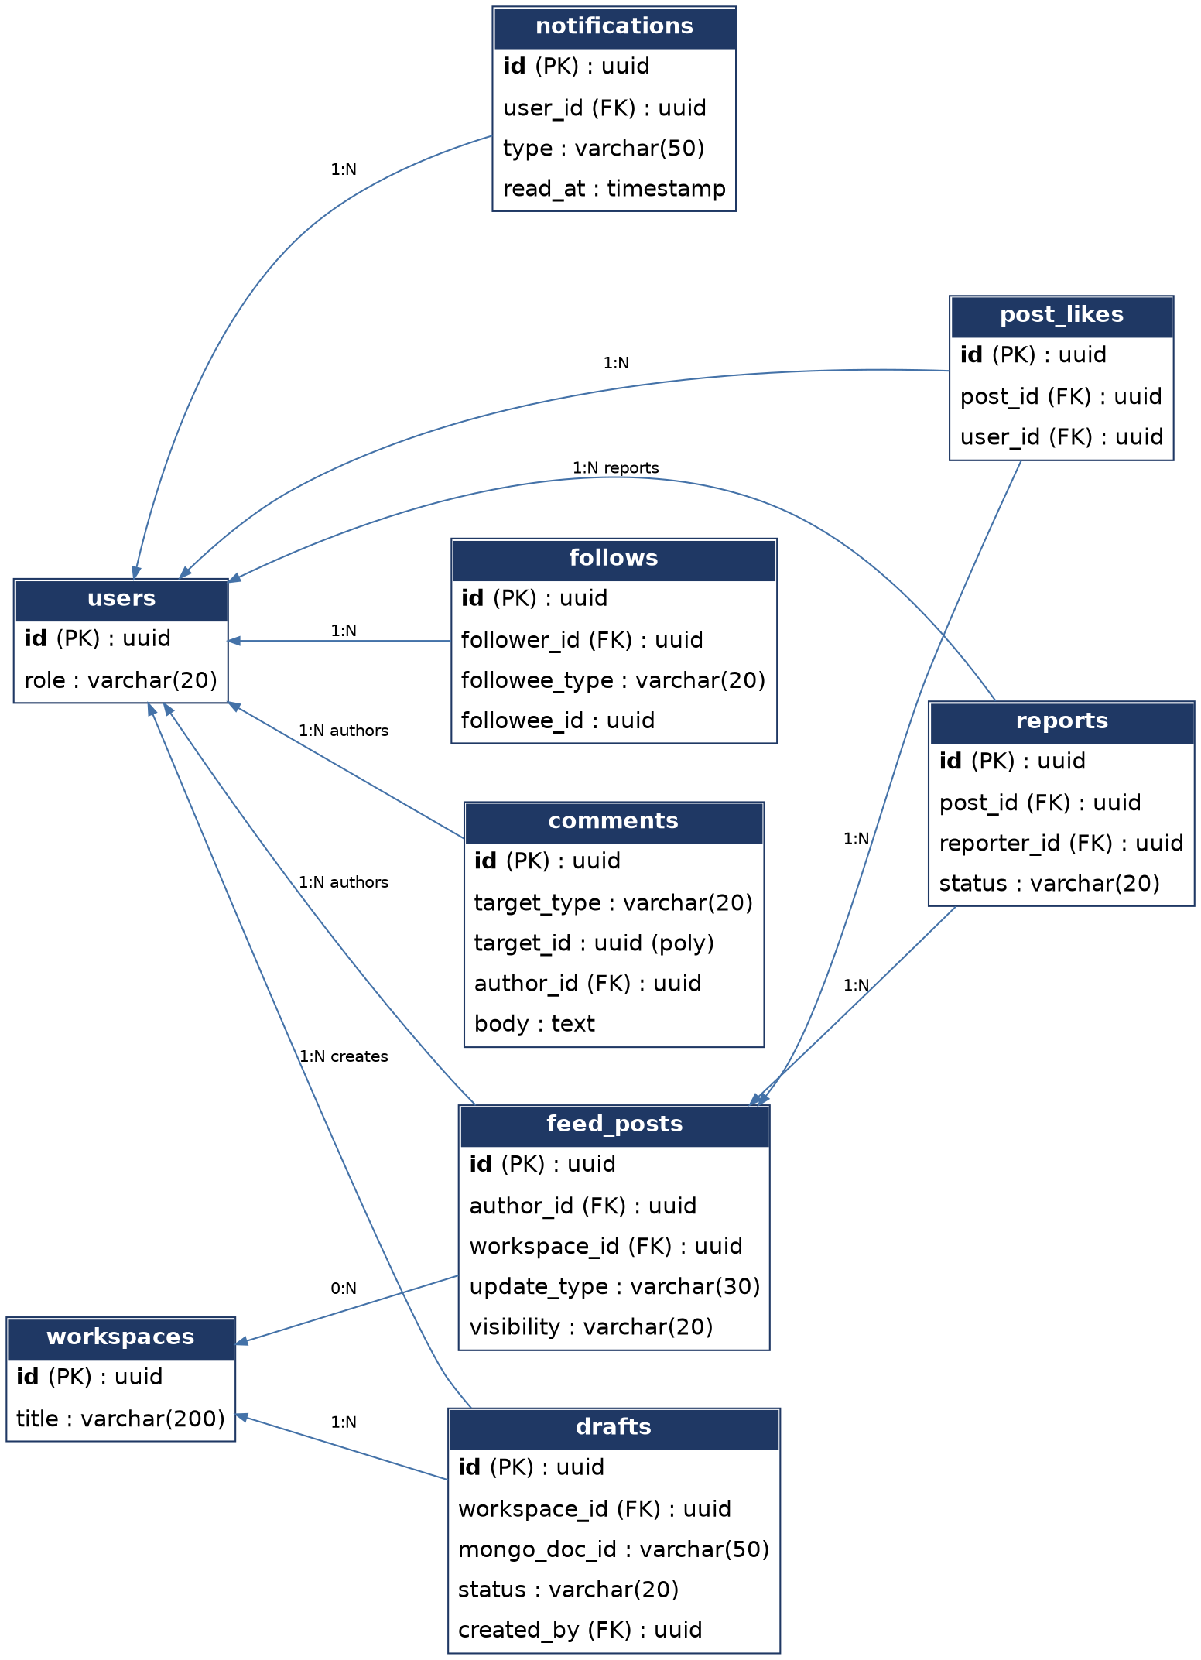
Figure 2 — ER diagram: collaboration and community entities.

3.3 Table Definitions
Each table below lists its purpose, full column definitions, and any table-level constraints beyond individual column constraints.

users
Core identity record for every actor in the system (Student, Researcher, Mentor, Administrator).
Column | Type | Constraints | Description
id | UUID | PK, DEFAULT gen_random_uuid() | Primary identifier.
email | VARCHAR(255) | UNIQUE, NOT NULL | Login identifier; also used for verification and notifications.
password_hash | VARCHAR(255) | NULL | Salted hash; NULL for OAuth-only accounts.
oauth_provider | VARCHAR(50) | NULL | e.g. 'google'; NULL for email/password accounts.
oauth_id | VARCHAR(255) | NULL | Provider-issued subject identifier.
role | VARCHAR(20) | NOT NULL, CHECK IN ('student','researcher','mentor','admin') | Primary role driving dashboard and permissions.
full_name | VARCHAR(150) | NOT NULL | Display name.
institution | VARCHAR(200) | NULL | Affiliated institution.
status | VARCHAR(20) | NOT NULL, DEFAULT 'active', CHECK IN ('active','locked','deactivated') | Account status.
failed_login_attempts | SMALLINT | NOT NULL, DEFAULT 0 | Counter supporting FR-UM-10 (lockout after 5 failures).
email_verified_at | TIMESTAMPTZ | NULL | Set once the verification link is followed.
created_at | TIMESTAMPTZ | NOT NULL, DEFAULT now() | Row creation time.
updated_at | TIMESTAMPTZ | NOT NULL, DEFAULT now() | Last modification time.

mentor_profiles
Extended profile data published only by users with role = 'mentor'; one-to-one with users.
Column | Type | Constraints | Description
user_id | UUID | PK, FK -> users.id ON DELETE CASCADE | Owning mentor.
research_interests | TEXT[] | NULL | Free-text interest tags.
expertise | TEXT[] | NULL | Expertise tags used for matching.
publications_url | VARCHAR(255) | NULL | Link to a publication list (e.g. Google Scholar).
availability | VARCHAR(20) | NOT NULL, DEFAULT 'available', CHECK IN ('available','limited','unavailable') | Current mentorship capacity.
bio | TEXT | NULL | Free-text biography shown on the profile.
updated_at | TIMESTAMPTZ | NOT NULL, DEFAULT now() | Last profile edit.

refresh_tokens
Server-side record of issued refresh tokens, enabling revocation and rotation.
Column | Type | Constraints | Description
id | UUID | PK, DEFAULT gen_random_uuid() | Primary identifier.
user_id | UUID | NOT NULL, FK -> users.id ON DELETE CASCADE | Token owner.
token_hash | VARCHAR(255) | NOT NULL, UNIQUE | Hash of the refresh token (raw token never stored).
expires_at | TIMESTAMPTZ | NOT NULL | Expiration time.
revoked_at | TIMESTAMPTZ | NULL | Set when the token is manually revoked (e.g., logout).
created_at | TIMESTAMPTZ | NOT NULL, DEFAULT now() | Issue time.

workspaces
The project workspace root entity; every paper, note, task, and draft is scoped to a workspace.
Column | Type | Constraints | Description
id | UUID | PK, DEFAULT gen_random_uuid() | Primary identifier.
owner_id | UUID | NOT NULL, FK -> users.id | Workspace creator/owner.
title | VARCHAR(200) | NOT NULL | Project title.
domain | VARCHAR(150) | NULL | Research domain, used for literature search context.
description | TEXT | NULL | Free-text project description.
visibility | VARCHAR(20) | NOT NULL, DEFAULT 'private', CHECK IN ('private','team','public') | Controls discoverability of the workspace.
status | VARCHAR(20) | NOT NULL, DEFAULT 'active', CHECK IN ('active','archived','deleted') | Lifecycle status.
created_at | TIMESTAMPTZ | NOT NULL, DEFAULT now() | Row creation time.
updated_at | TIMESTAMPTZ | NOT NULL, DEFAULT now() | Last modification time.

workspace_members
Join table granting a user membership and a permission level within a workspace.
Column | Type | Constraints | Description
id | UUID | PK, DEFAULT gen_random_uuid() | Primary identifier.
workspace_id | UUID | NOT NULL, FK -> workspaces.id ON DELETE CASCADE | Owning workspace.
user_id | UUID | NOT NULL, FK -> users.id ON DELETE CASCADE | Member.
role_in_project | VARCHAR(50) | NULL | Free-text role, e.g. 'ML Engineer', 'Frontend Developer'.
permission_level | VARCHAR(20) | NOT NULL, DEFAULT 'editor', CHECK IN ('owner','editor','viewer') | Access level within the workspace.
joined_at | TIMESTAMPTZ | NOT NULL, DEFAULT now() | Membership start time.
Table-level constraints: UNIQUE (workspace_id, user_id)

open_roles
Open collaborator postings for a workspace (Team Formation module).
Column | Type | Constraints | Description
id | UUID | PK, DEFAULT gen_random_uuid() | Primary identifier.
workspace_id | UUID | NOT NULL, FK -> workspaces.id ON DELETE CASCADE | Owning workspace.
title | VARCHAR(150) | NOT NULL | Role title, e.g. 'NLP Researcher'.
description | TEXT | NULL | Required skills and responsibilities.
required_skills | TEXT[] | NULL | Tag list used for matching/search.
status | VARCHAR(20) | NOT NULL, DEFAULT 'open', CHECK IN ('open','closed') | Posting status.
created_at | TIMESTAMPTZ | NOT NULL, DEFAULT now() | Row creation time.

join_requests
A user's application to fill an open role.
Column | Type | Constraints | Description
id | UUID | PK, DEFAULT gen_random_uuid() | Primary identifier.
open_role_id | UUID | NOT NULL, FK -> open_roles.id ON DELETE CASCADE | Target role.
applicant_id | UUID | NOT NULL, FK -> users.id | Applying user.
message | TEXT | NULL | Optional message to the workspace owner.
status | VARCHAR(20) | NOT NULL, DEFAULT 'pending', CHECK IN ('pending','approved','rejected') | Application status.
created_at | TIMESTAMPTZ | NOT NULL, DEFAULT now() | Application time.
decided_at | TIMESTAMPTZ | NULL | Time of approval/rejection.
Table-level constraints: UNIQUE (open_role_id, applicant_id)

mentorship_requests
Tracks the mentorship lifecycle between a student/researcher and a mentor.
Column | Type | Constraints | Description
id | UUID | PK, DEFAULT gen_random_uuid() | Primary identifier.
student_id | UUID | NOT NULL, FK -> users.id | Requesting user.
mentor_id | UUID | NOT NULL, FK -> users.id | Target mentor.
workspace_id | UUID | NULL, FK -> workspaces.id | Workspace shared with the mentor, if any.
message | TEXT | NULL | Optional request message.
status | VARCHAR(20) | NOT NULL, DEFAULT 'pending', CHECK IN ('pending','accepted','declined','ended') | Mentorship lifecycle state.
requested_at | TIMESTAMPTZ | NOT NULL, DEFAULT now() | Request time.
decided_at | TIMESTAMPTZ | NULL | Accept/decline/end time.

papers
Metadata for a paper added to a workspace, either discovered externally or uploaded manually.
Column | Type | Constraints | Description
id | UUID | PK, DEFAULT gen_random_uuid() | Primary identifier.
workspace_id | UUID | NOT NULL, FK -> workspaces.id ON DELETE CASCADE | Owning workspace.
title | VARCHAR(500) | NOT NULL | Paper title.
authors | TEXT[] | NULL | Author name list.
doi | VARCHAR(120) | NULL | Digital Object Identifier, where available.
source | VARCHAR(50) | NOT NULL, CHECK IN ('openalex','arxiv','semantic_scholar','pubmed','crossref','upload') | Origin of the paper record.
publication_year | SMALLINT | NULL | Year of publication.
storage_path | VARCHAR(500) | NULL | MinIO/S3 object key for the stored PDF, if any.
abstract | TEXT | NULL | Abstract text.
analysis_status | VARCHAR(20) | NOT NULL, DEFAULT 'pending', CHECK IN ('pending','processing','completed','failed','partial') | State of the AI analysis pipeline (FR-PA-01/02).
added_by | UUID | NOT NULL, FK -> users.id | User who added the paper.
created_at | TIMESTAMPTZ | NOT NULL, DEFAULT now() | Row creation time.
Table-level constraints: UNIQUE (workspace_id, doi) WHERE doi IS NOT NULL

tasks
Assignable units of work tracked within a workspace (Collaboration module).
Column | Type | Constraints | Description
id | UUID | PK, DEFAULT gen_random_uuid() | Primary identifier.
workspace_id | UUID | NOT NULL, FK -> workspaces.id ON DELETE CASCADE | Owning workspace.
title | VARCHAR(200) | NOT NULL | Task title.
description | TEXT | NULL | Task detail.
assignee_id | UUID | NULL, FK -> users.id | Assigned team member.
created_by | UUID | NOT NULL, FK -> users.id | Task creator.
status | VARCHAR(20) | NOT NULL, DEFAULT 'todo', CHECK IN ('todo','in_progress','done') | Progress state.
due_date | DATE | NULL | Optional due date.
created_at | TIMESTAMPTZ | NOT NULL, DEFAULT now() | Row creation time.
updated_at | TIMESTAMPTZ | NOT NULL, DEFAULT now() | Last modification time.

comments
Polymorphic threaded comments attachable to a paper, note, draft, task, or feed post.
Column | Type | Constraints | Description
id | UUID | PK, DEFAULT gen_random_uuid() | Primary identifier.
target_type | VARCHAR(20) | NOT NULL, CHECK IN ('paper','note','draft','task','feed_post') | Type of the commented-on entity.
target_id | UUID | NOT NULL | Identifier of the commented-on entity (application-enforced reference).
author_id | UUID | NOT NULL, FK -> users.id | Comment author.
body | TEXT | NOT NULL | Comment text.
created_at | TIMESTAMPTZ | NOT NULL, DEFAULT now() | Row creation time.

notifications
Per-user notification inbox for mentions, task assignment, mentorship events, and system messages.
Column | Type | Constraints | Description
id | UUID | PK, DEFAULT gen_random_uuid() | Primary identifier.
user_id | UUID | NOT NULL, FK -> users.id ON DELETE CASCADE | Notification recipient.
type | VARCHAR(50) | NOT NULL | e.g. 'mentorship_request', 'task_assigned', 'comment_mention'.
payload | JSONB | NOT NULL | Structured event data for rendering.
read_at | TIMESTAMPTZ | NULL | Set when the user views the notification.
created_at | TIMESTAMPTZ | NOT NULL, DEFAULT now() | Row creation time.

feed_posts
Community research feed updates (Research Feed module).
Column | Type | Constraints | Description
id | UUID | PK, DEFAULT gen_random_uuid() | Primary identifier.
author_id | UUID | NOT NULL, FK -> users.id | Post author.
workspace_id | UUID | NULL, FK -> workspaces.id | Linked workspace, if any.
update_type | VARCHAR(30) | NOT NULL, CHECK IN ('experiment','dataset_release','publication','milestone','conference') | Category of update.
content | TEXT | NOT NULL | Post body.
visibility | VARCHAR(20) | NOT NULL, DEFAULT 'public', CHECK IN ('public','followers','team') | Visibility scope.
created_at | TIMESTAMPTZ | NOT NULL, DEFAULT now() | Row creation time.
updated_at | TIMESTAMPTZ | NOT NULL, DEFAULT now() | Last edit time.

post_likes
Records a user liking a feed post; enforces one like per user per post.
Column | Type | Constraints | Description
id | UUID | PK, DEFAULT gen_random_uuid() | Primary identifier.
post_id | UUID | NOT NULL, FK -> feed_posts.id ON DELETE CASCADE | Liked post.
user_id | UUID | NOT NULL, FK -> users.id ON DELETE CASCADE | User who liked the post.
created_at | TIMESTAMPTZ | NOT NULL, DEFAULT now() | Row creation time.
Table-level constraints: UNIQUE (post_id, user_id)

follows
A user following another user or a public workspace, driving personalized feed assembly.
Column | Type | Constraints | Description
id | UUID | PK, DEFAULT gen_random_uuid() | Primary identifier.
follower_id | UUID | NOT NULL, FK -> users.id ON DELETE CASCADE | The following user.
followee_type | VARCHAR(20) | NOT NULL, CHECK IN ('user','workspace') | Type of the followed entity.
followee_id | UUID | NOT NULL | Identifier of the followed entity.
created_at | TIMESTAMPTZ | NOT NULL, DEFAULT now() | Row creation time.
Table-level constraints: UNIQUE (follower_id, followee_type, followee_id)

reports
User-submitted moderation reports against a feed post (Administrator review queue).
Column | Type | Constraints | Description
id | UUID | PK, DEFAULT gen_random_uuid() | Primary identifier.
post_id | UUID | NOT NULL, FK -> feed_posts.id ON DELETE CASCADE | Reported post.
reporter_id | UUID | NOT NULL, FK -> users.id | Reporting user.
reason | TEXT | NOT NULL | Reason for the report.
status | VARCHAR(20) | NOT NULL, DEFAULT 'open', CHECK IN ('open','reviewed','dismissed') | Moderation status.
created_at | TIMESTAMPTZ | NOT NULL, DEFAULT now() | Row creation time.

activity_log
Immutable, append-only audit trail of every mutating action within a workspace.
Column | Type | Constraints | Description
id | UUID | PK, DEFAULT gen_random_uuid() | Primary identifier.
workspace_id | UUID | NOT NULL, FK -> workspaces.id ON DELETE CASCADE | Owning workspace.
actor_id | UUID | NOT NULL, FK -> users.id | User who performed the action.
event_type | VARCHAR(50) | NOT NULL | e.g. 'paper_added', 'task_completed', 'member_joined'.
event_data | JSONB | NULL | Structured detail of the event.
created_at | TIMESTAMPTZ | NOT NULL, DEFAULT now() | Event time.

drafts
Relational pointer/metadata for a publication draft; the draft's rich content lives in MongoDB.
Column | Type | Constraints | Description
id | UUID | PK, DEFAULT gen_random_uuid() | Primary identifier.
workspace_id | UUID | NOT NULL, FK -> workspaces.id ON DELETE CASCADE | Owning workspace.
mongo_doc_id | VARCHAR(50) | NOT NULL, UNIQUE | Reference to the corresponding document in MongoDB's drafts collection.
title | VARCHAR(300) | NOT NULL | Draft title.
status | VARCHAR(20) | NOT NULL, DEFAULT 'draft', CHECK IN ('draft','under_review','exported') | Draft lifecycle status.
created_by | UUID | NOT NULL, FK -> users.id | Draft creator.
created_at | TIMESTAMPTZ | NOT NULL, DEFAULT now() | Row creation time.
updated_at | TIMESTAMPTZ | NOT NULL, DEFAULT now() | Last modification time.

3.4 Indexing Strategy
Indexes are chosen to support the access patterns described in the SDD's component design (Section 4) — primarily listing content scoped to a workspace or a user, and status-based filtering for background job retries and moderation queues.
Index Name | Columns | Purpose
idx_users_email | users(email) | Unique login lookup (also enforced by the UNIQUE constraint).
idx_workspaces_owner | workspaces(owner_id) | List a user's owned workspaces.
idx_workspace_members_workspace | workspace_members(workspace_id) | List members of a workspace.
idx_workspace_members_user | workspace_members(user_id) | List a user's workspace memberships.
idx_papers_workspace | papers(workspace_id) | List papers in a workspace.
idx_papers_analysis_status | papers(analysis_status) | Find papers pending/failed analysis for retry sweeps.
idx_tasks_workspace_assignee | tasks(workspace_id, assignee_id) | Filter a workspace's tasks by assignee.
idx_comments_target | comments(target_type, target_id) | Fetch all comments for a given entity.
idx_feed_posts_author_created | feed_posts(author_id, created_at DESC) | Render a user's own posts in reverse chronological order.
idx_feed_posts_created | feed_posts(created_at DESC) | Render the public feed in reverse chronological order.
idx_activity_log_workspace_created | activity_log(workspace_id, created_at DESC) | Render a workspace's activity timeline.
idx_notifications_user_read | notifications(user_id, read_at) | Fetch a user's unread notifications efficiently.
idx_mentorship_mentor_status | mentorship_requests(mentor_id, status) | List a mentor's pending/active requests.
idx_join_requests_role_status | join_requests(open_role_id, status) | List pending applications for a role.
idx_follows_follower | follows(follower_id) | Assemble a user's personalized feed.

3.5 Referential Integrity and Deletion Rules
- ON DELETE CASCADE is used for rows that have no meaning without their parent: workspace_members, open_roles, join_requests, activity_log, post_likes, and refresh_tokens all cascade from their owning workspace, role, post, or user.
- workspaces and papers use a status column (active/archived/deleted, pending/.../failed) rather than hard deletion, preserving history for the activity log and for AI analysis auditability.
- Cross-module references that are optional (e.g., feed_posts.workspace_id, mentorship_requests.workspace_id) are nullable foreign keys rather than mandatory joins, since a feed post or mentorship request can exist independently of a specific workspace.
- The polymorphic comments.target_id and follows.followee_id columns are validated at the application layer (FastAPI) rather than by a database foreign key, since PostgreSQL cannot express a foreign key that targets one of several tables; this trade-off is documented so a future migration to per-target comment tables can be evaluated if integrity issues arise.

4. MongoDB — Document Schema Design
MongoDB holds content whose structure varies by category or evolves over the life of a project: notes, AI-generated analysis, research-gap suggestions, publication drafts, and agent conversation logs. Every document carries the owning PostgreSQL identifier (workspace_id, paper_id, or user_id) so relational and document data remain cross-referenceable.

notes
Research notes, ideas, observations, meeting notes, and literature notes (Notes & Documentation module).
{
_id: ObjectId,
workspace_id: "uuid-string", // references PostgreSQL workspaces.id
category: "literature_note", // research_note | idea | observation | meeting_note | literature_note
linked_to: { type: "paper", id: "uuid-string" }, // optional
author_id: "uuid-string",
body: "markdown text",
versions: [
{ edited_at: ISODate, body: "previous text" }
],
created_at: ISODate,
updated_at: ISODate
}
Indexes:
- { workspace_id: 1, category: 1 }
- { workspace_id: 1, body: "text" } // full-text search fallback

paper_analysis
Structured AI extraction output per paper (AI Literature Analysis module).
{
_id: ObjectId,
paper_id: "uuid-string", // references PostgreSQL papers.id
objective: "string",
dataset: ["string"],
methodology: "string",
algorithms: ["string"],
results: "string",
metrics: ["string"],
limitations: "string",
future_work: "string",
confidence: { objective: 0.92, dataset: 0.88, methodology: 0.95, ... },
source_citations: [ { field: "methodology", section: "3.2", page: 4 } ],
analyzed_at: ISODate
}
Indexes:
- { paper_id: 1 } UNIQUE

research_gap_suggestions
Advisory research-direction suggestions generated collectively from a workspace's analyzed papers.
{
_id: ObjectId,
workspace_id: "uuid-string",
suggestion: "string",
rationale: "string",
supporting_paper_ids: ["uuid-string", "uuid-string"],
status: "new", // new | accepted | dismissed | saved
generated_at: ISODate
}
Indexes:
- { workspace_id: 1, status: 1 }

drafts
Full publication draft content: sections, figures, tables, references, and revision history.
{
_id: ObjectId, // referenced as mongo_doc_id from PostgreSQL drafts.id
workspace_id: "uuid-string",
sections: [ { heading: "Introduction", body: "..." } ],
figures: [ { caption: "...", storage_path: "s3://..." } ],
tables: [ { caption: "...", data: [["..."]] } ],
references: [ { paper_id: "uuid-string", citation_text: "..." } ],
revisions: [ { edited_at: ISODate, editor_id: "uuid-string" } ],
created_at: ISODate,
updated_at: ISODate
}
Indexes:
- { workspace_id: 1 }

ai_conversations
Logged agent interactions (inputs, retrieved context, outputs) supporting auditability of AI output.
{
_id: ObjectId,
user_id: "uuid-string",
agent: "writing_assistant", // literature_search | paper_analysis | knowledge | research_gap | recommendation | writing_assistant
workspace_id: "uuid-string",
messages: [ { role: "user", content: "..." }, { role: "agent", content: "...", sources: [] } ],
created_at: ISODate
}
Indexes:
- { user_id: 1, created_at: -1 }
- { workspace_id: 1, agent: 1 }

4.5 Schema Governance
Although MongoDB does not enforce a schema at the database level, ResearchOS applies JSON Schema validation at the application layer (Pydantic models in FastAPI) for each collection shown above, so that the flexibility of the document store does not become a source of silent data-quality issues.

5. Qdrant — Vector Store Design
A single collection, paper_embeddings, stores one vector per paper abstract plus one vector per retrievable passage chunk for full-text papers, enabling both coarse (paper-level) and fine-grained (passage-level) retrieval for the RAG pipeline described in the SDD, Section 6.3.
Collection: paper_embeddings

{
"vectors": {
"size": 384, // Sentence-Transformers all-MiniLM-L6-v2 output dimension
"distance": "Cosine"
},
"payload_schema": {
"paper_id": "keyword", // references PostgreSQL papers.id
"workspace_id": "keyword", // references PostgreSQL workspaces.id
"title": "text",
"chunk_index": "integer", // 0 for a whole-abstract embedding, >=0 for passage chunks
"source": "keyword"
}
}

Semantic literature search (FR-LD-01..08) queries this collection by cosine similarity against the embedded query, filtered by workspace_id where the search is scoped to a specific project.

6. Neo4j — Knowledge Graph Design
The knowledge graph connects papers to their authors, datasets, methods, citations, and topics, supporting the Knowledge Organization module's exploration view (FR-KO-01..06).

6.1 Node Labels
Node Label | Key Properties | Notes
Paper | id (references PostgreSQL papers.id), title, year | Mirrors a subset of PostgreSQL/MongoDB data needed for graph traversal.
Author | name, normalized_name | Deduplicated by normalized_name across papers.
Dataset | name | Extracted from paper_analysis.dataset.
Method | name | Extracted from paper_analysis.algorithms/methodology.
Topic | name | Derived from workspace domain and paper keywords.

6.2 Relationship Types
Relationship | From -> To | Notes
AUTHORED_BY | Paper -> Author | One paper may have multiple authors.
USES_DATASET | Paper -> Dataset | One paper may use multiple datasets.
APPLIES_METHOD | Paper -> Method | One paper may apply multiple methods.
CITES | Paper -> Paper | Directed citation relationship, where resolvable.
RELATED_TO_TOPIC | Paper -> Topic | Supports topic-centric exploration (FR-KO-01..06).

6.3 Example Query
// Find everything connected to a given method
MATCH (m:Method {name: $methodName})<-[:APPLIES_METHOD]-(p:Paper)
OPTIONAL MATCH (p)-[:AUTHORED_BY]->(a:Author)
OPTIONAL MATCH (p)-[:USES_DATASET]->(d:Dataset)
OPTIONAL MATCH (p)-[:CITES]->(cited:Paper)
RETURN p, a, d, cited

7. Redis — Key-Space Design
Redis serves three distinct roles in ResearchOS: an application cache, the Celery broker/result backend, and the Socket.IO pub/sub backplane. Key patterns are namespaced by purpose to keep operational monitoring straightforward.
Key Pattern | Type | TTL | Purpose
session:{user_id} | Hash | Access token lifetime | Active session metadata (role, last activity).
search:{query_hash} | String (JSON) | 15 min | Cached literature search results, per FR-LD-01..08.
ratelimit:login:{ip} | String (counter) | 15 min | Login attempt throttling.
feed:{user_id} | List | 5 min | Precomputed personalized feed page.
graph:{workspace_id} | String (JSON) | 10 min | Cached rendered subgraph for the Knowledge Organization view.
celery (broker/queues) | n/a | n/a | Task queues for analyze_paper, update_knowledge_graph, generate_research_gaps, export_draft, reindex_search.
socketio# (pub/sub channels) | n/a | n/a | Multi-instance fan-out for real-time chat, comments, notifications, presence.

8. Cross-Store Data Ownership and Consistency

8.1 Ownership Rules
- PostgreSQL owns every identifier that other stores reference (workspace_id, paper_id, user_id); no other store generates identifiers for these entities.
- MongoDB documents always carry the owning PostgreSQL identifier and are considered dependent data: deleting a workspace triggers deletion of its dependent MongoDB documents via an application-level cleanup job, not a database-level cascade.
- Qdrant points and Neo4j nodes are derived data, rebuildable from PostgreSQL and MongoDB content; they are treated as a cache/index rather than a system of record.

8.2 Consistency Approach
ResearchOS accepts eventual consistency between PostgreSQL/MongoDB (written synchronously on the request path) and Qdrant/Neo4j (updated asynchronously by Celery tasks after analysis completes). This matches the SDD's design, where analyze_paper and update_knowledge_graph run as background jobs so user-facing requests are not blocked on graph or vector updates. A paper's analysis_status column in PostgreSQL reflects the true state of this pipeline at any point in time.

8.3 Rebuild Strategy
Because Qdrant and Neo4j hold derived data, both can be rebuilt from PostgreSQL and MongoDB by replaying the analyze_paper and update_knowledge_graph tasks across all papers, providing a recovery path if either store is lost or needs schema migration.

9. Backup, Retention, and Migration Strategy

9.1 Backup
- PostgreSQL: continuous WAL archiving plus daily full snapshots; this is the highest-priority store to protect, as it is the system of record for identity and access control.
- MongoDB: daily snapshots; acceptable recovery point objective is higher than PostgreSQL's since most content (notes, drafts) is also reflected in user-facing activity that can be partially reconstructed from the activity_log.
- Qdrant and Neo4j: periodic snapshots are a convenience, not a requirement, since both can be rebuilt from PostgreSQL/MongoDB per Section 8.3.
- MinIO/AWS S3: versioned buckets for uploaded PDFs, exported drafts, and datasets.

9.2 Retention
Deactivated user accounts and archived workspaces are retained in a soft-deleted state for a defined grace period (e.g., 90 days) before a scheduled hard-deletion job removes dependent rows and associated object storage, honoring applicable data-protection requirements referenced in the SRS, Section 6.1.

9.3 Schema Migration
PostgreSQL schema changes are managed through versioned migrations (e.g., Alembic) applied in a backward-compatible sequence (add nullable column -> backfill -> enforce constraint) to support zero-downtime deployment of the FastAPI backend described in the SDD.

Appendix A — Consolidated PostgreSQL Data Dictionary
Summary of every PostgreSQL table defined in this document, for quick reference alongside the full definitions in Section 3.3.
Table | # Columns | Purpose
users | 13 | Core identity record for every actor in the system (Student, Researcher, Mentor, Administrator).
mentor_profiles | 7 | Extended profile data published only by users with role = 'mentor'; one-to-one with users.
refresh_tokens | 6 | Server-side record of issued refresh tokens, enabling revocation and rotation.
workspaces | 9 | The project workspace root entity; every paper, note, task, and draft is scoped to a workspace.
workspace_members | 6 | Join table granting a user membership and a permission level within a workspace.
open_roles | 7 | Open collaborator postings for a workspace (Team Formation module).
join_requests | 7 | A user's application to fill an open role.
mentorship_requests | 8 | Tracks the mentorship lifecycle between a student/researcher and a mentor.
papers | 12 | Metadata for a paper added to a workspace, either discovered externally or uploaded manually.
tasks | 10 | Assignable units of work tracked within a workspace (Collaboration module).
comments | 6 | Polymorphic threaded comments attachable to a paper, note, draft, task, or feed post.
notifications | 6 | Per-user notification inbox for mentions, task assignment, mentorship events, and system messages.
feed_posts | 8 | Community research feed updates (Research Feed module).
post_likes | 4 | Records a user liking a feed post; enforces one like per user per post.
follows | 5 | A user following another user or a public workspace, driving personalized feed assembly.
reports | 6 | User-submitted moderation reports against a feed post (Administrator review queue).
activity_log | 6 | Immutable, append-only audit trail of every mutating action within a workspace.
drafts | 8 | Relational pointer/metadata for a publication draft; the draft's rich content lives in MongoDB.

Appendix B — Glossary
Term | Definition
System of Record | The authoritative store for a piece of data; other copies are derived and may lag behind it.
Derived Data | Data computed or copied from a system of record, rebuildable if lost (e.g., Qdrant vectors, Neo4j nodes).
Polyglot Persistence | An architecture that uses multiple database technologies, each chosen for a specific data access pattern.
TTL | Time To Live — the duration a cached key remains valid before automatic expiry.
WAL | Write-Ahead Log — PostgreSQL's mechanism for durability and point-in-time recovery.
Eventual Consistency | A consistency model where dependent stores converge to the same state after a short delay, rather than instantly.

