**Session2Assignment1.1**

Task: 1: Hadoop fs -mkdir /user/acadgild

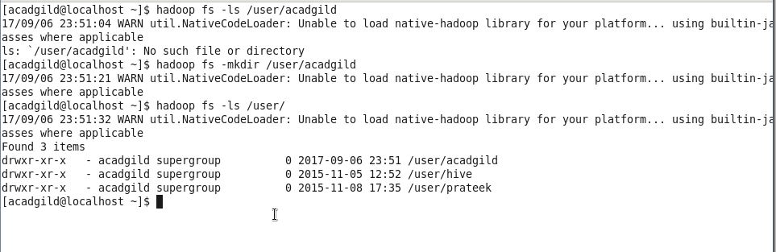

Task: 2:

Hadoop fs -touchz /user/acadgild/word-count.txt

echo “the word count algorithm, like most that you might implement with Hadoop, is a little involved” | Hadoop fs -appendToFile - /user/acadgild/word-count.txt

Hadoop fs -cat /user/acadgild/word-count.txt

