**Session2Assignment1.2**

Task:1: Hadoop fs -put /home/acadgild/max-temp.txt /user/acadgild/Hadoop/

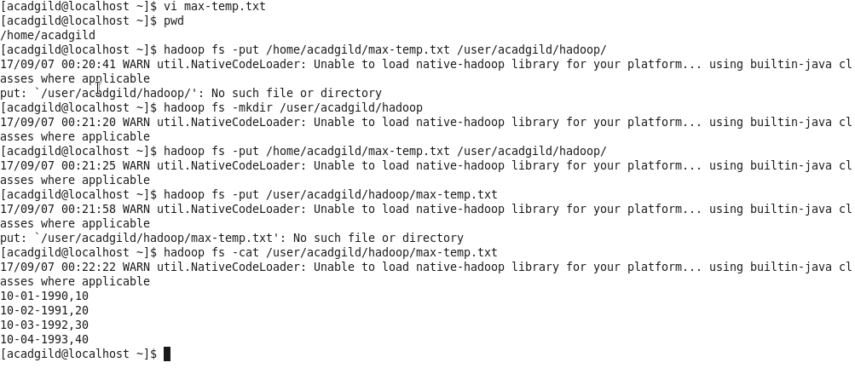

Task: 2: Hadoop fs -chmod 770 /user/acadgild/hadoop/max-temp.txt

