**Assignment #4: T-primes + 贪心**

2024 fall, Complied by 吕金浩，物理学院

1. **题目**

**在网站上提交的可能会有被注释掉的代码，这里已经删去。**

**34B. Sale**

greedy, sorting, 900, <https://codeforces.com/problemset/problem/34/B>

代码

n,m=input().split()  
n=int(n)  
m=int(m)  
ai=list(input().split())  
earn=[]  
earnmoney=0  
  
for i in range(n):  
 if int(ai[i])<0:  
 earn.append(int(ai[i]))  
earn.sort()  
if m>=len(earn):  
 for j in range(len(earn)):  
 earnmoney+=earn[j]  
else:  
 for j in range(m):  
 earnmoney+=earn[j]  
print(-earnmoney)

代码运行截图 （至少包含有"Accepted"）

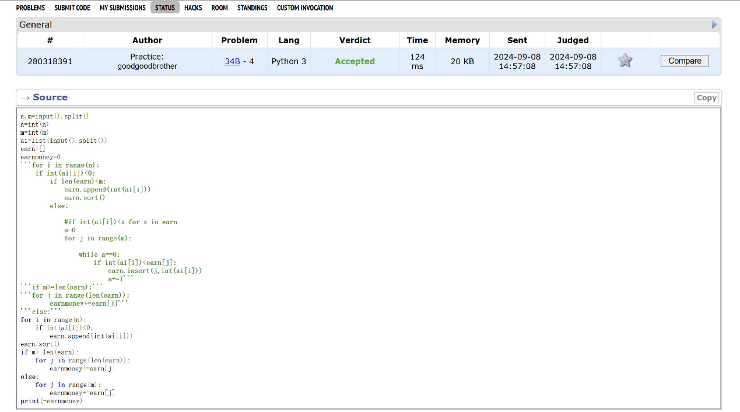

**160A. Twins**

greedy, sortings, 900, <https://codeforces.com/problemset/problem/160/A>

代码

n=int(input())  
value=list(input().split())  
for i in range(n):  
 value[i]=int(value[i])  
value.sort()  
value.reverse()  
valuesum=0  
currentsum=0  
for i in range(n):  
 valuesum+=value[i]  
j=0  
while currentsum<=valuesum/2:  
 currentsum+=value[j]  
 j+=1  
print(j)

代码运行截图 ==（至少包含有"Accepted"）==

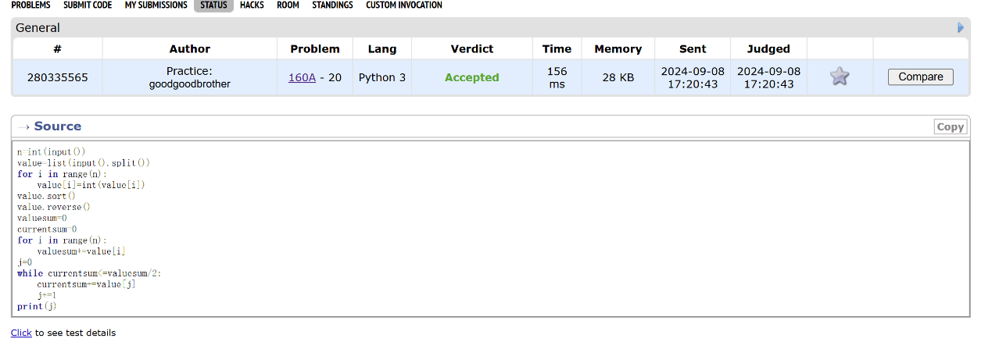

**1879B. Chips on the Board**

constructive algorithms, greedy, 900, <https://codeforces.com/problemset/problem/1879/B>

代码

t=int(input())  
for i in range(t):  
 n=int(input())  
 a=list([int(x) for x in input().split()])  
 b = list([int(x) for x in input().split()])  
 a2=a  
 b2=b  
 a2.sort()  
 b2.sort()  
 suma=0  
 sumb=0  
 for j in range(n):  
 suma=suma+a2[0]+b2[j]  
 sumb=sumb+b2[0]+a2[j]  
 if suma>sumb:  
 print(sumb)  
 else:  
 print(suma)

代码运行截图 （至少包含有"Accepted"）

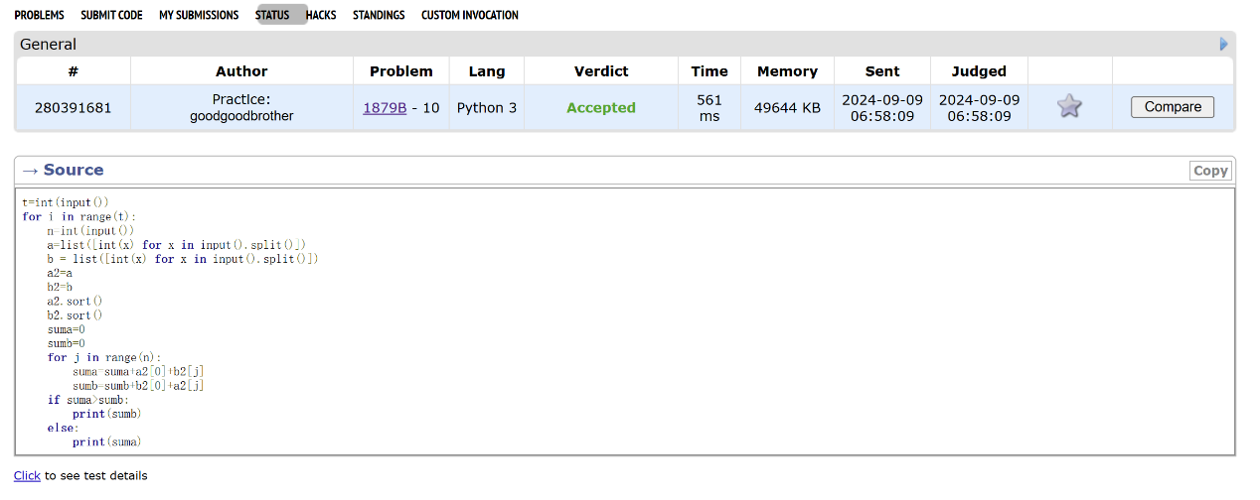

**158B. Taxi**

*special problem, greedy, implementation, 1100, <https://codeforces.com/problemset/problem/158/B>

代码

from math import *  
input()  
groups=[int(x) for x in input().split()]  
ones=groups.count(1)  
twos=groups.count(2)  
threes=groups.count(3)  
taxi=groups.count(4)+threes  
ones=max(0,ones-threes)  
taxi_for_twos=ceil(twos/2)  
taxi+=taxi_for_twos  
rest_for_ones=4*taxi_for_twos-twos*2  
if ones>rest_for_ones:  
 ones-=rest_for_ones  
 taxi += ceil(ones / 4)  
  
print(taxi)

代码运行截图 （至少包含有"Accepted"）

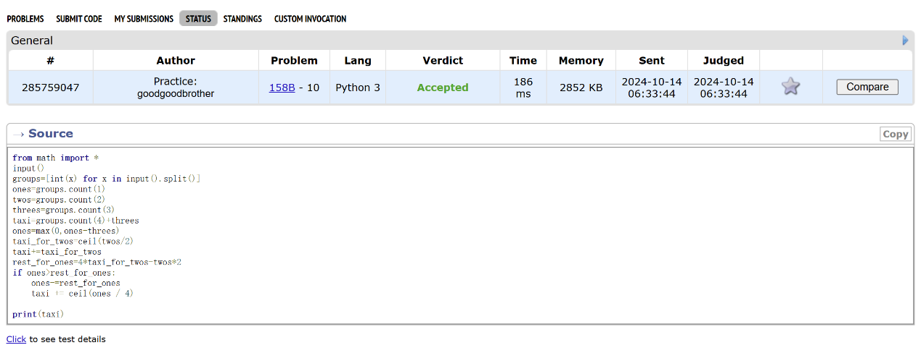

**\*230B. T-primes（选做）**

binary search, implementation, math, number theory, 1300, <http://codeforces.com/problemset/problem/230/B>

代码

s=1000000  
ifprime=[1]*(s+1)  
for i in range(2,s):  
 if ifprime[i]:  
 for j in range(2*i,s+1,i):  
 ifprime[j]=0  
#print(ifprime)  
  
n=int(input())  
xs=[int(j) for j in input().split()]  
for x in xs:  
 sqrtx = x ** 0.5  
 if sqrtx != int(sqrtx) or x==1:  
 print('NO')  
 else:  
 sqrtx=int(sqrtx)  
 print(['NO','YES'][ifprime[sqrtx]])

代码运行截图 （至少包含有"Accepted"）

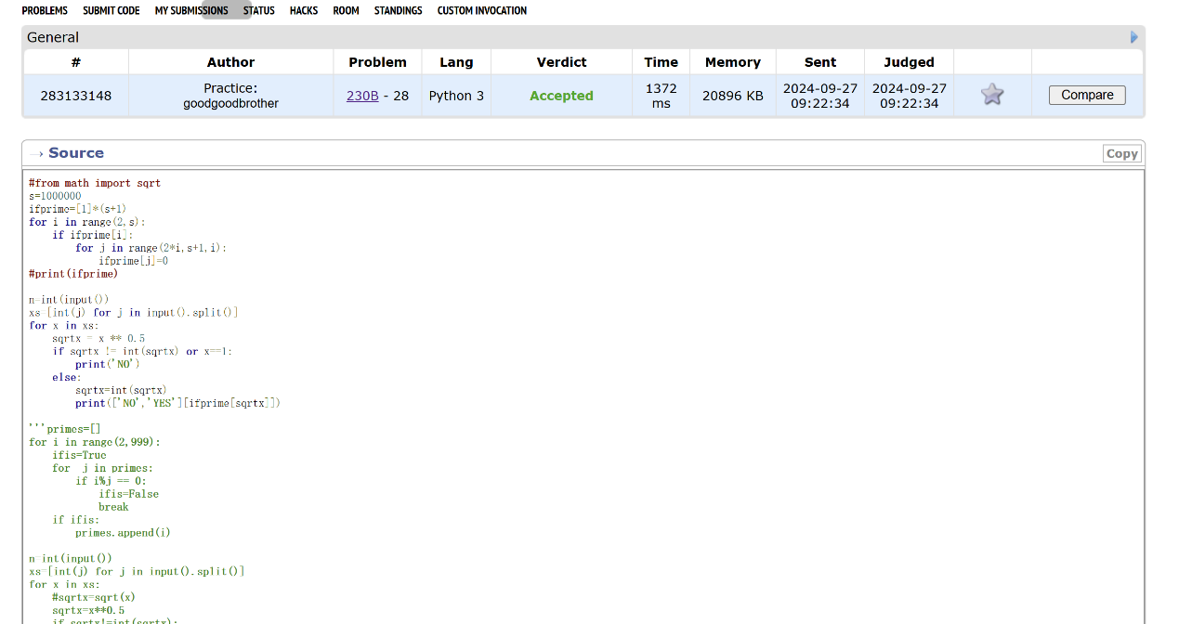

**\*12559: 最大最小整数 （选做）**

greedy, strings, sortings, <http://cs101.openjudge.cn/practice/12559>

代码

n=int(input())  
num=[x for x in input().split()]  
num.sort(reverse=True)  
  
while '原神启动！':  
 if_break=True  
 for i in range(n-1):  
 a=num[i]  
 b=num[i+1]  
 if a==b:  
 continue  
  
 if int(a+b)<int(b+a):  
 num[i],num[i+1]=b,a  
 if_break=False  
  
 if if_break:  
 break  
for x in num:  
 print(x,end='')  
print(' ',end='')  
num.sort()  
  
while '原神启动！':  
 if_break = True  
 for i in range(n - 1):  
 a = num[i]  
 b = num[i + 1]  
 if a == b:  
 continue  
 # min_len=min(len(a),len(b))  
 if int(a + b) > int(b + a):  
 num[i], num[i + 1] = b, a  
 if_break = False  
  
 if if_break:  
 break  
for x in num:  
 print(x,end='')  
print(' ',end='')

代码运行截图 （至少包含有"Accepted"）

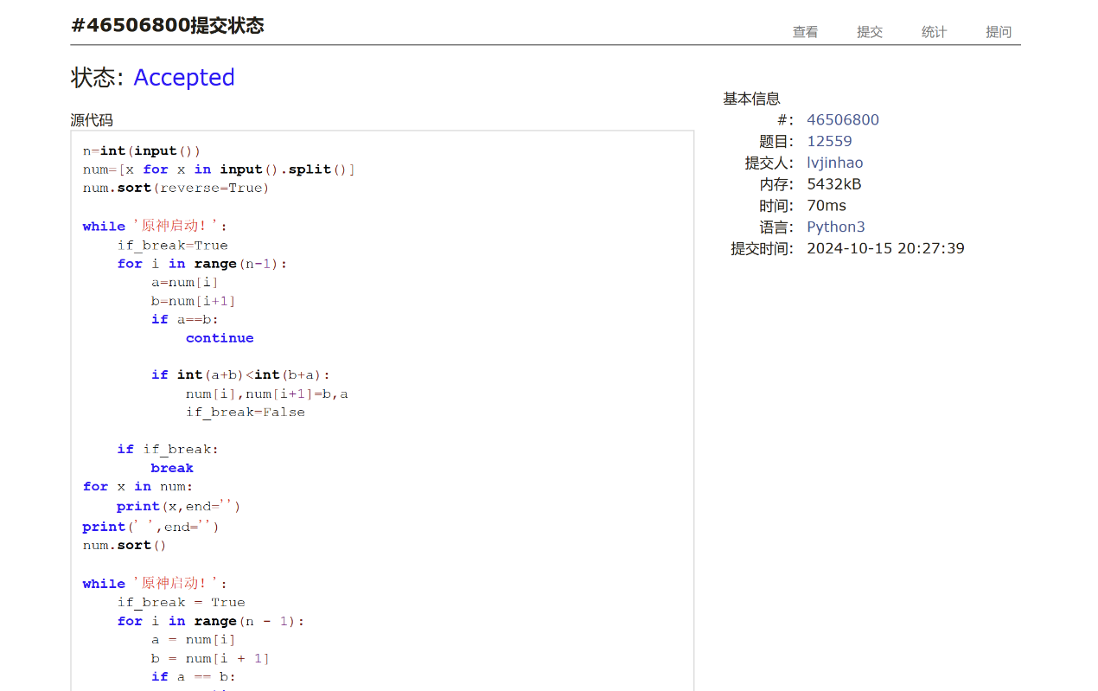

**2. 学习总结和收获**

发现自己有时会把简单的题目想得很复杂，或者说找到简单方法很慢。就比如罗马数字转整数那个，考场上为了把罗马数字转整数写了二三十分钟的if/else，然后才突然想到可以利用一一对应的关系秒了。碰到像排队这样的题有时不知道从何下手。对自己的评价是菜就多练。