**Assignment #1: 自主学习**

Updated 0110 GMT+8 Sep 10, 2024

2024 fall, Complied by 吕金浩，物理学院

**1. 题目**

**02733: 判断闰年**

<http://cs101.openjudge.cn/practice/02733/>

**大致用时：5min**

**代码**

year=int(input())  
  
if year%3200 ==0:  
 print('N')  
elif year%400 ==0:  
 print('Y')  
elif year%100 ==0:  
 print('N')  
elif year%4 ==0:  
 print('Y')  
else:  
 print('N')

​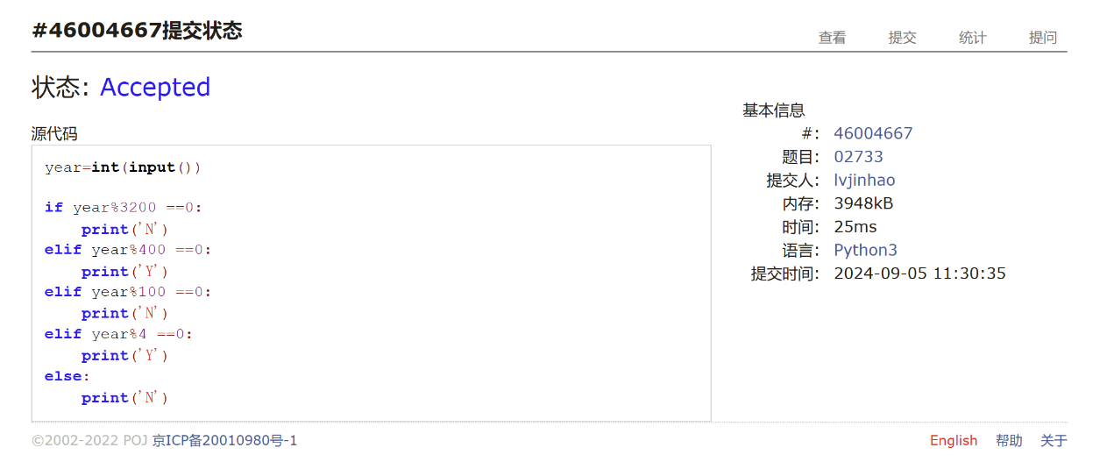

**02750: 鸡兔同笼**

<http://cs101.openjudge.cn/practice/02750/>

**大致用时：8min**

**代码**

num=int(input())  
if num%2 !=0:  
 print(0,0)  
elif num%4 ==0:  
 print(int(num/4),int(num/2))  
else:  
 print(int((num+2)/4),int(num/2))

​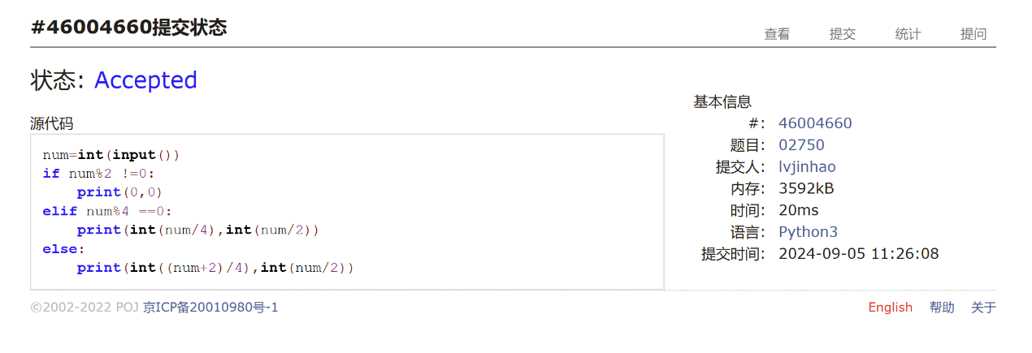

**50A. Domino piling**

greedy, math, 800, <http://codeforces.com/problemset/problem/50/A>

**大致用时：8min**

**代码**

M,N=(input().split())  
M=int(M)  
N=int(N)  
print(int(M*N/2))

​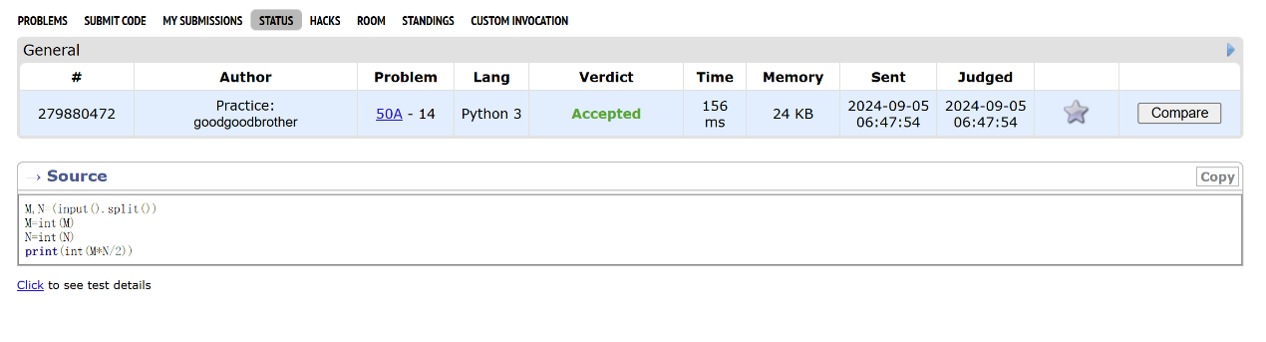

**1A. Theatre Square**

math, 1000, <https://codeforces.com/problemset/problem/1/A>

**大致用时：7min**

**代码**

import math  
  
  
n,m,a=(input().split())  
na=math.ceil(int(n)/int(a))  
ma=math.ceil(int(m)/int(a))  
  
print(int(na)*int(ma))

​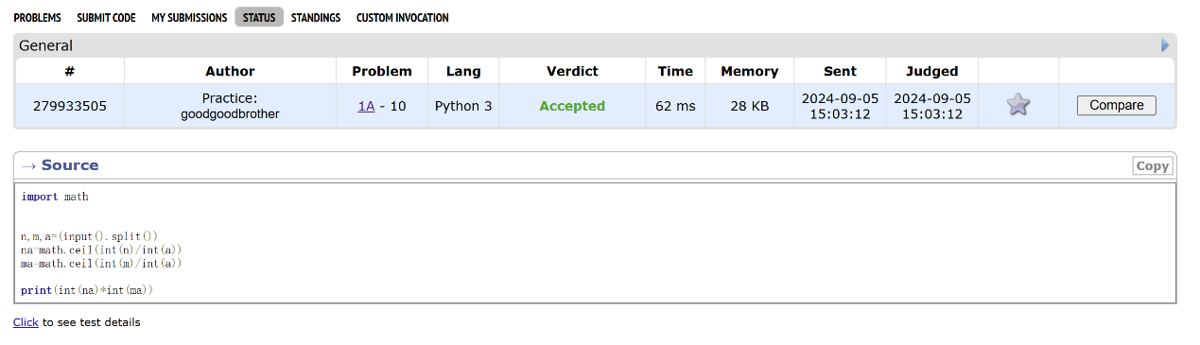

**112A. Petya and Strings**

implementation, strings, 1000, <http://codeforces.com/problemset/problem/112/A>

**大致用时：15min**

**代码**

str1='abcdefghijklmnopqrstuvwxyz'  
str2='ABCDEFGHIJKLMNOPQRSTUVWXYZ'  
dicta={}  
for i in range(26):  
 dicta[str1[i]]=i  
 dicta[str2[i]]=i  
  
str3=input()  
str4=input()  
length=len(str3)  
m=0  
v1=-1  
v2=-1  
while v1==v2 and m<length:  
 v1 = dicta[str3[m]]  
 v2 = dicta[str4[m]]  
 m+=1  
if v1==v2:  
 print(0)  
elif v1>v2:  
 print(1)  
else:  
 print(-1)

​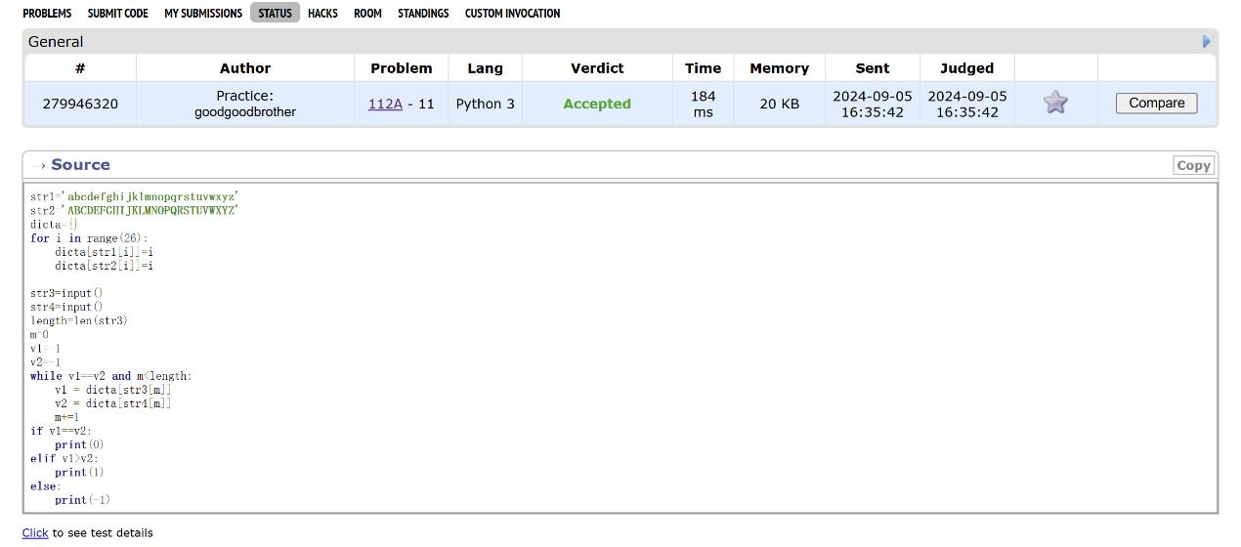

**231A. Team**

bruteforce, greedy, 800, <http://codeforces.com/problemset/problem/231/A>

**大致用时：7min**

**代码**

n=int(input())  
num=0  
for i in range(n):  
 lst=input().split()  
 v1=int(lst[0])  
 v2=int(lst[1])  
 v3=int(lst[2])  
 if v1+v2+v3>1:  
 num+=1  
print(num)

​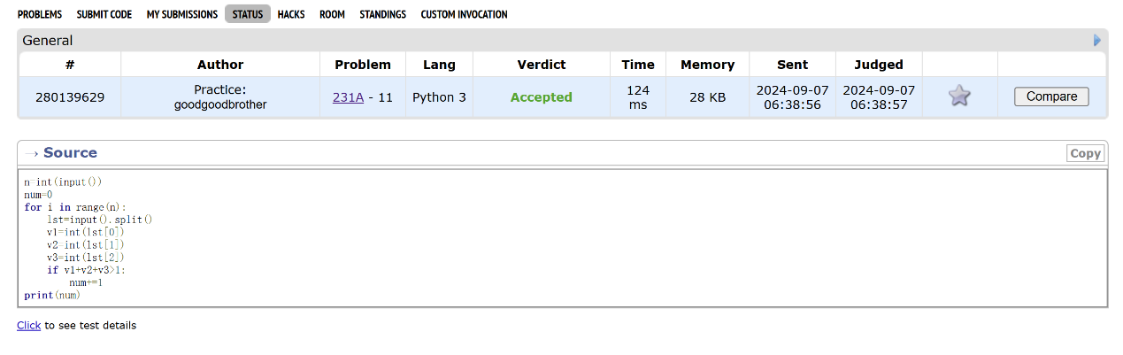

**2. 学习总结和收获**

本人基本是这学期零基础开始学的python，经过几天的基础语法学习，对目前作业难度的题目基本都应付得过来，并且也逐渐在学到一些函数或者方法（比如上面那道Petya and Strings，开学前时我还不知道可以直接用lower方法，创了一个字典去做，非常麻烦）。现在我也有在及时跟进每日选做保持手感。