**Assignment #2: 语法练习**

Updated 0126 GMT+8 Sep 24, 2024

2024 fall, Complied by 吕金浩，物理学院

**1. 题目**

**263A. Beautiful Matrix**

<https://codeforces.com/problemset/problem/263/A>

**代码**

m,n=0,0  
for i in range(5):  
 lst=input().split()  
 for j in range(5):  
 if int(lst[j])==1:  
 m=i  
 n=j  
num=abs(m-2)+abs(n-2)  
print(num)

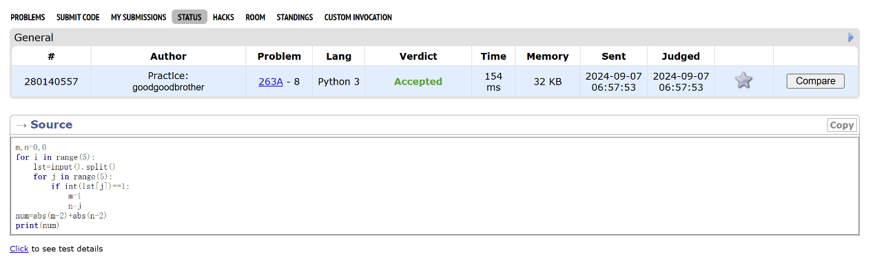

**1328A. Divisibility Problem**

<https://codeforces.com/problemset/problem/1328/A>

**代码**

n=int(input())  
lst=[]  
for i in range(n):  
 a,b=input().split()  
 a=int(a)  
 b=int(b)  
 if a%b==0:  
 lst.append(0)  
 else:  
 lst.append(b-(a%b))  
for j in range(n):  
 print(lst[j])

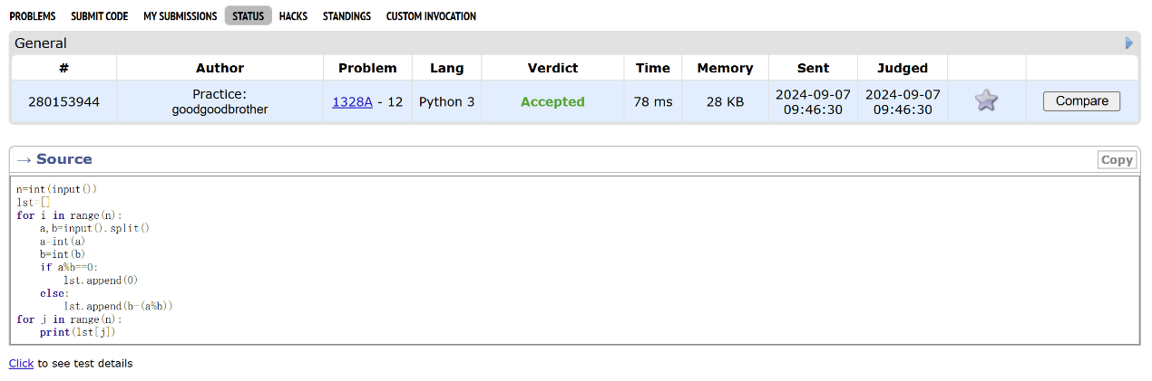

**427A. Police Recruits**

<https://codeforces.com/problemset/problem/427/A>

**代码**

n=int(input())  
policerest=0  
eventlist=(input().split())  
untreated=0  
for i in range(n):  
 if int(eventlist[i])>0:  
 policerest+=int(eventlist[i])  
 else:  
 if policerest>0:  
 policerest-=1  
 else:  
 untreated+=1  
print(untreated)

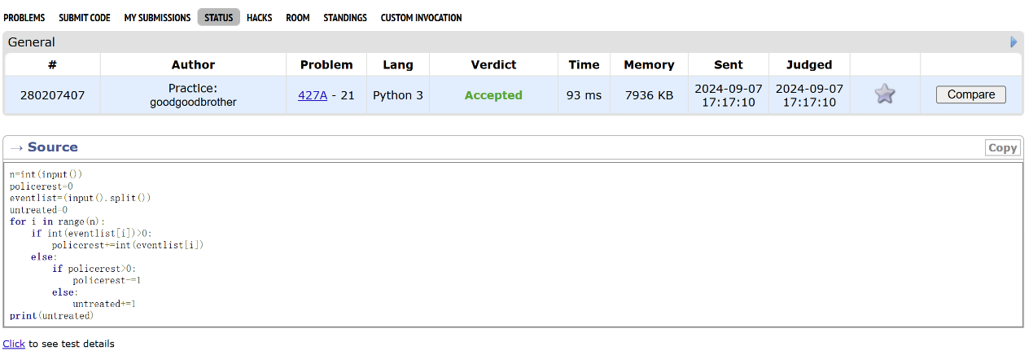

**02808: 校门外的树**

<http://cs101.openjudge.cn/practice/02808/>

**代码**

l,m=[int(x) for x in input().split()]  
initree=[1]*(l+1)  
remaintree=0  
for i in range(m):  
 start,end=[int(x) for x in input().split()]  
 for j in range(start,end+1):  
 initree[j]=initree[j]-1  
for i in range(l+1):  
 if initree[i]>0:  
 remaintree+=1  
print(remaintree)

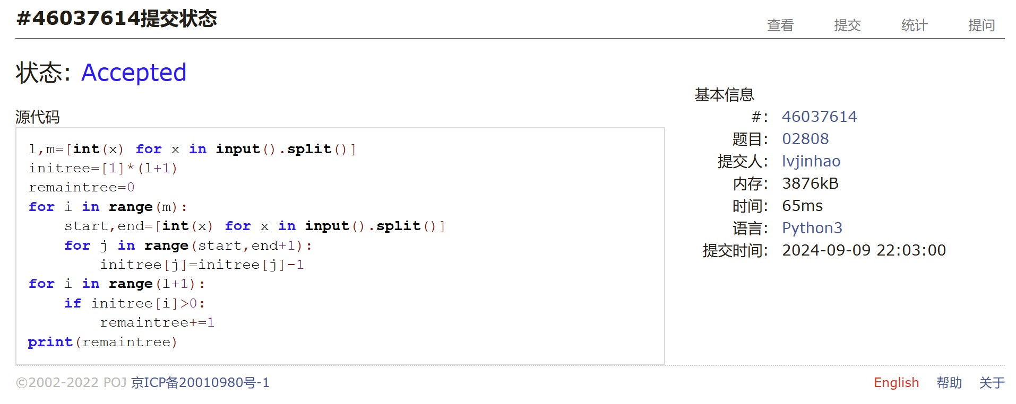

**sy60: 水仙花数II**

<https://sunnywhy.com/sfbj/3/1/60>

**代码**

a,b=map(int,input().split())  
ansstr=''  
for x in range(a,b+1):  
 strx=str(x)  
 lstx=list(strx)  
 if int(lstx[0])**3+int(lstx[1])**3+int(lstx[2])**3==x:  
 ansstr=ansstr+strx+' '  
if ansstr=='':  
 print('NO')  
else:  
 print(ansstr.rstrip())

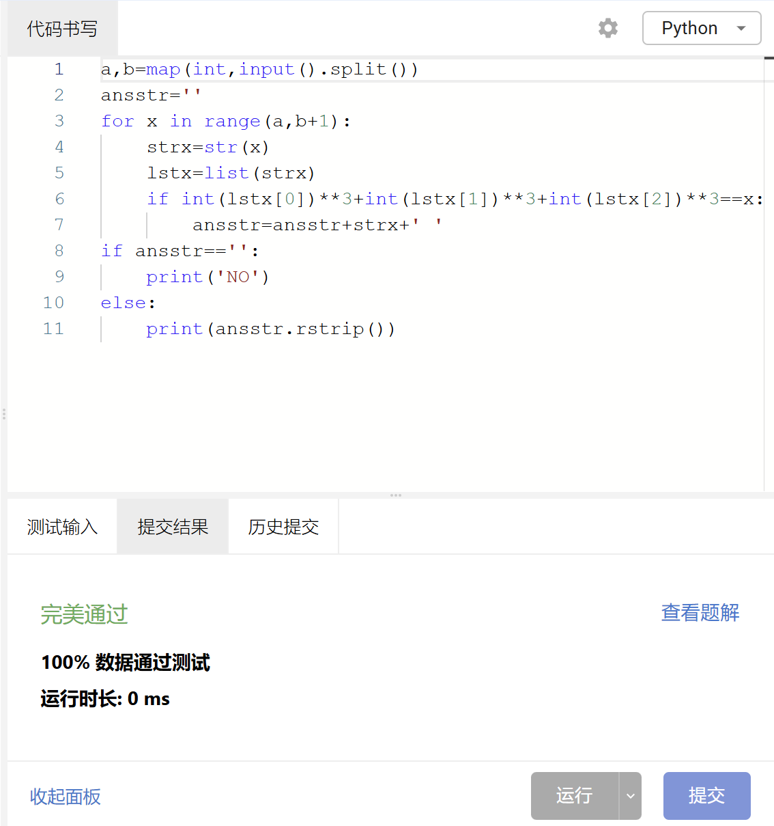

**01922: Ride to School**

<http://cs101.openjudge.cn/practice/01922/>

**代码**

import math  
while True:  
 n=int(input())  
 vt=[]  
 if n:  
 needtime=0  
 for i in range(n):  
 v,t=map(int,input().split('\t'))  
 #print(t)  
 #needtime=0  
 #if i==0:  
  
 if t>=0:  
 thistime=t+(16200/v)  
 if needtime==0:  
 needtime=thistime  
 if thistime<needtime:  
 needtime=thistime  
 print(math.ceil(needtime))  
 #vt.append((v,t))  
 else:  
 break

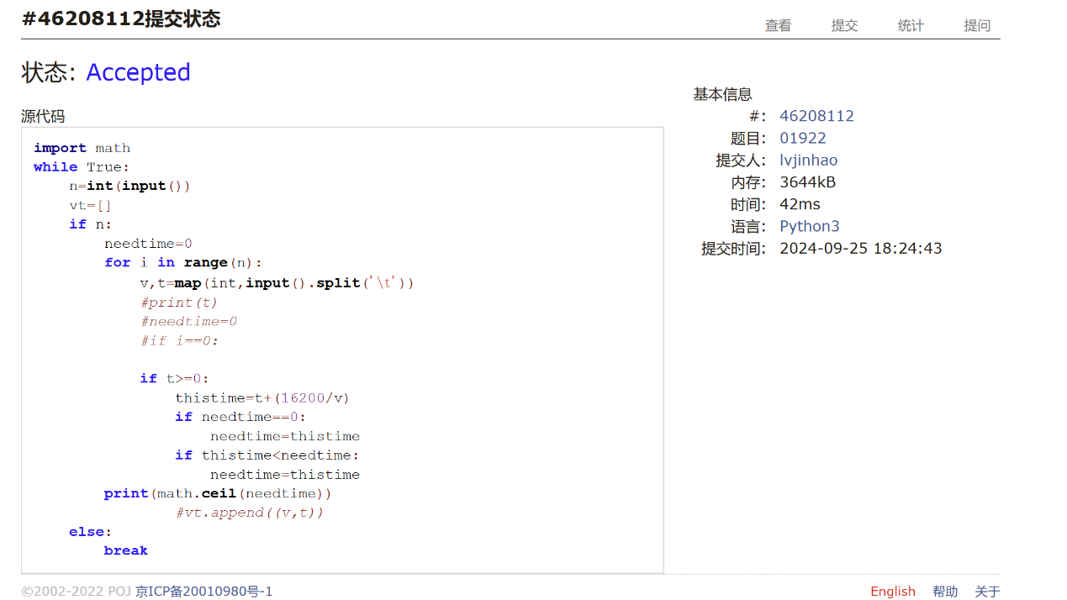

**2. 学习总结和收获**

作为几乎零基础的同学，我一直在跟进每日选做，觉得目前题目难度不够高。