**Assignment #5: Greedy穷举Implementation**

2024 fall, Complied by 吕金浩，物理学院

**1. 题目**

**04148: 生理周期**

brute force, <http://cs101.openjudge.cn/practice/04148>

代码：

case=1  
while True:  
 a,b,c,d=map(int,input().split())  
 ans=0  
 if a==-1:  
 break  
 else:  
 for i in range(d+1,d+21253):  
 if (i-a)%23==0 and (i-b)%28==0 and (i-c)%33==0:  
 ans=i-d  
 break  
 print('Case {}: the next triple peak occurs in {} days.'.format(str(case),str(ans)))  
 case+=1

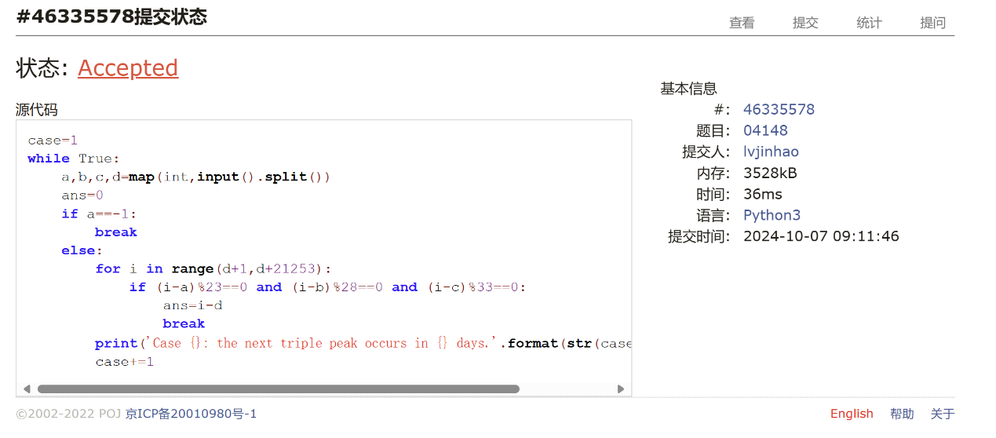

**18211: 军备竞赛**

greedy, two pointers, <http://cs101.openjudge.cn/practice/18211>

代码：

own=int(input())  
costs=[int(x) for x in input().split()]  
costs.sort()  
more=0  
most=0  
while costs:  
 if own<costs[0]:  
 if more==0:  
 break  
 else:  
 more-=1  
 own+=costs[-1]  
 del costs[-1]  
  
 #break  
 else:  
 own-=costs[0]  
 more+=1  
 del costs[0]  
 most=max(more,most)  
print(most)

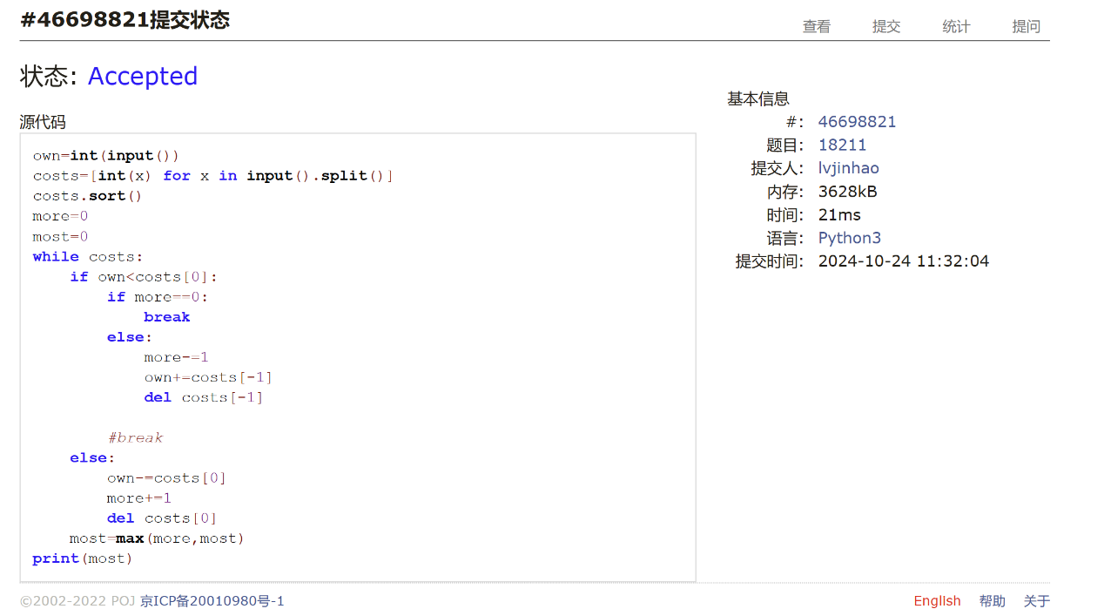

**21554: 排队做实验**

greedy, <http://cs101.openjudge.cn/practice/21554>

代码：

n=int(input())  
lst=input().split()  
for i in range(n):  
 lst[i]=(int(lst[i]),i)  
lst.sort()  
ans1=''  
tot_time=0  
for i in range(n):  
 ans1+=str(lst[i][1]+1)+' '  
 tot_time+=(n-1-i)*lst[i][0]  
print(ans1.rstrip())  
a=tot_time/n  
  
print('%.2f' % a)

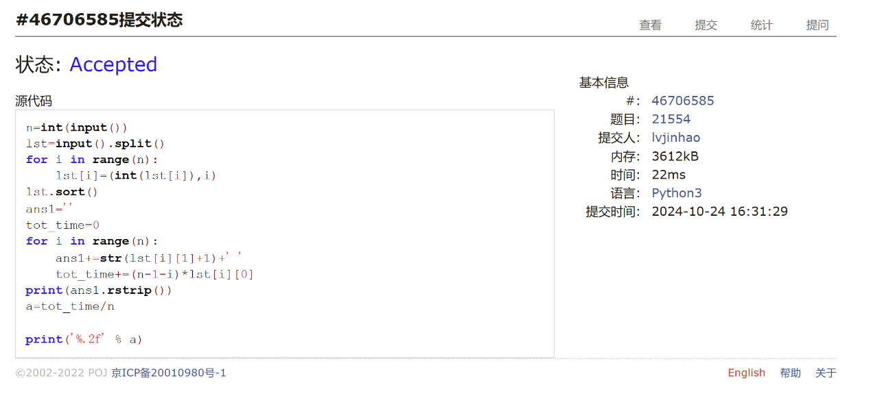

**01008: Maya Calendar**

implementation, <http://cs101.openjudge.cn/practice/01008/>

代码：

t=int(input())  
print(t)  
Haab=['pop', 'no', 'zip', 'zotz', 'tzec', 'xul', 'yoxkin', 'mol', 'chen', 'yax', 'zac', 'ceh', 'mac', 'kankin', 'muan', 'pax', 'koyab', 'cumhu','uayet']  
Haab_name_to_num={}  
Tzolkin=['imix', 'ik', 'akbal', 'kan', 'chicchan', 'cimi', 'manik', 'lamat', 'muluk', 'ok', 'chuen', 'eb', 'ben', 'ix', 'mem', 'cib', 'caban', 'eznab', 'canac', 'ahau']  
#Tzolkin_name_to_num={}  
for i in range(19):  
 Haab_name_to_num[Haab[i]]=i  
  
#for i in range(20):  
 #Tzolkin_name_to_num[Tzolkin[i]]=i  
  
  
for _ in range(t):  
 a,b,c=map(str,input().split())  
 a=int(a.rstrip('.'))  
 c=int(c)  
 whole_days=c*365+Haab_name_to_num[b]*20+a  
 year=whole_days//260  
 rest_days=whole_days%260  
 num=rest_days%13+1  
 name=Tzolkin[rest_days%20]  
 print(str(num)+' '+name+' '+str(year))

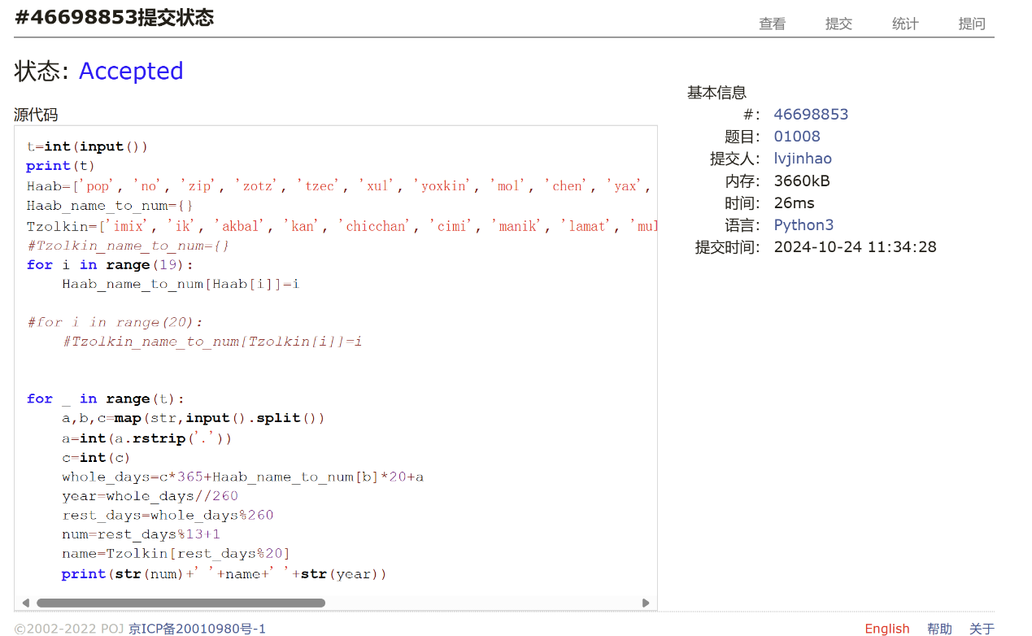

**545C. Woodcutters**

dp, greedy, 1500, <https://codeforces.com/problemset/problem/545/C>

代码：

n=int(input())  
coordinate_height=[]  
for _ in range(n):  
 coordinate_height.append([int(x) for x in input().split()])  
if n<3:  
 print(n)  
else:  
 max_cutdown=2  
 end=coordinate_height[0][0]  
 for i in range(1,n-1):  
 if coordinate_height[i][0]-coordinate_height[i][1]>end:  
 max_cutdown+=1  
 end=coordinate_height[i][0]  
 elif coordinate_height[i][0]+coordinate_height[i][1]<coordinate_height[i+1][0]:  
 max_cutdown+=1  
 end=coordinate_height[i][0]+coordinate_height[i][1]  
 else:  
 end=coordinate_height[i][0]  
 print(max_cutdown)

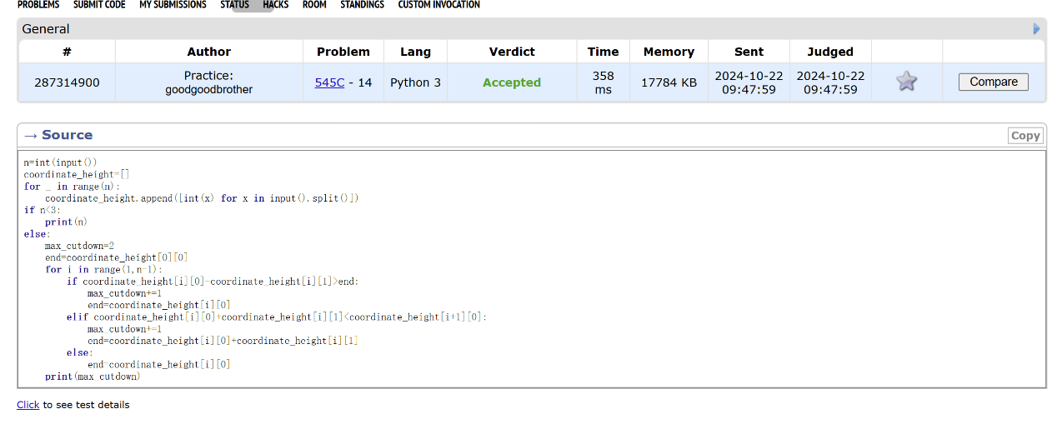

**01328: Radar Installation**

greedy, <http://cs101.openjudge.cn/practice/01328/>

代码：

t=0  
from math import *  
while True:  
 t+=1  
 n,d=map(int,input().split())  
 radar=1  
  
 if n:  
 coordinates=[]  
 if_skip=False  
 for _ in range(n):  
 x,y=map(int,input().split())  
  
  
  
 if y>d or d<0:  
 #print('Case '+str(t)+': -1')  
 if_skip=True  
 else:  
 coordinates.append((x-sqrt(d**2-y**2),x+sqrt(d**2-y**2)))  
 input()  
 if if_skip:  
 print('Case ' + str(t) + ': -1')  
  
 continue  
 else:  
  
  
 coordinates.sort()  
 #coordinates[0]=set(range(coordinates[0][0],coordinates[0][1]+1))  
 common=coordinates[0]  
 for i in range(1,n):  
 #coordinates[i]=set(range(coordinates[i][0],coordinates[i][1]+1))  
 #common=coordinates[i]&coordinates[i-1]  
 if coordinates[i][0]>common[1]:  
 common=coordinates[i]  
 radar+=1  
 else:  
 common=(coordinates[i][0],min(common[1],coordinates[i][1]))  
  
 '''if not common:  
 radar+=1  
 else:  
 coordinates[i]=common'''  
 print('Case '+str(t)+': '+str(radar))  
 #input()  
  
  
 else:  
 break

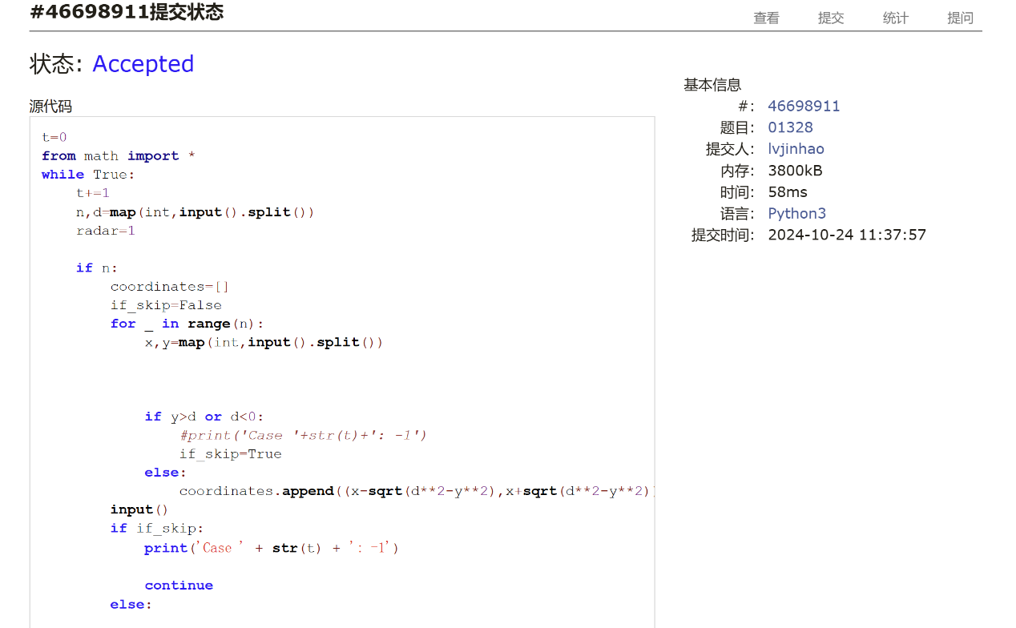

**2. 学习总结和收获**

最近每日选做做起来比较顺利，基本都能一次AC，或者抱着尝试心态TLE一次，做了优化后也能AC（比如Cipher）。那道标示难度1700的466C: Number of Ways我做了二三十分钟左右，一次AC，也给了自己一点信心。只是发现自己一道题可能用时太长，有时可能得三四十分钟，感觉有点慌（