Localized Reward-Conditioned Information Usage Reduces Exploration Diversity and Limits Long-Term Optimization in Fragmented Nonlinear Environments
Yangze Wang¹
¹College of Life Science and Technology,Jinan University,Guangzhou,China. wang04@stu2022.jnu.edu.cn

Abstact
Learning-related computational theories in neuroscience frequently rely on gradient-based optimization or localized reward-conditioned learning mechanisms (Richards et al., 2019; Fernández et al., 2025). However, how localized information usage influences long-term optimization performance in fragmented non-linear environments remains poorly understood. To investigate this problem, we constructed a recurrent non-linear dynamical system containing multiple stable regions and discontinuous reward structures, and formulated parameter learning as a reward-guided search problem. Within this framework, we compared local evolutionary search, random search, greedy regional selection, and diversity-preserving regional exploration strategies that retained multiple candidate regions during optimization. Our results showed that localized reward-conditioned update strategies frequently produced unstable search trajectories, intermittent gradient collapse, and progressive reduction of exploration diversity. In contrast, regional exploration maintained broader exploratory structure and achieved superior long-term optimization performance under constrained evaluation budgets. Importantly, these optimization differences could not be explained solely by the presence or absence of stochastic exploration. Instead, the results suggest that long-term optimization performance may depend not only on sampling behavior, but also on how sampled information is retained and incorporated into subsequent updates. These findings provide a search-theoretic interpretation of potential non-gradient optimization mechanisms in biological learning systems(Whittington & Bogacz, 2019,Richards et al., 2019). More broadly, the present framework suggests that maintaining distributed exploratory structure may improve optimization robustness in fragmented non-linear environments.

Keywords
Optimization,Exploration–Exploitation Trade-off,Information Usage,ExplorationDiversity,Nonlinear Dynamical Systems,Reward-Guided Search,Computational Neuroscience

1 Introduction

Complex biological and artificial systems frequently operate in highly non-linear environments, where optimization landscapes may become fragmented, discontinuous, or only weakly informative(Kauffman & Levin, 1987;Holland, 1992). Under such conditions, locally favorable reward signals do not necessarily provide reliable information regarding globally favorable long-term solutions(Lehman & Stanley, 2011). Consequently, optimization trajectories may progressively concentrate within restricted regions of parameter space, reducing exploratory diversity and limiting access to distant high-performing regions(Lehman et al., 2013). In contrast, biological systems often exhibit exploratory behaviors that preserve broader behavioral variability under uncertainty(Cohen et al., 2007), suggesting that adaptive search in complex environments may benefit from maintaining distributed exploratory structure rather than relying exclusively on highly localized optimization dynamics(Lehman et al., 2013).

Many conventional optimization approaches, including greedy search, gradient-based optimization, and evolutionary search methods, rely primarily on locally conditioned reward information to guide parameter updates(Sutton & Barto, 1998; Nocedal & Wright, 2006 ;Lehman & Stanley, 2011). These approaches perform efficiently in smooth or approximately continuous optimization landscapes, where local reward improvement reliably reflects nearby high-performing directions(Kauffman & Levin, 1987). However, when reward landscapes become fragmented by strong non-linearity or discontinuous evaluation criteria, locally favorable reward statistics may become only weakly correlated with globally favorable solutions(Weinberger, 1991;Jones & Forrest, 1995). Under such conditions, repeatedly conditioning updates on restricted local reward structure may progressively localize both search trajectories and the information retained for future optimization, thereby reducing the probability of discovering distant high-performing regions(Lehman & Stanley, 2011).

Previous studies have extensively investigated local optima, premature convergence, and exploration–exploitation trade-offs in optimization systems(Goldberg, D.E. & Richardson, J. 1987,Eiben;A.E. & Schippers, C.A. 1998;Lehman, J. & Stanley, K.O. 2011). Nevertheless, less attention has been paid to how information usage itself dynamically evolves during optimization in fragmented non-linear environments. In particular, localized update strategies may progressively lose exploratory diversity over time, leading to exploration collapse in which optimization trajectories become increasingly concentrated within restricted regions of parameter space(Lehman & Stanley, 2011; Mouret & Clune, 2015). Importantly, such collapse may emerge not only from restricted sampling range, but also from how sampled information is compressed, discarded, or repeatedly reused during subsequent updates. From an information-theoretic perspective, this process may reflect inefficient long-timescale accumulation of globally useful information when optimization remains dominated by locally conditioned reward statistics.

In this study, we constructed a recurrent non-linear dynamical system containing multiple stable regions and discontinuous reward structures, and formulated parameter learning as a reward-guided search problem. Within this framework, we compared several search strategies under identical evaluation budgets, including local evolutionary search, random search, greedy regional selection, and diversity-preserving regional exploration. We analyzed search trajectories, exploration entropy, spatial spread, explored area, and landscape coverage throughout optimization. Our results show that localized reward-conditioned update strategies progressively reduce exploration diversity and become concentrated within restricted regions of parameter space, whereas regional exploration maintains broader search coverage and achieves superior long-term optimization performance. These findings suggest that preserving distributed exploratory structure may provide a useful computational principle for adaptive search in fragmented non-linear environments.

2 Methods

2.1 Recurrent dynamical system
To investigate search behavior within fragmented non-linear environments, we constructed a recurrent dynamical system composed of interacting simulated neurons. The system consisted of ($n_{s}$= 7) neurons, where the internal state at each time step was represented by a continuous-valued vector:

$$s ∈ ℝ^{n_{s}}$$
The system dynamics evolved according to the following recurrent update rule:ns*ns

$$\text{s(t+1)=W∗tanh}\text{(}\text{s}\text{)}$$
where ($\text{W ∈ }{\text{ℝ}}^{n_{s}{∗n}_{s}}$) denotes the recurrent connectivity matrix, and ($\text{tanh}\text{(}\text{s}\text{)}$) introduces element-wise non- linearity into the recurrent dynamics.
Target states (strue) were generated as binary vectors whose elements were sampled uniformly from ({−1, 1}). The recurrent weights were initialized using a Hopfield-style constructive rule:
$$\text{W=a∗S}{\text{S}}^{\text{T}}$$
where (S) denotes the matrix aggregating all predefined target states and (α = 3.0) controls the recurrent interaction strength.
To evaluate retrieval performance, noisy initial conditions were generated around target states according to:
$${\text{s}}_{start}\text{ = }{\text{s}}_{true}\text{ + N(0, }{\text{σ}}_{\text{noise}}\text{)}$$
where (${\text{σ}}_{\text{noise}}$ = 0.3). The recurrent dynamics were then iteratively evolved until convergence.
To prevent degenerate dynamical collapse, parameter configurations yielding negligible final-state magnitudes were excluded from subsequent evaluations.

2.2 Reward sturcture and evaluation
Inference performance was evaluated by assessing the alignment between the evolved system states and the predefined target states. Following recurrent evolution, cosine similarity between the steady-state vector and all target states was computed. If the target state exhibiting the highest similarity matched the correct observed object, the trial received a positive reward of (+1); otherwise, the trial received a penalty of (−0.5)For each candidate parameter configuration, the inference process was repeated across multiple stochastic trials (n = 30 or 50, depending on the experimental setting), and the mean score across these trials was defined as the final evaluation score.
Because the evaluation metric depended strictly on discrete classification outcomes rather than continuous reconstruction errors, the resulting reward landscape contained fragmented high-performing regions and discontinuous reward transitions.

2.3 Search strategies

Evolutionary Search (ES)
Evolutionary search optimized parameter configurations via localized stochastic perturbations. Candidate samples were generated according to:
$$S_{try}=S+σϵ$$

where (ε ~ Ñ(0, I)).
The rewards obtained from sampled candidates were normalized and used to estimate locally reward-conditioned update directions:

$${\text{∇}}_{\text{θ}}\text{J(θ)≈}\frac{\text{1}}{\text{nσ}}\sum_{\text{i=1}}^{\text{n}}{{\text{R}}_{\text{i}}}\text{⋅}{\text{ϵ}}_{\text{i}}$$
where (${\text{R}}_{\text{i}}$) denotes the normalized reward associated with perturbation vector (${\text{ϵ}}_{\text{i}}$).
Parameter updates therefore depended primarily on locally sampled reward statistics around the current search position.

Greedy Regional Selection
Greedy regional selection partitioned parameter space into candidate regions but retained only the single highest-scoring region during optimization. Consequently, information associated with alternative candidate regions was discarded after each update cycle, progressively concentrating subsequent search behavior into restricted regions of parameter space.

Diversity-Preserving Regional Exploration
Regional exploration maintained multiple candidate regions simultaneously throughout optimization. Candidate regions were recursively partitioned into randomly generated subregions, and regional scores were estimated via uniform sampling within each subregion.
Rather than preserving only the currently highest-scoring region, multiple high-scoring candidate regions were retained across optimization steps. This strategy preserved broader exploratory structure and reduced premature concentration of search trajectories.

All search strategies were evaluated under identical total evaluation budgets within each experimental setting.

2.4 Exploration diversity
To quantitatively characterize exploration behavior during optimization, high-dimensional search trajectories were projected into a two-dimensional space using Principal Component Analysis (PCA).
Exploration spread was defined as the mean pairwise Euclidean distance among explored points within the projected latent space:
$$Spread=\frac{1}{N(N−1)}\sum_{i≠j}{|}x_{i}−x_{j}|_{2}$$
where (xi) and (xj) denote sampled points in the projected PCA space.
Exploration entropy was computed from two-dimensional spatial occupancy histograms:

$$\text{H = −∑}{\text{p}}_{\text{i}}\text{log }{\text{p}}_{\text{i}}$$
where (${\text{p}}_{\text{i}}$) represents the normalized occupancy probability of the (i)-th spatial bin.
Additionally, explored area was quantified using the convex hull area encompassing all sampled points within the PCA space.
Because these analyses were computed within a projected low-dimensional subspace, all derived metrics—including spread, entropy, and convex hull area—were interpreted as relative indicators of exploration structure rather than exact geometric measurements of the original high-dimensional parameter space.

3 Results

3.1 Localized reward-conditioned information usage exhibits unstable search dynamics
To investigate how localized reward-conditioned optimization behaves in fragmented non-linear environments, we first analyzed the search dynamics of evolutionary search (ES) trajectories within parameter space. PCA visualization revealed that ES trajectories frequently returned to previously explored regions rather than continuously expanding into unexplored regions of the search space (Fig. 1). In parallel, estimated gradient signals intermittently approached zero and exhibited strong fluctuations during optimization, suggesting that locally conditioned reward information provided unstable update directions under the current reward structure.
Importantly, ES included stochastic perturbations during sampling, indicating that unstable optimization behavior cannot be explained solely by the absence of exploration. Instead, these observations suggest that optimization strategies relying primarily on localized reward-conditioned information usage may repeatedly reinforce restricted search directions in fragmented reward landscapes.
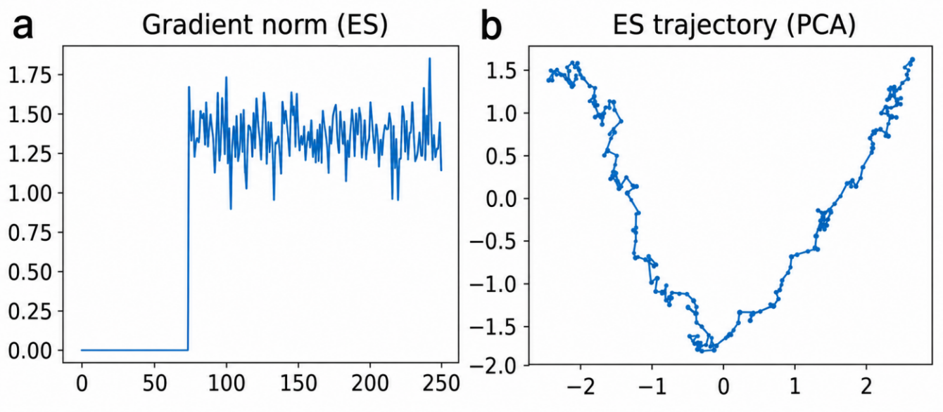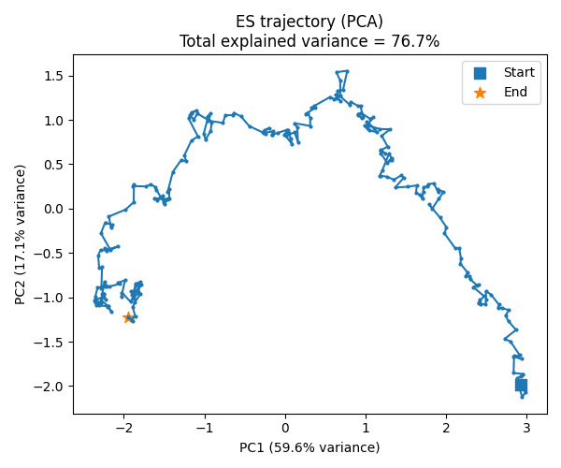
b

Figure 1. Evolutionary search exhibits unstable trajectory dynamics under localized reward-conditioned updates.(a) Gradient norm during evolutionary search optimization as a function of evaluation steps. Gradient estimates intermittently approached zero and exhibited strong fluctuations throughout optimization.(b) PCA projection of ES search trajectories in parameter space. Each point represents a sampled parameter state during optimization. ES trajectories frequently revisited previously explored regions rather than continuously expanding into unexplored regions of parameter space.

3.2 Greedy regional selection progressively reduces exploration diversity
To quantitatively characterize changes in exploration structure, we compared greedy regional selection with diversity-preserving regional exploration strategies. Greedy regional selection progressively exhibited lower exploration entropy, reduced spatial spread, and smaller explored area during later optimization stages compared with regional exploration (Fig. 2), indicating gradual contraction of the explored search distribution.
Importantly, differences in exploration diversity did not emerge immediately, but became increasingly pronounced during extended optimization. In contrast, regional exploration maintained broader coverage across parameter space throughout later search stages, suggesting that preserving multiple candidate regions can delay premature concentration of optimization trajectories.

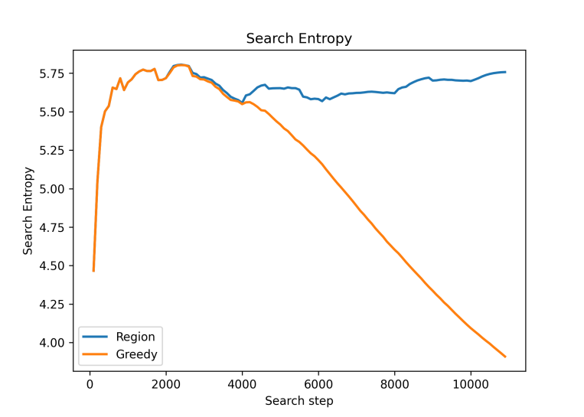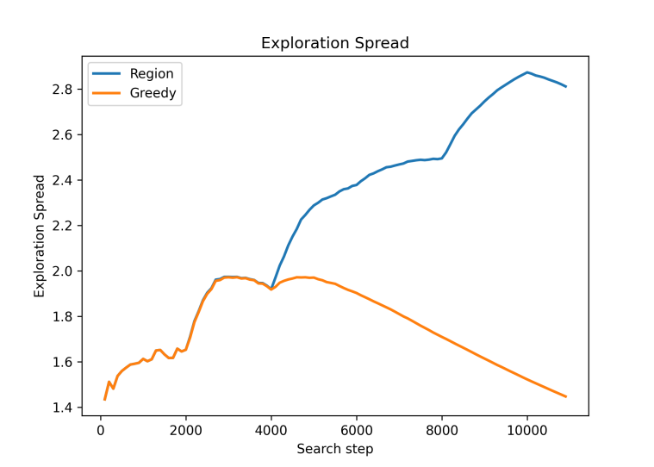
b
a

Figure 2. Greedy regional selection progressively reduces exploration diversity during optimization.(a) Spatial spread of sampled points as a function of optimization steps for greedy regional selection and diversity-preserving regional exploration.(b) Exploration entropy over optimization steps for the two search strategies. Regional exploration maintained broader exploratory structure during later optimization stages, whereas greedy regional selection progressively concentrated sampling into narrower regions of parameter space.

3.3 Reduced exploration diversity limits access to delayed high-performing regions
We next examined how changes in exploration structure influenced long-term optimization performance. Visualization of explored landscape regions revealed that greedy regional selection rapidly concentrated around regions associated with relatively favorable early reward signals (Fig. 3). However, the regions producing the highest final scores were frequently not those that appeared most favorable during early optimization stages.
Interestingly, divergence in long-term optimization performance emerged shortly after exploration diversity began to decrease, suggesting a potential relationship between reduced exploration diversity and subsequent performance limitation. In contrast, regional exploration maintained broader spatial coverage and later accessed distant high-performing regions that were weakly represented during early optimization. These results suggest that localized reward-conditioned information alone may provide insufficient information regarding long-timescale optimization potential in fragmented non-linear environments.

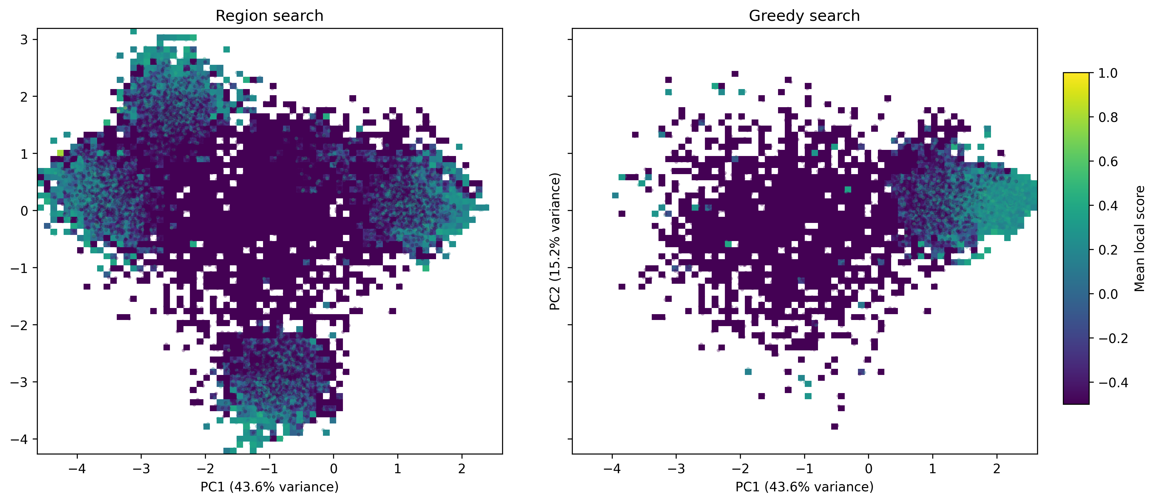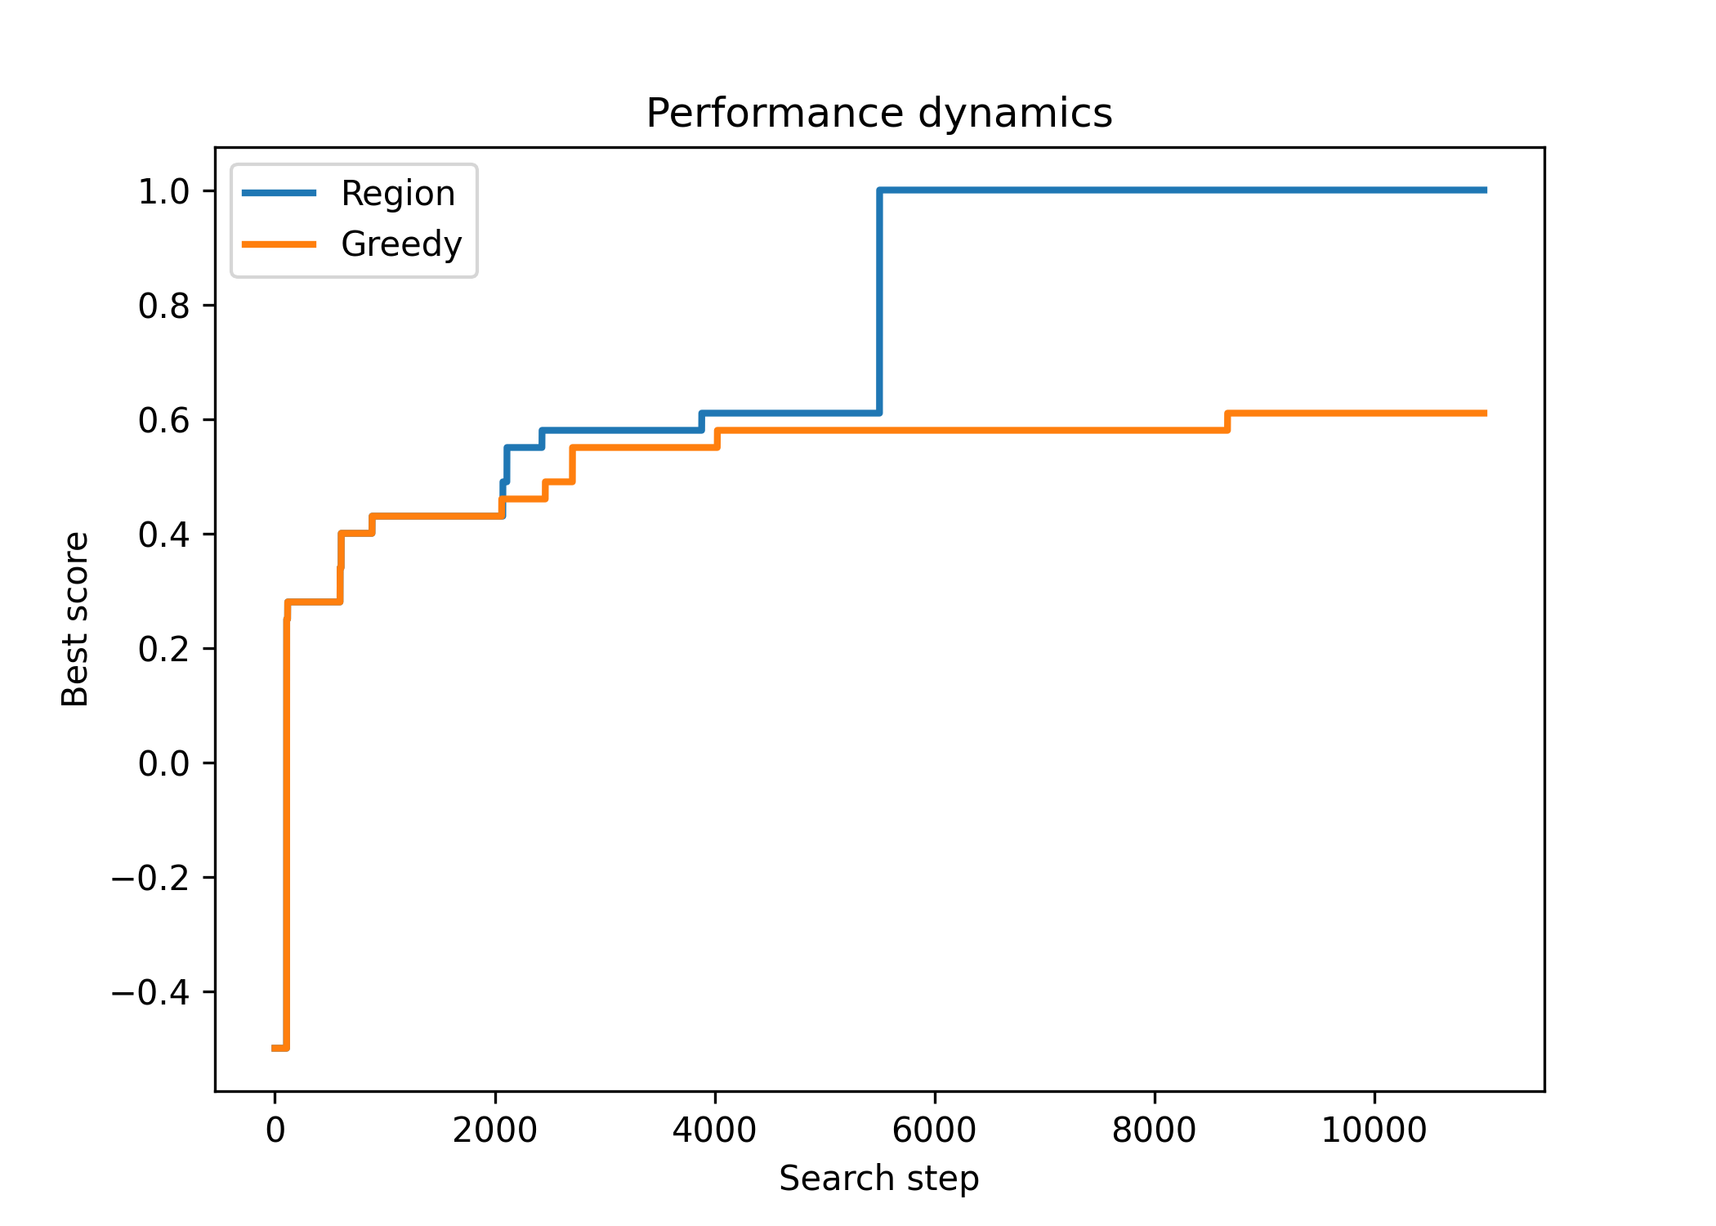
a
b

Figure 3. Reduced exploration diversity is associated with delayed divergence in optimization performance.(a) PCA-based landscape visualization of explored regions for greedy regional selection and regional exploration. Pixel intensity represents the average score of sampled points within each region. White regions indicate unsampled areas.(b) Best-score trajectories during optimization for greedy regional selection and regional exploration. Performance divergence emerged during later optimization stages despite similar early-stage performance. High-performing final regions were frequently not strongly represented among early high-scoring regions.

3.4 Diversity-preserving regional exploration improves long-term optimization performance
Finally, we compared the long-term optimization performance of different search strategies across repeated experiments. Diversity-preserving regional exploration consistently achieved higher final scores than greedy regional selection and local evolutionary search under constrained evaluation budgets (Fig. 4). Under multiple parameter settings, performance differences reached statistical significance across repeated runs.
Interestingly, random search occasionally outperformed local evolutionary search despite lacking explicit reward-guided updates, suggesting that repeated localized reward-conditioned information reuse may become less effective than broader unbiased sampling in fragmented reward landscapes.
Although individual runs exhibited stochastic variability, the overall trend consistently associated preserved exploration diversity with improved long-term optimization performance. Together, these findings support the possibility that maintaining distributed exploratory structure can improve optimization robustness in discontinuous non-linear environments.
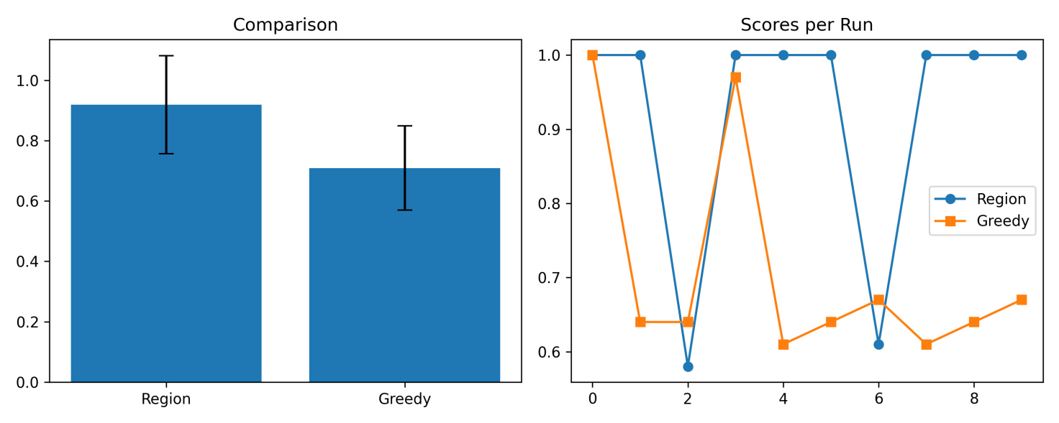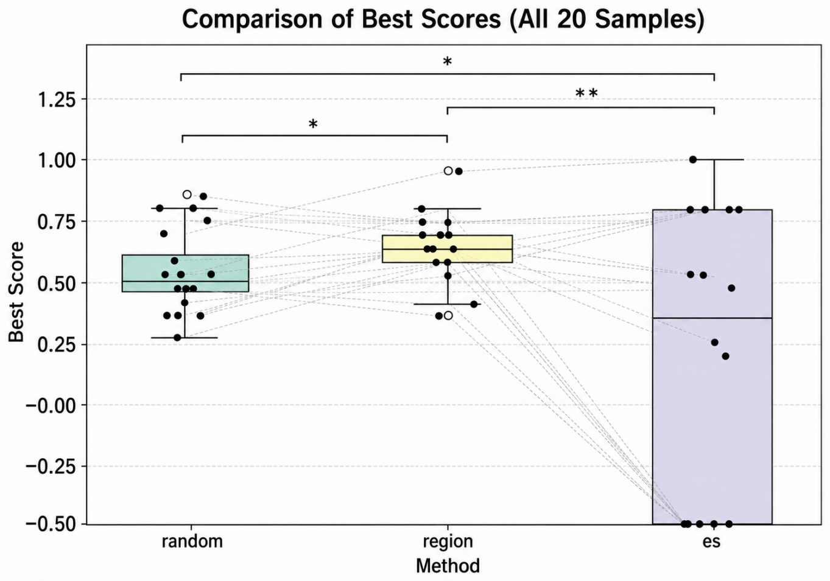
c
a
b

Figure 4. Diversity-preserving regional exploration improves long-term optimization performance across repeated experiments.(a) Boxplot comparison of final best scores between regional exploration and greedy regional selection across repeated experiments,p<0.05.(b) Paired comparison of final best scores across individual experiments. Connected points represent results obtained under the same environment.(c) Boxplot comparison of final best scores among regional exploration, random search, and evolutionary search. Dashed lines connect paired experiments performed under identical environments.

4 Discussion
The present study investigated how different search strategies behave in fragmented non-linear optimization environments. Although all methods operated under identical evaluation budgets and reward structures, they produced markedly different search dynamics and long-term optimization performance. Evolutionary search frequently exhibited unstable trajectories, repeated returns in parameter space, and intermittent gradient collapse. Greedy regional selection progressively reduced exploration diversity and concentrated sampling within restricted regions of parameter space. In contrast, regional exploration maintained broader exploratory coverage and consistently achieved superior long-term optimization performance under constrained evaluation budgets.

Importantly, these differences cannot be explained solely by whether an algorithm contains stochastic exploration. Evolutionary search included stochastic perturbations during sampling, and greedy search could still evaluate large numbers of candidate points. However, the present results suggest that long-term optimization performance depends not only on where information is sampled, but also on how sampled information is preserved and incorporated into future updates. Consequently, search behavior may be constrained not merely by sampling locality, but also by the degree to which previously acquired information remains available for guiding subsequent optimization. From this perspective, optimization failure in fragmented environments may arise from at least two partially distinct forms of localization. The first is sampling localization, in which newly sampled points remain concentrated near previously explored regions(Lehman & Stanley, 2011;Mouret & Clune, 2015). The second is update localization, in which future search directions are determined primarily by locally conditioned reward statistics or by a compressed subset of previously sampled information. Together, these effects may progressively narrow the effective informational structure available for long-timescale optimization.

The contrast between greedy regional selection and regional exploration is particularly consistent with this interpretation. Greedy selection aggressively exploits the currently highest-scoring region while discarding information associated with alternative candidate regions. In contrast, regional exploration preserves multiple candidate regions throughout optimization, thereby maintaining broader exploratory structure over longer timescales. Although this strategy may sacrifice immediate local reward maximization, it preserves greater long-term capacity for discovering globally favorable solutions.

The behavior of evolutionary search may reflect a related mechanism. Although stochastic perturbations generate candidate samples around the current parameter state, the update rule remains dominated by localized reward-conditioned estimates. Consequently, sampled information repeatedly reinforces nearby search directions while contributing relatively limited information regarding distant regions of parameter space. The observed intermittent gradient collapse and repeated trajectory returns are consistent with the possibility that localized updates reduce the efficiency of long-timescale information accumulation in fragmented reward landscapes.

From an information-theoretic perspective, search can be interpreted as a process of progressively reducing uncertainty regarding the location of high-performing solution regions(Cover & Thomas, 2006；Hernandez-Lobato et al., 2014;Srinivas et al., 2010). Under this view, long-term optimization performance depends on how effectively sampled information influences future search behavior(Srinivas et al., 2010). Strategies preserving broader exploratory structure may therefore support more efficient long-timescale uncertainty reduction than strategies dominated by localized reward-conditioned updates(Lehman & Stanley, 2011;Mouret & Clune, 2015). Importantly, the present study does not directly compute entropy or posterior distributions, and these formulations should therefore be regarded as conceptual interpretations rather than formal proofs.

This framework may also provide a potential connection to biological learning systems. Biological agents frequently operate in environments where reward structures are non-linear, delayed, and dynamically changing(Tolman, 1948;Behrens et al., 2018；Daw et al.2006). Under such conditions, maximizing immediate local reward may not reliably produce globally adaptive behavior(Lehman & Stanley, 2011). The present results raise the possibility that biological learning systems may benefit from maintaining distributed exploratory structures or preserving information across multiple candidate behavioral regions, rather than relying exclusively on localized reward-conditioned updates(Behrens et al., 2018;Dombrovski et al., 2020).

The present framework may also relate to broader theories of predictive adaptation and biological learning. Unlike predictive-processing-style frameworks that primarily emphasize prediction-error minimization(Friston, 2010;Clark, 2015;Hohwy, 2013), the current framework treats environmental reward structure as the primary optimization target. This distinction may become particularly relevant in environments where prediction accuracy and long-term adaptive reward are not linearly aligned. Under such conditions, adaptive behavior may require optimization strategies that balance local exploitation against broader uncertainty reduction across possible future states.

Several limitations should be acknowledged. First, the present study used simplified low-dimensional toy systems rather than biologically realistic neural architectures. Second, information-theoretic quantities such as entropy reduction were not directly measured and instead served as conceptual explanatory tools. Third, several visualizations relied on PCA projections, which may not fully preserve the geometric structure of the original high-dimensional search space. Finally, statistical significance remained modest in some experiments due to stochastic variability and limited trial numbers.

Future work could extend this framework in several directions. More rigorous probabilistic formulations may clarify how search trajectories influence uncertainty reduction over time. Higher-dimensional neural systems and more complex reward landscapes may help determine whether similar search-structure effects persist in biologically relevant regimes. Future studies could also investigate whether biological systems implement mechanisms analogous to distributed region retention, long-timescale information accumulation, or non-local exploratory updates during adaptive behavior. Such work may help bridge non-linear optimization theory, information-driven search, and biologically motivated learning systems.

Data and Code Availability
The Python code and simulation parameters are available at GitHub:https://github.com/ggbdull/dynamics-in-attractor-landscapes.git

Acknowledgments
No external funding or specific acknowledgments are associated with this work.

Reference
- Richards, B. A., Lillicrap, T. P., Beaudoin, P., Bengio, Y., Bogacz, R., Christensen, A., ... & Kording, K. P. (2019). A deep learning framework for neuroscience. Nature neuroscience, 22(11), 1761-1770.
- Fernández, J. G., Ahmad, N., & van Gerven, M. (2025). Noise-based reward-modulated learning. arXiv preprint arXiv:2503.23972.
- Whittington, J. C., & Bogacz, R. (2019). Theories of error back-propagation in the brain. Trends in cognitive sciences, 23(3), 235-250.
- Kauffman, S., & Levin, S. (1987). Towards a general theory of adaptive walks on rugged landscapes. Journal of theoretical Biology, 128(1), 11-45.
- Holland, J. H. (1992). Adaptation in natural and artificial systems: an introductory analysis with applications to biology, control, and artificial intelligence. MIT press.
- Lehman, J., & Stanley, K. O. (2011). Abandoning objectives: Evolution through the search for novelty alone. Evolutionary computation, 19(2), 189-223.
- Lehman, J., Stanley, K. O., & Miikkulainen, R. (2013, July). Effective diversity maintenance in deceptive domains. In Proceedings of the 15th annual conference on Genetic and evolutionary computation (pp. 215-222).
- Cohen, J. D., McClure, S. M., & Yu, A. J. (2007). Should I stay or should I go? How the human brain manages the trade-off between exploitation and exploration. Philosophical Transactions of the Royal Society B: Biological Sciences, 362(1481), 933-942.
- Sutton, R. S., & Barto, A. G. (1998). Reinforcement learning: An introduction (Vol. 1, No. 1, pp. 9-11). Cambridge: MIT press.
- Nocedal, J., & Wright, S. J. (2006). Numerical optimization. New York, NY: Springer New York.
- Weinberger, E. D. (1991). Local properties of Kauffman’s N-k model: A tunably rugged energy landscape. Physical review A, 44(10), 6399.
- Jones, T., & Forrest, S. (1995, July). Fitness distance correlation as a measure of problem difficulty for genetic algorithms. In ICGA (Vol. 95, pp. 184-192).
- Goldberg, D. E., & Richardson, J. (1987, July). Genetic algorithms with sharing for multimodal function optimization. In Genetic algorithms and their applications: Proceedings of the Second International Conference on Genetic Algorithms (Vol. 4149, pp. 414-425).
- Mouret, J. B., & Clune, J. (2015). Illuminating search spaces by mapping elites. arXiv preprint arXiv:1504.04909.
- Cover, T. M., & Thomas, J. A. (2006). Elements of information theory (wiley series in telecommunications and signal processing). Wiley-interscience.
- Hernández-Lobato, J. M., Hoffman, M. W., & Ghahramani, Z. (2014). Predictive entropy search for efficient global optimization of black-box functions. Advances in neural information processing systems, 27.
- Srinivas, N., Krause, A., Kakade, S. M., & Seeger, M. (2009). Gaussian process optimization in the bandit setting: No regret and experimental design. arXiv preprint arXiv:0912.3995.
- Tolman, E. C. (1948). Cognitive maps in rats and men. Psychological review, 55(4), 189.
- Behrens, T. E., Muller, T. H., Whittington, J. C., Mark, S., Baram, A. B., Stachenfeld, K. L., & Kurth-Nelson, Z. (2018). What is a cognitive map? Organizing knowledge for flexible behavior. Neuron, 100(2), 490-509.
- Daw, N. D., O'doherty, J. P., Dayan, P., Seymour, B., & Dolan, R. J. (2006). Cortical substrates for exploratory decisions in humans. Nature, 441(7095), 876-879.
- Dombrovski, A. Y., Luna, B., & Hallquist, M. N. (2020). Differential reinforcement encoding along the hippocampal long axis helps resolve the explore–exploit dilemma. Nature Communications, 11(1), 5407.
- Friston, K. (2010). The free-energy principle: a unified brain theory?. Nature reviews neuroscience, 11(2), 127-138.
- Clark, A. (2015). Surfing uncertainty: Prediction, action, and the embodied mind. Oxford University Press.
- Hohwy, J. (2013). The predictive mind. OUP Oxford.

SUPPLEMENTARY METHODS

S1 EXPERIMENTAL SETTINGS

S1.1 ES vs. Random vs. Regional Exploration
The hyperparameter configuration for comparing local evolutionary search, random search, and regional exploration was as follows:
• Number of neurons (ns): 7
• Number of objects (no): 5
• Total evaluation budget: 5000
• Recurrent evolution steps: 200
• Regional subdivision count: 60
• Retained region count: 8
• Samples per region: 20
• Inference trials per evaluation: 30
• Noise level: 0.3
• Parameter boundaries: [−2, 2]
• Evolutionary search hyperparameters:
◦ Perturbation scale (σ): 0.1
◦ Learning rate: 0.3
◦ Population size: 20

S1.2 Greedy Regional Selection vs. Regional Exploration
The hyperparameter configuration for comparing localized regional retention and regional exploration was as follows:
• Number of neurons (ns): 7
• Number of objects (no): 2
• Total evaluation budget: 11000
• Recurrent evolution steps: 300
• Regional subdivision count: 100
• Samples per region: 20
• Inference trials per evaluation: 50
• Noise level: 0.3
• Parameter boundaries: [−1.5, 1.5]
• Retained region counts:
• Greedy regional selection: 1
• Regional exploration: 600

S2 STABILITY AND DYNAMICAL CONSTRAINTS

To prevent numerical stagnation during recurrent evolution, optimization trajectories satisfying the following convergence criterion were terminated early:
${\text{||}\text{s}\text{(}\text{t}\text{+1)} \text{−} \text{s}\text{(}\text{t}\text{)||}}^{\text{2}}$< 10 −5
Additionally, parameter configurations yielding extremely small final-state magnitudes were excluded from evaluation:

$${\text{||}\text{s}\text{final}\text{||}}^{\text{2}} \text{<} \text{0.1}$$
This constraint prevented degenerate low-activity dynamical states from contributing to the evaluation process.

S3 Repeating results

To increase the reliability of some single results, we repeated the experiment.
Fig 1 repeat
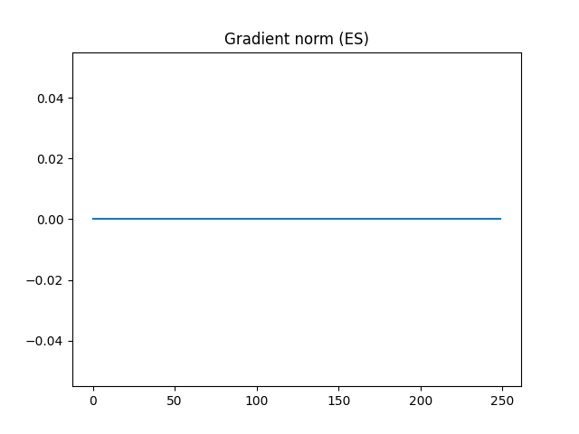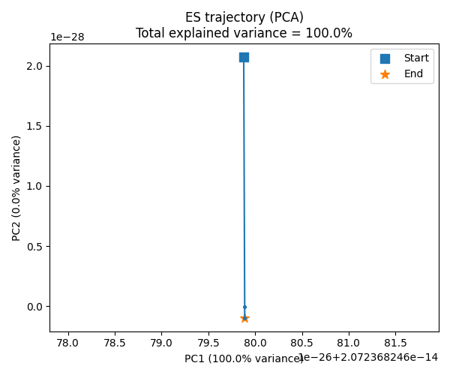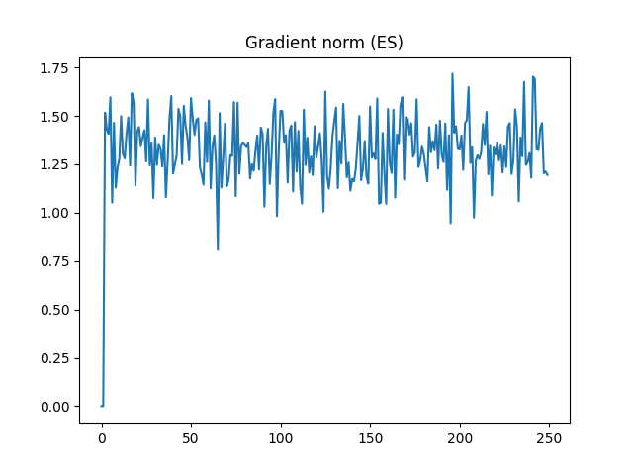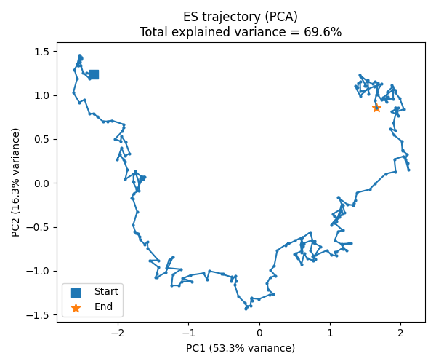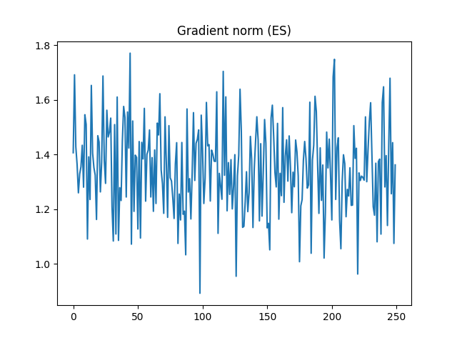
Pictures from same line are from same trail

About Fig3 (a) heat map, because this graph is time-consuming, this version only provides an existence statement; statistics on similar cases will be compiled later.

