1. "flag_{This_Is_What_I_Call_Encrypted_L4}"
2. flag and comment in ghidra

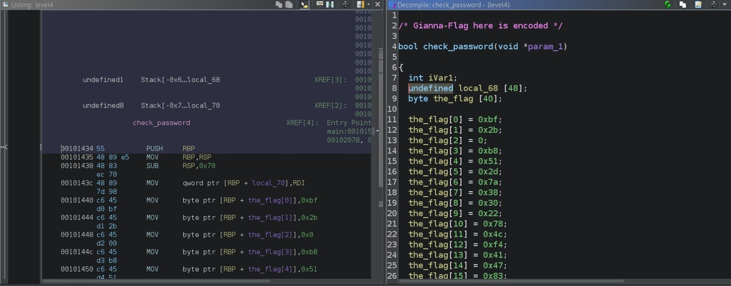

3)

Gdb –args ./level4 gianna_fake_flag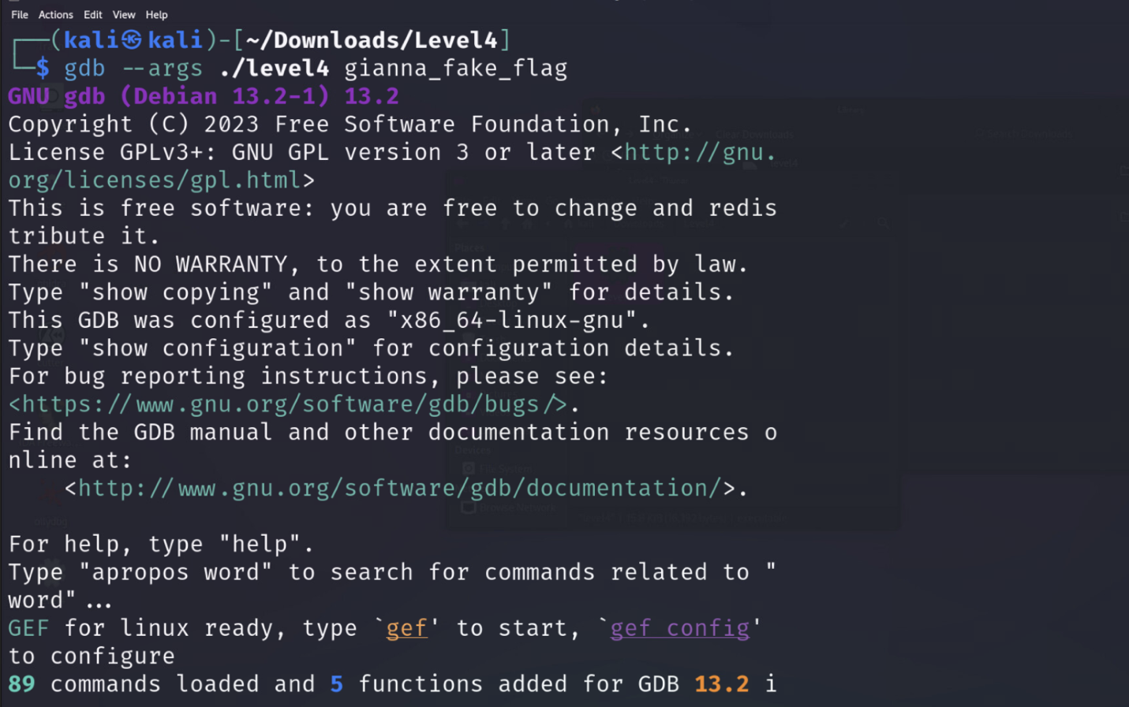

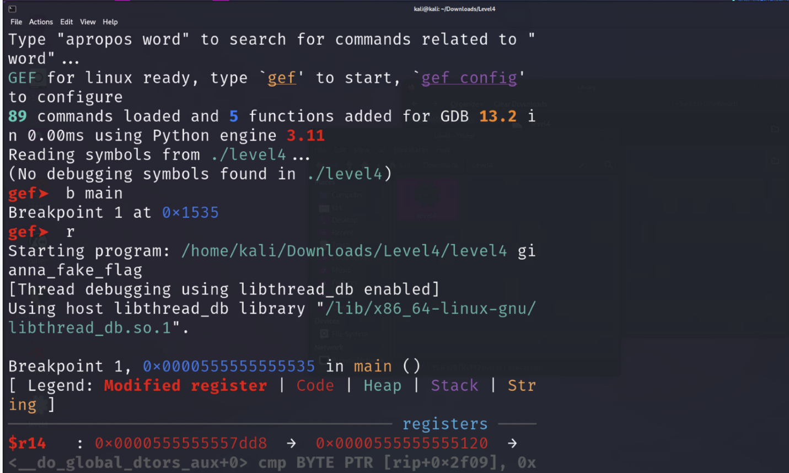I then set a breakpoint at main and then I ran it. I did this because I realized the address changed once the program is run.

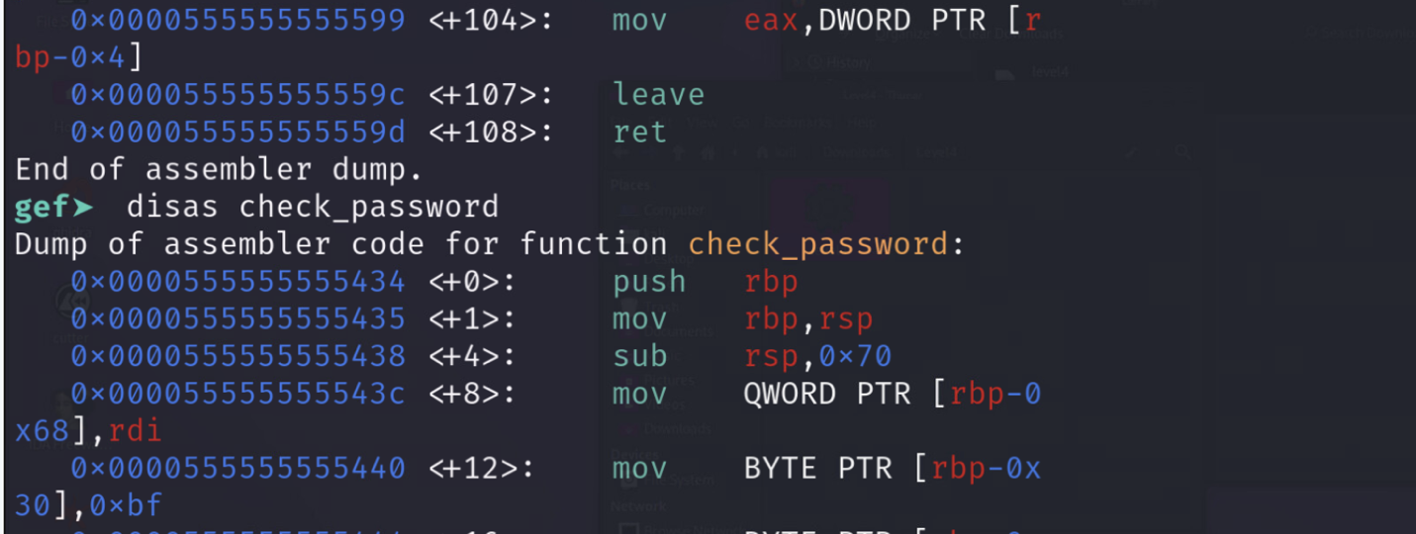I then did a dump of the assembler code for the check_password function. To find the address for the memory compare.

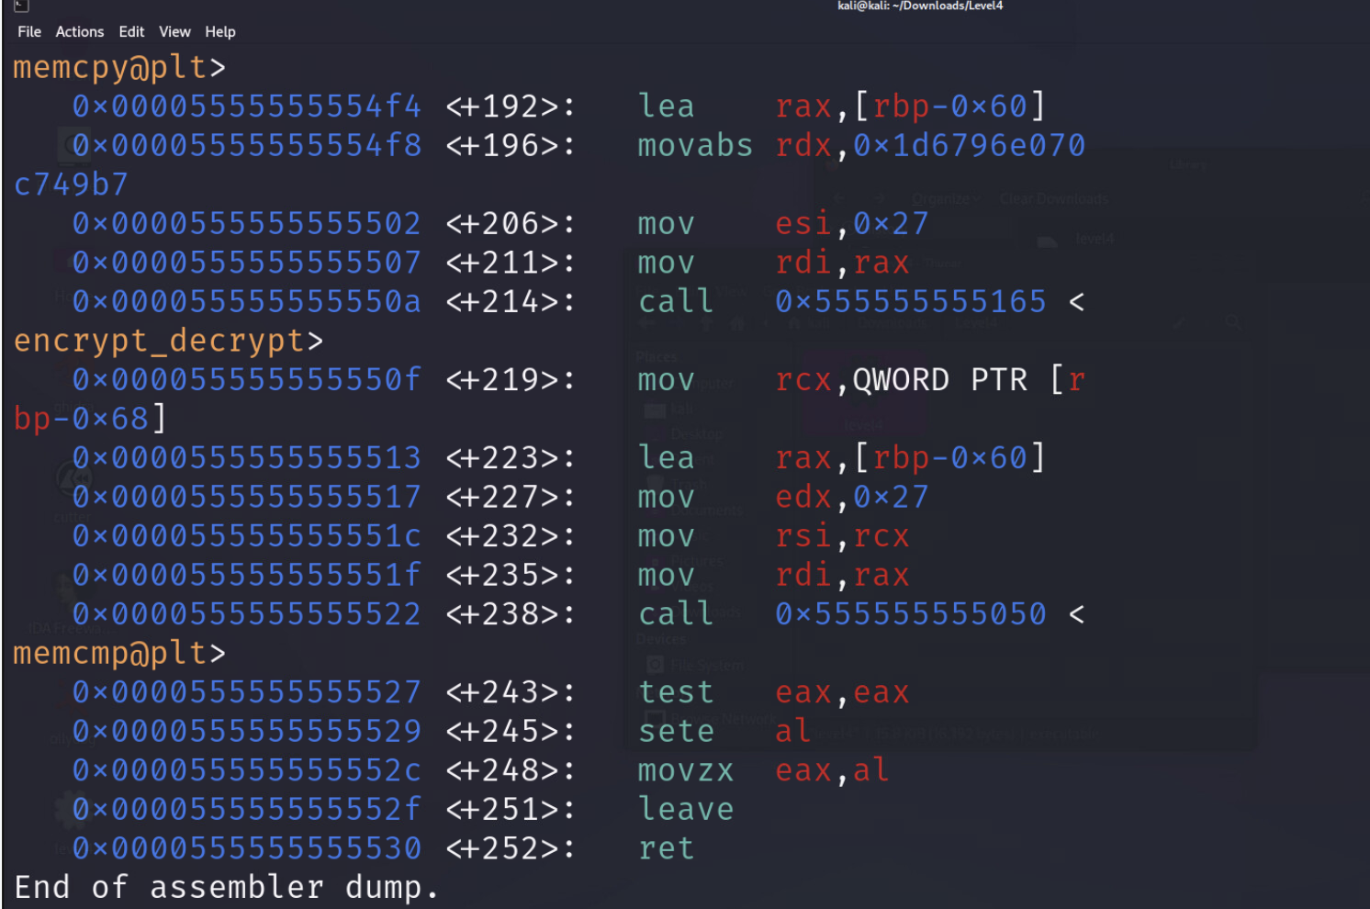I found the address for the memory copy here.

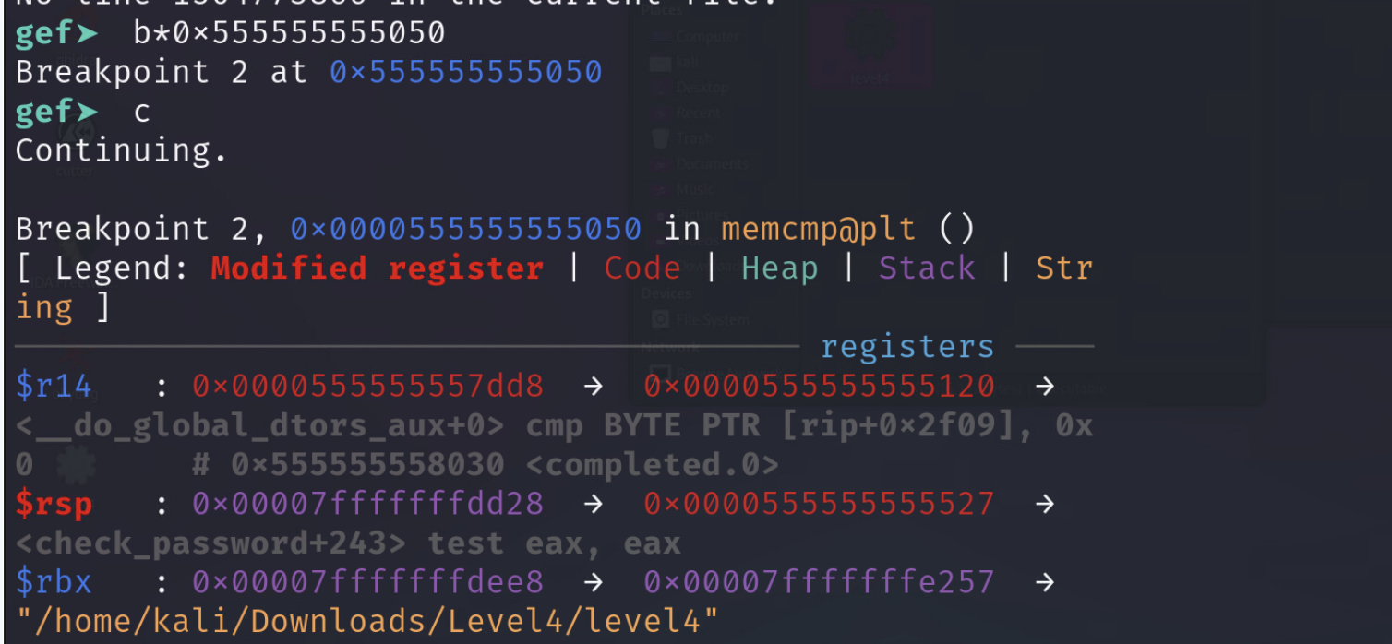I then made a breakpoint at the memory copy and then continued running the program.

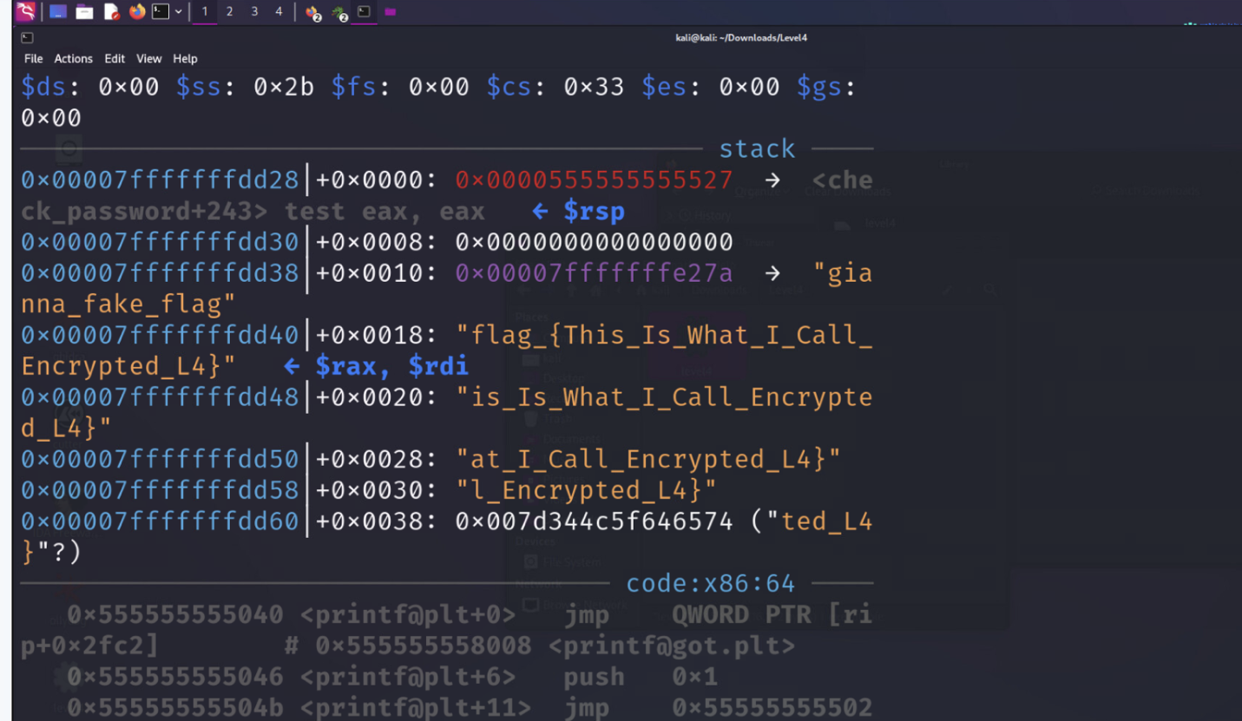I found the flag

5)

Congrats message 