I first opened the file in ghidra and searched in strings to look for the “you have succeeded” string

I then clicked on the what I believe is the check_password function (FUN_00400ad), which then brought me to what I believe to be the encrypt_decrypt and string compare



After I found the string compare, I ran qemu in one terminal

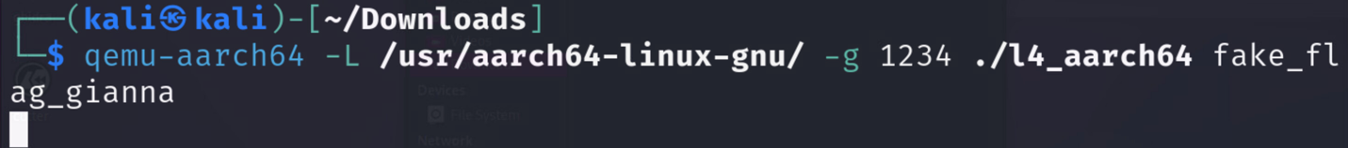

I opened another terminal and ran qemu

I then set a breakpoint at the string compare and then checked the registers to find the flag. I found the flag at x0

I then ran the flag to check to make sure it was right

