项目环境

cordova 7.1.0 android 6.3.0 ios 4.5.4

//项目初始化

cordova create bs

vue init webpack bs

//cordova插件安装

cordova plugin add cordova-plugin-background-mode

cordova plugin add cordova-plugin-camera

cordova plugin add cordova-plugin-splashscreen

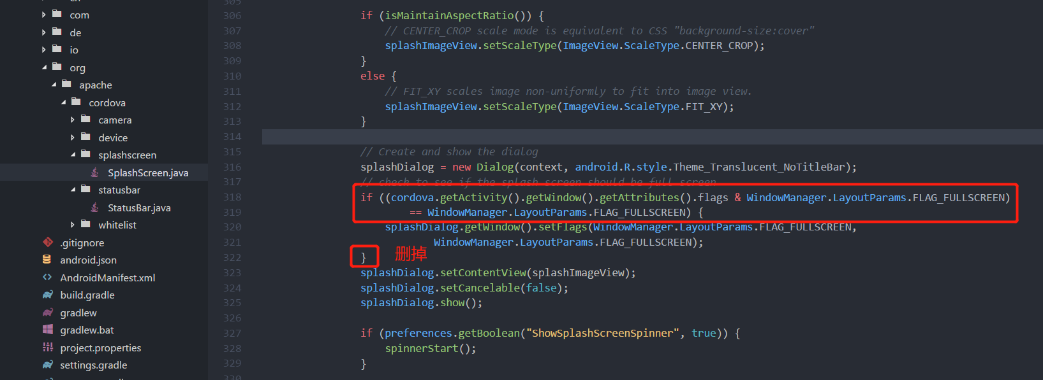

cordova plugin add cordova-plugin-statusbar

*//添加内容start*

window.addFlags(WindowManager.LayoutParams.FLAG_TRANSLUCENT_STATUS);

window.addFlags(WindowManager.LayoutParams.FLAG_TRANSLUCENT_NAVIGATION);

window.addFlags(WindowManager.LayoutParams.FLAG_DRAWS_SYSTEM_BAR_BACKGROUNDS);

window.setStatusBarColor(Color.TRANSPARENT);

window.setNavigationBarColor(Color.TRANSPARENT);

*//添加内容end*

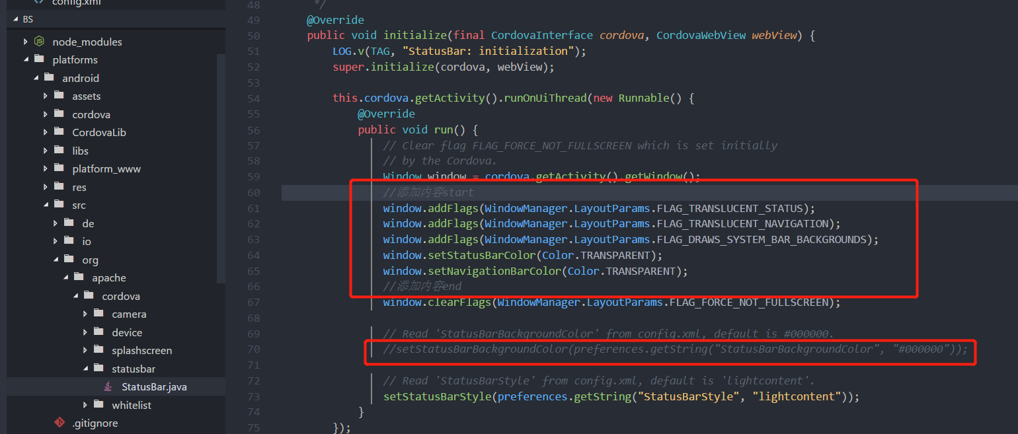

cordova plugin add cordova-sqlite-storage

cordova plugin add phonegap-plugin-barcodescanner

cordova plugin add ionic-plugin-keyboard

cordova plugin add cordova-plugin-alipay-v2 --variable APP_ID="2016080600177461"

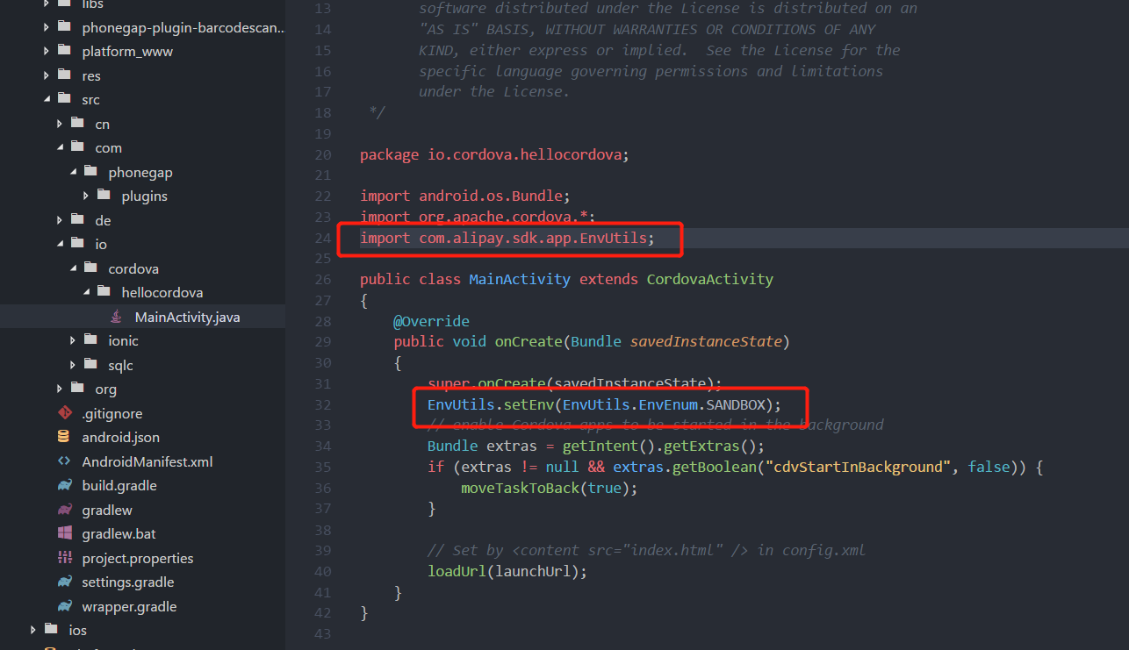

import com.alipay.sdk.app.EnvUtils;

EnvUtils.setEnv(EnvUtils.EnvEnum.SANDBOX);

cordova plugin add cordova-plugin-baidumaplocation --variable ANDROID_KEY="3IYf8CExg3Qf6xxZeCT7ybGDib55Dw9d" --variable IOS_KEY="OIlX6M6Pvf7k0Z8sUHLkGf7WYaje2Yfc"

cordova plugin add jpush-phonegap-plugin --variable APP_KEY="fbfaef04a0930b9075126e9a"



注意项目包名要和极光推送设置的保名一致

//其他插件安装

cnpm install axios –save

cnpm install jquery –save

cnpm install muse-ui –save

mu-icon替换

cnpm install qrcode-svg –save

cnpm install vue-awesome-swiper –save

cnpm install better-picker --save

cnpm install vuex --save