**Anytown Water DISTRICT**

00012-345-6789

BI-MONTHLY BILL:

**AWD**

|  |  |
| --- | --- |
| *Amount Due*  *Amount Due if Received After 6/3/13* | *$56.15*  *$63.53* |
| *Amount Enclosed* | *$* |

P.O. Box 1234

Anytown, CA 94781

*Bill Date: 05/15/13*

*Payment Due Date: 06/03/13 Account Number:* 00012-345-6789

*Service Address:* 321 Consumer Wy.

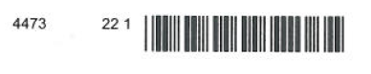

*Element #3: Customer option for paper copy delivery of CCR.*

John Doe Anytown Water District

321 Consumer Way P.O. Box 1234

Anytown, CA 94781 Anytown, CA 94781

Please check the box if you would prefer a paper copy of your annual water quality report delivered to your mailing address.

*Multilingual Requirement*

PLEASE RETURN TOP PORTION WITH PAYMENT

***THIS REPORT CONTAINS IMPORTANT INFORMATION ABOUT YOUR DRINKING WATER. PLEASE CONTACT ANYTOWN WATER DISTRICT AT P.O. BOX 1234, ANYTOWN, CA 94781 OR 555-555-5555   
FOR ASSISTANCE.***

***Este informe contiene información muy importante sobre su agua para beber. Favor de comunicarse Anytown Water District a P.O. Box 1234, Anytown, CA 94781 or   
555-555-5555 para asistirlo en español.***

The Consumer Confidence Report, or CCR, is an annual water quality report that the Safe Drinking Water Act (SDWA) requires AWD to provide you with. The purpose of the CCR is to raise customers’ awareness of the quality of their drinking water, where their drinking water comes from, what it takes to deliver water to their homes, and the importance of protecting drinking water sources.

In the past, AWDhas mailed its customers a printed copy of the CCR to comply with the SDWA. In 2013, the State of California expanded its interpretation of the SDWA to allow for electronic delivery of the CCR. The electronic delivery method will allow AWD to reduce the consumption of paper, and minimize potential printing and mailing costs.

***To view your 2012 Consumer Confidence Report and to learn more about your drinking water, please visit the following URL:***

**www.awd.org/CCR/2012**

If you would like a paper copy of the 2012 CCR mailed to your mailing address or would like to speak with someone about the report, please call (555) 555-5555.

**Summary of Charges**

Previous Balance 42.81

3/03/13 Payment – *Thank You* 42.81

Past Due Balance 0.00

Current Charges – *See Below*  56.24

Total Current Charges 56.24

**Total Amount Due $56.15**

**Payment Due Date 6/3/13**

**Calculation of Current Charges**

**Water Charges** 56.24

Water Service Charge 8.99

Water Consumption Charge 27 units @ 1.75 = 47.25

**Current Charges $56.15**

**Meter Readings** March 12, 2013 to May 12, 2013

Meter Meter Previous Current Consumption

Number Size Reading Reading

1234567 5/8 698 725 27

Total Consumption in units of water: 27

Total Consumption in gallons of water: 20196

Next Scheduled m*e*ter reading on or about July 13, 2013

*Element #5: Prominent display of the direct URL in bold type and a message explaining purpose of the URL.*

*Another possible option for satisfying Element #3: Providing customer with option to receive mailed paper copy of the CCR.*

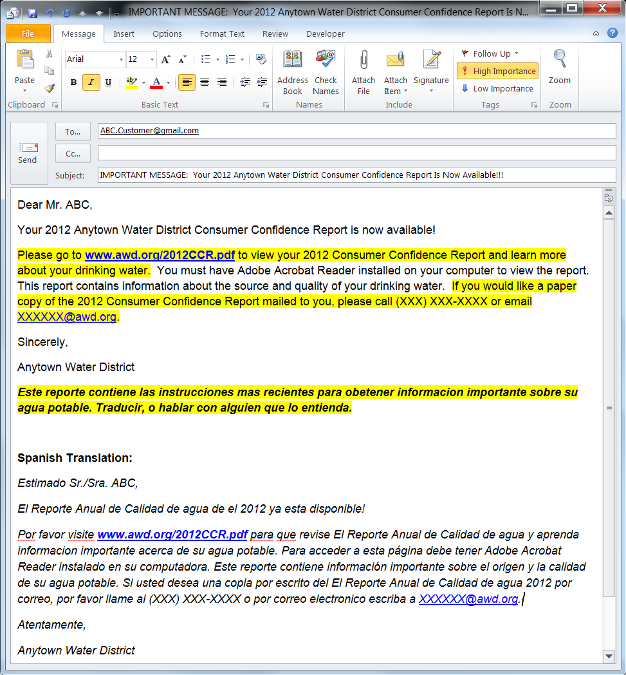

*Element #1 and #5: Prominent display of the direct link URL and a message explaining purpose of the URL.*

*Multilingual Requirement: At minimum, each delivery method must include the prescribed sentence translated in Spanish and in any additional languages as required by population size.*

*Element #3: Customer option for delivery of a mailed copy of the CCR*

*Element #6: Dedicated e-mail with a CCR-related subject line.*

*Multilingual Requirement: Water systems may choose to exceed the minimum multilingual requirement and translate the entire text of their email to ensure delivery to non-English speaking customers (optional).*

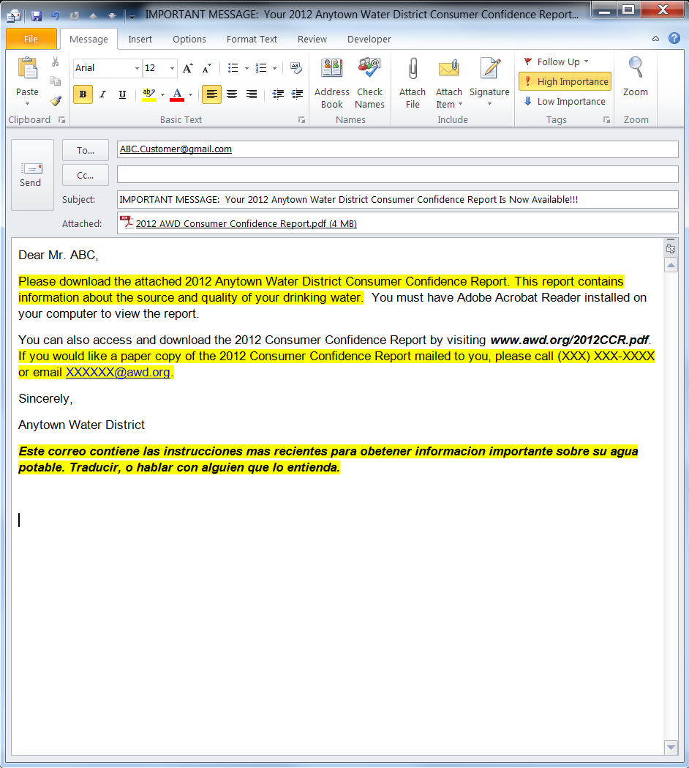

*Element #3: Inclusion of customer option for delivery of a mailed copy of the CCR*

*Multilingual Requirement: At minimum, each delivery method must include the prescribed sentence translated in Spanish and in any additional languages as required by population size.*

*Elements #1 and #5: Direct delivery of CCR by pdf attachment. Message containing instructions for opening attachment and purpose of attachment included.*

*Element #6: Dedicated e-mail with a CCR-related subject line.*

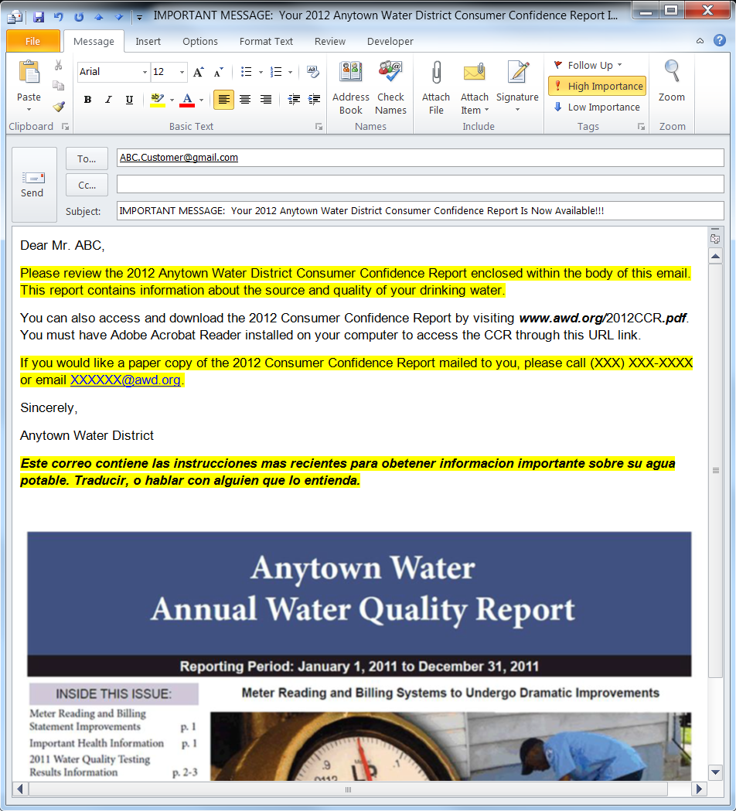

**Reporting Period: January 1, 2012 to December 31, 2012**

*Element #3: Inclusion of customer option for delivery of a mailed copy of the CCR*

*Multilingual Requirement*

*Element #1 and #5: Direct delivery of CCR by embedded image. Message containing instructions for viewing CCR enclosure and purpose of enclosure included.*

*Element #6: Dedicated e-mail with a CCR-related subject line.*

*Element #5: Prominent display of the direct URL and message explaining purpose of the URL.*