**The “Boston Medhane Alem Ethiopian Orthodox Tewahedo Church” ASP.NET MVC 5 Web Application**

**Description of the Web Site**

The “Boston Medhane Alem Ethiopian Orthodox Tewahedo Church web site provides church related information, Ethiopian Liturgy, church events, and audios/videos to the public. The web site also provides administration services to the **Boston Medhane Alem** **Church** administrators based on their roles: Add new user(s) delete/deactivate current user(s), post audio/video, get list of members, generate reports, and so on by the church admins.

**Purpose**

The purpose of this document is to list the functionalities/components to develop the actual web site.

**High level overview**

Create an ASP.NET MVC 5 application using the ASP.NET MVC Template that is installed in Visual Studio 2013. Additionally, Create the database with tables and stored procedures that will store and process church information. The Web site has Admin and Account controllers that will be accessible only to the registered church admins based on their roles. There are 3 types of users: application administrators, registered church member admins, and anonymous users.

* **Administration Section:** This section is accessible only to application administrators.
* **Church Member(Admin) Sections**: This section is accessible only to registered church

members(admins) and enables them to manages details of each member as well us to create/manage different reports

* **Public Section**: This Section is accessible to everyone (anonymous users) and displays church info/images/audio/video, and so on

Administration Section

The purpose of the administration section is to provide a place for the owner of the web site to configure the general web site settings and perform administrative actions, such us

* Suspend or even cancel member accounts
* See reports about membership
* Enable/Disable the email message features
* Add new user
* Modify record of current user

Church Member(Admin) Section

The Church Member(Admin) Section is where church member admins can create/add church member profile data to the database. To access the church member admin section, church admins are required to have an account that to uniquely identify them

Public Section

The public section of the web site is accessible to anyone with a web browser and is the place where members of the public can go to

* Register to gain access to church member section
* View church info
* See images/audio/video
* Send an email message to admins and post church related comments

The following tables/stored procedures are required

1. Member – lists the fields of each Member
2. Role- lists the fields of each Role
3. UserLoin – lists the fields of each User Name
4. Payment – lists the fields to generate report
5. PasswordChanges – lists fields for password change

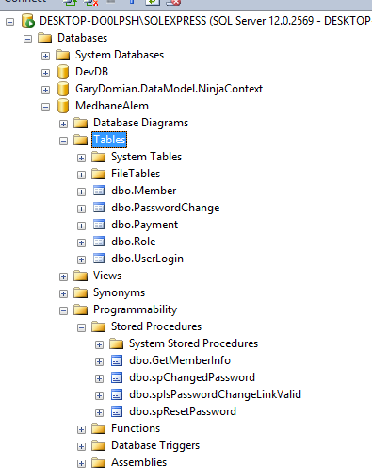

The following shows sample member data

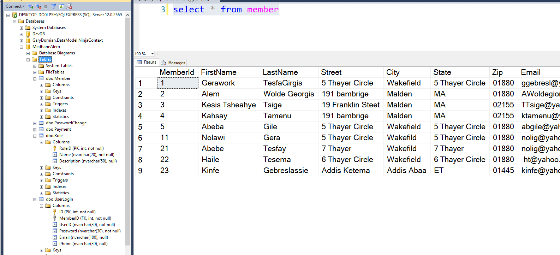

INSERT INTO [dbo].[members]

([FistName],[LastName],[Street] ,[City],

[State],[Zip],[Email],[Fax],[CellPhone],

[HomePhone],[RoleID],[MemberCreateDate],

[MemberUpdateDate])

VALUES ('Gerawork', 'Gebreslassie', '5 Thayer Circle',

'Wakefield', 'MA', '01880', 'ggebresl@yahoo.com',

null, '7814547638',null, 1, GETDATE(),GETDATE())

INSERT INTO [dbo].[members]

([FistName],[LastName],[Street] ,[City],

[State] ,[Zip],[Email],[Fax],[CellPhone],

[HomePhone],[RoleID],[MemberCreateDate],[MemberUpdateDate])

VALUES ('Alem', 'Wolde Georgis', '191 bambrige',

'Malden', 'MA', '01880', 'AWoldegiorgis@yahoo.com',

null, '6172835348',null, 2, GETDATE(),GETDATE())

INSERT INTO [dbo].[members]

([FistName],[LastName],[Street] ,[City],

[State] ,[Zip],[Email],[Fax],[CellPhone],

[HomePhone],[RoleID],[MemberCreateDate],[MemberUpdateDate])

VALUES ('Kesis Tsheahye', 'Tsige', '19 Franklin Steet',

'Malden', 'MA', '02155', 'TTsige@yahoo.com',

null, '7815886329',null, 3, GETDATE(),GETDATE())

, 5,GETDATE(),GETDATE())

INSERT INTO [dbo].[UserLogin]

([MemberID],[UserID],[Password],[Email],[Phone]) VALUES(1, 'ggebresl', '1ggebresl', 'ggebresl@yahoo.com', '7814547638')

INSERT INTO [dbo].[UserLogin]

([MemberID] ,[UserID],[Password],[Email],[Phone])

VALUES(2, 'awolde', '2awolde', 'AWoldegiorgis@yahoo.com', '6172835348')

INSERT INTO [dbo].[UserLogin]

([MemberID] ,[UserID],[Password],[Email],[Phone])

VALUES(3, 'ktsige', '3ktsige', 'TTsige@yahoo.com', '7815886329')

INSERT INTO [dbo].[UserLogin]

([MemberID] ,[UserID],[Password],[Email],[Phone])

VALUES(4, 'ktamenu', '4ktamenu', 'ktamenu@yahoo.com', '6173202217')

**The following shows relationship of each tables:**

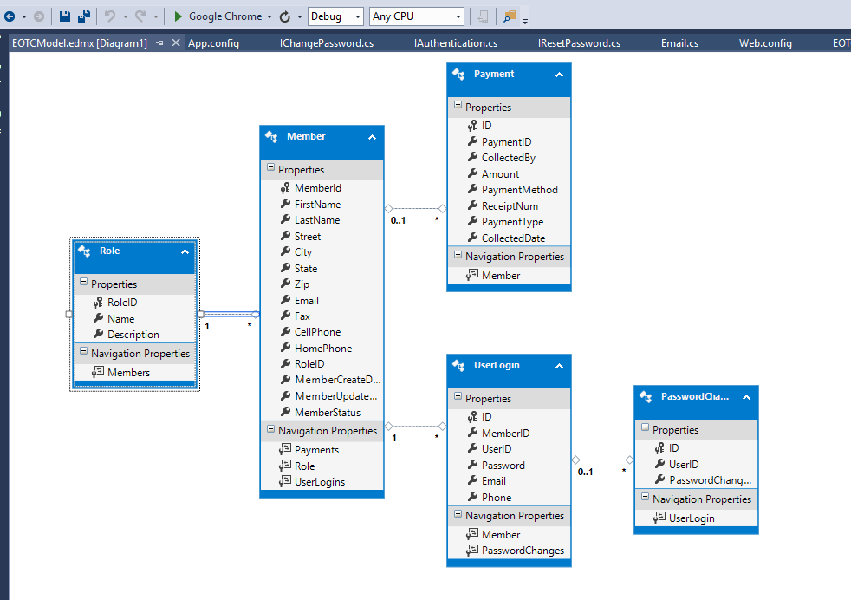

**Sample Solution:**

