[https://zoom.us/j/616718094](https://nam04.safelinks.protection.outlook.com/?url=https%3A%2F%2Fzoom.us%2Fj%2F616718094&data=02%7C01%7C%7Cfa040ac4a8e4440197bf08d6aefac1ab%7C84df9e7fe9f640afb435aaaaaaaaaaaa%7C1%7C0%7C636888789340901948&sdata=mExWKuFCKH7maanFhqqi22jWQ0ScVzca38Ah05b0Tbk%3D&reserved=0)

<https://docs.python.org/3/library/re.html>

[https://zoom.us/j/616718094](https://nam04.safelinks.protection.outlook.com/?url=https%3A%2F%2Fzoom.us%2Fj%2F616718094&data=02%7C01%7C%7Cfa040ac4a8e4440197bf08d6aefac1ab%7C84df9e7fe9f640afb435aaaaaaaaaaaa%7C1%7C0%7C636888789340901948&sdata=mExWKuFCKH7maanFhqqi22jWQ0ScVzca38Ah05b0Tbk%3D&reserved=0)

<http://www.numpy.org/>

<http://pandas.pydata.org/>

<https://www.scipy.org/>

<https://www.scipy.org/scipylib/>

<https://scikit-learn.org/stable/>

<https://matplotlib.org/>

**04/15/2019**



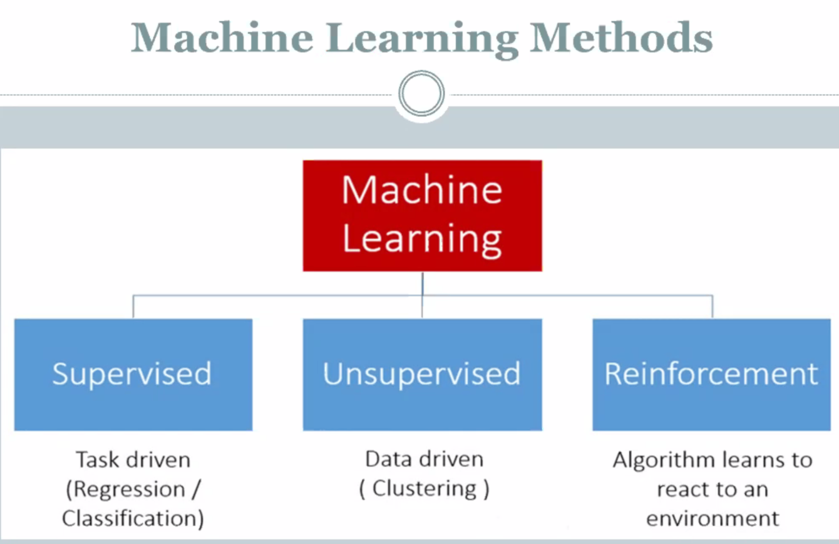

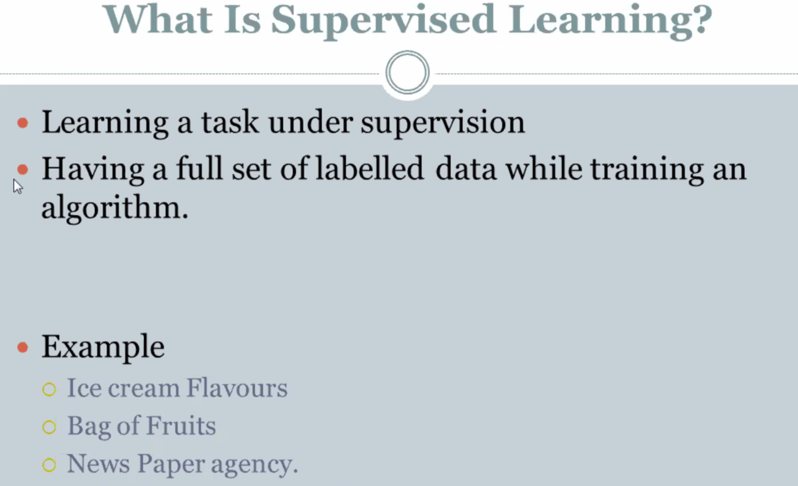



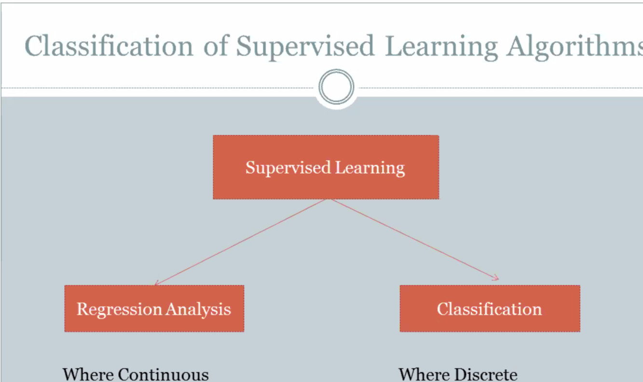

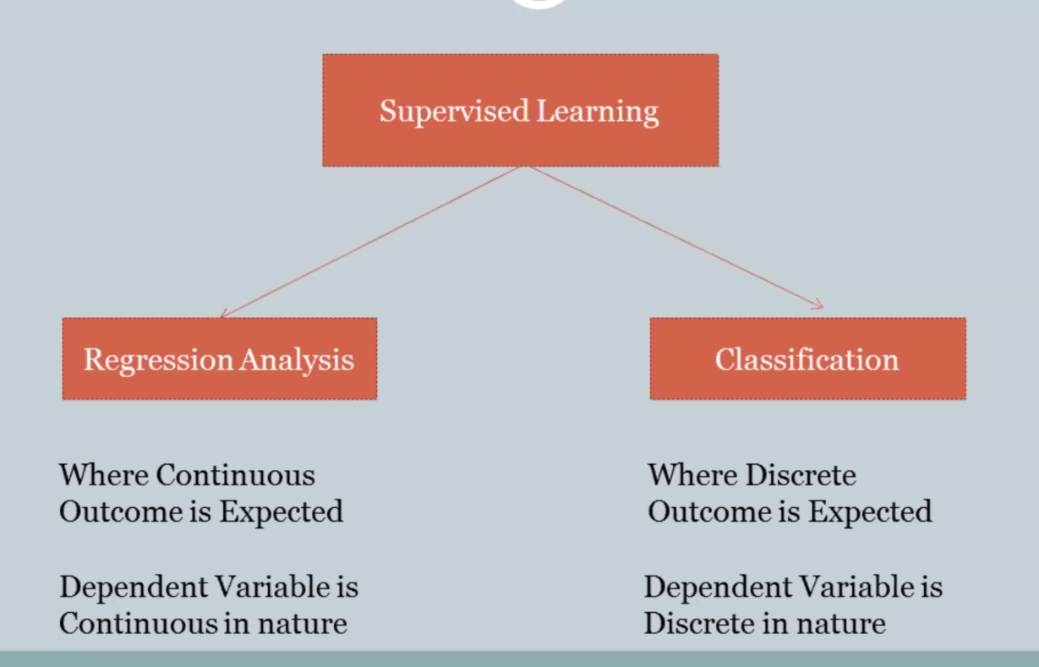

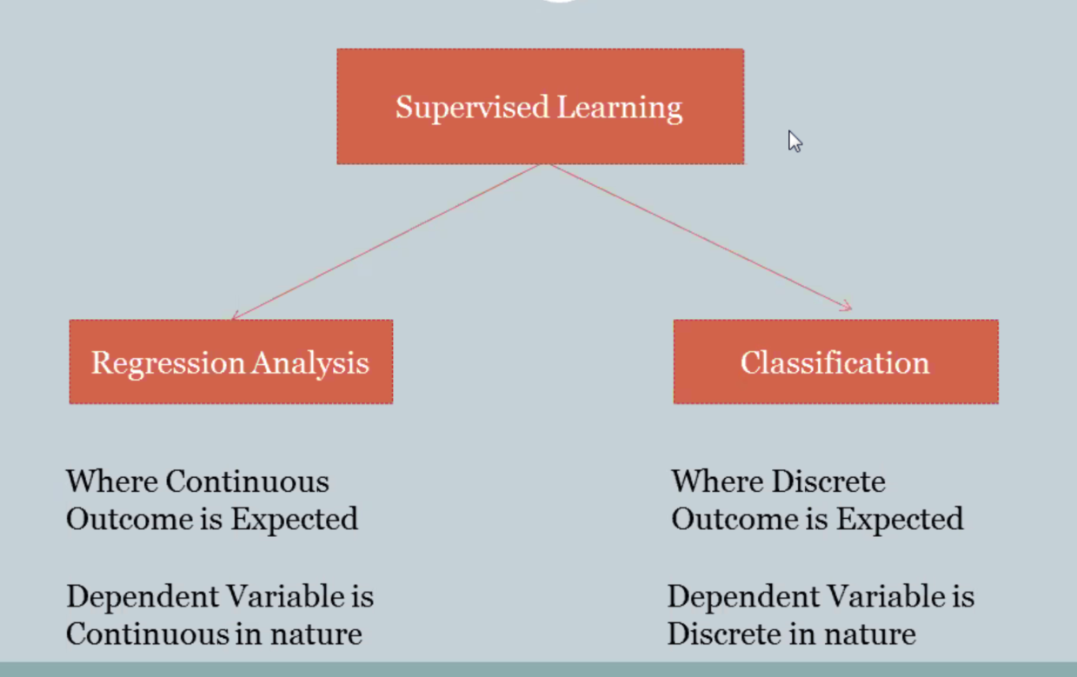

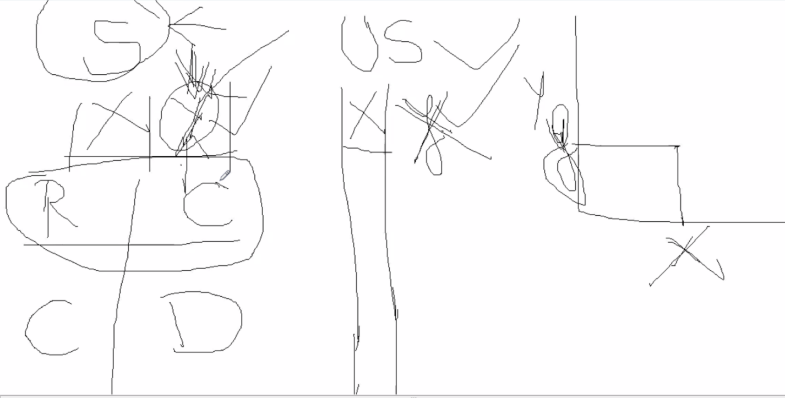

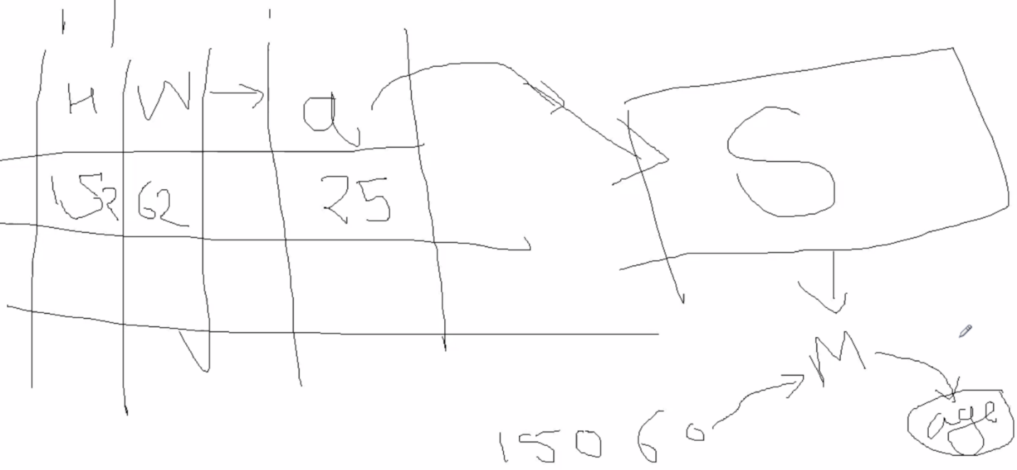

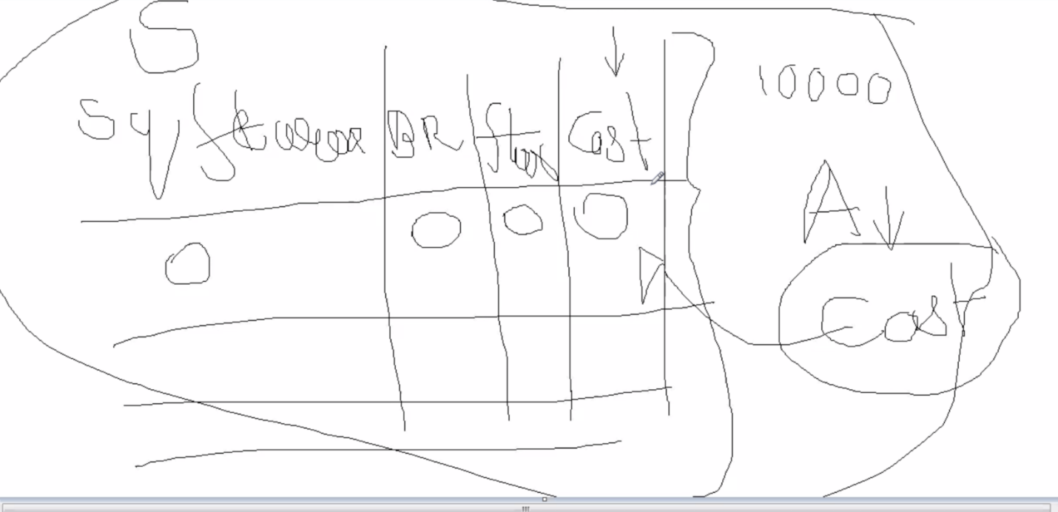

**Based on the outcome. This is a regression**

