**What is t-test?**

The t test (also called Student’s T Test) compares two averages (means) and tells you if they are different from each other. The t test also tells you how [significant](http://www.statisticshowto.com/what-is-statistical-significance/) the differences are; In other words it lets you know if those differences could have happened by chance.

**What is t-test?**

The t test (also called Student’s T Test) compares two averages (means) and tells you if they are different from each other. The t test also tells you how significant the differences are; In other words it lets you know if those differences could have happened by chance.

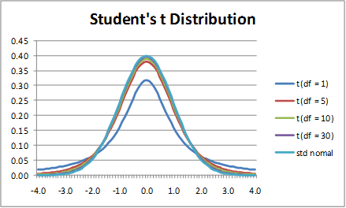

**t-distribution**

**A very simple example:** Let’s say you have a cold and you try a naturalistic remedy. Your cold lasts a couple of days. The next time you have a cold, you buy an over-the-counter pharmaceutical and the cold lasts a week. You survey your friends and they all tell you that their colds were of a shorter duration (an [average](http://www.statisticshowto.com/average/) of 3 days) when they took the homeopathic remedy. What you *really* want to know is, are these results repeatable? A t test can tell you by comparing the means of the two groups and letting you know the probability of those results happening by chance.

**Another example:** Student’s T-tests can be used in real life to compare means. For example, a drug company may want to test a new cancer drug to find out if it improves life expectancy. In an experiment, there’s always a [control group](http://www.statisticshowto.com/control-group/) (a group who are given a placebo, or “sugar pill”). The control group may show an average life expectancy of +5 years, while the group taking the new drug might have a life expectancy of +6 years. It would seem that the drug might work. But it could be due to a fluke. To test this, researchers would use a Student’s t-test to find out if the results are repeatable for an entire population.

**What is t-score?**

The [t score](http://www.statisticshowto.com/t-score-formula/) is a ratio between the **difference between two groups and the difference within the groups**. The larger the t score, the more difference there is between groups. The smaller the t score, the more similarity there is between groups. A t score of 3 means that the groups are three times as different *from* each other as they are within each other. When you run a t test, the bigger the t-value, the more likely it is that the results are repeatable.

* A large t-score tells you that the groups are different.
* A small t-score tells you that the groups are similar.

**What are T-Values and P-values?**

How big is “big enough”? Every t-value has a p-value to go with it. A p-value is the [probability](http://www.statisticshowto.com/probability-and-statistics/probability-main-index/) that the results from your sample data occurred by chance. P-values are from 0% to 100%. They are usually written as a decimal. For example, a p value of 5% is 0.05. **Low p-values are good**; They indicate your data did not occur by chance. For example, a p-value of .01 means there is only a 1% probability that the results from an experiment happened by chance. In most cases, a p-value of 0.05 (5%) is accepted to mean the data is valid.

**Types of t-tests?**

There are **three main types of t-test:**1.An **Independent Samples t-test** compares the means for two groups.  
2. A **Paired sample t-tes**t compares means from the same group at different times (say, one year apart).  
3. A **One sample t-test** tests the mean of a single group against a known mean.

**How to perform a 2 sample t-test?**

Lets us say we have to test whether the height of men in the population is different from height of women in general. So we take a sample from the population and use the t-test to see if the result is significant.

**Steps:-**

1. **Determine a null and alternate hypothesis.**In general, the null hypothesis will state that the two populations being tested have no statistically significant difference. The alternate hypothesis will state that there is one present. In this example we can say that:

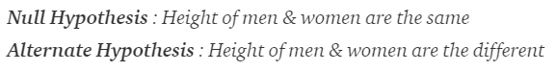

**2. Collect sample data**Next step is to collect data for each population group. In our example we will collect 2 sets of data, one with the height of women and one with the height of men. The sample size should ideally be the same but it can be different. Lets say that the sample sizes are nx and ny.

**3. Determine a confidence interval and degrees of freedom**This is what we call alpha (α). The typical value of α is 0.05. This means that there is 95% confidence that the conclusion of this test will be valid. The degree of freedom can be calculated by the the following formula:

https://cdn-images-1.medium.com/max/1600/1*qRJLlOvVG_56qsDqrdLkyQ.png

**4. Calculate the t-statistic**t-statistic can be calculated using the below formula:

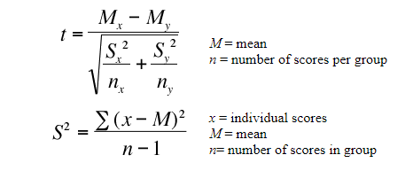

where,Mx and My are the mean values of the two samples of male and female.  
Nx and Ny are the sample space of the two samples  
S is the standard deviation

**5. Calculate the critical t-value from the t distribution**To calculate the critical t-value, we need 2 things, the chosen value of alpha and the degrees of freedom. The formula of critical t-value is complex but it is fixed for a fixed pair of degree of freedom and value of alpha. We therefore use a table to calculate the critical t-value:

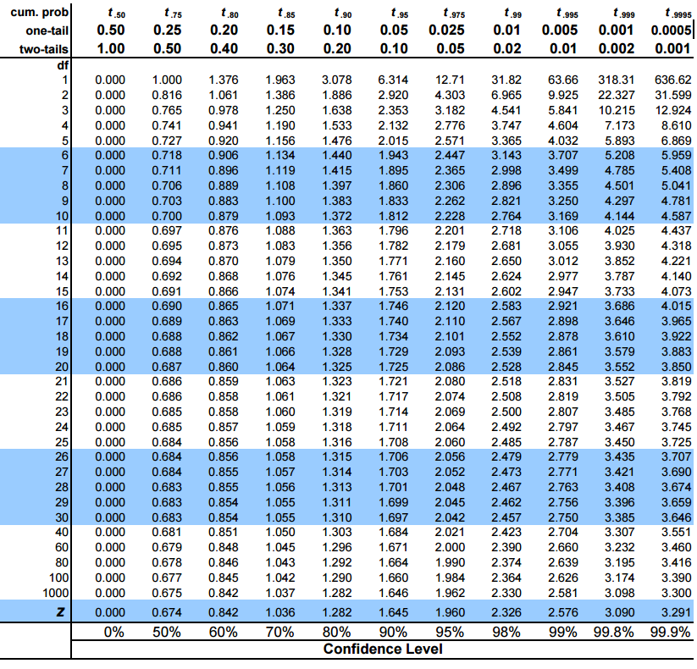

In python, rather than looking up in the table we will use a function from the sciPy package

**6. Compare the critical t-values with the calculated t statistic**If the calculated t-statistic is greater than the critical t-value, the test concludes that there is a statistically significant difference between the two populations. Therefore, you reject the null hypothesis that there is no statistically significant difference between the two populations.

In any other case, there is no statistically significant difference between the two populations. The test fails to reject the null hypothesis and we accept the alternate hypothesis which says that the height of men and women are statistically different.