Control and the press back tick (on the left side or number 1 in the key board). Doing this will take you to the integrated IDE/Palet

<https://cran.r-project.org/>

[http://www.superdatascience.com/2](http://superdatascience.com/2)

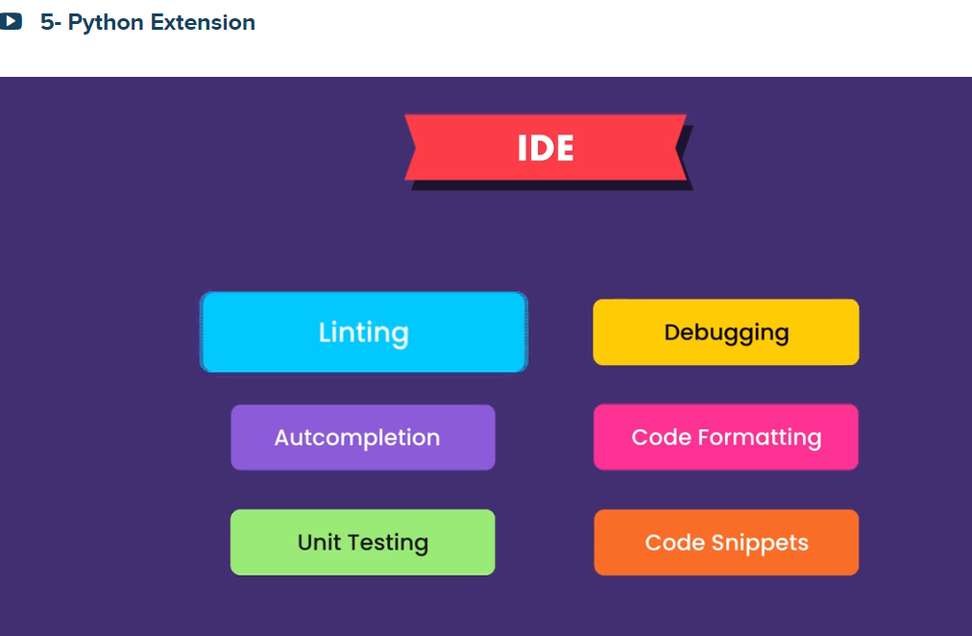

Look at Python Pep8 or <https://www.python.org/dev/peps/>

From the Palate install

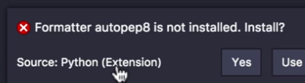

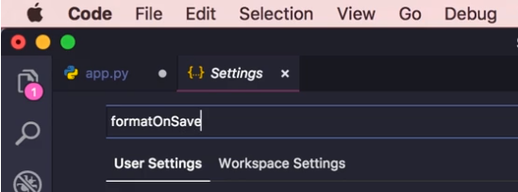

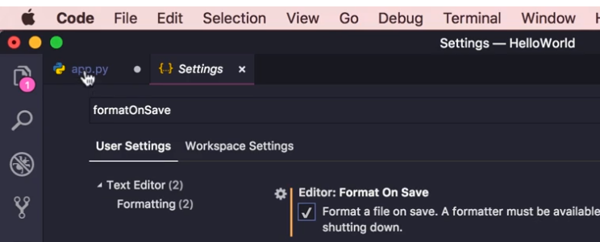

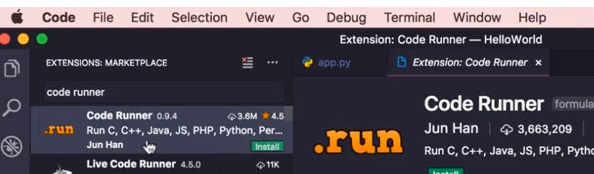

Press Control, ALT and press n