**基于Reactor模式的HTTP服务器**

**Github链接：**[**https://github.com/gggggwen/HTTPWebServer**](https://github.com/gggggwen/HTTPWebServer)

**个人项目还在更新中……**

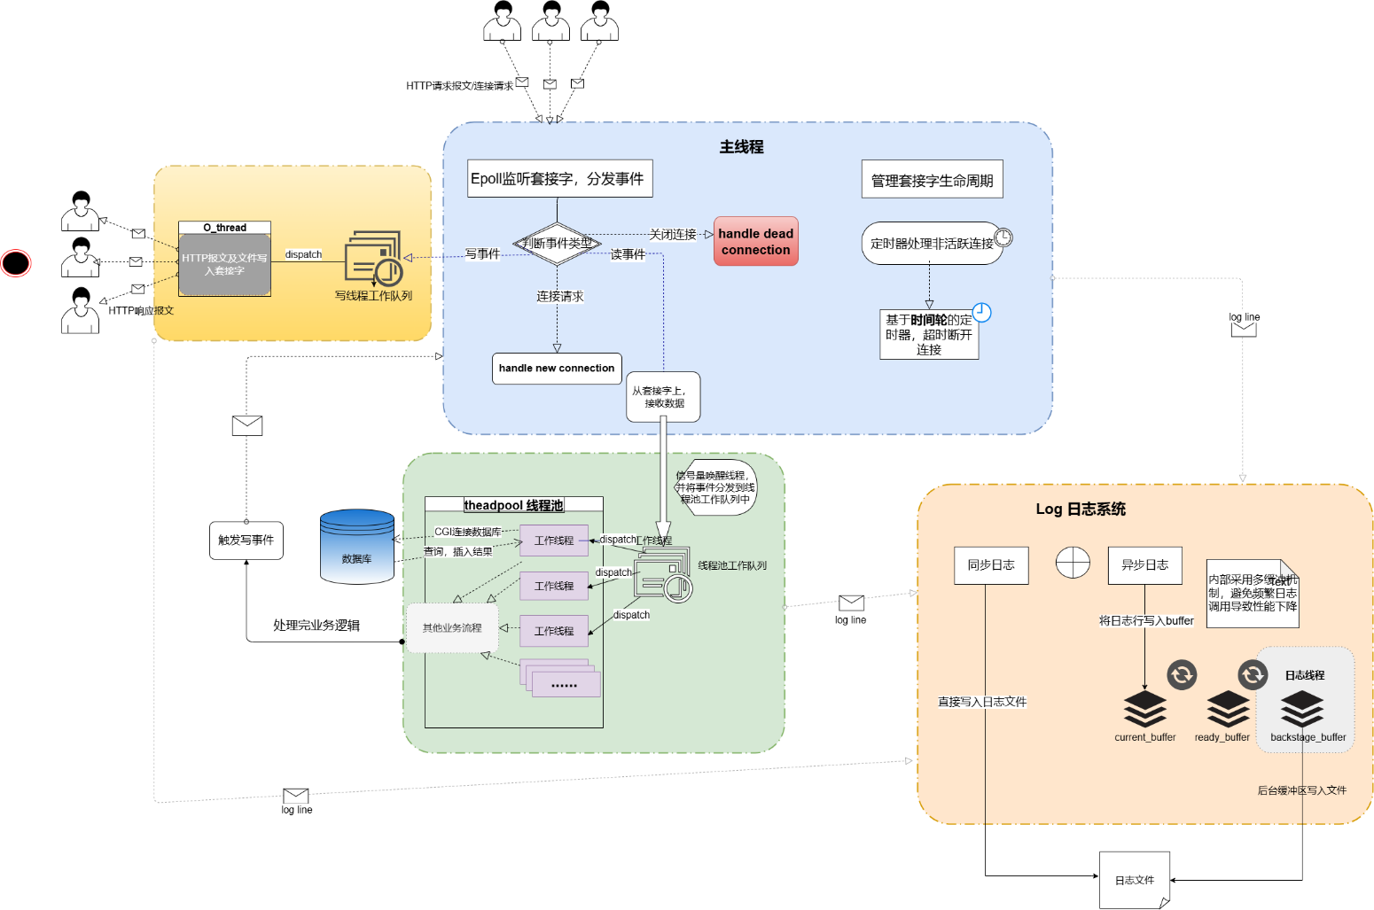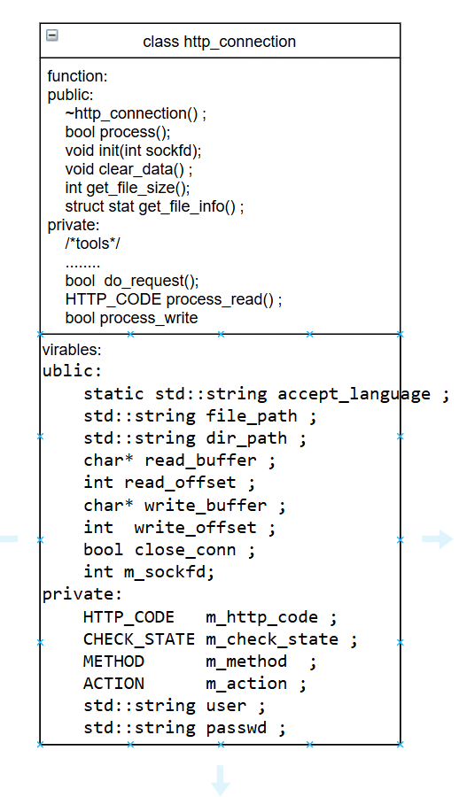**类图关系如下：**



