**Print Log For Tester**

**————————————————————————————————**

**1.Connect Device With Jlink**

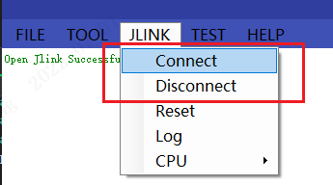

**2.Put “*DSP_ID_Table.data*” of FW in work Directory。**

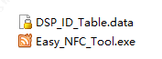

**3.Open Log Form**

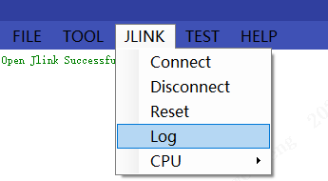

**4.Check Log Status**

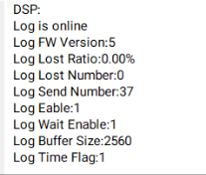

**————————————————————————————————**

**Add Code For Developer**

**————————————————————————————————**

1. **Add printf_wilf.c/.h To Dsp Project**
2. **Call printf_rtt to output log**

* Int Var = 123;
* printf_rtt(0,main) //ID=0 for function
* Printf_rtt(1~250,Var) //ID>0 for variable, reserve:251~255

1. **Generate DSP_ID_Table.data**

* Set DSP Project Directory at first(input command “Set [DspProjectPath]“)

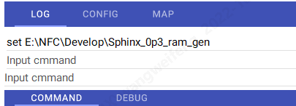

* Open Log Form will Generate **“*DSP_ID_Table.data”*** Automatically In Current Work Directory

**————————————————————————————————**

**Read/Write Memory**

* ws register_name value
* rs register_name
* w address value
* r address value

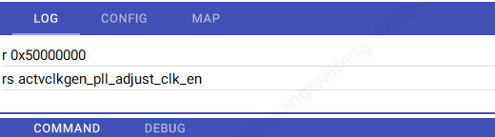

**MARK:Enter For Execute**

**————————————————————————————————**

**Map Signal To Pin**

* **For Eaxmple: Map pll lock Signal To AOGPIO1 For Test**

