**5.4**

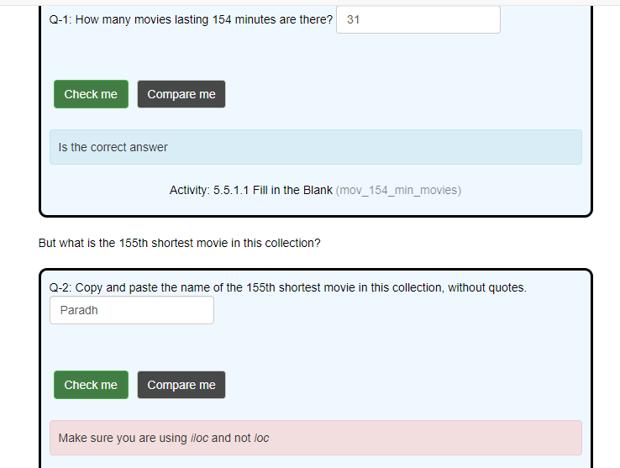**5.5**

**5.6**