1 - Getting Started with Excel

3 - Creating and Opening Workbooks

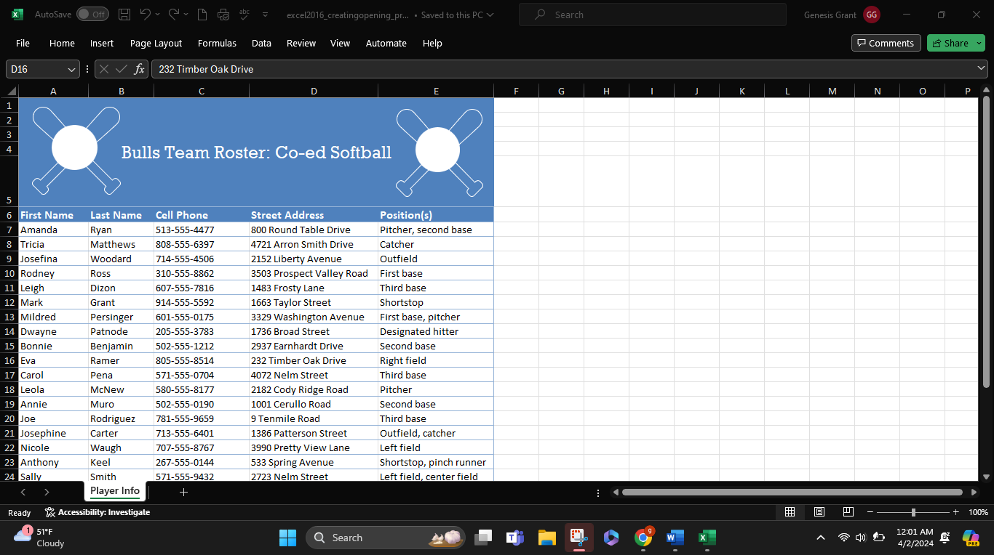

4 - Saving and Sharing Workbooks

5 - Cell Basics

6 - Modifying Columns, Rows, and cells

7 - Formatting Cells