15 - Relative and Absolute Cell References

16 – Functions

Lesson 18: Freezing Panes and View Options

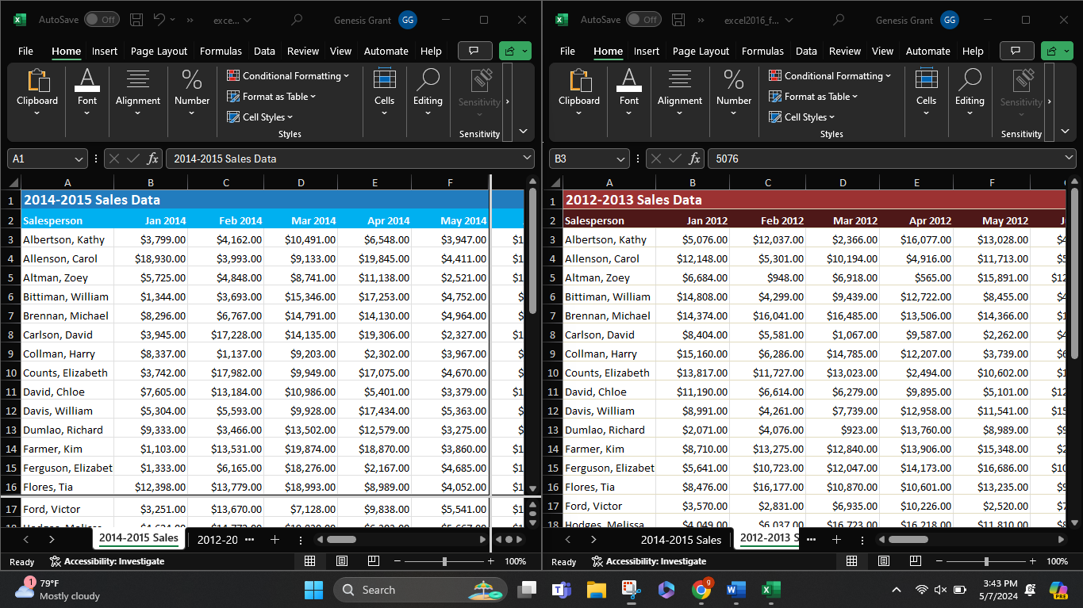

19 - Sorting Data

20 - Filtering Data

