CODE HS ASSIGNMENT

2.1.5

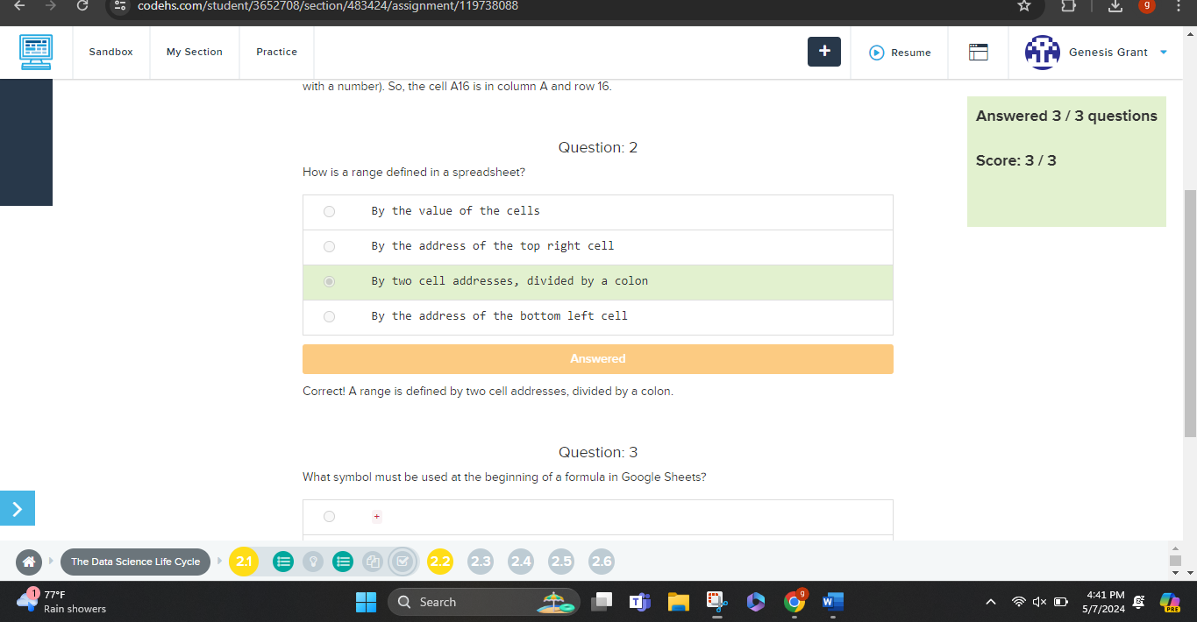

2.2.2

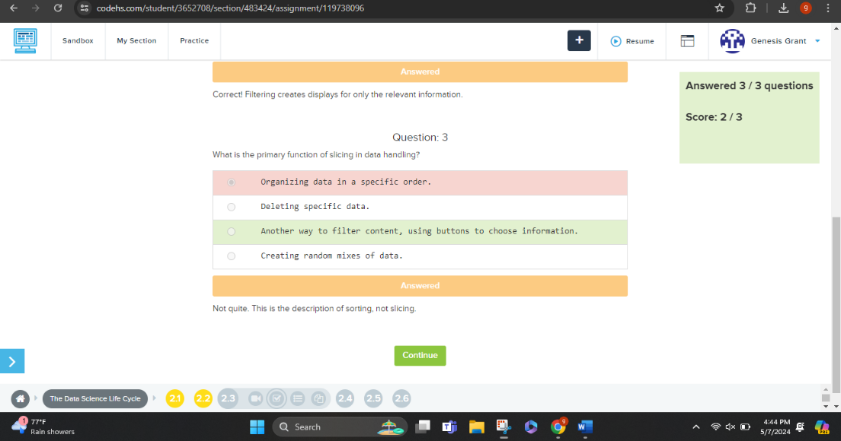2.3.2

2.4.2

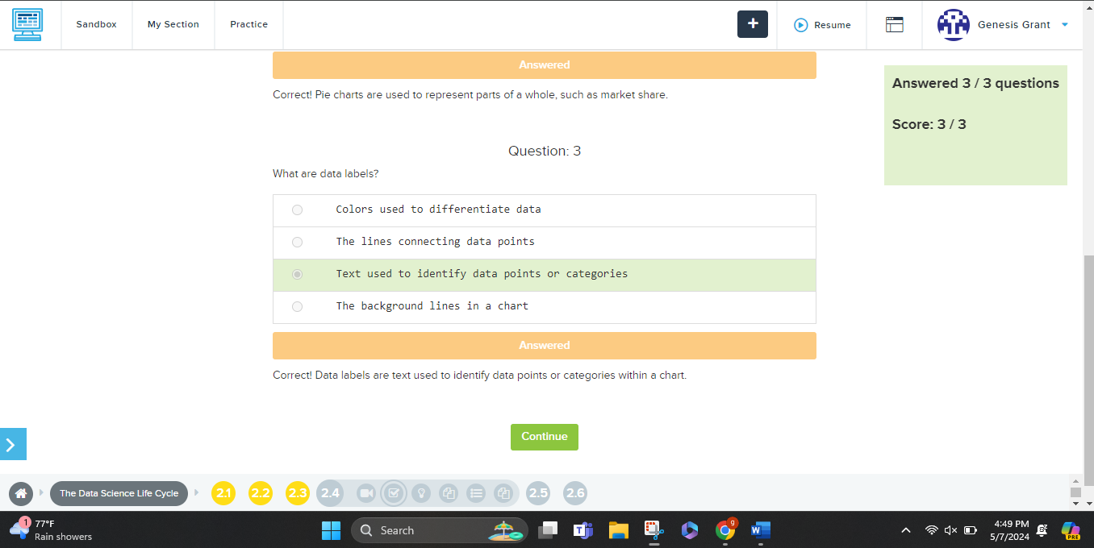

2.5.2

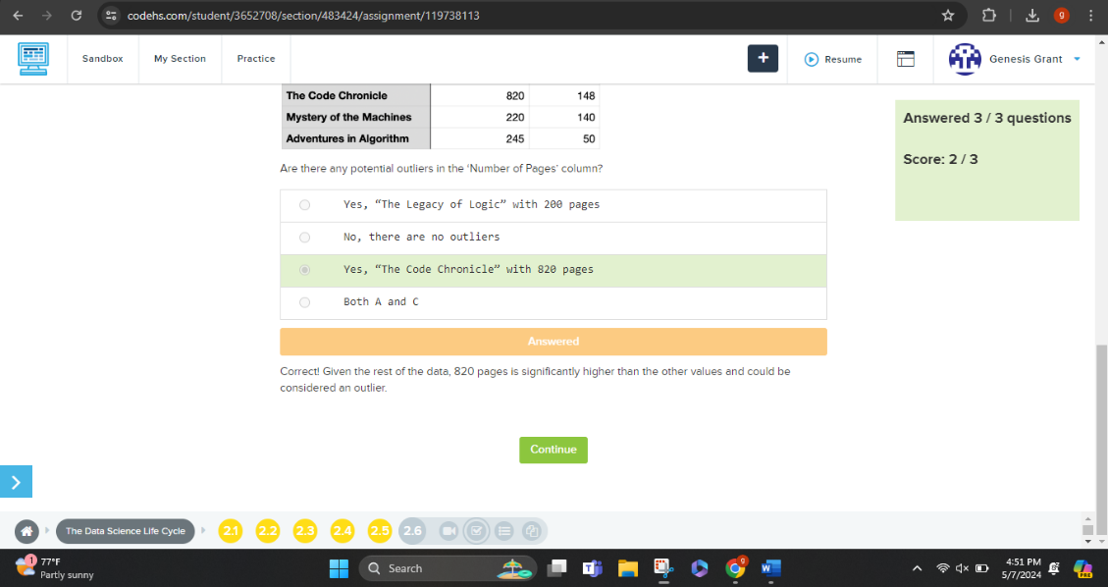2.6.2