Genesis Grant

Week 6: Stats Assignment

**2.3.1**

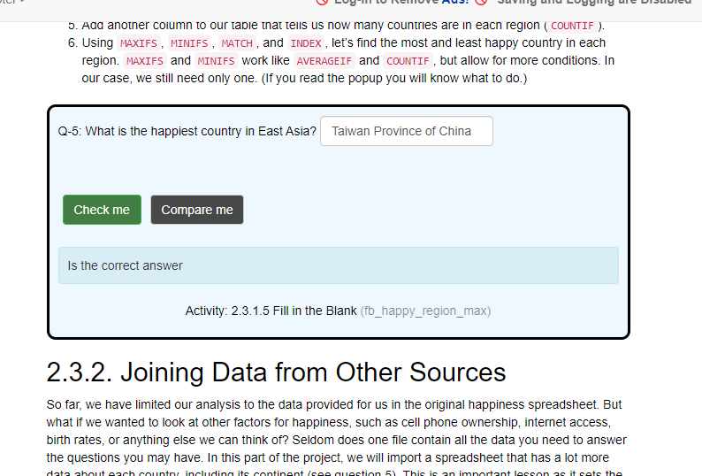

**2.3.2**

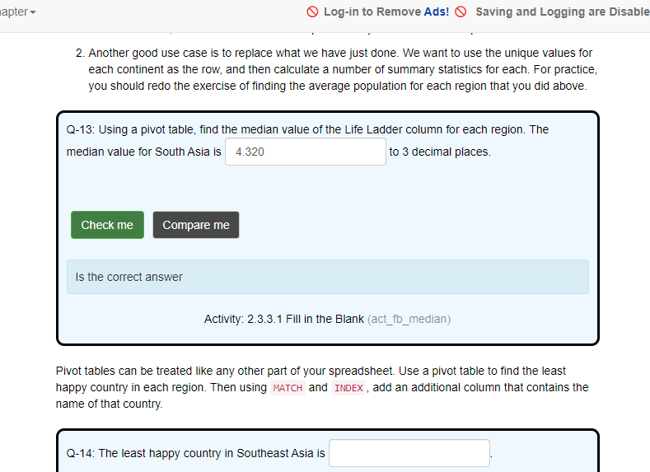**2.3.3.**

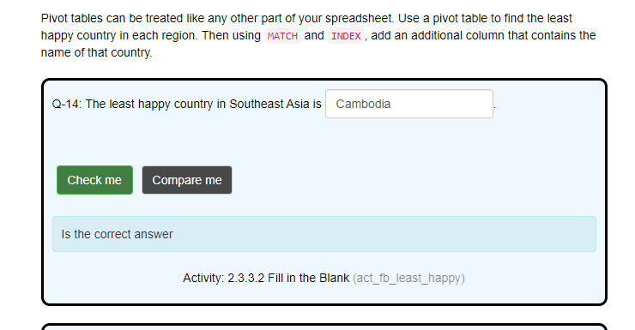

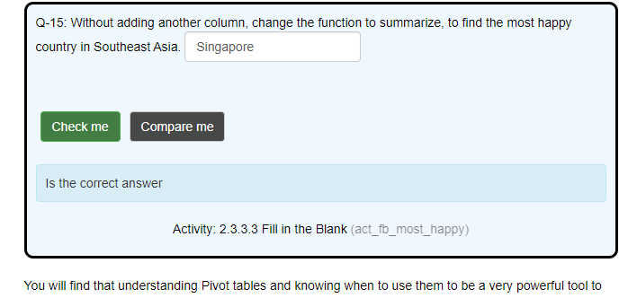

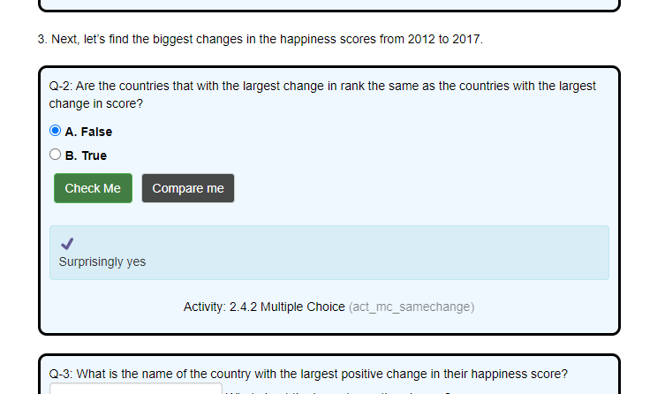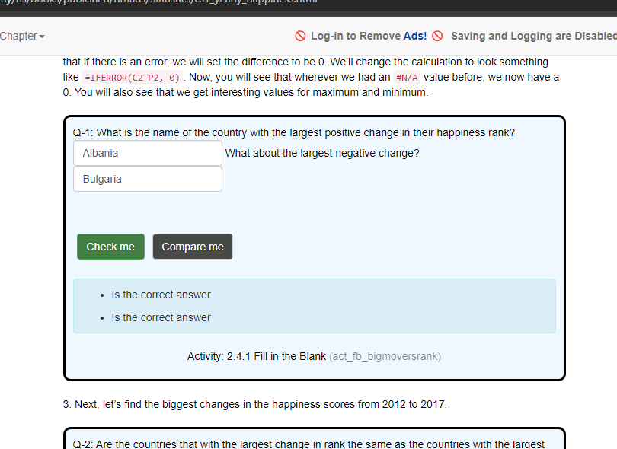**2.4**

