Genesis Grant

CTEC 324

LAB 11: Functions

gpa_message CODE:

gpa_message(3.55)  
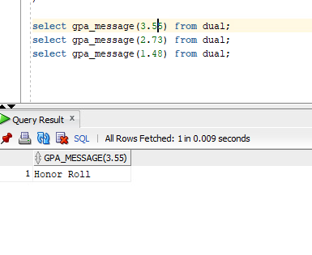

gpa_message(2.73)

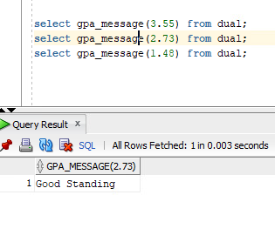

gpa_message(1.48)

