Genesis Grant

CTEC 350

Chapter 5 Exercises

Exercise 1

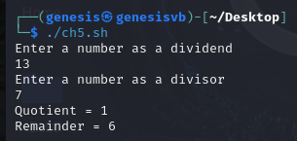

Exercise 2

Exercise 3

Exercise 4

Exercise4

