Genesis Grant

CTEC 350

John the Ripper CW1

Task 1

Task 2

Task 3

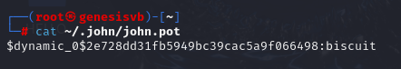

Task 4

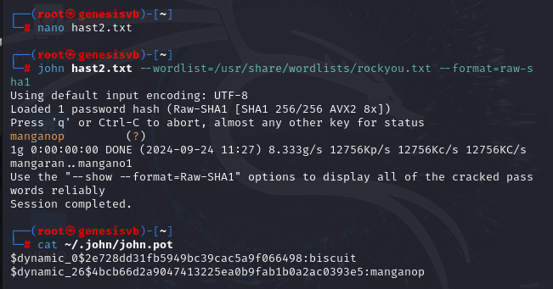

Task 5

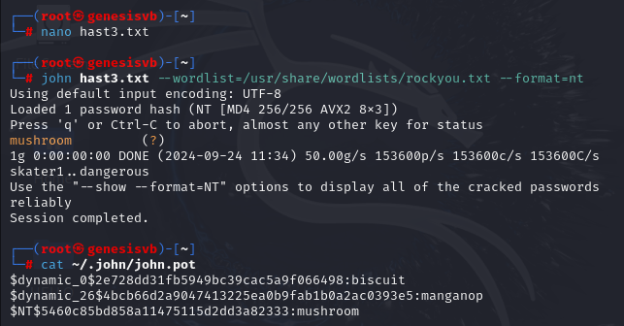

Task 6

\*Created own hash from sha224

\*Switched with CHIEF BENTIL (unable to upload file)

