Genesis Grant

Python Classwork

Task1:

Task2:

Task3:

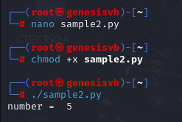

Task4:

