Genesis Grant

CTEC 402

In Class Assignment 4

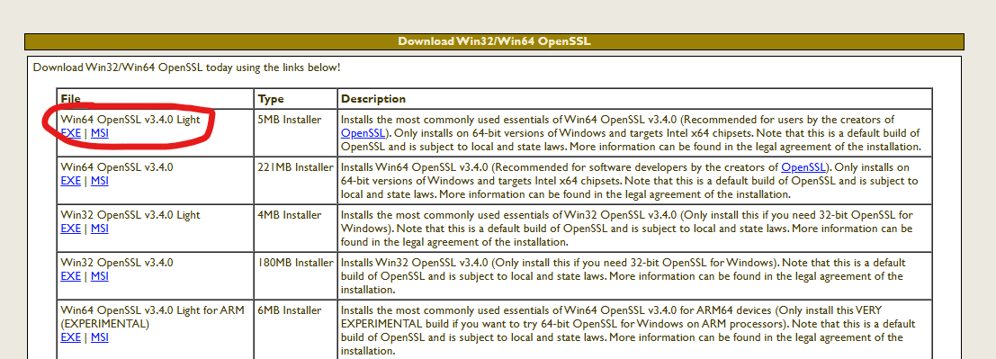

**How to Create Self Signed X509 Certificate:**

1. Navigate to download the Win64 Open SSL

download.

1. After the simple installation questions, install

the downloads.

**OPENSSL did not download for any of the installers so when I tried to use command prompt to create a digital certificate it kept saying the package was not there.

1. To create a private key(RSA key pair) use this script in command prompt as an administrator:
   1. openssl genrsa -des3 -out server.key 2048
2. To create a certified signing request use this script in command prompt as an administrator:
   1. openssl req -new -key server.key -sha256 -out server.csr)
3. To create a Self Signed Certificate use this script in command prompt as an administrator:
   1. openssl x509 -req -days 365 -in server.csr -signkey server.key -sha256 -out server.crt)