Genesis Grant

CTEC 298

Learn the Basics: Part 2

7. Conditions

8. Loops

9. Functions

10. Classes and Objects

11. Dictionaries

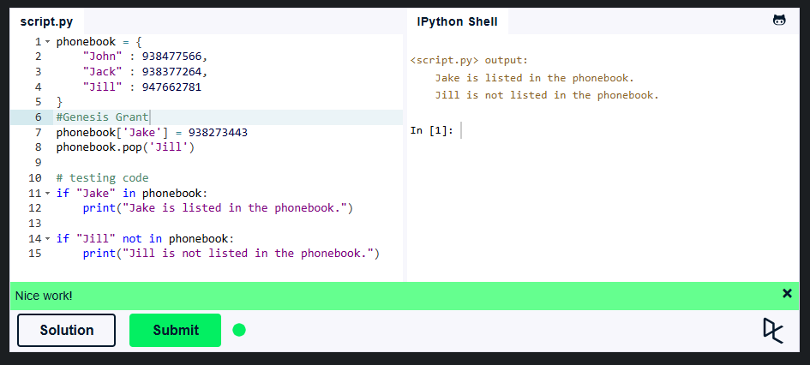

12. Modules and Packages

