heatmap_final

GG

1/28/2019

Loading Libraries

library(ggplot2)  
library(tidyverse)

## ── Attaching packages ─────────────────────────────────────── tidyverse 1.2.1 ──

## ✔ tibble 1.4.2 ✔ purrr 0.2.4  
## ✔ tidyr 0.8.0 ✔ dplyr 0.7.4  
## ✔ readr 1.1.1 ✔ stringr 1.3.0  
## ✔ tibble 1.4.2 ✔ forcats 0.3.0

## ── Conflicts ────────────────────────────────────────── tidyverse_conflicts() ──  
## ✖ dplyr::filter() masks stats::filter()  
## ✖ dplyr::lag() masks stats::lag()

library(readxl)  
library(janitor)  
library(dbplyr)

##   
## Attaching package: 'dbplyr'

## The following objects are masked from 'package:dplyr':  
##   
## ident, sql

Input datafile from computer

heatmap <- read_csv("~/Desktop/Lionfish/Heatmap data.csv")

## Parsed with column specification:  
## cols(  
## species = col_character(),  
## site = col_character(),  
## sum = col_double(),  
## mean = col_double()  
## )

plot data Basic Heatplot

ggplot(data = heatmap, aes(x = site, y = species)) + geom_tile(aes(fill = mean))

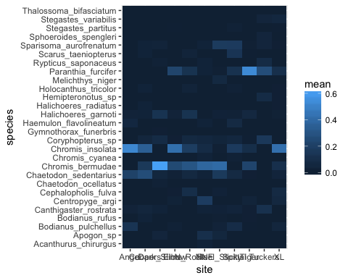 Changing color schemes

ggplot(data = heatmap, aes(x = site, y = species)) + geom_tile(aes(fill = mean), color = "white") +  
 scale_fill_gradient(low = "white", high = "darkred") +  
 ylab("Species") +  
 xlab("") +   
 theme(legend.title = element_text(size = 10),  
 legend.text = element_text(size = 12),  
 plot.title = element_text(size=16),  
 axis.title=element_text(size=14,face="bold"),  
 axis.text.x = element_text(angle = 45, hjust = 1)) +  
 labs(fill = "Percent")

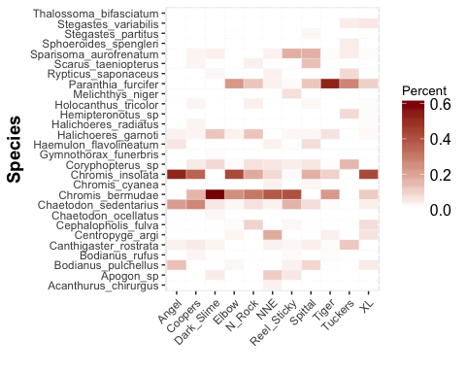 Changing the order of the fish species

ggplot(data = heatmap, aes(x = site, y = species)) + geom_tile(aes(y = reorder(species, mean, median, order = TRUE), fill = mean), color = "white") +  
 scale_fill_gradient(low = "white", high = "darkblue") +  
 ylab ("Species") +  
 xlab("") +   
 theme(legend.title = element_text(size = 10),  
 legend.text = element_text(size = 12),  
 plot.title = element_text(size=16),  
 axis.title=element_text(size=14,face="bold"),  
 axis.text.x = element_text(angle = 45, hjust = 1),  
axis.text.y=element_text(face="italic")) +  
 labs(fill = "Percent")

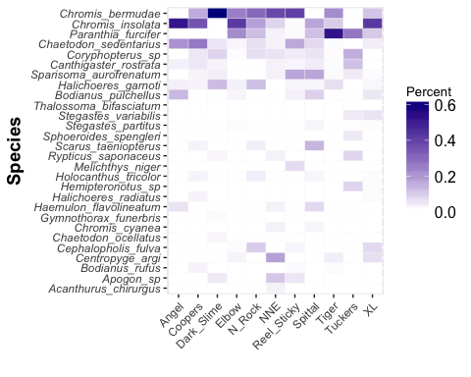

First version sent to review

heatmap_plot_red <- ggplot(data = heatmap, aes(x = site, y = species)) + geom_tile(aes(y = reorder(species, mean, order = TRUE), fill = mean), color = "white") +  
 scale_fill_gradient(low = "white", high = "red") +  
 ylab ("Species") +  
 xlab("") +   
 theme(legend.title = element_text(size = 10),  
 legend.text = element_text(size = 12),  
 plot.title = element_text(size=16),  
 axis.title=element_text(size=14,face="bold"),  
 axis.text.x = element_text(angle = 45, hjust = 1),  
axis.text.y=element_text(face="italic")) +  
 labs(fill = "Percent")  
heatmap_plot_red

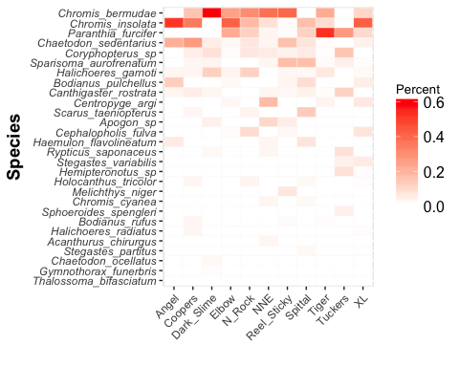

ggsave(plot = heatmap_plot_red, path= "~/Desktop/Lionfish", filename = "heatmap_plot_red_rev.eps", device = "eps")

## Saving 5 x 4 in image

Modifications made based on reviewer comments, including changing the x-axis to reorder sites in clockwise location around Bermuda and using mean instead of median for the order of the species.

# reorder x axis to go around the platform  
# mtcars$cyl2 <- factor(mtcars$cyl, levels = c("6","4","8"))  
heatmap$site <- as.character(heatmap$site)  
heatmap$site <- factor(heatmap$site, levels = c("Angel", "Dark_Slime", "N_Rock", "Reel_Sticky", "NNE", "XL", "Coopers", "Tuckers", "Spittal", "Elbow", "Tiger"))  
heatmap_plot_rev <- ggplot(data = heatmap, aes(x = site, y = species)) + geom_tile(aes(y = reorder(species, mean, order = TRUE), fill = mean), color = "white") +  
 scale_fill_gradient(low = "white", high = "red") +  
 ylab ("Species") +  
 xlab("") + theme_classic() +  
 theme(legend.title = element_text(size = 10),  
 legend.text = element_text(size = 12),  
 plot.title = element_text(size=16),  
 axis.title=element_text(size=14,face="bold"),  
 axis.text.x = element_text(angle = 45, hjust = 1),  
axis.text.y=element_text(face="italic")) +  
 labs(fill = "Percent")  
heatmap_plot_rev

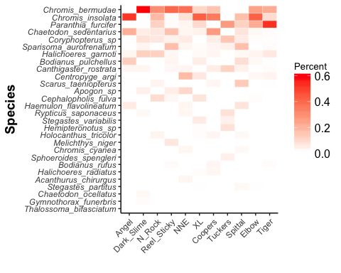

ggsave(plot = heatmap_plot_rev, path= "~/Desktop/Lionfish", filename = "heatmap_plot_rev.eps", device = "eps")

## Saving 5 x 4 in image

Adjusting colors and font size

heatmap$site <- as.character(heatmap$site)  
heatmap$site <- factor(heatmap$site, levels = c("Angel", "Dark_Slime", "N_Rock", "Reel_Sticky", "NNE", "XL", "Coopers", "Tuckers", "Spittal", "Elbow", "Tiger"))  
heatmap_plot_revBP <- ggplot(data = heatmap, aes(x = site, y = species)) + geom_tile(aes(y = reorder(species, mean, order = TRUE), fill = mean), color = "white") +  
 scale_fill_gradient2(low = "white", high = "darkred", mid = "red", midpoint = 0.31) +  
 ylab ("Species") +  
 xlab("") + theme_classic() +  
 theme(legend.title = element_text(size = 10),  
 legend.text = element_text(size = 12),  
 plot.title = element_text(size=16),  
 axis.title=element_text(size=14),  
 axis.text.x = element_text(angle = 45, hjust = 1, size = 12),  
axis.text.y=element_text(face="italic", size = 12)) +  
 labs(fill = "Percent Contribution")  
heatmap_plot_revBP

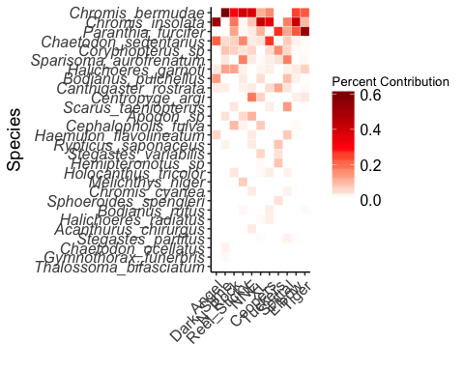

ggsave(plot = heatmap_plot_revBP, path= "~/Desktop/Lionfish", filename = "heatmap_final.eps", device = "eps")

## Saving 5 x 4 in image

Final Version in publication

heatmap$site <- as.character(heatmap$site)  
heatmap$site <- factor(heatmap$site, levels = c("Angel", "Dark_Slime", "N_Rock", "Reel_Sticky", "NNE", "XL", "Coopers", "Tuckers", "Spittal", "Elbow", "Tiger"))  
heatmap_plot_revBP <- ggplot(data = heatmap, aes(x = site, y = species)) + geom_tile(aes(y = reorder(species, mean, order = TRUE), fill = mean), color = "white") +  
 scale_fill_gradient2(low = "white", high = "darkred", mid = "red", midpoint = 0.31) +  
 ylab ("Species") +  
 xlab("") + theme_bw() +  
 theme(legend.title = element_text(size = 10),  
 legend.text = element_text(size = 12),  
 plot.title = element_text(size=16),  
 axis.title=element_text(size=14),  
 axis.text.x = element_text(angle = 45, hjust = 1),  
axis.text.y=element_text(face="italic")) +  
 labs(fill = "Percent Contribution")  
heatmap_plot_revBP

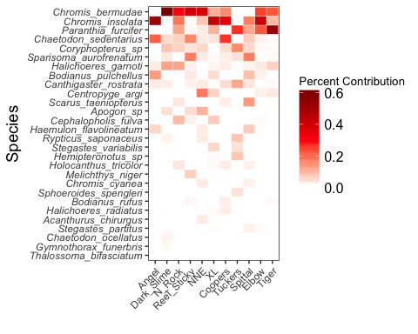

ggsave(plot = heatmap_plot_revBP, path= "~/Desktop/Lionfish", filename = "heatmap_final2.eps", device = "eps")

## Saving 5 x 4 in image