Correlation_matrix

GG

1/28/2019

# Darwin Correlation Analyses

library(ggplot2)  
library(tidyverse)

## ── Attaching packages ────────────────────────────────────────────────────────────────────────────────────────── tidyverse 1.2.1 ──

## ✔ tibble 1.4.2 ✔ purrr 0.2.4  
## ✔ tidyr 0.8.0 ✔ dplyr 0.7.4  
## ✔ readr 1.1.1 ✔ stringr 1.3.0  
## ✔ tibble 1.4.2 ✔ forcats 0.3.0

## ── Conflicts ───────────────────────────────────────────────────────────────────────────────────────────── tidyverse_conflicts() ──  
## ✖ dplyr::filter() masks stats::filter()  
## ✖ dplyr::lag() masks stats::lag()

library(readxl)  
library(janitor)  
library(dbplyr)

##   
## Attaching package: 'dbplyr'

## The following objects are masked from 'package:dplyr':  
##   
## ident, sql

Throughout this code I reference my computer desktop for reading and saving files, however the data files are available in github and can be accessed with a quick modification to the code.

darwin <- read_csv("~/Documents/darwin_stats2.csv")

## Parsed with column specification:  
## cols(  
## lionfish_den = col_integer(),  
## fish_div = col_double(),  
## fish_den = col_double(),  
## fish_bio = col_double(),  
## temp = col_double(),  
## c_bda = col_double(),  
## c_enchry = col_double(),  
## p_furc = col_double()  
## )

Creating a correlation matrix

corr <- round(cor(darwin), 1)

library(ggcorrplot)  
corr <- round(cor(darwin), 1)

p.mat <- cor_pmat(darwin)  
p.mat

## lionfish_den fish_div fish_den fish_bio temp  
## lionfish_den 0.000000000 0.8935592 0.03009850 0.01057712 0.01806799  
## fish_div 0.893559176 0.0000000 0.92823721 0.91829555 0.68157010  
## fish_den 0.030098503 0.9282372 0.00000000 0.01272457 0.12126003  
## fish_bio 0.010577116 0.9182956 0.01272457 0.00000000 0.04265957  
## temp 0.018067992 0.6815701 0.12126003 0.04265957 0.00000000  
## c_bda 0.638577500 0.8103600 0.39611960 0.90473476 0.95400950  
## c_enchry 0.500057009 0.5562265 0.10163415 0.01791172 0.36935829  
## p_furc 0.006140467 0.7441944 0.01375855 0.14222050 0.19339997  
## c_bda c_enchry p_furc  
## lionfish_den 0.6385775 0.50005701 0.006140467  
## fish_div 0.8103600 0.55622650 0.744194401  
## fish_den 0.3961196 0.10163415 0.013758553  
## fish_bio 0.9047348 0.01791172 0.142220495  
## temp 0.9540095 0.36935829 0.193399967  
## c_bda 0.0000000 0.63232147 0.847874198  
## c_enchry 0.6323215 0.00000000 0.830663067  
## p_furc 0.8478742 0.83066307 0.000000000

This figure includes the r values. These values can be removed by elimiating the lab = TRUE assignment

darwin_corr <- ggcorrplot(corr, hc.order = TRUE,   
 type = "lower",   
 lab = TRUE,   
 lab_size = 3, outline.col = "white",  
 p.mat = p.mat,  
 title="Correlogram of Lionfish Density",   
 colors = c("darkblue", "white", "red"),  
 ggtheme=theme_bw)  
darwin_corr

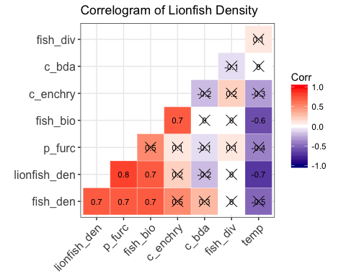

ggsave(darwin, plot = darwin_corr, device = "eps", path = "~/Desktop/Lionfish")

## Saving 5 x 4 in image