Lionfish GLM

GG

12/17/2018

## R Markdown

library(ggplot2)  
library(tidyverse)library(readxl)  
library(janitor)  
library(dbplyr)

library(vegan)

Visualizing the GLM resutls with a PCA analysis

# remove unwanted variables   
darwin.pca <- darwin[, 2:8]  
darwin.pca[6] = NULL  
darwin.pca[5] = NULL  
darwin.den <- (darwin[, 1] +1)  
   
# apply PCA - scale. = TRUE is highly   
# advisable, but default is FALSE.   
pca <- prcomp(darwin.pca,  
 center = TRUE,  
 scale. = TRUE)

# print method  
print(pca)

## Standard deviations (1, .., p=5):  
## [1] 1.6527303 1.0391372 0.7639914 0.6501548 0.4269572  
##   
## Rotation (n x k) = (5 x 5):  
## PC1 PC2 PC3 PC4 PC5  
## fish_div -0.007165718 -0.9169657 -0.3946599 0.04103037 -0.04102009  
## fish_den 0.542395402 -0.1071666 0.2788520 -0.33027914 -0.71237616  
## fish_bio 0.518714486 0.0871676 -0.3271884 -0.58406751 0.52454742  
## temp -0.457733358 -0.2765148 0.5690557 -0.59457821 0.19149965  
## p_furc 0.476624942 -0.2522511 0.5793173 0.44110553 0.42310217

In order to create the biplot we need devtools and ggbiplot available from CRAN and github

library(devtools)

d.factanal2 <- factanal(darwin.pca, factors = 2, scores = 'regression')  
pca.plot2 <- autoplot(d.factanal2, data = darwin, colour = 'lionfish_den', size = 4,  
 loadings = TRUE, loadings.label = TRUE, loadings.label.size = 5) + theme_classic()  
pca.plot2

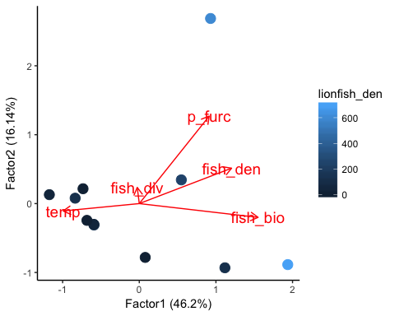

ggsave(darwin, plot = pca.plot2, device = "eps", path = "~/Desktop/Lionfish")

NOW FOR THE GLM *using Gamma distribution as this model results in the most “normal” data, see plots below of model fits*

scale((darwin[,2:8]), center = TRUE, scale = TRUE)

## fish_div fish_den fish_bio temp c_bda c_enchry  
## [1,] 0.4809800 1.4365108 1.2281635 -0.1297499 0.09054847 2.60244718  
## [2,] -0.0497952 2.0336000 0.5682290 -0.8433746 0.23309789 -0.43401594  
## [3,] -0.1564501 0.8528393 2.0426555 -1.5569993 -0.37682665 0.99732680  
## [4,] 0.2879963 -0.6834913 0.5114883 -0.1297499 -0.73904237 0.08487951  
## [5,] -0.5657100 -0.7103267 -0.5480014 -0.1297499 -0.57546108 -0.64805727  
## [6,] 0.0724305 -0.7639977 -0.8468391 -0.8433703 -0.59882984 -0.48007135  
## [7,] 0.2267893 0.0410664 -0.5568844 -0.1297499 2.35211988 -0.66488296  
## [8,] -1.3837317 -0.1199464 0.1806320 0.5838747 1.36414569 -0.65962493  
## [9,] -0.7697882 -0.6029849 -0.6502334 -0.1297499 -0.73904237 0.10444226  
## [10,] 2.5176680 -0.6029849 -0.7515916 1.2974951 -0.27166725 -0.23756036  
## [11,] -0.6603889 -0.8802847 -1.1776184 2.0111241 -0.73904237 -0.66488296  
## p_furc  
## [1,] -0.1154827  
## [2,] 2.7300946  
## [3,] 0.4089936  
## [4,] 0.6103919  
## [5,] -0.5969805  
## [6,] -0.4244987  
## [7,] -0.5969805  
## [8,] -0.5908870  
## [9,] -0.5969805  
## [10,] -0.2520169  
## [11,] -0.5756534  
## attr(,"scaled:center")  
## fish_div fish_den fish_bio temp c_bda   
## 1.043875e+00 3.456499e+03 2.160150e+05 2.232323e+01 7.658861e+03   
## c_enchry p_furc   
## 5.930354e+04 2.953466e+04   
## attr(,"scaled:scale")  
## fish_div fish_den fish_bio temp c_bda   
## 2.459291e-01 3.105964e+03 1.395158e+05 7.784982e-01 1.036322e+04   
## c_enchry p_furc   
## 8.919395e+04 4.947341e+04

fit_bio <- glm((lionfish_den + 1)~fish_bio, data=darwin, family = Gamma)  
fit_den <- glm((lionfish_den + 1)~fish_den, data=darwin, family = Gamma)  
fit_div <- glm((lionfish_den + 1)~fish_div, data=darwin,family = Gamma, start = c(0.5, 0.5))

fit_pfur <- glm((lionfish_den + 1)~p_furc, data=darwin,family = Gamma)  
fit_temp <- glm((lionfish_den + 1)~temp, data=darwin, family = Gamma)

AIC(fit_bio, fit_den, fit_pfur, fit_temp, fit_div)

## df AIC  
## fit_bio 3 132.1325  
## fit_den 3 132.9021  
## fit_pfur 3 133.0543  
## fit_temp 3 130.5879  
## fit_div 3 135.4520

coef(fit_bio, fit_den, fit_pfur, fit_temp, fit_div)

## (Intercept) fish_bio   
## 1.418382e-02 -2.590616e-08

summary(fit_bio)

##   
## Call:  
## glm(formula = (lionfish_den + 1) ~ fish_bio, family = Gamma,   
## data = darwin)  
##   
## Deviance Residuals:   
## Min 1Q Median 3Q Max   
## -2.7729 -1.6877 -0.5795 0.4458 1.7658   
##   
## Coefficients:  
## Estimate Std. Error t value Pr(>|t|)   
## (Intercept) 1.418e-02 5.939e-03 2.388 0.0407 *  
## fish_bio -2.591e-08 1.270e-08 -2.039 0.0718 .  
## ---  
## Signif. codes: 0 '***' 0.001 '**' 0.01 '*' 0.05 '.' 0.1 ' ' 1  
##   
## (Dispersion parameter for Gamma family taken to be 1.485765)  
##   
## Null deviance: 33.732 on 10 degrees of freedom  
## Residual deviance: 26.879 on 9 degrees of freedom  
## AIC: 132.13  
##   
## Number of Fisher Scoring iterations: 7

summary(fit_den)

##   
## Call:  
## glm(formula = (lionfish_den + 1) ~ fish_den, family = Gamma,   
## data = darwin)  
##   
## Deviance Residuals:   
## Min 1Q Median 3Q Max   
## -2.7576 -1.8288 -0.7249 0.3836 1.6406   
##   
## Coefficients:  
## Estimate Std. Error t value Pr(>|t|)   
## (Intercept) 1.144e-02 4.857e-03 2.355 0.0430 *  
## fish_den -1.024e-06 5.547e-07 -1.845 0.0981 .  
## ---  
## Signif. codes: 0 '***' 0.001 '**' 0.01 '*' 0.05 '.' 0.1 ' ' 1  
##   
## (Dispersion parameter for Gamma family taken to be 1.50623)  
##   
## Null deviance: 33.732 on 10 degrees of freedom  
## Residual deviance: 28.346 on 9 degrees of freedom  
## AIC: 132.9  
##   
## Number of Fisher Scoring iterations: 7

summary(fit_div)

##   
## Call:  
## glm(formula = (lionfish_den + 1) ~ fish_div, family = Gamma,   
## data = darwin, start = c(0.5, 0.5))  
##   
## Deviance Residuals:   
## Min 1Q Median 3Q Max   
## -2.93731 -2.04226 -0.38759 0.06849 1.69945   
##   
## Coefficients:  
## Estimate Std. Error t value Pr(>|t|)  
## (Intercept) 0.003937 0.010800 0.365 0.724  
## fish_div 0.001435 0.010377 0.138 0.893  
##   
## (Dispersion parameter for Gamma family taken to be 1.923602)  
##   
## Null deviance: 33.732 on 10 degrees of freedom  
## Residual deviance: 33.694 on 9 degrees of freedom  
## AIC: 135.45  
##   
## Number of Fisher Scoring iterations: 8

summary(fit_pfur)

##   
## Call:  
## glm(formula = (lionfish_den + 1) ~ p_furc, family = Gamma, data = darwin)  
##   
## Deviance Residuals:   
## Min 1Q Median 3Q Max   
## -2.7662 -1.8014 -0.2507 0.2023 2.0405   
##   
## Coefficients:  
## Estimate Std. Error t value Pr(>|t|)   
## (Intercept) 8.872e-03 3.963e-03 2.239 0.0519 .  
## p_furc -4.612e-08 2.690e-08 -1.714 0.1206   
## ---  
## Signif. codes: 0 '***' 0.001 '**' 0.01 '*' 0.05 '.' 0.1 ' ' 1  
##   
## (Dispersion parameter for Gamma family taken to be 1.917667)  
##   
## Null deviance: 33.732 on 10 degrees of freedom  
## Residual deviance: 28.644 on 9 degrees of freedom  
## AIC: 133.05  
##   
## Number of Fisher Scoring iterations: 7

summary(fit_temp)

##   
## Call:  
## glm(formula = (lionfish_den + 1) ~ temp, family = Gamma, data = darwin)  
##   
## Deviance Residuals:   
## Min 1Q Median 3Q Max   
## -2.7016 -1.6302 -0.3070 0.3184 1.4462   
##   
## Coefficients:  
## Estimate Std. Error t value Pr(>|t|)   
## (Intercept) -0.162890 0.066513 -2.449 0.0368 *  
## temp 0.007765 0.003134 2.478 0.0351 *  
## ---  
## Signif. codes: 0 '***' 0.001 '**' 0.01 '*' 0.05 '.' 0.1 ' ' 1  
##   
## (Dispersion parameter for Gamma family taken to be 1.165115)  
##   
## Null deviance: 33.732 on 10 degrees of freedom  
## Residual deviance: 24.127 on 9 degrees of freedom  
## AIC: 130.59  
##   
## Number of Fisher Scoring iterations: 6

hist(resid(fit_temp))

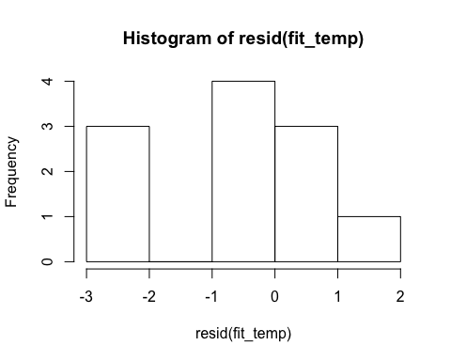

qqnorm(resid(fit_temp))  
qqline(resid(fit_temp))

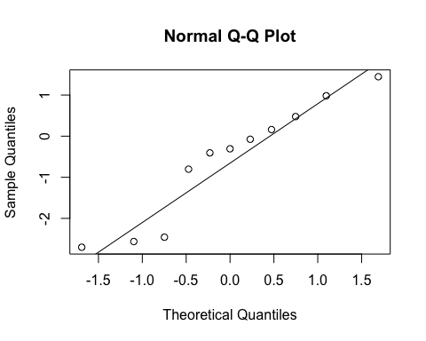

hist(resid(fit_den))

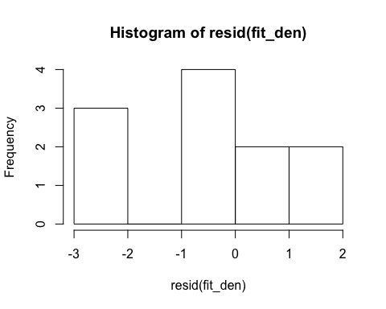

qqnorm(resid(fit_den))  
qqline(resid(fit_den))

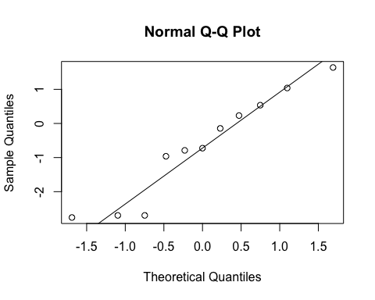

hist(resid(fit_div))

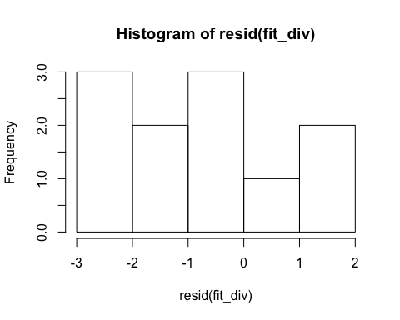

qqnorm(resid(fit_div))  
qqline(resid(fit_div))

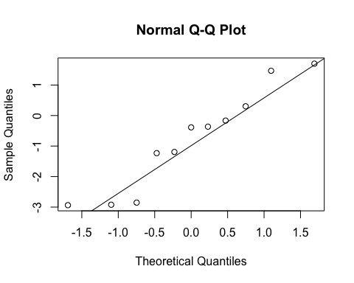

hist(resid(fit_bio))

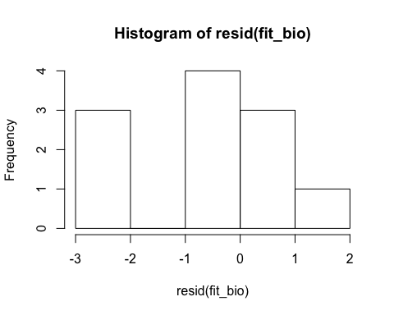

qqnorm(resid(fit_bio))  
qqline(resid(fit_bio))

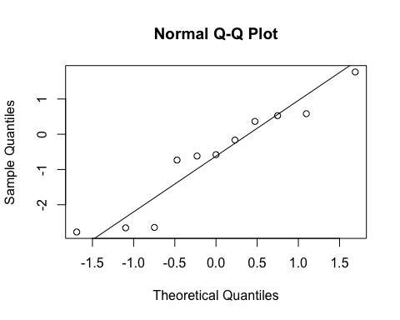

hist(resid(fit_pfur))

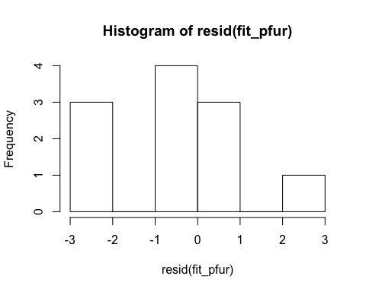

qqnorm(resid(fit_pfur))  
qqline(resid(fit_pfur))

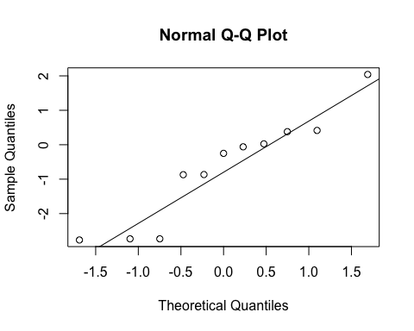

coef(fit_bio)

## (Intercept) fish_bio   
## 1.418382e-02 -2.590616e-08

coef(fit_pfur)

## (Intercept) p_furc   
## 8.871575e-03 -4.611608e-08

coef(fit_temp)

## (Intercept) temp   
## -0.162889556 0.007764716

coef(fit_div)

## (Intercept) fish_div   
## 0.003937398 0.001435102

coef(fit_den)

## (Intercept) fish_den   
## 1.143692e-02 -1.023463e-06