https://www.youtube.com/watch?v=oGmAhwnmaWc

dynamixel id setting

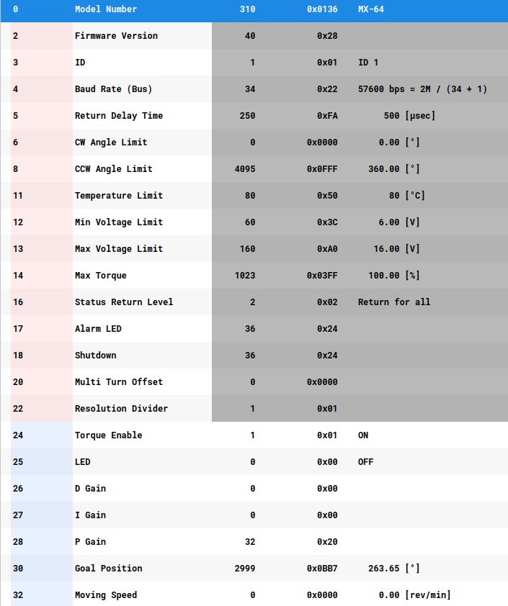

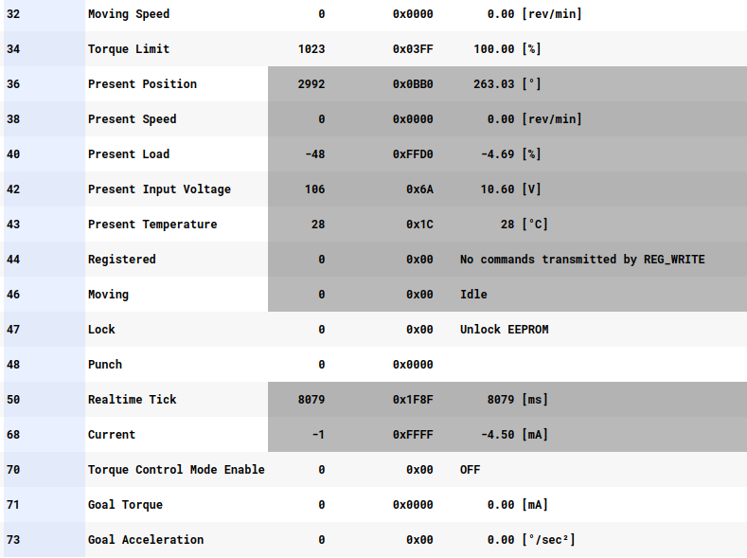

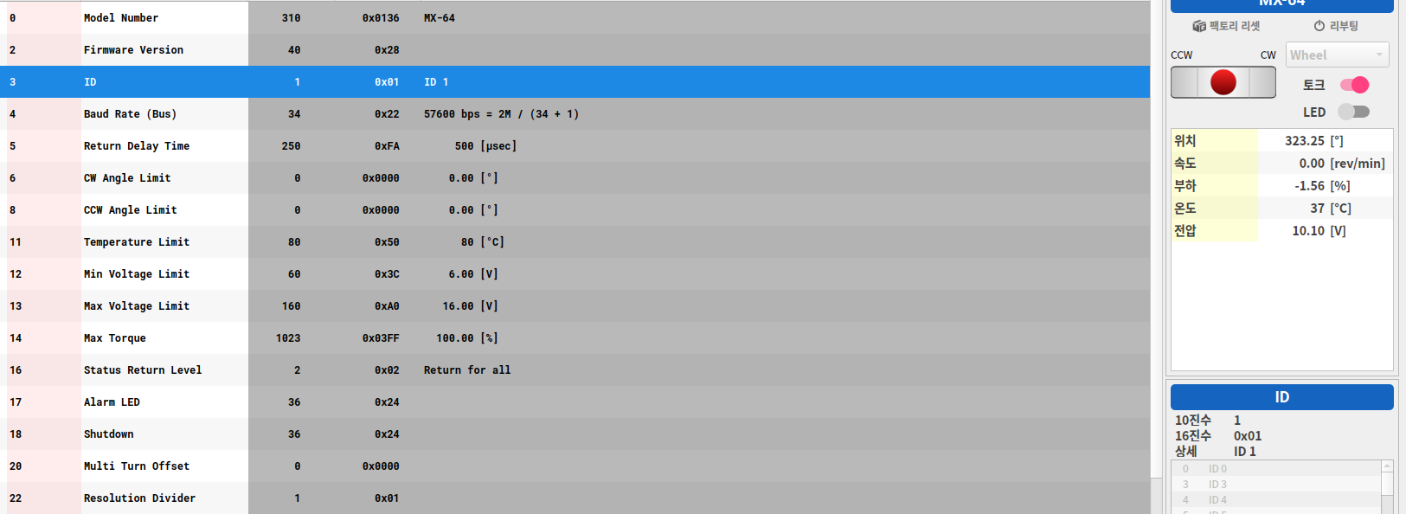
dynamixel ID 설정

