UI:

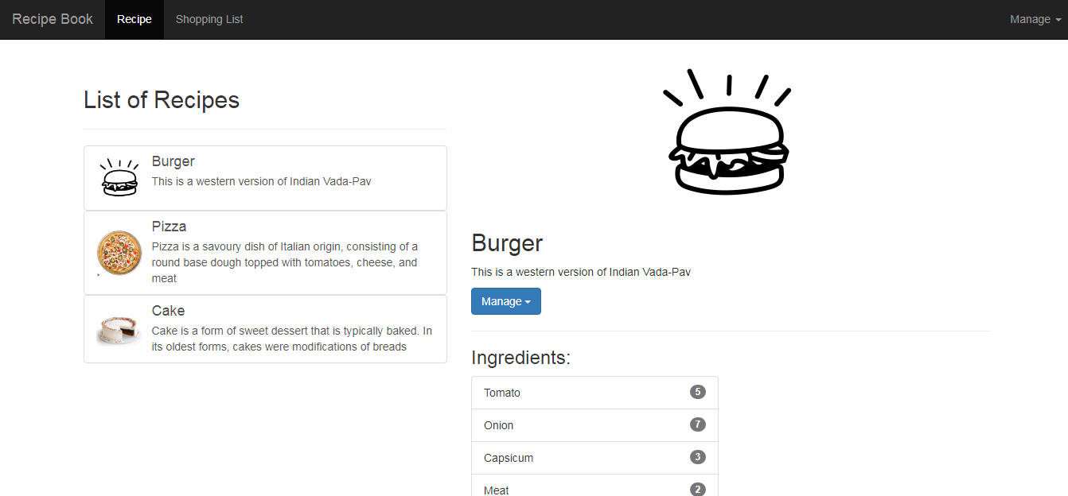

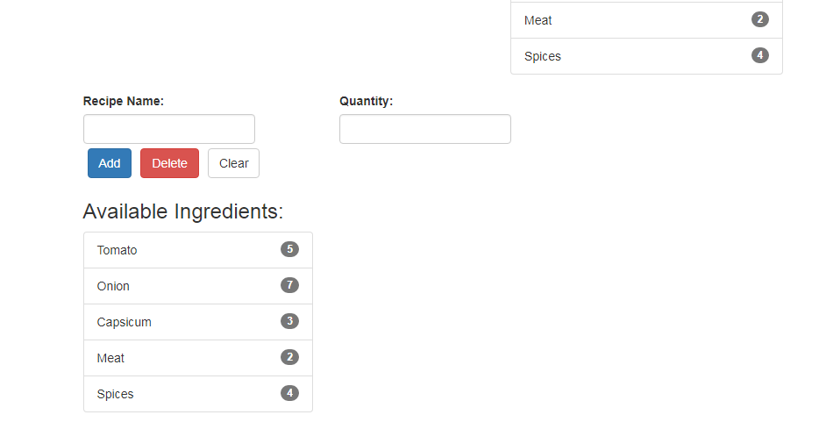

App.module.ts

import { BrowserModule } from '@angular/platform-browser';

import { NgModule } from '@angular/core';

import { AppComponent } from './app.component';

import { HeaderComponent } from './header/header.component';

import { RecipeComponent } from './recipe/recipe.component';

import { ShoppingListComponent } from './shopping-list/shopping-list.component';

import { RecipeListComponent } from './recipe/recipe-list/recipe-list.component';

import { RecipeDetailsComponent } from './recipe/recipe-details/recipe-details.component';

import { RecipeItemComponent } from './recipe/recipe-list/recipe-item/recipe-item.component';

import { ShoppingListEditComponent } from './shopping-list/shopping-list-edit/shopping-list-edit.component';

@NgModule({

declarations: [

AppComponent,

HeaderComponent,

RecipeComponent,

ShoppingListComponent,

RecipeListComponent,

RecipeDetailsComponent,

RecipeItemComponent,

ShoppingListEditComponent

],

imports: [

BrowserModule

],

providers: [],

bootstrap: [AppComponent]

})

export class AppModule { }

app.component.ts

import { Component } from '@angular/core';

@Component({

selector: 'app-root',

templateUrl: './app.component.html',

styleUrls: ['./app.component.css']

})

export class AppComponent {

// title = 'basic-app';

}

App.component.html

<app-header></app-header>

<div class="container" style="padding-top: 70px">

<div class="row">

<div class="col-md-12">

<app-recipe></app-recipe>

</div>

</div>

<div class="row">

<div class="col-md-12">

<app-shopping-list></app-shopping-list>

</div>

</div>

</div>

Header.component.ts

import { Component, OnInit } from '@angular/core';

@Component({

selector: 'app-header',

templateUrl: './header.component.html',

styleUrls: ['./header.component.css']

})

export class HeaderComponent implements OnInit {

constructor() { }

ngOnInit() {

}

}

Header.component.html

<!-- <nav class="navbar navbar-expand-sm bg-dark navbar-dark">

<a class="navbar-brand" href="#">

Online Recipe Book

</a>

<ul class="navbar-nav">

<li class="nav-item">

<a class="nav-link" href="#">Recipe</a>

</li>

<li class="nav-item">

<a class="nav-link" href="#">Shopping List</a>

</li>

</ul>

<ul class="navbar-nav ml-auto">

<li class="nav-item dropdown">

<a class="nav-link dropdown-toggle" href="#" id="navbardrop" data-toggle="dropdown">

Manage

</a>

<div class="dropdown-menu">

<a class="dropdown-item" href="#">Fetch Data</a>

<a class="dropdown-item" href="#">Save Data</a>

</div>

</li>

</ul>

</nav> -->

<nav class="navbar navbar-inverse navbar-fixed-top">

<div class="container-fluid">

<div class="navbar-header">

<a class="navbar-brand" href="#">Recipe Book</a>

</div>

<ul class="nav navbar-nav">

<li class="active">

<a href="#">Recipe</a>

</li>

<li>

<a href="#">Shopping List</a>

</li>

</ul>

<ul class="nav navbar-nav navbar-right">

<li class="dropdown">

<a class="dropdown-toggle" data-toggle="dropdown" href="#">Manage

<span class="caret"></span>

</a>

<ul class="dropdown-menu">

<li>

<a href="#">Fetch Data</a>

</li>

<li>

<a href="#">Send Data</a>

</li>

</ul>

</li>

</ul>

</div>

</nav>

Recipe.component.ts

import { Component, OnInit } from '@angular/core';

@Component({

selector: 'app-recipe',

templateUrl: './recipe.component.html',

styleUrls: ['./recipe.component.css']

})

export class RecipeComponent implements OnInit {

constructor() { }

ngOnInit() {

}

}

Recipe.component.html

<div class="row">

<div class="col-md-5">

<app-recipe-list></app-recipe-list>

</div>

<div class="col-md-7">

<app-recipe-details></app-recipe-details>

</div>

</div>

Recipe-list.component.ts

import { Component, OnInit } from '@angular/core';

import { Recipe } from '../models/recipe.model';

import { HandleDataService } from '../handle-data.service';

@Component({

selector: 'app-recipe-list',

templateUrl: './recipe-list.component.html',

styleUrls: ['./recipe-list.component.css']

})

export class RecipeListComponent implements OnInit {

recipes: Recipe[] = [];

constructor(private handleData: HandleDataService) { }

ngOnInit() {

this.recipes.push(

new Recipe(

'Burger',

'./assets/Burger.png',

'This is a western version of Indian Vada-Pav'

)

);

this.recipes.push(

new Recipe(

'Pizza',

'./assets/Pizza.png',

// tslint:disable-next-line:max-line-length

'Pizza is a savoury dish of Italian origin, consisting of a round base dough topped with tomatoes, cheese, and meat'

)

);

this.recipes.push(

new Recipe(

'Cake',

'./assets/Cake.png',

'Cake is a form of sweet dessert that is typically baked. In its oldest forms, cakes were modifications of breads'

)

);

}

showDetail(recipe: Recipe) {

this.handleData.updateRecipe(recipe);

}

}

Recipe-list.component.html

<br>

<h2>List of Recipes</h2>

<hr>

<app-recipe-item *ngFor="let recipe of recipes;" [recipe]="recipe" (click)="showDetail(recipe)">

</app-recipe-item>

Recipe-item.component.ts

import { Component, OnInit, Input } from '@angular/core';

import { Recipe } from '../../models/recipe.model';

@Component({

selector: 'app-recipe-item',

templateUrl: './recipe-item.component.html',

styleUrls: ['./recipe-item.component.css']

})

export class RecipeItemComponent implements OnInit {

@Input() recipe: Recipe;

constructor() { }

ngOnInit() {

}

}

Recipe-item.component.html

<a href="#" class="list-group-item list-group-item-action">

<div class="media">

<div class="media-left media-middle">

<img class="media-object" [src]="recipe.img_url" alt="Recipe Image" style="width:60px">

</div>

<div class="media-body">

<h4 class="media-heading">{{ recipe.name }}</h4>

{{ recipe.description }}

</div>

</div>

</a>

Recipe-details.component.ts

import { Component, OnInit, OnDestroy, ElementRef } from '@angular/core';

import { Observable, Subscription } from '../../../../node_modules/rxjs';

import { Recipe } from '../models/recipe.model';

import { HandleDataService } from '../handle-data.service';

import { Ingredient } from '../ingredient.model';

import { IngredientService } from '../../ingredient.service';

@Component({

selector: 'app-recipe-details',

templateUrl: './recipe-details.component.html',

styleUrls: ['./recipe-details.component.css']

})

export class RecipeDetailsComponent implements OnInit, OnDestroy {

temp: Observable<Recipe>;

recipe: Recipe = new Recipe(

'Burger',

'./assets/Burger.png',

'This is a western version of Indian Vada-Pav'

);

subscription: Subscription;

dummy = 'Dummy';

ingredients: Ingredient[] = [];

constructor(

private handleData: HandleDataService,

private ingredientService: IngredientService

) { }

ngOnInit() {

this.subscription = this.handleData.recipeObs$.subscribe(data => {

this.recipe = data;

});

this.ingredients = this.ingredientService.getIngredients();

}

ngOnDestroy() {

this.subscription.unsubscribe();

}

}

Recipe-details.component.html

<div class="row">

<div class="col-md-12">

<img [src]="recipe.img_url" alt="Recipe Image">

<!-- <h1>Hi there</h1> -->

</div>

</div>

<div class="row">

<div class="col-md-12">

<h2>{{ recipe.name }}</h2>

</div>

</div>

<div class="row">

<div class="col-md-12">

<p>{{ recipe.description }}</p>

</div>

</div>

<!-- Single button -->

<div class="row">

<div class="col-md-12">

<div class="btn-group">

<button type="button" class="btn btn-primary dropdown-toggle" data-toggle="dropdown" aria-haspopup="true" aria-expanded="false">

Manage

<span class="caret"></span>

</button>

<ul class="dropdown-menu">

<li>

<a href="#">Add</a>

</li>

<li>

<a href="#">Delete</a>

</li>

</ul>

</div>

</div>

</div>

<hr>

<h3>Ingredients:</h3>

<div class="row">

<div class="col-md-6">

<ul class="list-group">

<li class="list-group-item" *ngFor="let i of ingredients;">

<span class="badge">{{ i.quantity }}</span>

{{ i.name }}

</li>

</ul>

</div>

</div>

Recipe-details.component.css

.row:first-child {

text-align: center;

}

Shopping-list.component.ts

import { Component, OnInit } from '@angular/core';

@Component({

selector: 'app-shopping-list',

templateUrl: './shopping-list.component.html',

styleUrls: ['./shopping-list.component.css']

})

export class ShoppingListComponent implements OnInit {

constructor() { }

ngOnInit() {

}

}

Shopping-list.component.html

<app-shopping-list-edit></app-shopping-list-edit>

Shopping-list-edit.component.ts

import { Component, OnInit } from '@angular/core';

import { Ingredient } from '../../recipe/ingredient.model';

import { IngredientService } from '../../ingredient.service';

@Component({

selector: 'app-shopping-list-edit',

templateUrl: './shopping-list-edit.component.html',

styleUrls: ['./shopping-list-edit.component.css']

})

export class ShoppingListEditComponent implements OnInit {

ingredients: Ingredient[] = [];

constructor(private ingredientService: IngredientService) { }

ngOnInit() {

this.ingredients = this.ingredientService.getIngredients();

}

}

Shopping-list-edit.component.html

<div class="row">

<form class="form-inline">

<div class="col-md-3">

<div class="form-group">

<label for="recipeName">Recipe Name:</label>

<br>

<input type="text" class="form-control" id="recipeName">

</div>

</div>

<div class="col-md-3">

<div class="form-group">

<label for="quantity">Quantity:</label>

<br>

<input type="number" class="form-control" id="quantity">

</div>

</div>

</form>

<div class="col-md-6">

</div>

</div>

<div class="row">

<div class="col-md-6">

<button type="button" class="btn btn-primary">Add</button>

<button type="button" class="btn btn-danger">Delete</button>

<button type="button" class="btn btn-default">Clear</button>

</div>

<div class="col-md-6"></div>

</div>

<div class="row">

<div class="col-md-6">

<h3>Available Ingredients:</h3>

<div class="row">

<div class="col-md-6">

<ul class="list-group">

<li class="list-group-item" *ngFor="let i of ingredients;">

<span class="badge">{{ i.quantity }}</span>

{{ i.name }}

</li>

</ul>

</div>

</div>

</div>

<div class="col-md-6"></div>

</div>

Shopping-list-edit.component.css

button {

margin: 5px;

}

Models Added:

Recipe.model.ts

export class Recipe {

constructor(

public name: string,

public img_url: string,

public description: string

) { }

}

Ingredient.model.ts

export class Ingredient {

constructor(public name: string, public quantity: number) { }

}

Services Added:

Handle-data.service.ts

import { Injectable } from '@angular/core';

import { Subject } from 'rxjs';

import { Recipe } from './models/recipe.model';

@Injectable({

providedIn: 'root'

})

export class HandleDataService {

recipeSource = new Subject<Recipe>();

recipeObs$ = this.recipeSource.asObservable();

constructor() { }

updateRecipe(recipe: Recipe) {

this.recipeSource.next(recipe);

}

}

Ingredient.service.ts

import { Injectable } from '@angular/core';

import { Ingredient } from './recipe/ingredient.model';

@Injectable({

providedIn: 'root'

})

export class IngredientService {

ingredients: Ingredient[] = [

new Ingredient('Tomato', 5),

new Ingredient('Onion', 7),

new Ingredient('Capsicum', 3),

new Ingredient('Meat', 2),

new Ingredient('Spices', 4)

];

constructor() { }

getIngredients(): Ingredient[] {

return [...this.ingredients];

}

}